1-MONTH PROGRAM DESIGN OVERVIEW (Resistance and Aerobic Progression)
Aerobic Progression:
Program Stage | Weeks | Frequency | Exertion Level | RPE (10pt) | Duration (mins)
Improvement | 1-4 | 4 | Somewhat Hard | 4 | 25-30 minutes
 | 5-7 | 4 | Somewhat Hard | 4 | 25-30 minutes

Weeks 1-4:
Aerobic Training Day | Exercise | Duration (mins)
Day 1 | Brisk Walking: Treadmill: 3.7 mi/hr, incline 1.0% | 25 mins
Day 2 | Stair Climbing: Step Mill: 40 steps/ minute | 25 mins
Day 3 | Brisk Walking: Treadmill: 3.7 mi/hr, incline 1.0% | 25 mins
Day 4 | Stair Climbing: Step Mill: 40 steps/ minute | 25 mins
Alternative Exercise exception | Dance class (Zumba Fitness)  Beginner Step Class (Only if comfortable) | If class is 60 mins, this counts for 2 cardio days!

Weeks 5-8:
Aerobic Training Day | Exercise | Duration
Day 1 | Brisk Walking: Treadmill: 3.9 mi/hr, incline 1.0% | 30 mins
Day 2 | Stair Climbing: Step Mill: 45 steps/ minute | 30 mins
Day 3 | Brisk walking: Treadmill: 3.9 mi/ hr, incline 1.0% | 30 mins
Day 4 | Stair Climbing: Step Mill: 45 steps/ minute | 30 mins
Alternative Exercise exception | Dance class (Zumba Fitness), or Beginner Step Class (Only if comfortable) | If class is 60 mins this counts for 2 aerobic sessions!

Resistance Training Program (*see Exercise Examples below and complete all for whole body strength training)
Program Stage | Weeks | Frequency (days/week) | Exertion Level | 1RM % | Sets | Reps | Weight
Improvement | 1-4 | 2 | 3 | 62-67% 1RM | 2 | 8 | 8lbs
 | 5-7 | 2 | 3 | 62-67% 1RM | 2 | 10 | 8lbs

Weeks 1-4:
Resistance Days | Exercise | Sets | Reps | 1RM or Weight | Tempo
Day 1 | Whole Body (12 exercise total) | 2 | 8 | 8lbs or 62-67% 1RM | 1 1 1
Day 2 | Whole Body (12 exercise total) | 2 | 8 | 8lbs or 62-67% 1RM | 1 1 1

Weeks 5-7
Resistance Days | Exercise | Sets | Reps | 1RM or Weight | Tempo
Day 1 | Whole Body (12 exercise total) | 2 | 10 | 8lbs or 62-67% 1RM | 1 1 1
Day 2 | Whole Body (12 exercise total) | 2 | 10 | 8lbs or 62-67% 1RM | 1 1 1

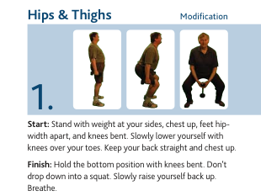

Notes: Knees not to go over the toes, use sitting motion, if assistance needed use chair

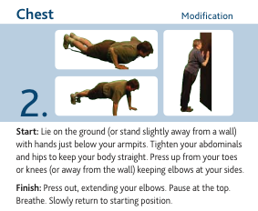

Notes: Can also perform push up with knees and toes together on the floor with feet pointed, with a mat underneath to protect the knees.

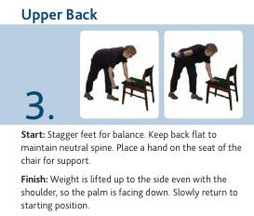

Notes: Start with 3Ib DB (weeks 1-10) and work your way up to 5 Ib DB (weeks 10-25+)

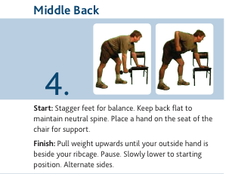

Notes: Start with 3Ib DB (weeks 1-10) and work your way up to 5 Ib DB (weeks 10-25+)

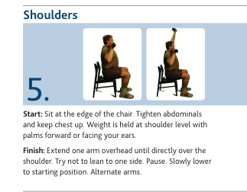

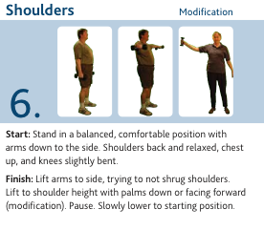
Notes: If more back support is needed while doing this exercise place a cushion or mat behind the lower back to provide support. Start with 3Ib DB (weeks 1-10) and work your way up to 5 Ib DB (weeks 10-25+)

Notes: Start with 3Ib DB (weeks 1-10) and work your way up to 5 Ib DB (weeks 10-25+)

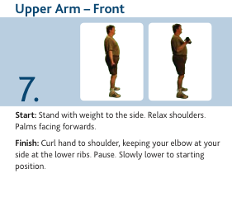

Notes: Start with 3Ib DB (weeks 1-10) and work your way up to 5 Ib DB (weeks 10-25+)
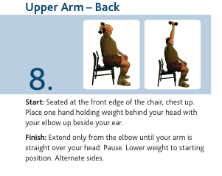

Notes: for more back support use a cushion or yoga mat behind back. Start with 3Ib DB (weeks 1-10) and work your way up to 5 Ib DB (weeks 10-25+)

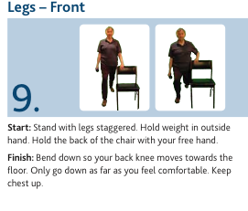

Notes: ensure that the legs are staggered enough so that on the front leg the knee does not go past the toe in the bending motion.
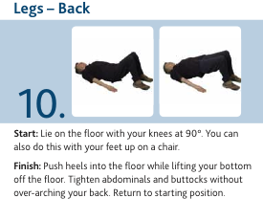

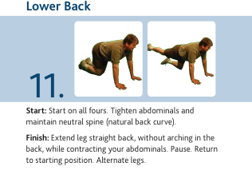

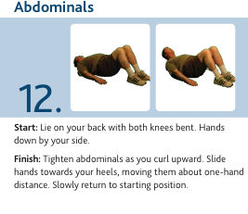

Extra Exercises (Introduce weeks 10-25+)

