**Week 3: Assignment 1.3 – Definitions (Revised)**

**What is Social Space? (Parenthetical Definition and Sentence Definition)**

Social space (social segregation) follows the collective tendencies of group dynamics. Social space is a sociological metaphor to explain how people are related to each other regarding types of capital.

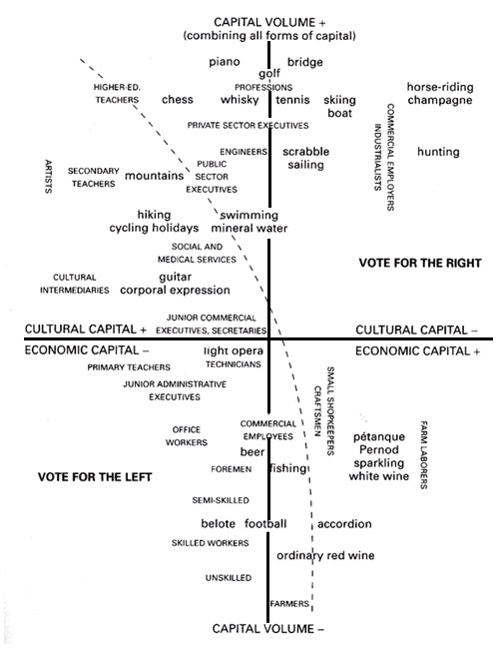**How did it develop? (History and Visual)**

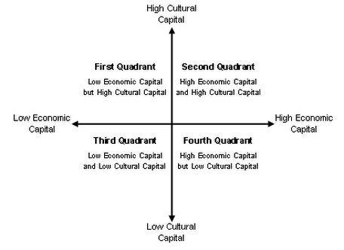

Figure 1. Representation of Social Space (Bourdieu, P. 1984)

Figure 2. Representation of Social Space - simplified model

Social space is a sociological concept developed by the French sociologist Pierre Bourdieu. Bourdieu describes modern capitalist society as a multi-dimensional social space where distributions in social characteristics are seen geographically. The idea is constructed on the basis of differentiation to the relations of social position and Bourdieu argues that people who are at opposing ends of the class map are often socially distant from one another.

**How is it used? (Example)**

Under social space, there are two types of capitals - economic and cultural capital. Economic capital refers to something which can be immediately converted into money, such as property ownership. Cultural capital refers to non-financial asset that can mobilize one’s social standing, such as educational investment. For instance, Brian is a sessional sociology professor at a university so he possesses high cultural capital (intellectual) with respect to the sociological field. However, sessional professors are not a well-paid job in comparison to full-time professors, thus he is distant from economic capital.

**How does it resemble or differ from something else? (Comparison & Contrast)**

People in the high right corner of the map (High Economic and High Cultural Capita – *Second Quadrant*) represent the dominant class often associated with “old money” and “established capitalists”. People in the low right corner of the map (High Economic and Low Cultural Capital – *Fourth Quadrant*) represent people associated with “newer money” like managers, engineers, entrepreneurs and son on. People in the high left corner (Low Economic and High Cultural Capital – *First Quadrant*) represent people associated with the intellectual classes including teachers, professors, and academics. Lastly, people in the low left corner (Low Economic and Low Cultural Capital – *Third Quadrant*) represent people associated with the working class and forms of lower paid manual or service industry labour.

**Works Cited**

Bourdieu, P. (1984). *Distinction: A social critique of the judgment of taste*. London: Routledge & Kegan Paul.

Bourdieu, P. (1985) The Social Space and the Genesis of Groups. Theory and Society. 14(6), 723-744.

Bourdieu, P. (1986) The forms of capital. In J. Richardson (Ed.) Handbook of Theory and Research for the Sociology of Education. 241-258.

Weininger, E. (2004) Foundations of Pierre Bourdieu’s Class analysis. *Approaches to class analysis.*119-171.