ENGL 301 – Unit 1:3 Assignment

Algorithm

Introduction
As instructed on the English 301 course page, I will be presenting three definitions (parenthetical, sentence, and expanded) for a relatively complex term used within my particular field of study. The term I will be defining is “algorithm.” Below are the objectives and criteria of the assignment specified on the course website.

Objectives:
- Appreciated the importance and role of definitions in technical writing
- Understand how audience and purpose indicate the need for definitions
- Differentiate between the levels of details in a definition
- Select the right level of detail according to the situation

Criteria:
- Choose a relatively complex term used within your field of study
- Choose a situation and an audience of “non-technical readers”
- Compose a parenthetical, sentence and expanded definition. For the expanded definition, you will:
- Use at least four expansion strategies
- Include at least one visual
- Consult at least three outside references and provide a works cited list in MLA or APA style
- Include an introduction to your assignment that states the objectives and criteria of the assignment

Situation: I am a teaching assistant for CPSC 100: Computational Thinking. The professor of the course has tasked me with composing a handout for students that introduces the concept of an algorithm.

Audience: The UBC Bachelor of Arts degree requires students to take 60 credits outside their field of study. CPSC 100 in this case is an easy elective that many students choose to fulfill this requirement.

Parenthetical Definition: A computer program can be viewed as an algorithm (sequence of instructions or steps to solve a problem).

Sentence Definition: An algorithm is a set of steps or instructions to accomplish a task. The task being completed can range from “following a recipe to make sandwiches” to Dijkstra’s algorithm (finding the shortest paths between two nodes in a graph).

Expanded Definition:
What is an algorithm?
Formally, an algorithm is a mathematical set of instructions that are systematically performed based on a set of rules to produce a solution. More specifically and encompassing the term outside of mathematics, the term can also mean an ordered set of instructions or steps that when performed, produces a result within a finite amount of time. Algorithm exists everywhere and they can range from simply “how to get home” to the American Heart Association’s Acute Coronary Syndromes Algorithm (Figure 1). In Computer Science, the study of algorithms is an area of interest for the majority of scientists. Particularly, when to use them, and how to make them better and more efficient (Lowther).

Where did the notion of “algorithm” come from?
In terms of where the word originates from, a Persian mathematician, Muhammad ibn Musa al-Khwarizmi, wrote an important mathematical textbook titled Kitab al jabrw’almuqabala which introduced the term al-jabr (the Latinized form being algebra). The term algoism (the more original form of algorithm) comes directly from the Latinized form of the author’s name (Martignon, 2015) and explains the connection the word has to computer science and mathematics.

How do we describe algorithms?
To describe an algorithm, we require a notation for expressing the sequence of instructions that need to be performed. There are a variety of ways that algorithms can be expressed. The most common methods are by natural language, flowcharts, pseudocode (a simplified notation that focuses on what the algorithm does), or programming languages (Skiena, 1997). Natural language is the least precise way to describe an algorithm since it only describes the “idea”, but it is the easiest to construct. Programming languages are hard to write and understand, but are precise. Flowcharts and pseudocode are good mediums that balance precision and ease of construction. An example is provided in Figure 2.

What makes a good algorithm?
The two main criteria for a good algorithm is its correctness and efficiency (how fast it runs). However, the most accurate or best solution usually takes a long time to compute, and thus we prefer to choose a more efficient algorithm that produces a good enough result.

To measure the efficiency of an algorithm, computer scientists use asymptotic analysis to compare algorithms. This analysis is independent from the implementation (different programming languages the algorithm is written in) or the computer hardware (a modern day computer vs. a computer from 20 years ago) and only focuses on the number of steps in an algorithm.

Some examples of good algorithms we use on a daily basis are using Google Maps to get directions, PageRank (algorithm used by Google Search), dating website matching, Facebook’s New Feed, and so on.

References

Lowther, J. What is Computer Science? Retrieved from https://www.cs.mtu.edu/~john/whatiscs.html
Martignon, L. (2015). Algorithm. International Encyclopedia of Social & Behavioral Sciences, 2, 529-533. Retrieved from http://dx.doi.org/10.1016/B978-0-08-097086-8.43002-3
O’Connor, R.E, Brady, W., Brooks, S.C., Diercks, D., Egan, J., Ghaemmaghami, C., Menon, V., O’Neil, B.J., Travers, A.H., & Yannopoulos, D. (2010). Part 10: Acute Coronary Syndromes - 2010 American Heart Association Guidelines for Cardiopulmonary Resuscitation and Emergency Cardiovascular Care. Circulation 122, 787-817. Retrieved from http://dx.doi.org/10.1161/circulationaha.110.971028
Skiena, S.S. (1997). Expressing Algorithms. Retrieved from https://www8.cs.umu.se/kurser/TDBAfl/VT06/algorithms/BOOK/BOOK/NODE10.HTM

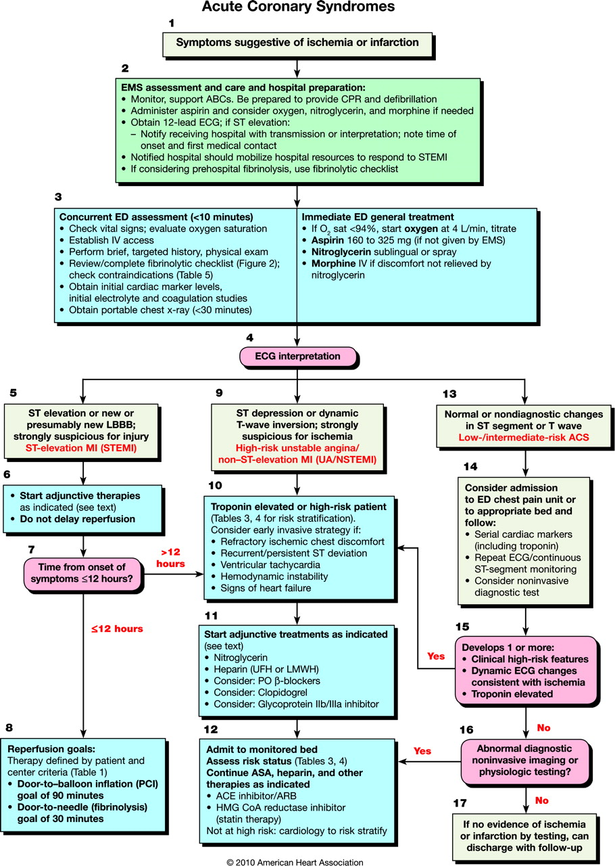

Figure 1. American Heart Association’s Acute Coronary Syndromes Algorithm

- Natural Language: Given two numbers, “a” and “b”, adding “a” and “b” (i.e., a+b) is the sum.

- Pseudocode:
sumOfTwoNumbers (a, b) {
return add (a and b)
}

- Algorithm in C++ (a programming language)
int sumOfTwoNumbers(int a, int b) {
return a+b;
}

Figure 2. Three different ways of describing an algorithm.

