**EDUC 451A – 110**

**INQUIRY PROJECT**

**DENIS SMAJLOVIC**

**UNIVERSITY OF BRITISH COLUMBIA**

**MARCH 2016**

**Table of Contents:** **Page #**

Inquiry Question…..………………………………………………………….………....3

Research and Resources…………………………………………………….…………..4

Research………………....………………………………………….…………..5

Learning on Practicum…………………………………………….…………....8

Co-Learning from Peers.…………………………………………..……………9

Where I’m Going……………………………………………………………………....10

Conclusion………………...…………………………………………………………...12

References………..……………………………………………………………….........13

Appendix A...…………………………………………………………………………...15

Appendix B...…………………………………………………………………………...16

Appendix C...…………………………………………………………………………...19

Appendix D...…………………………………………………………………………...20

Appendix E...…………………………………………………………………………...21

Appendix F...…………………………………………………………………………...22

**Inquiry Question**

As we began this inquiry process last term I found myself asking questions surrounding how one would assess if students are learning what is being taught. I was comfortable planning activities and lessons that would be beneficial to the students but I had never assessed or evaluated whether or not those same students learned what I had intended. This led me to realize that it would be very difficult for me to evaluate what each student learned and how comfortable they were with the content. Therefore, it became evident to me that self-assessment would be the key to using my students as resources. As a result, my question became; How can I use formative self-assessment to enhance students’ learning?

I believe that this question is important because as educators we need to be able to find out what our students are learning, what they are missing and how we can alter and vary our strategies and pedagogies from their perspective. From my experiences on practicum the best questions a teacher can ask themselves are; what do I want my students to get from this activity or lesson (lesson objectives) and how will I know they have taken away what I intended (assessment and evaluation). When we plan activities, lesson, and units in this fashion we have to engage ourselves in this process of metacognition. Essentially, we must plan from our assessment backwards. By incorporating student feedback in the form of formative self assessment we empower ourselves to individualize instruction and promote learning for our students (Garrison & Ehringhaus, n.d.; Kaftan, Buck & Haack, 2006). Additionally, The Principles for Fair Student Assessment Practices for Education in Canada (Alberta, 1993) guidelines state that students need to be engaged in the assessment of their learning. It is essential that it is communicated to students what is expected of them to learn, how this learning will be assessed which results in student control of student learning and assessment (Alberta, 1993), which is essentially self regulation. Therefore, I believe that not only is this question significant but this question is also at the head of the movement in which education is going. Away from being a teacher focused classroom and towards being my individualized for our students which promotes learning.

Furthermore, this question is actionable and specific while also being personally meaningful. During my two-week practicum assessment was an area that I found difficult and for this reason it is an area that I chose to develop. My research has taught me that there are many good and bad examples of assessment practice and for this reason I believe assessment is an area all teachers should always seek to develop. During the course of this semester my question and research has evolved to include more than just formative assessment and to look at assessment more holistically. Therefore, my current inquiry project looks to holistically frame assessment for, as and of learning (both summative and formative) in a student centered approach. This has allowed me to adapt my question in order to look beyond just formative assessment and to focus on assessment holistically. This approach is based on the research I have conducted, my cooperative learning with my peers and learning from my practicum placement and my school associate (SA).

**Research and Resources**

As a teacher candidate we are ideally positioned to address any inquiry process because we bring with us two perspectives; that of teacher and that of student. We can appreciate both positions for their challenges and shortcomings and then address those challenges and short comings with solutions that address both parties’ needs. As our careers extend it is easy to forget what its like to sit in the chair and listen to someone teach, as a result this student perspective is invaluable to bring into planning and teaching.

Additionally, with regards to formative self assessment from a students’ perspective this promotes thinking towards a growth mindset (Dweck, 2007). In my opinion when we include student feedback into their learning we are treating students with the respect they deserve. As a result of this respect for their perspective on their learning we are teaching students to begin to look at learning as opportunity for growth and improvement, which is the “message” we want to be sending according to Carol Dweck (2007).

**Research**

To begin this semester, I set a goal of using the following resources to anchor my learning. They include journal articles, a ministry document, websites, my colleagues and my experiences on practicum. The journal articles I chose include Dweck (2007); William (2011); Louis & Harada (2012); Bures et al (2013). The ministry document I have chosen to use is Alberta (1993), and I chose to use the Association for Middle Level Education (AMLE) to find my other two articles; Kaftan, Buck & Haack (2006); Garrison & Ehringhaus (n.d.). In addition, my School Advisor and Teacher Candidate colleagues will be great resources for professional learning regarding what they have seen and are doing in relation to using formative self-assessment in their classes.

The Louis & Harada (2012) article was a genuine starting point when it comes to founding my inquiry in research. As I was reading this article for the second time as part of this semester’s learning I found it interesting to note that new ideas developed. This caused me to think that as our inquiry continues and we learn more about our inquiry topic our minds become exposed to new ideas that then allow us to draw more information from second readings of the same information. This second spiral of learning (Halbert & Kaser, 2013) caused me to appreciate that as educators our understanding often comes from our context, our place in time. The takeaways from this article align with ideas of setting clearer goals as a starting point for assessment (Louis & Harada, 2012). Clear goals setting can lead to better co-constructed criteria (Davies & Herbst, 2013) for assignments which can lead to more genuine self and peer assessment on the part of students.

In addition, the Dweck (2007) article discusses messages that motivate and a fixed versus growth mindset. I feel this is important for my inquiry because when we use formative self-assessment to gauge learning we are also learning about self regulation from a student perspective. Thus this article provides some insight into how the messages we send to our students when we ask them for their perspectives on their learning is a sign of respect. This level of respect in my opinion could lead to the building of a growth mindset in relation to self-regulation. Furthermore, how we choose to assess students can also be tied to a growth mindset. If we only assess students in a summative fashion without time and effort put into gathering evidence of learning through the process, we cannot push our students away from a fixed mindset. However, good and varied assessment practices are difficult to implement within the context of having to teach classrooms of up to thirty students. Bures et al (2013) suggest that an innovative way to approach assessment for twenty first century learners is to use interactive technology. They suggest that teachers and students benefit from the use of a formative interactive digital assessment tool. Tools where students can share their learning process and teachers can provide formative feedback and engage students in ongoing dialogue about their learning (Bures et al, 2013). When we enter into this process of feedback and time for revision we are essentially building assessment practices that foster a growth mindset (Dweck, 2007; Bures at al, 2013).

Furthermore, digital assessment platforms like Fresh Grade and Edmodo provide teachers with an opportunity to engage in assessment of their own practice with their students. When we give a summative test and students do poorly, that is as much a reflection on our teaching methods as it is on their preparation habits. Therefore, a platform where we can share criteria, study tools, or provide process feedback to all students in a timely fashion would be invaluable to approaching a growth mindset, setting clear goals, co-constructing criteria, and making sure we are creating fair assessment practices (Dweck, 2007; Louis & Harada, 2012; Davies & Herbst, 2013; Bures et al, 2013; Alberta, 1993).

Approaching fair assessment practices (Alberta, 1993) is a process that has been also adopted by the British Columbia Ministry of education. This process entails varied and diversified assessment practices that include assessment for, as and of learning (Alberta, 1993). These assessment practices benefit learners by focusing on setting clear goals, and criteria, something that is also echoed by other researchers (Dweck, 2007; Louis & Harada, 2012; Davies & Herbst, 2013, Bures et al, 2013; Garrison & Ehringhaus, n.d.). Furthermore, William (2011) and Kaftan, Buck & Haack (2006) suggest that formative assessment and assessment for learning can be used to individualize instruction, improve instructional strategies and promote learning.

Lastly, a key resource for my learning this semester came from the Nicol & Macfarlane-Dick (2006) article which looked at feedback and assessment. This article presented seven recommendations that support and develop learner self-regulation which leads to learning gains. They include: (1) clarify what good performance is, (2) facilitate self-assessment, (3) deliver high quality feedback information, (4) encourage teacher and peer dialogue, (5) encourage positive motivation and self-esteem, (6) provide opportunities to close the gap, (7) use feedback to improve teaching (Nicol & Macfarlane-Dick, 2006). Each of these recommendations aligns with my own beliefs and will be key to my assessment practices going forward. They will be discussed below.

**Learning on Practicum**

In the context of my practicum experience I have been fortunate to witness many examples of assessment. Furthermore, I have also been able to experiment with assessment during my own teaching. During my two-week practicum I was fortunate to be able to plan, teach and assess students through an entire mini-unit. This unit provided me with some insight and valuable practice to assessment methods. As part of this unit my students and I co-constructed a rubric that would be used for assessment. A screen shot of this rubric is included in appendix A. From this I learned that no matter how clear and simple instructions may be, there is always space for improvement. One thing that I would do the next time that I create a rubric would be to ask my students to self-assess themselves on the rubric in addition to my assessment of their work. By having them self-assess and then revise their work students are engaging directly with a growth mindset (Dweck, 2007). Additionally, this unit provided me the opportunity to engage my students in informal goal setting, self and peer assessment and reflection on learning. Each of these opportunities has been invaluable for me in shaping how I will assess during my extended practicum.

I have also been fortunate to witness what other teachers in my placement school are doing when it comes to assessment. One example, which I will call self-regulation blocks, allows students to provide feedback on their control of assignments or activities by turning their blocks to red, yellow or green. These colours reflect how comfortable to the students feel with he assigned task or activity. Green means they are fine, yellow means they have some questions and red means they need help. This formative feedback challenges students to self-regulate their learning while also providing teachers with a visual cue for which students need their help most. In addition, I have witnessed the use of quick scales, rubrics and was able to co-assess with my school advisor. This opportunity was invaluable for my learning because we got to exchange ideas on evaluation and to discuss our assessments of student work. This co-operative learning opportunity has given me many insights into how difficult it can be to assess during presentation, how challenging even simple rubrics can be, and how difficult in can be to give good feedback to students.

**Co-Learning from peers**

This term has provided me the invaluable opportunity to co-learn from my peers in my middle-years cohort. Initially my co-learning took the role of presenting an hour long theme presentation on assessment. This presentation engaged me in sharing my learning from the Louis & Harada (2012) article, which was stated above. In addition, I was fortunate to learn about what my peers were learning in regards to their inquiry process. From this presentation I learned about the use digital portfolio’s as an adaptive teaching tool which could improve assessment (Bures et al, 2013), project based learning and personalization (Wanner & Palmer, 2015), and the connection between self-regulation and assessment practices (Davis & Neitzel, 2011). Through this process I was able to look at the opportunities that are provided in adapting the learning my peers were doing to my own inquiry project. The implications of this learning will be discussed below.

Furthermore, other peers presented their inquiry themes as well which ranged from motivation, and mindfulness to technology use for students with learning disabilities. The question and reflection assignment associated with these presentations helped me to center these themes into my inquiry project as well. I have already spoken about the connection between technology and the assessment of learning relating to the Bures et al, 2013 article, however Allsopp et al, 2010 brings in another key piece, students with learning disabilities. The points presented in this article relate to the use of technology as a potential tool for learning and improved assessment for students with learning challenges (Allsopp et al, 2010). This is a point that I had not considered to this point but I can connect directly to my own intentions for trying to use technology in the classroom, which will be discussed below. Motivation was previously discussed in relation to the Dweck (2007) article but could also be discussed from the lens of the activities we choose to engage our students with. The presentation on motivation focused on the ability to connect messages that motivate and a growth mindset (Dweck, 2007) with the activities we plan, which can be key to assessment. These activities can also be connected to the idea of mindfulness and building mindfulness into our teaching practice. While mindfulness is not directly connected to my inquiry project it is interesting to note that mindfulness can play a role into assessment practices (The Hawn Foundation, n.d.). My approach to building mindfulness into my teaching will be discussed further below.

**Where I’m going**

During my ten-week practicum I have planned units which will allow me to put into practice much of what I have learned through my inquiry project. First and foremost, I have designed units which have varied assessment forms that include assessment for as and of learning. Examples can be found in Appendices B, C, D, E and F. These varied assessment formats allow for the fair and equitable assessment of students (Alberta, 1993) while also fostering a growth mindset through opportunities to reflect and improve learning (Dweck, 2007) and engage students in the self and peer assessment for learning process (William, 2011; Kaftan, Buck & Haack, 2006; Davies & Herbst, 2013; Louis & Harada, 2012). Lastly, the use of these varied methods allows students the opportunity to self-regulate their own learning (Davis & Neitzel, 2011) through self-assessment and reflective learning.

Secondly, I have planned for project based learning (Wanner & Palmer, 2015) which will engage students in the co-construction of criteria, will challenge me to create and implement clear goals which should foster my students’ self-regulation (Louis & Harada, 2013; Davies & Herbst, 2013; Davis & Neitzel, 2011). Additionally, I will be planning to incorporate mindfulness into my teaching practice through the implementation of a coping with stress unit. This unit seeks to teach students about the stressors in their daily lives and coping strategies. In connection to assessment I will be modelling the use of meditative practice prior to test writing, public speaking and presentations by giving my students 3-5 minutes to meditate and prepare their minds for the upcoming stressor (The Hawn Foundation, n.d.).

Lastly, I wish to include technology to improve my assessment practices. As part of my learning for this inquiry project I attempted to learn how to use a digital platform for assessment, Edmodo. The limitations of this tool which include is privacy storage and difficulty to use have been reason I have decided against continuing its use into my classroom. However, the benefits of a digital tool for assessment are not lost on me and I will be trying to use Fresh Grade as part of my teaching practice during my ten-week practicum. Previously I have had my students set goals for the time they spend doing co-operative project work. These goals have been written on a note and then been reflected on at the end of the lesson to see if they were met and then adjusted. My hope is that I can use this similar method through Fresh Grade to allow students to share a goal, and to document their learning process as we work through an assignment. This platform will allow me to give my students feedback and allow them to make revisions and improvements along the way which promote self-regulation and a growth mindset. I will not however, be using this tool for all of my teaching because not all of my students have access to an electronic device. For this reason, I will be implementing this tool only when we are in the school computer lab which allows all of my students’ access to an electronic device. In addition to Fresh Grade, I will be using Kahoot as a formative assessment tool with my students. Kahoot is a website that allows for the creation and use of a quiz format in an interactive classroom manner. I will be using Kahoot in preparation for test taking, and to check if my learning intentions are being met for my students. By going through this question and answer format I can ease student anxieties towards test taking, allow for self-regulation for what areas students need to focus their studying on and promote a growth mindset. Both of these uses of technology for the purposes of assessment align with suggestions made by Bures et al, 2013 and Allsopp et al, 2010.

**Conclusion**

I have learned much about assessment from the professional reading I have been doing, the co-learning from my peers and from the experiences I have had on practicum. I have made an effort to plan meaningful, varied and fair assessment practices into the units I have planned for my extended practicum. While these plans are at this point in time seemingly well defined, I will seek to be reflective and flexible in my assessment practices as my ten-week practicum unfolds. As Halbert & Kaser, 2013 stated, inquiry is a spiraling process which takes multiple turns and revisions. My hope is that I will be able to adapt my assessment practices as I continue to develop as a teacher candidate to better serve the needs of my students, my school and my professional practice. I believe that this project has given me a good starting point, but I will continue to develop my inquiry in the coming months.

**References**

Alberta. (1993). *Principles for fair student assessment practices for education in Canada*.

Edmonton: The Province.

Allsopp, D. H., McHatton, P. A., & Farmer, J. L. (2010). Technology, mathematics PS/RTI, and

students with LD: What do we know, what have we tried, and what can we do to improve outcomes now and in the future? *Learning Disability Quarterly*, *33*(4), 273–288.

Bures, E. M., Barclay, A., Abrami, P. C., & Meyer, E. J. (2013). The reality of assessing

"authentic" electronic portfolios: Can electronic portfolios serve as a form of standardized assessment to measure literacy and self-regulated learning at the elementary level? *Canadian Journal of Learning and Technology, 39*(4).

Davies, A., & Herbst, S. (2013). Co-construction success criteria. *Education Canada, 53* (5).

Retrieved January 5th, 2014, from: http://www.cea-ace.ca/education-canada/article/co-constructing-success-criteria

Davis, D. S., & Neitzel, C. (2011). A self-regulated learning perspective on middle grades

classroom assessment. *The Journal of Educational Research*, *104*, 202-215.

Dweck, C. (2007). Boosting student achievement with messages that motivate. *Education*

*Canada, 47*, 6- 10.

Garrison, C. & Ehringhaus, M. (n.d.). *Formative and summative assessment in the*

*classroom.* Retrieved from https://www.amle.org/BrowsebyTopic/WhatsNew/WNDet/TabId/270/ArtMID/888/ArticleID/286/Formative-and-Summative-Assessments-in-the-Classroom.aspx

Halbert, J., & Kaser, L. (2013). *Spirals of inquiry for equity and quality*. Vancouver, BC; British

Columbia Principals’ and Vice-Principals’ Association.

The Hawn Foundation (n.d.). *MindUP*. Retrieved from http://thehawnfoundation.org/mindup/

Kaftan, J.M., Buck, G.A., & Haack, A. (2006). *Using formative assessments to*

*individualize instruction and promote learning*. Retrieved from https://www.amle.org/BrowsebyTopic/Assessment/AsDet/TabId/180/ArtMID/780/ArticleID/454/Using-Formative-Assessments-to-Individualize-Instruction-and-Promote-Learning.aspx

Louis, P., & Harada, V.H. (2012). Did students get it? self-assessment as key to learning.

*School Library Monthly, 29*(3), 13-16.

Nicol, D.J., & Macfarlane-Dick, D. (2006). Formative assessment and self-regulated learning: A

model and seven principles of good feedback practice. *Studies in Higher Education, 31*(2), 199-218.

Wanner, T., & Palmer, E. (2015). Personalizing learning: exploring student and teacher

perceptions about flexible learning and assessment in a flipped university course. *Computers & Education*, *88*, 354-369.

William, D. (2011). What is assessment for learning?. *Studies in Educational*

*Evaluation, 37*(1), 3-14.

**Appendix A**

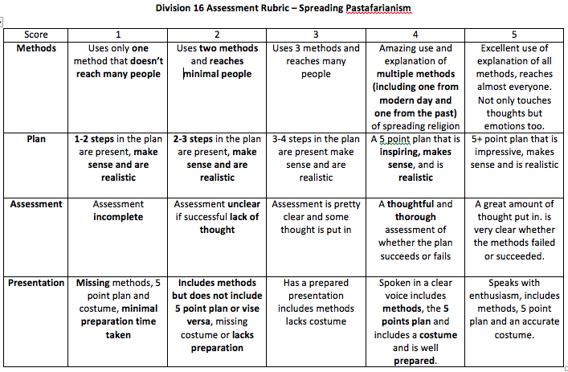

A screenshot sample of one of the co-create rubrics I used during my two-week practicum with my students.

**Appendix B**

**Cooperative Partner Test:**

|  |  |  |  |  |  |  |
| --- | --- | --- | --- | --- | --- | --- |
| **Badminton Unit Final Test**  Name:_______________________ Date:_______________________ Block:_______________________  *Choose a partner and find a space in the gym away from others where the two of you can work quietly on the test. You may discuss questions and answers with partner but make sure you each fill out the answers your own test page.  **Short Answer Questions:**  **1. *How do you obtain a point in badminton?* (1 mark)**  **2. *List 3 elements of a “ready position”:* (3 marks)**  **3. *Name the two types of racket holding grips?* (2 marks)**  **4. *Name one type of Badminton Shot and tell why/when you might use it:* (2)**  **5. *Describe the “Base Position” and why it is important:* (2)**  **6. *A shot hit so that the shuttle just clears the net and falls quickly into the opponent’s court is called?* (1)**  **7. *What serve (forehand or backhand) works best for you, and how come?* (2)**  **8. *What is the most difficult Badminton Shot for you, and how come?* (2)**  **9. *Why is it important to constantly and quickly “attack” the shuttle?* (2)**  **10. *List as many reasons as you can of why think Badminton is fun and educational:* (5)**  **True or False Questions:**  T / F 1. Badminton is fun?  T / F 2. During the game, you may hit the shuttle two times in a row?   |  |  | | --- | --- | |  |  |   T / F 3. Points may only be scored by the serving side?  T / F 4. If the shuttle lands on the line, it is considered out of bounds?  T / F 5. While serving it is proper etiquette for the receiver to try and distract the server?   |  |  | | --- | --- | |  |  |   **Multiple Choice**  ***1. When serving the shuttle, the racket head must be where?***   1. Above the waist 2. Above the fingers 3. Below the waist  |  |  | | --- | --- | |  |  |   ***2. A shot to which the shuttle is hit sharply downward into the opponent’s court is called?***   1. Drop 2. Drive 3. Clear 4. Smash   ***3. Players keep track of the score during a match by?***   1. Remembering it in their head 2. A referee keeping track 3. Stating it out loud before every serve 4. Writing it on a paper or whiteboard   ***4. The most sustainable mode of human transportation is?***   1. A truck 2. A bicycle 3. A plane 4. This is not relevant to Badminton at all   ***Congratulations! You’re Finished! Thank you! :^)*** |

Cooperative partner test will be used as a summative assessment for learning. Rationale behind including a summative cooperative test is that students are learning cooperatively during this unit and thus testing should also mimic their learning format. Additionally, cooperative testing may reduce anxiety and allow students to reflect on learning as they process the information gathered throughout this unit cooperatively with a partner.

**Appendix C**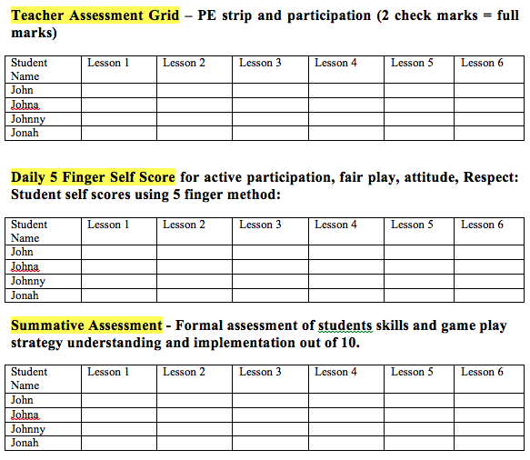

Teacher assessment examples which include informal formative assessment, self assessment, and summative assessment of skills and game play.

**Appendix D**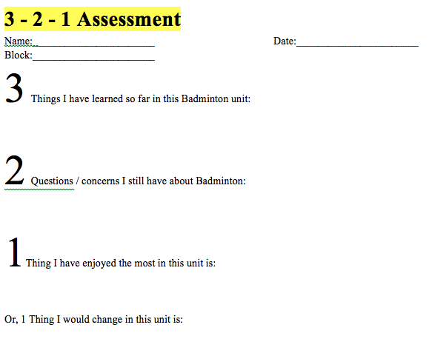

Formative assessment which allows students to provide teacher feedback on their learning which can be used by the teacher to improve later lessons and also to revise the unit for future use.

**Appendix E**

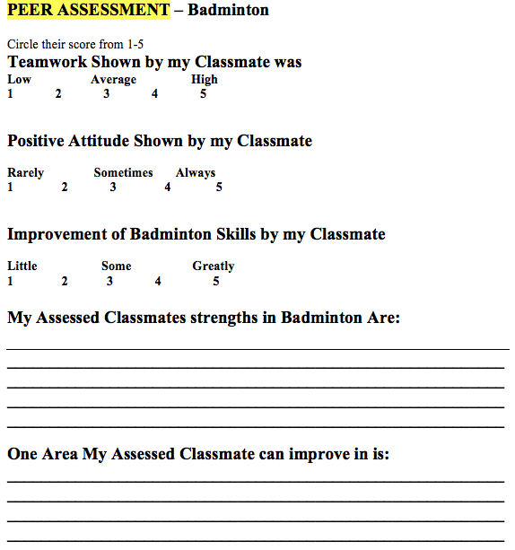

Peer assessment for learning allows students to assess one another and to give constructive feedback on their peers learning.

**Appendix F**

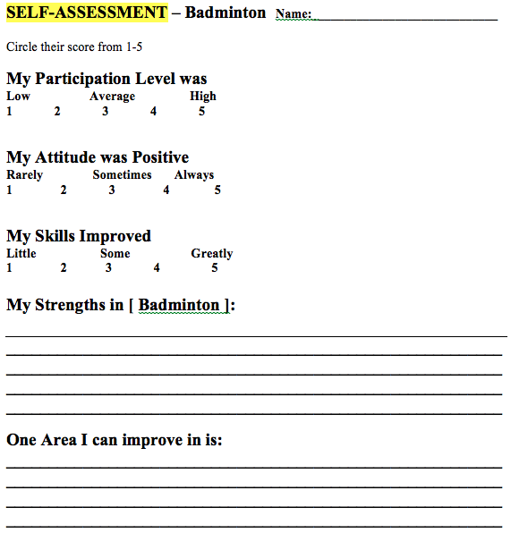

Self assessment for learning allows students to reflect on their learning in this unit and to give themselves constructive feedback.