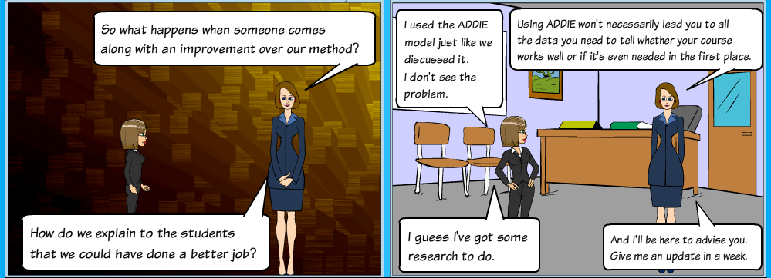

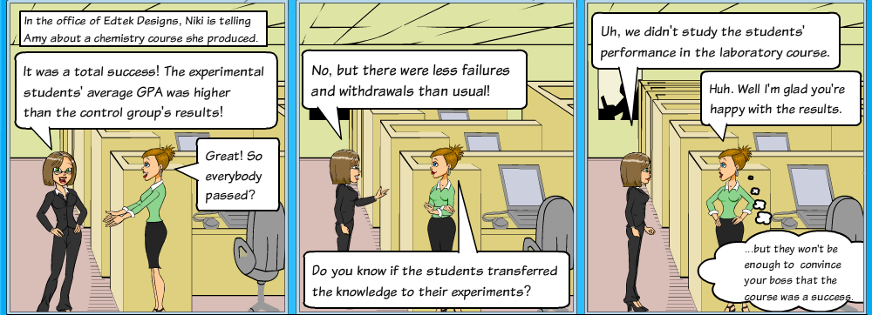

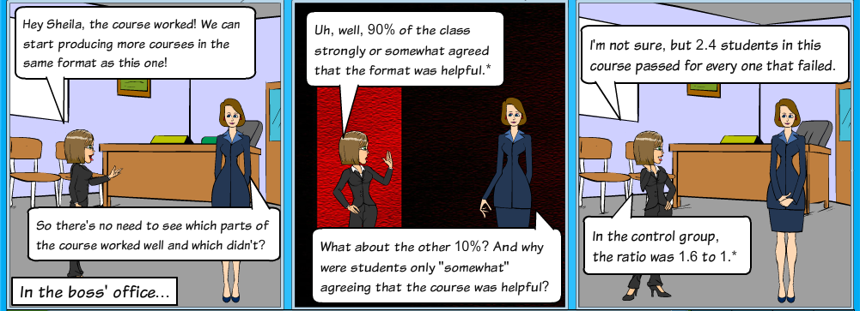

\*Shibley, I., Amaral, K. E., Shank, J. D. & Shibley, L. R. (2011). Designing a blended course: Using ADDIE to guide instructional design. *Journal of College Science Teaching, 40*(6), 80-85. Retrieved from: [http://www.nsta.org](javascript:__doLinkPostBack('','target~~URL||args~~http%3A%2F%2Fwww%2Ensta%2Eorg||type~~','');)