Educational Developer Portfolio

Introduction

This portfolio is intended to showcase my areas of strength and growth as an educational developer, instructional designer, and teacher. Each section begins with an overview of the topic at hand, contains materials such as a philosophy or a description of experiences, and may or may not conclude with a reflection. Throughout, there are links to materials in my Google Docs folder.

Educational development philosophy

My educational development philosophy presents three beliefs that I have about education. They are placed in descending order of importance. Each belief or value is described in a paragraph and is followed by a paragraph to explain how I act on it. The section concludes with a view to the future by identifying goals I’d like to attain as an educational developer.

The belief that I prioritise above all is ethical educational practices that foster a pleasant learning experience (Elwick & Cannizzaro, 2017). For me, ethics are about relationships, and healthy relationships are crucial for effective and appealing learning to occur. Healthy relationships are also based on equity and inclusion. My experience as a university student and as an educational developer feeds into this belief. I have witnessed situations where instructors have encouraged students, fostered growth and risk-taking, and have created learning situations that were fun and purposeful. I have also unfortunately witnessed instructors who communicated their expectations and instructions unclearly, who held strict and narrow views on learning processes, and who considered it acceptable to act harshly towards students and exploit them for their advancement. In my view, such practices have no place in a learning or a professional environment. This opinion has grown stronger since I discovered that roughly 30% of students have some form of trauma that hinders their learning (e.g., Auerbach, 2018).

To act on this belief, I mention ethics in discussions with professors and colleagues and promote ways to teach ethically. For example, I encourage professors to build a culture of trust in their courses instead of assuming that students might want to cheat on exams. I also tend to suggest that instructors offer assignments that make cheating moot, such as case studies, video essays etc. These types of assignments can take longer to assess. However, a well-designed assignment with a clearly written rubric can guide students in producing higher quality work. As well, a peer-review activity such as the “Study Buddy” approach (Madland & Richards, 2016) allows students to suggest improvements to each other’s work before submitting it. In my experience, work of higher quality lends itself to a quicker process of providing feedback and provides a stronger basis for suggesting further creative or higher-skilled work for future assignments. Additionally, I have been increasingly researching and discussing trauma-informed pedagogies (Davidson & Northwest 2017; Harrison et al., 2020), particularly for students with traits associated with low university attendance, such as Indigenous and disabled students (Michalski, et al. 2017). I’ve begun adopting methods that promote equity and inclusion based on social justice frameworks and open educational practices (Bali et al., 2020; Lambert, 2018).

It follows from my interest in ethics that I believe that developing a strong work relationship with professors – and indeed, staff across the university - is essential. Collaborative relationships allow for mutual learning. I believe in the importance of patiently and empathically listening to instructors to make sense of their perceived needs with regards to course development and delivery. Further, by listening to professors describe the context they teach in, I can collaboratively work with them to build suitable lessons.

In applying these beliefs, I ask professors about their course, its context, and what they want to achieve with it. From there, we can write or revise the learning objectives. As the professor describes their assignments and learning activities, we can together to determine how well they align with the learning objective. I ask open-ended questions to determine what issues are at play. I might offer suggestions based on the literature on multimedia use (Clark & Mayer, 2016); cognitive load (Plass et al., 2010); or teaching involving declarative learning, concepts, procedures, principles, problem-solving, and other forms of learning (Smith & Ragan, 2005).

Regarding my own development of instructional materials, I value experimentation, which I apply in a design thinking approach (Henriksen et al., 2017). Either when designing webinars or courses, I empathise with the intended audience of my training sessions by talking with them directly, consulting survey responses about similar training sessions, or asking more experienced colleagues about my audience’s likely abilities. I tend to ask colleagues to act as participants in a prototype of my training materials to test collaborative activities, the clarity of my instructions and transitions, ease of use, navigation, etc. When I deliver the webinars, I tend to indicate that I am experimenting with a training approach or a technology. Thus, my hope is to lead by example in teaching while innovating.

I recently applied this process of experimentation when I built fake course content in Microsoft Teams. I inserted instructions, various forms of media (images, audio clips, etc.), questions, and solo and collaborative activities. I asked my colleagues for feedback and learned a great deal from them. Hopefully, my colleagues were also inspired to try new things; it is important for me that these peer-review activities be beneficial for all involved. In these experiences, I reflect on the design process to challenge and develop my values and assumptions regarding higher education (Mezirow, 1981). With my colleagues’ recommendations about my fake course and new understandings based on my reflections, I was able to continue the design thinking process and further develop my course materials.

Considering my beliefs and values regarding ethical educational practices, collaborative work relationships, and experimentation, there are a few goals I have as I continue my career in educational development. First, I aim to further develop my skills by exploring openly available courses and examining how they use visual supports for delivering content and for developing activities (e.g., with graphic organisers). I aim to provide research-based guidance about open educational practices (OEP) (e.g., safely using open online platforms that invite participation from learners outside of a course). (OEP are approaches to teaching based on open education using OERs, open platforms, open source tools, open access articles, etc.) I also intend to deepen my understanding of trauma-informed pedagogy so that more students may feel a stronger sense of belonging. The ultimate intended result of all of my actions and goals is to collaborate with instructors to build courses that are strongly aligned with program-level and course-level learning objectives. In turn, I hope that students will benefit from improved and pleasant educational experiences.

References
Auerbach, R. P., Mortier, P., Bruffaerts, R., Alonso, J., Benjet, C., Cuijpers, P., ... & Murray, E. (2018). WHO World Mental Health Surveys International College Student Project: Prevalence and distribution of mental disorders. Journal of abnormal psychology, 127(7), 623.

Bali, M., Cronin, C., & Jhangiani, R. S. (2020). Framing Open Educational Practices from a Social Justice Perspective. Journal of Interactive Media in Education, 2020(1).

Clark, R. C., & Mayer, R. E. (2016). E-learning and the science of instruction: Proven guidelines for consumers and designers of multimedia learning. John Wiley & Sons.

Elwick, A., & Cannizzaro, S. (2017). Happiness in higher education. Higher Education Quarterly, 71(2), 204-219.

Harrison, N., Burke, J., & Clarke, I. (2020). Risky teaching: developing a trauma-informed pedagogy for higher education. Teaching in Higher Education, 1-15.

Henriksen, D., Richardson, C., & Mehta, R. (2017). Design thinking: A creative approach to educational problems of practice. Thinking Skills and Creativity, 26, 140-153. doi:10.1016/j.tsc.2017.10.001

Lambert, S. R. (2018). Changing our (dis) course: A distinctive social justice aligned definition of open education. Journal of Learning for Development-JL4D, 5(3).

Madland, C., & Richards, G. (2016). Enhancing student-student online interaction: Exploring the study buddy peer review activity. International Review of Research in Open and Distributed Learning, 17(3), 157-175

Mezirow, J. (1981). A critical theory of adult learning and education. Adult education, 32(1), 3-24.

Michalski, J. H., Cunningham, T., & Henry, J. (2017). The diversity challenge for higher education in Canada: The prospects and challenges of increased access and student success. Humboldt Journal of Social Relations, 39, 66-89.

Plass, J. L., Moreno, R., & Brünken, R. (Eds.). (2010). Cognitive load theory. Cambridge university press.

Smith, P. L., & Ragan, T. J. (2005). Instructional design. John Wiley & Sons.

Educational development roles and responsibilities.

An overview of my main tasks in my positions as an educational developer is provided. I have held three positions as an educational developer in higher education, despite the variety of titles listed below. Prior to working in higher education, I held roles that included educational development: Instructional Designer - Centre franco-ontarien de ressources pédagogiques, and Teacher – CSCDGR. The tasks I completed while in these roles are listed on my resume.

2020 – present Educational Developer - McMaster University

- Participated in a committee to promote OER engagement across the university
- Designed, developed, and delivered a webinar on Open Educational Practices (OEP) to increase equity and inclusion in higher education during Open Access Week
- Completed the Professor Hippo-on-Campus Student Mental Health Education Program
- Designed and developed reflection activities for Engineering students
- Advised professors and Teaching assistants in the Faculty of Engineering on online course design
- Developed asynchronous workshops on OER development and the Scholarship of Teaching and Learning for delivery in Brightspace
- Collaborated with other educational developers and instructional designers on various projects

2019 – 2020 Specialist, Educational Development and Digital Learning - UOttawa

- Participated in a committee to promote OER engagement across the university
- Analysed program review documents to inform the design of an online Master’s degree
- Developed alignment documents and storyboards for courses in BrightSpace
- Completed training on the Quality Matters Rubric and on inclusive education
- Collaborated with other instructional designers on various projects, including student training on academic integrity
- Developed and delivered webinars and gave personal consultations about online learning and how to use the Brightspace LMS.

2013 – 2015 Instructional Designer - African Virtual University (AVU)

- Coordinated the authoring of undergraduate and professional development programs (consisting of OER) in three languages by professors located globally, and mostly in Africa.
- Organized and co-organized several weeklong workshops. Developed and delivered content in three languages to train professors from across Africa in ICT skills, curriculum development, and organizational change
- Created, delivered, monitored, and evaluated online courses as OER in Moodle for the professional development of African professors in the development of open and distance programs
- Worked directly with a videographer, graphic designer, and IT staff to develop courses and promotional animations and videos
- Designed surveys on needs assessment with regards to African professors’ technological skills; collected and analysed the survey data
- Participated in a panel discussion on OERs at the 2013 Distance Education and Teacher Education in Africa conference held in Nairobi
- Participated in the hiring of several consultants and staff members
- Performed administrative work (project planning, issuing payments, procurement, developing Terms of Reference documents, developing contracts)

As a reflection on my career progression, I have been continuously building on my knowledge of OER and have progressed not only to OEP, but also OEP that promote social justice. My active involvement in my Professional Learning Network has fostered this knowledge growth as have my regular exploration of literature on open education and my participation in conferences on open education. My thoughts and beliefs about open education have evolved as I have come to realise that OER can increase inequities. Therefore, I am far more cautious about promoting open education in ways that are beneficial.

I have increasingly taken an interest in mental health issues and am particularly curious about trauma-informed pedagogy. This is because of the relatively high proportion of students who have experienced trauma. This trauma hinders both learning and human development. Given that I see post-secondary education as being personally and professionally formative, I believe that I have a role in promoting trauma-informed pedagogies. Consequently, I have been participating in webinars on this topic and have been reading articles and books on the topic too.

Educational development approaches, methods, materials, and innovations

A description of projects I completed is presented, along with the context and justifications for my approaches. Samples of my work are provided as figures and as links to Google Drive.

The work I am most proud of consists of the three in-person professional development sessions that each lasted 6 days. I coordinated them while working at the AVU. These were all instances of cross-cultural professional development since my AVU colleagues and I were training professors from across the continent. I was the lead coordinator in two of those sessions and assisted in coordinating another. As lead coordinator, I outlined the training topics for the week and developed and delivered some of the training. Colleagues and consultants developed and delivered much of the material as well. All of this work was done in three languages and involved translators to support development of print material, and interpreters for the in-person sessions. To make the training more inclusive, I consulted with several African professors who had participated in a previous version of this training. Thus, I was able to better adapt the training to their cultural preferences and institutional circumstances.

One of the week-long sessions was part of a larger program called the Open, Distance, and eLearning Professional Development (ODeLPD) program. The aim of the program was to train the professors to develop an online program for use at their respective universities. The program included online modules delivered in Moodle in English, French, and Portuguese. There were four modules in each of the program’s three streams: Instructional Design, Management, and Technology. All participants took the introductory module of each stream, and then they specialised by taking the remaining three modules in one of the streams, for a total of six modules per participant. Along the way, there were tasks to complete for building an institutional plan for their online program. My role was to coordinate the development and revision of the online modules and have the modules translated and loaded into Moodle for delivery. Three links to Google Drive will now be shared to view artifacts from this project. A colleague and I developed the syllabus for the ODeLPD program. We also developed templates for building the modules, and they were based on instructional design approaches recommended by Smith and Ragan (2005). The modules each contained three units, and the template shared here is for Unit 1. We also developed a checklist for reviewing the completed drafts of the modules. Note that the AVU logo changed during my time there. The current logo is that found in the syllabus.

The online portion of the ODeLPD program was an innovation in that it represented an international collaboration of course developers that we at the AVU had contracted. The work was developed at a distance in Google Drive in English or French and then translated. (Note that a portion of the program design existed before my arrival at the AVU; we needed to replace a large portion of the content so that it could be openly licensed for sharing freely online.) My colleagues and I hired additional contractors as facilitators during the delivery of the program. Some facilitators worked from parts of Africa, from Canada, and from Brazil. We met with them regularly to monitor the delivery and offer support in case of educational, administrative, or technical issues. This work required a great deal of empathy so that everyone involved could work harmoniously and productively. It was helpful that many of us had experience working with people from different cultures. Consequently, we could advise each other on ways to communicate in written or oral forms that maintained or strengthened our working relationships. We also aimed to make all of the module development work enjoyable for the contractors as well as for the participants of the ODeLPD program. For example, we sent celebratory emails to the participants upon completing each module.

Later, at UOttawa, I collaborated with colleagues to build and deliver webinars in English and French using Adobe Connect. These webinars were about the educational use of functions in Brightspace (Assignments, Quizzes, and Discussion forums). Our recommendations tended to be based on ethical and trust-based approaches; we offered suggestions for assessment that made cheating irrelevant, such as group assignments or personal reflections. At McMaster, a colleague and I developed asynchronous modules delivered in BrightSpace on the topic of the Scholarship of Teaching and Learning. A screen capture (Figure 1) shows the topics covered. The second item in the module is a handout that participants were to complete. It is available for viewing in Google Drive. My colleague developed Parts 1 and 4 and a portion of Part 3. I developed Parts 2, 5, and 6, and a portion of Part 3.

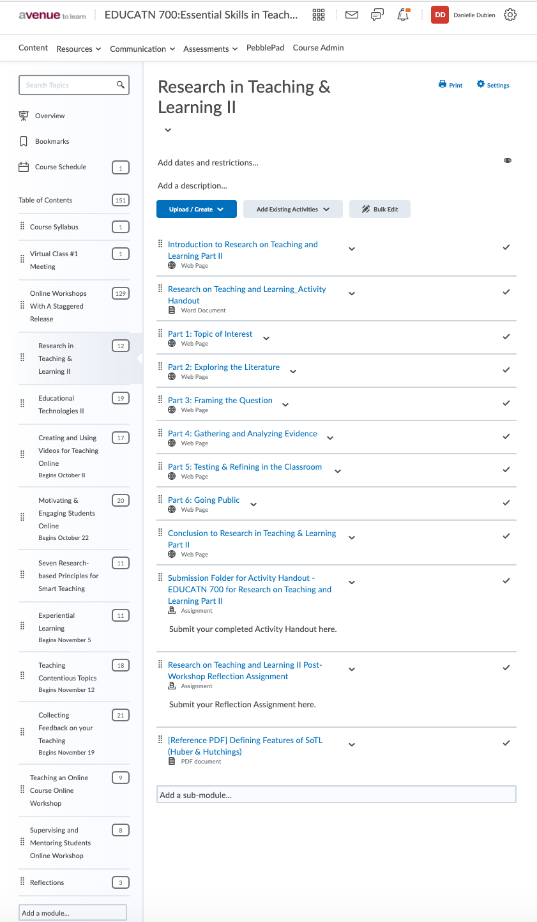

Figure 1: Module for professional development on Research in Teaching and Learning

At McMaster, I also developed an asynchronous module on the development of OER in BrightSpace, along with Joanne Kehoe. In that module, I developed a slide show with multiple-choice questions inside using H5P. In Figure 2 is an image that I created for that slide show. This was the second time I used H5P, and it was the first time I used it in a professional development module. The purpose was to combine visual elements, text, and questions in a dynamic component of the module. This is an instance of my attempts to experiment with online learning.

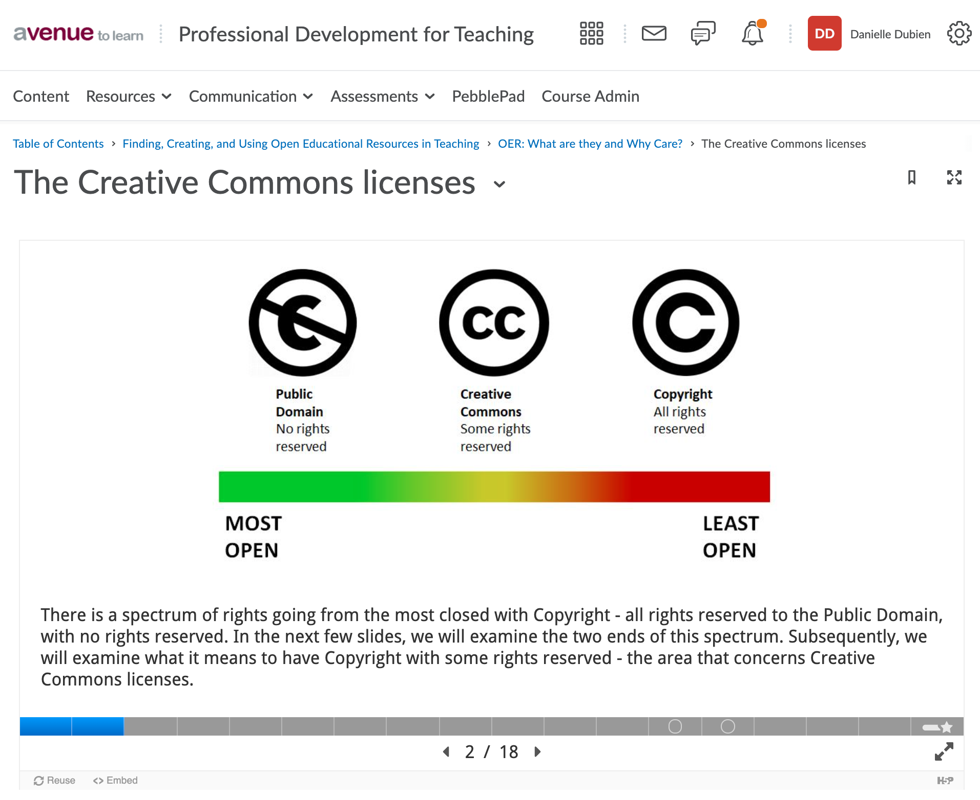
Figure 2. Image from a H5P slide show embedded in BrightSpace

Also at McMaster, I designed, developed, and delivered a webinar on Open Educational Practices. The title slide of this presentation is shown in Figure 3 and is available for viewing in Google Drive. I used Zoom to deliver the webinar. In all of these situations, I referred as necessary to my resources on instructional design (Clark & Mayer, 2016; Plass et al., 2010; Smith & Ragan, 2005).

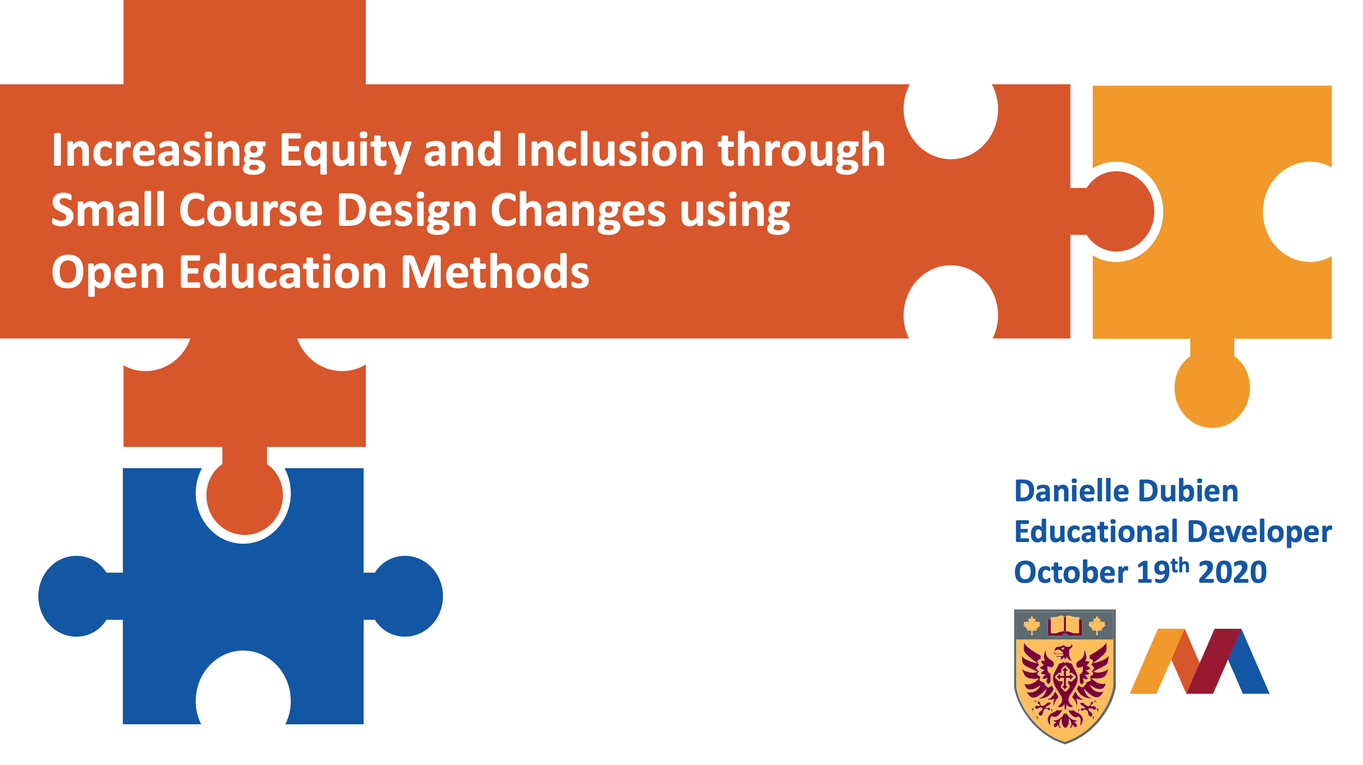
Figure 3. Title slide of my webinar on OEP

Recently, I worked on a reflection activity for first-year students in a two-semester Engineering course. One of the instructors was leading a reflection activity planned for the end of the first semester, in December 2020. There will be a second reflection activity in the second semester. The instructor met with another educational developer and me so that we could design and develop a workshop and a worksheet for students to fill out and submit. The worksheet (or handout) can be viewed in Google Drive. This was an instance where the instructor was very new to teaching and was not familiar with the concept of reflection. For these reasons, my colleague and I had separate discussions so that we could be sure to share the same recommendations with the instructor regarding the design and development of the workshop and worksheet. In this way, it was easier to build a working relationship with the instructor. We also gave the instructor positive feedback about her design of the workshop so as to reassure her; she had expressed nervousness about designing a task that was new to her. Based on the instructor’s intentions for the workshop, my colleague and I collaborated online for several hours to produce a worksheet that was suitable for a high-quality reflection. We worked extensively on the explanations and instructions so that the vocabulary would most likely be understood by the students. In this sense, we were empathising with the students by presenting abstract concepts in simple ways.

I offered consultations mainly to Engineering professors and teaching assistants (McMaster, UOttawa). I did program planning for a Master’s degree in Engineering Management (UOttawa) and for the development of a program to train African professors to develop and manage online educational programs (AVU). Again, I referred to the literature on instructional design for this work. Many of my consultations at UOttawa and McMaster occurred during the pandemic this year. In these situations, I was extra patient with professors who may have been overwhelmed with the stress of suddenly moving their courses online. To maintain these relationships, it was important to reassure the professors, give them repeated instructions as necessary, and to remind them to be compassionate with themselves and their students.

Contributions to the educational development community and engagement in the scholarship of educational development, curriculum practice, and/ or teaching and learning.

I have made contributions to the educational development community mostly through my PhD program, since 2016. I reviewed many submissions made to the Journal of Open Flexible and Distance Learning (JOFDL) and the Journal for Learning Development (J4LD). I reviewed submissions for the OER19 and PCF9 conferences as well. I have been on OER committees at McMaster and UOttawa. I am a member of GO-GN, which promotes networking among early career researchers in the field of OER. Through my GO-GN membership, I am also an associate member of the Association for Learning Technology. Below are listed my publications and presentations at various online and in-person conferences.

- Book chapter: Tentative chapter title (chapter in development): Practical and ethical considerations for designing open and online courses for developing students' online study skills. Tentative book title: Understanding digital literacy in resource-constrained contexts. Chapter co-author: Cheryl Brown

- Presentation: An ecological lens on the stressors of planning for OER engagement. Presented at the GOGN seminar associated with the OER20 conference held online. Coventry, UK, 2020. https://youtu.be/wui1FPC1hfg?t=2405

- Presentation and conference article: Using open source technologies to design courses for student-student interaction and building elearning skills. Presented at the Pan-Commonwealth Forum in Edinburgh, Scotland, 2019 http://dspace.col.org/handle/11599/3246

- Presentation: Course development by higher education partners of the OERu: Case studies using Davis’ Arena of change with technology in education. Presented at the OER19 conference in Galway, Ireland, 2019

- Article: Sotardi, V. A., & Dubien, D. (2019). Perfectionism, well-being, and university performance: A sample validation of the Frost Multidimensional Perfectionism Scale (FMPS) in New Zealand. Personality and Individual Differences, 143, 103-106.

- Online presentation: Open course development by the OERu: A case study using Davis’ Arena. Presented at the e/merge Africa 2018 Festival of eLearning held online, 2018.

- Presentation: Course development by the OERu: A case study using Davis’ Arena of change with technology in education. Presented at the Flexible Learning Association of New Zealand conference in Palmerston North, NZ, 2018.

- Presentation: Development and use of a quality assurance framework for OER while practicing open philanthropy. Presented at the Flexible Learning Association of New Zealand conference in Palmerston North, NZ, 2018.

- Presentation: Open educational practices of partners in the OERu: A case of the coevolution of education and digital technologies. Presented at the New Zealand Association for Research in Education (NZARE) conference in Hamilton, NZ, 2017.

Professional development activities

Throughout my career, I have continuously sought out opportunities to develop the depth and breadth of my skills. I have also experimented with training techniques and adapted my approaches to professional development. As well, I have taught myself skills by experimenting with a variety of educational approaches and technologies.

Over the years, I have gained an appreciation for building a strong network of instructional designers and educational developers. Much of this network is located on Twitter and Facebook. This network allows me to observe colleagues and their various instructional methods. It also provides me with insight on how to communicate with professors and teaching assistants who are not familiar with instructional design. Consequently, it is often useful to briefly explain instructional design processes. As professors become more used to educational terminology (course learning objectives; diagnostic, formative, and summative assessments; blended learning, etc.), it becomes easier and faster to work together. Below is a list of professional development sessions that I have participated in.

2020 Instructional Skills Workshop (ISW) for Faculty and Instructors (December 2020)

- Completed the Professor Hippo-on-Campus Student Mental Health Education Program. The certificate is shown in Figure 4.
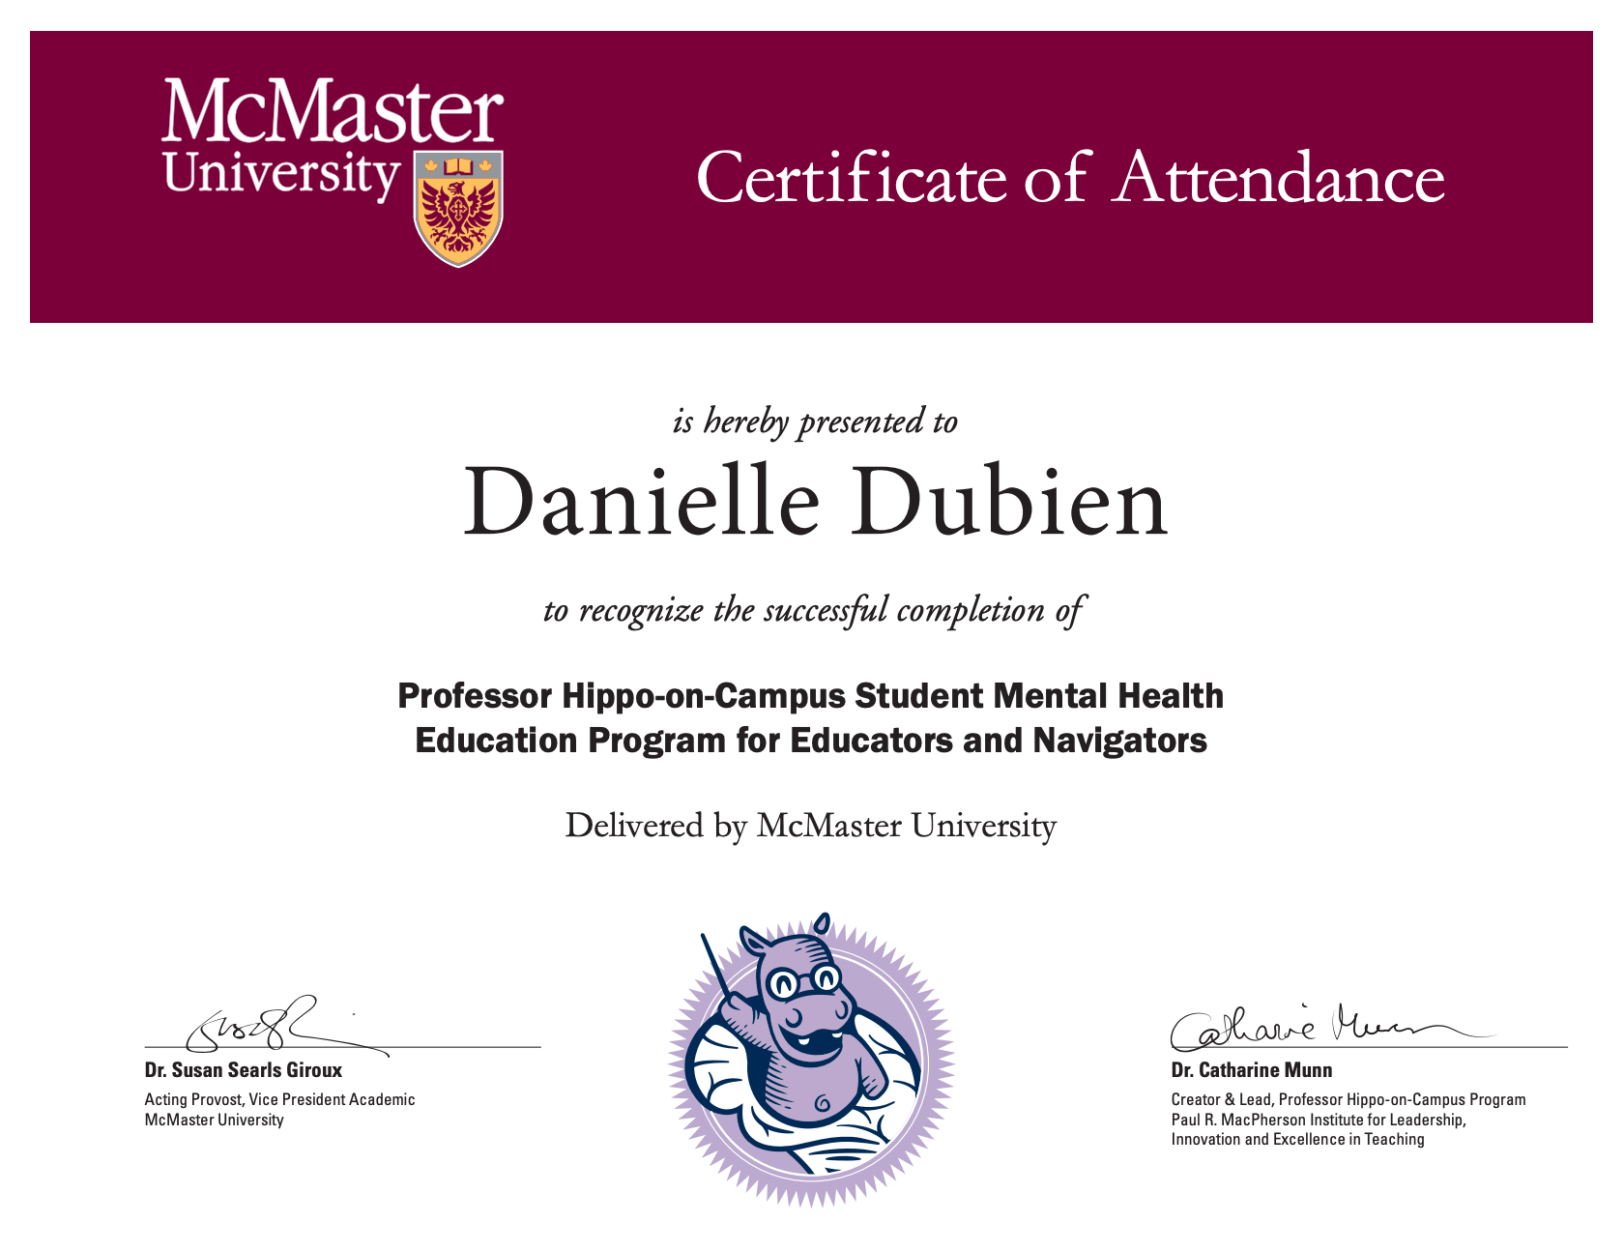
Figure 4. Certificate of completion of the Professor Hippo-on Campus program

2019 Participated in a seminar organized by the Global OER Graduate Network (GO-GN) in Galway, Ireland. The purposes of this seminar were to develop research skills related to OER, to learn about current research on OER, and to expand my professional network.

2018 Participated in a seminar entitled Flourishing as an Academic led by Professor Jeanie Forray. Topics included teaching in higher education, crafting a teaching philosophy, engaged learning practices, the course design process, ethical issues in teaching, and finding and nurturing your teaching network.

2016 Participated in a seminar entitled Thriving as an Academic led by Professor William Starbuck. Topics included work in academia, comparison of qualitative and quantitative research methods, teaching methods, plagiarism, and the academic writing process.

2012-
2013 Took two online courses as additional qualifications to my B.Ed. These courses were Parts 1 and 2 of a 3-part series on Special Education.

2006 Participated in a leadership training program consisting of two weekend sessions and several meetings with a mentor over four months. Topics of discussion included leadership styles, communication and organizational skills, leading productive meetings and effective collaboration.

2002 Participated in a seminar entitled Théorie et pratique de l’enseignement au premier cycle (ESG5500) taught by Aline Germain-Rutherford.

- Teaching experience

My experience in various teaching and training roles has shaped my understanding of education and educational development. I will provide examples that stand out from my career and explain how they show the application of my philosophy as an educational developer. Please refer to my resume for details and the timeline of my teaching roles.

I am currently teaching EDUCATN 700 Essential Skills in Teaching and Learning (II) which is taken by graduate students at McMaster University. This course is a part of the Teaching and Learning Scholar Certificate of Completion program. There are 26 students enrolled in this course, which is being delivered in a blended format. There are ten modules available online in the Brightspace LMS (named Avenue to Learn at McMaster), and they are complemented by sessions on Zoom. While teaching this course, I have taken opportunities to model behaviours of a good online instructor. I welcomed students to the course, and I encouraged them to inform me of any difficulties they might encounter so that I can support them in completing the course. I provide feedback to the whole class based on their weekly assignments, and I have described to them my processes of developing learning activities for various learning objectives and using educational technologies. I have invited students to one-on-one calls when I perceived that they were encountering difficulties with their assignments. Being a teacher in this course requires experience in teaching and learning in higher education so that the students’ experience can be meaningful. It also requires courage and confidence to discuss topics such as ethics and racism in constructive ways with students who seek guidance on these topics.

My first teaching role in higher education was that of a teaching assistant in the last year of my undergraduate studies in chemistry through to the end of my Master’s degree at UOttawa. I was a laboratory demonstrator for much of this time. Having studied at UOttawa, I was familiar with the experiments in the laboratories, where I supervised undergraduate students. To prepare for this work, I conducted the experiments on my own when possible. I also thoroughly read the students’ guidebook, so that I could become familiar with the explanations provide to them. That was my way of empathising with the students so that I could tailor my explanations to them. At the beginning of the laboratory sessions, I provided an overview of the experiments. During this time, I would quiz the students on both the theoretical concepts that they had been required to study in advance, and the experimental equipment, which they were working with for the first time. The aim was to correct misconceptions, to teach them about trouble-shooting experimental errors, and to review safety measures. During the sessions, I made a point of joking with the students if I sensed that they would receive these interactions well. The purpose was to put the students at ease, particularly first-year students who were the most anxious of all. With this experience, I am now able to guide instructors when they design laboratory experiments, be they in-person or online. I can support them in breaking down their explanations of laboratory experiments and linking them to theory. This way, students are more likely to make connections between theory and application. My work as a laboratory demonstrator also provided me with experience with regards to teaching students how to write lab reports using scientific conventions. In one instance, other teaching assistants and I met well in advance of the start of the semester to discuss improvement to the student lab guidebook. We developed a few pages of additional instructions and had them included in the printing of the guidebooks. As a result, we noticed a large drop in questions in comparison with our experience from the previous year.

My experience as a schoolteacher and as a science interpreter at the Canadian Museum of Nature required me to think on my feet so that I could formulate suitable explanations and answer a wide variety of questions. This skill remains relevant to this day, as I offer consultations to instructors. To prepare for my consultations, I research the topic of interest, which is indicated in advance by the instructor. If I have never met the instructor, I begin my consultation by asking them about their experience and about the particular issue at hand. This approach informs me about how to respond: with detailed and complex answers about educational approaches, or with basic guidance. When I finish my consultations, I ask the instructors to re-explain to me the concepts that we explored in our session. This approach allows me to determine whether I have communicated effectively; it is an example of building a professional relationship.

My volunteer work consisting of the development and delivery of content for a MOOC in 2014 was an excellent experience that involved an international audience of French-speaking adult learners. The course was coordinated by an instructional design team in New Brunswick, while I was located in Kenya. This was my first time working with these coordinators, and I made a point of having fun with this experience. It was quite stressful for the coordinators, as they were managing people located all around the globe. In contrast, the work was a delight for me to complete; I shared my joy for the work with the coordinators. Given that the audience for this MOOC was international, with a large portion of the participants coming from Africa, I used openly licensed images of students in various technology-based learning contexts in African countries. This was an instance of making my work inclusive to learners.

