EDCP PhD Program Visioning
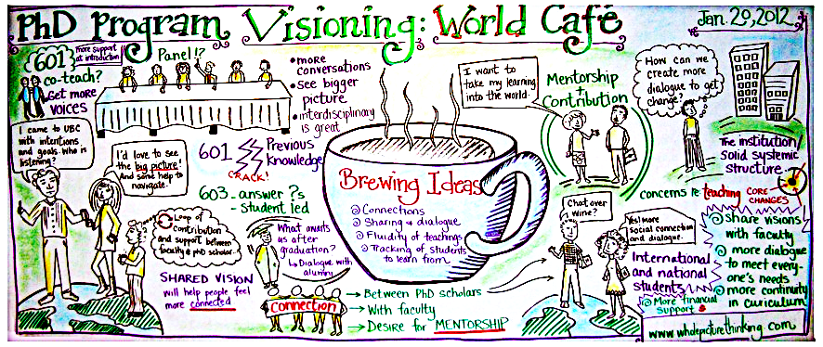

World Café
January 20, 2012
DRAFT Report

Prepared by Julia Ostertag
with the EDCP Peer Advising Team

March 27, 2012

Executive Summary

As a living document, this executive summary emerges from a World Café visioning session and suggests areas for action in changing EDCP’s doctoral program to address student concerns. Further consultation with students & faculty members is required to implement broader changes; however, a number of actions are already underway to address particular recommendations.

A. The doctoral program’s current identity minimizes the significance of pedagogical practices and theories
Recommendation #1: Change the name of the doctoral program to
Curriculum & Pedagogy
Recommendation #2: Create a more porous PhD program by creating connections within the broader Faculty of Education community

B. Students desire stronger scholarly integration between curriculum & pedagogy in core courses
Recommendation #3: Frame core doctoral courses around scholarly and
professional approaches to curriculum & pedagogy through, for instance, the
study and practice of currere, a more nurturing teaching style, and co-
teaching
Recommendation #4: Create 603, a student-led doctoral seminar course, to
parallel the period when students write comprehensive exams, prepare their
proposals, commence their research
Recommendation #5: Increase accessibility by posting methodology
courses being offered throughout the FoE in advance and in a way that
provides oversight between the various departments (Action: GCAC)

C: When entering the program, students feel alienated and disconnected from the EDCP community
Recommendation #6: Create a full-day orientation for graduate students,
and potentially extended this orientation for the entire first week of classes
(Action: Quality of Life Committee & Peer Advising Team)
Recommendation #7: Encourage all Faculty members to attend graduate
student orientation

D: Students desire stronger relationships with faculty members, better mentoring, and collaborative work with peers
Recommendation #8: Create clusters of research groups in the department/faculty

E: Doctoral students seek to contribute to meaningful discussions around issues affecting them
Recommendation #9: Hold yearly mini-retreats for doctoral students

Overview of Event: Description of World Café session on Friday, January 20, 2012

Around 30 PhD students attended the world café on a rainy Friday evening from 3-5:30pm. Students from all years of the program were present, including one recent graduate. Julia facilitated the session, along with Taraneh Efan from Whole Picture Thinking. Taraneh also recorded the discussions graphically on a large sheet of white paper. Light refreshments were available throughout the session, and many participants arrived early to chat and eat. The tables in room 2414 were set up ‘café style’ with candles, tablecloths, interesting objects (shells and stones), paper, markers, and crayons.
Julia welcomed all the participants, introduced the peer advising team, and explained the purpose of the world café. The emphasis was on thinking positively and constructively about our personal experiences in the EDCP PhD program, and envisioning how we can draw on these experiences to build our scholarly community. Julia read out loud a very general list of issues that students might want to consider in their discussions (everything ranging from how many courses, to supervision, to space design, to the name of the program, to international student experiences, and funding). Julia positioned this discussion within increasing efforts to revision and strengthen PhD programs throughout North America (see: The formation of scholars: Rethinking doctoral education for the twentieth-first century). Taraneh then described in more detail how a world café works, what is world café etiquette, what is graphic recording and how it contributes to world café-style sessions, and gave an overview of the three guiding questions for the afternoon. A peer advisor sat at each table to act as a note-taker and record all the conversations.
Taraneh explained to students how they would sit at different tables for each of the three questions, and how where they would introduce each other and listen to the note-taker’s review of discussion to date before beginning the new question. Approximately 20-30 minutes were given for each question, though it was difficult to stop discussions and move onto the new question.
The three guiding questions were:
- What could a good PhD program also be?
- What’s taking shape in the conversation so far? What’s missing?
- What have we learned that we can take forward to create change?
During discussions, Taraneh circulated between tables to gather ideas as they emerged and begin creating the graphic recording. After the third question, the note-takers from each table provided a brief summary of all the questions for the whole group. Some open discussion ensued, and then Taraneh presented her graphic recording, asking for clarification and feedback to complete the drawing. Finally, Julia concluded the session with some final thoughts and thanked everyone for attending.

Recommendations
In many ways, the world café was a necessary first step for PhD students to identify issues but it was not long enough for us to explore detailed solutions to these issues. However, based on the key themes that emerged during the visioning session and our understanding of the program, the Peer Advising Team has developed recommendations in the following areas:
- Name change and program identity strengthened: PhD in Curriculum & Pedagogy
- Change in core courses: 601, 602, 603 (& potentially a 604 methodology course)
- Student orientation & community
- Stronger relationships with faculty members: Research groups
- Yearly visioning sessions
As will become evident throughout the report, many of these areas are closely related and overlapping. Graduate students were invited to review an early version of this Report and provide comments and feedback.

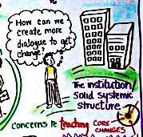
1. Program identity & name
We recommend that the name of the PhD program change to Curriculum & Pedagogy (from Curriculum Studies). Much of our discussion focused on the ways in which doctoral courses were being taught, and by bringing the word pedagogy into the program name, we hope to see a greater emphasis placed on the practices (and places) of teaching and learning. This will emphasize the importance of doctoral students’ professional development in becoming post-secondary educators, as well as curriculum theorists and researchers in our disciplinary areas.

We also recommend that the PhD program’s identity become more closely connected with the broader Faculty of Education community. For instance, recognizing the teacher education program as a “living laboratory” would allow doctoral students to explore, in a spirit of co-discovery, ways in which curriculum & pedagogy inform our practices and understanding of education, beyond K-12 and school-based education. This could involve 601 & 602 course projects, research methodology courses, class visits, shared orientation activities in September, mentored teaching experiences (GTAs), etc. Stronger connections with teacher education could benefit both teacher education students and doctoral students (and also MA/MEd students if a similar structure is adopted for those programs). Graduate students can act as “bridges” between academic theorizing around education and more practice-oriented approaches in teacher education, creating opportunities for integrating research and teaching.

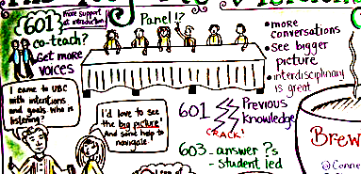
2. Scholarly integration of C&P in course structure
Students describe confronting an enormous chasm between their previous lives and their introduction to the PhD program through 601. Taraneh’s drawing illustrates this as a huge “crack” between previous experiences and the doctoral program. Overwhelmingly, students were critical of both 601 & 602. Some expressed that they enjoyed the courses, that they needed to be pushed, and that the hardships were worth it in the end. Nevertheless, it seems clear that a more effective approach to teaching the core courses in the doctoral program is required. This would include an experience of scholarly and professional nurturing and meaningful apprenticeship/mentorship in the practices of curriculum and pedagogy. While students recognize the need for cognitive dissonance and intellectual stimulation, no student should feel traumatized or oppressed by his or her education, yet as student comments indicate, this is part of their experiences of their doctoral seminars. Students identify systemic problems in the core PhD courses, including being taught from a dominant perspective, excessive reading load, aggressive teaching, and so on.

Overall, students largely appreciated the theoretical concepts covered in the courses, though some wanted more curriculum theory, Canadian curriculum history, and, since few students have backgrounds in philosophy, better introductions to philosophical concepts.

However, it was the pedagogy that informs and was enacted in these courses that received the most sustained and near-unanimous criticism. In re-orientating the identity of the program to a PhD in Curriculum & Pedagogy, the practices of teaching and learning that are explored theoretically must also be reflected in the compulsory doctoral seminars. At present, scholarship on pedagogy is not represented in any meaningful way in the core doctoral program.

The inherent interdisciplinarity of our department and the PhD program is our greatest strength, yet it is also a weakness if students are left feeling isolated and disconnected from each other and from the content of the courses. If we don’t acknowledge this interdisciplinarity, as well as the vast subjective experiences each graduate student brings to the department, we lose profound opportunities for learning. Therefore, we recommend framing the core doctoral courses around scholarly and professional approaches to curriculum & pedagogy, which explicitly bring the subjective and autobiographical in learning to the fore as, for example, in the study and practice of currere. This approach allows for professors and students to “learn from the other” and explore how curriculum & pedagogy can be approached from different horizons of understanding (e.g., feminist, Marxist, postcolonial), without feeling excessively alienated from the program.

For instance, Madeleine Grumet’s approach to teaching the 2010 summer scholar course, EDCP 585 The possibilities of pedagogy, could be exemplary in thinking about what a currere-based PhD program looks like: Start with narratives from our teaching/learning experience, weave pedagogy, curriculum theory, philosophy, performance, personal experience, fictional novels, breathing exercises, movement, outdoor activities, art, textiles, multi-media explorations, peer review, etc. into the journey from 601, 602, to the proposed 603. This approach will also address concerns that 601 & 602 are taught from predominantly white Canadian and U.S. perspectives, which makes it especially difficult for international students to connect with the theories and share their own knowledge.

While students feel isolated even during their first two years in courses, this feeling is exacerbated after courses end and students begin comprehensive exams, research, and writing their dissertations. There are few opportunities for shared learning experiences, which is why we recommend the creation of 603, a doctoral course largely led by the graduate students to bridge the transition from course-work to independent research and writing during comprehensive exams, developing the research proposal, and potentially also writing the dissertation. Many students expressed disappointment that they no longer had contact with their cohorts after 602 ended; this additional course will provide a frame to continue meeting within a scholarly community of peers with guidance from faculty members.

In addition to changes to the core doctoral courses, students also expressed the need to know which courses are being offered when, in particular for methodology courses. We recommend that methodology courses being offered throughout the FoE be posted in advance and in a way that provides oversight between the various departments. [Apparently the GCAC is developing this resource already]

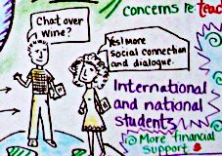
3. Student orientation & building community
The issue of students’ isolation affects international as well as Canadian students, many of who come to UBC from other regions and provinces take, on average, seven years to complete the program. While restructuring 601, 602, and creating 603 will address some of these issues, we recommend creating a full-day orientation for graduate students, and potentially extended this orientation for the entire first week of classes. Already, the Peer Advising Team and the Quality of Life committee are working on changing the orientation to provide a warmer invitation and more thorough orientation to the program and the Faculty of Education. One key step will be to separate the orientation day from the SSHRC workshop, since this pairing instills an emphasis on frantically seeking funding instead of meeting a warm and inviting scholarly community. Furthermore, we recommend that all Faculty members be engaged in this orientation, which also addresses the issue of doctoral students’ feeling distant and alienated from faculty members.

Holding orientation events during the first week of classes, including during 601, will delay the sudden transition to purely theoretical discussion, and allow students to have opportunities to:
- discover the library,
- meet professors,
- attend funding workshops,
- be mentored by upper-year graduate students,
- answer pressing questions (particularly for international students, who are particularly overwhelmed during these early weeks),
- discover employment opportunities (GRA, GTA, etc.),
- meet the Teacher Education students and broader FoE community,
- participate in social events, and
- build personal connections with their cohort and other graduate students, as well as faculty members and staff.

4. Stronger relationships with faculty members
Many students were interested in seeing 601 & 602 co-taught by various faculty members in order to learn more about the research areas of faculty members. Students also talked about their concerns that faculty members are simply too busy to attend to graduate students in a meaningful and sustained way. Many students were also concerned that the lives of faculty members appear so busy and stressed, that it forces us to seriously question ever wanting to become a professor. As these various comments suggest, students long to be closer with faculty members, yet feel that there are various barriers preventing these relationships from growing. Students also clearly identified the need to meet with other students that have similar research interests and work collaboratively with their peers in a mentorship kind of relationship. Understanding FoGS regulations and procedures would be beneficial for both faculty & students.

Our recommendation is to create clusters of research groups within the department (and potentially more broadly within the Faculty) led by faculty members or co-chaired by one faculty member and one graduate student. All students would be strongly encouraged to join a research group, and groups would ensure a welcoming environment for diverse students. All groups would be posted on the EDCP website with a brief description and contact information. Students would present their research ideas in these groups, engage in theoretical reading and discussion, experiment with pedagogical practices, etc. The structure of the groups could be that a faculty member and student co-chair the group for one year/one semester, and that these responsibilities then rotate to new co-chairs. Clusters could be around technology, place studies, indigenous epistemologies, queer theory, art education, research methodologies, teacher education, etc. These themes can change yearly but some may remain in place for many years. An outcome might be that each group publishes an article collaboratively or presents together at a conference. While more discussion is required to develop these research clusters, potential models to build upon are the seminars hosted by CREATE, teacher education, Pinar, and EDCP. In the past, doctoral students also presented their research to the department prior to defending their dissertation.

5. Yearly visioning sessions
At the end of the world café, Julia asked participants for a show of hands to find out how many students would like to have yearly visioning sessions. The response was a resounding, “Yes!” Therefore, we recommend yearly mini-retreats for doctoral students to talk about the program and create ideas for change (similar visioning sessions should also be held for MA and MEd students). Students noted throughout the event that they felt that a more “student-centred” or democratic approach to determining the workings of the program was required, and that more opportunities for students to advocate for changes to the department were needed. Holding yearly visioning sessions addresses a number of students’ concerns:
- Build community, share experiences, reduce isolation
- Strategize to make changes, advocate for our program
- Learn different communication approaches (e.g., World Café & graphic recording)
One student’s email to Julia following the event summarizes students’ overall response:
Dear Julia and the Advising Team,
THANK YOU for an amazing World Cafe. It was my first experience and I must say it has been so convivial, enriching, productive and you did it in style! A wonderful university moment shared with friends, classmates and peers.
Thank you again.

While this world café was solely for and by students, we worried a bit that it set up a potentially antagonistic relationship with the faculty members by leaving ‘them’ out of the conversation. And yet, the sense that we got was that students needed this opportunity to come together, talk openly, and, yes, complain a bit, but – at the end of the day – we felt very strongly that all the elements to improving the doctoral program are already within EDCP’s incredible faculty, staff, and students.

Further actions:

-Present Report to GAC, March 29, 2012
-Request GAC to comment on report and make recommendations for actions
-Include World Café Report and GAC comments in EDCP department retreat in May, 2012
-Submit report to EDCP department meeting to be included in the minutes
-Include report in EDCP peer advising year-end report, for future peer advisors to build upon

For instance, consider two student comments from the café: “Systemic problem in 601-602 since it traumatizes some (or many) students” and “601 was a real shocker for me. Prescriptive, judgmental, oppressive. A difficult introduction”

