**How to create a slideshow using iPhoto ‘09**  
*Joanne Oh & Ephra Lee*  
  
At the Vancouver Art Gallery, there is a display called 'Every House I've Ever Lived In'. The artist, Alex Morrison, sketches the skeletons of each house he's ever lived in and it is a wall display of over 20 sketches. Alex Morrison said,

"The houses we've lived in, each one acts as a sort of net that captures and tempers our individual experiences. Role of memory to temporal experience suggests an increasingly nomadic lifestyle that seems characteristic to this global age, when individuals are constantly on the move, rootless except in the memories they carry with them from place to place.'   
  
If memories are becoming more important than tangible things to our lives, and if technology is an extension of the human, then technology can help us extend the preservation of our memories and digital media can expand the ways we can share our memories.   
  
iPhoto is a digital software that can import, organize, edit, print and share digital photos .It was first developed by Apple Inc and only operates in OS X and iOS system. Compared to professional software such as Adobe Photoshop Album and Phase One’s Media Pro which can be difficult and stressful to begin working with, iPhoto allows you to easily edit, organize, and manage photos. They can be imported into the iPhoto Library from the internet, digital cameras, scanners, and CDs. Also iPhoto gives you various ways to share your photos through Facebook, Flickr, MobileMe, Email and CD/DVD.  
  
One of the ways you can make the great use out of iPhoto is to make a slideshow. If you want to keep the memories of special occasions like birthdays, weddings, family trips, or graduation indelible and want to share those memories with others, it would be best to create a slideshow with the photos that you’ve taken. If you are new to iPhoto, you won’t have much difficulty in creating a slideshow if you play around with the program a little, however to save even more of your time, here is a step-by-step tutorial in how to create a slideshow using iPhoto:

1. Import photos into iPhoto Album (File → Import To Library *or* Drag photos into an ‘Album’)  
2. Select all the photos (or you can add the photos right into the slideshow later) and click https://lh4.googleusercontent.com/y1DFtYT8wNSMOsTYwvsjVcs5kzZdylchUl3AmvlFk_G94hrGWoR0tD6UCg5xkQ6ktTetfIRLUn3ZRjKlssHiXYjXqlaFYASMXFl-c08exrangEbz9cobutton on the left-bottom to create a slideshow

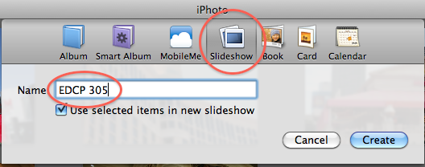

3. Overall Slideshow Settings

* Themes: 6 themes for the slideshow

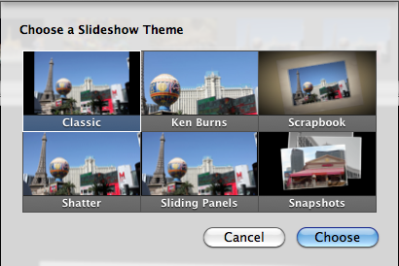

* Music - You can choose a song from the samples, from your own library, or even import one you’ve made in GarageBand
* Slideshow Settings
  + *13 Transition* options from one photo to the next
  + Show caption - You can add a description of the photo for your audience
  + Aspect Ratio - Slideshow can fit the size of an HDTV, TV, or even an iPhone

4. Edit photos in the photo album

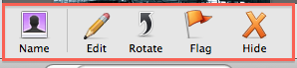

* Name - You can tag the people in your photos.

(Tagged names are organized in the ‘Faces’ section under the Left-hand column → Library)

* Edit → These options show up

https://lh4.googleusercontent.com/7ExAUo3BKBMaMzhXFLHjGqQ9TgvuSLdx8UhBpFAHezAmNrKLvEQToNzcBP2s31vwcx4zKZ6JT8M4Wr19p9sNllGLyrHTXqlALqepuJTLLIoJAK9HrxE

* + Effects (Just like Instagram filters)
    - 1 Click Editing - Only one of Black and White or Sepia are used at a time
    - Multiple Clicks - All other effects can go up to 9 levels and can be used together!  
      eg. Sepia + Vignette + Antique all for one photo
  + Adjust - Regular options such as exposure, saturation, temperature, and more are here

5. Exporting your slideshow

1. Click https://lh3.googleusercontent.com/UU9WHxWpGAipaHKWG811mENWgnS5o8Zs_YwouWauDerhLvNoDPqGZy6xOk06XJQ5yZvi2IoJCLS87SZsv4_yI-jv_fUhAX8Jg7DSweXQaf8VUcM7uF0button on the right-bottom
2. You will see 4 different options for the file size. Select one and clickhttps://lh4.googleusercontent.com/z49eWjje-bEklozwDJS1csg7bzz2Aq_NJrN32htBzvTl43W7fWW_YnC9bV4_CFFRuwABqdQYkcRbE0N1Z4PnYP295MFcSnjF_igGJAnAqEJwH4QKBBc. The file will be saved as “_____.**m4v**”

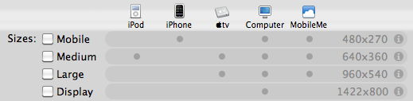

*or*

You can also do ahttps://lh4.googleusercontent.com/qKbCz0qXjE0EtJpt_-s7CsIUOo7yemz8wh0HY-iqlX6B4GisTU_OVrAgfmRG-VGMQ5Gc9rvO5RR6vcJlrFQ3OPeGIb9VJ5l7LCRsJ0bzgoUO5_Eoeek, that will give you these options:

|  |  |
| --- | --- |
| https://lh5.googleusercontent.com/XT4hYrCf_ae0Vf3tRQHt7wIJYmX4dpMQunU-Fq3wI1UO45ky62ob_u9odHsY4lVE0oJb23gmxZR_cnphY7NG1XT_UFyIpEd_etMtTIo0hAAyY4dnZw4 | Movie to 3G--> **.3gp**  Movie to Apple TV--> **.m4v**  Movie to iPhone--> **.m4v**  Movie to iPhone (Cellular)--> **.3gp**  Movie to iPod--> **.m4v**  Movie to MPEG-4--> **.mp4**  Movie to QuickTime Movie--> **.mov** |

Select one option and click https://lh5.googleusercontent.com/9OASXAGjLUuFDb6dclzGvEW5DJCNbGmT9_fazQCkCpTQ2JZ82PvjwXBvnGwSB4E8csATjH8YxKK1k7kg6SD03Ai-eHCGkK8TG0asPTVvOGWvm9nqsGM