Editha Tomaszewski

May 27, 2016

Revised Jun 3, 2016

**English 301 Assignment 1.3 Definitions**

**Introduction to Assignment:**

Criteria:

1. Choose a *relatively* complex term used within your particular discipline or profession
2. Choose a situation and an audience of “non-technical readers”.
3. Compose a parenthetical and expanded definition of the term. For the expanded definition:
   * use at least four expansion strategies
   * include at least one visual
   * consult no fewer than three outside references and provide a works cited list MLA style or APA style

Objectives:

* + Appreciate the importance and role of definitions in technical writing
  + Understand how audience and purpose indicate the need for definition
  + Differentiate between the levels of details in definition
  + Select the right level of detail according to the situation

The purpose of this assignment is to write three definitions of a term related to one’s field of study- parenthetical, sentence, and expanded, for a non-technical audience. The objective is to understand how different readers require a different form of definition, such as levels of detail and vocabulary if they are not familiar with the area of knowledge. In my field of practice as a Dental Hygienist I encounter patients from all different educational backgrounds. It has been my philosophy to convey the message in plain language rather than in technical dental jargon. Although the word I have chosen for this assignment does not seem overly complex, I had to explain it at least few times within the past week, hence my decision to define it.

This assignment allows the student to realize the importance of defining in technical writing.

**Term:** Maxilla [mak-sil´ah]

The ***parenthetical*** definition:

Maxilla (a jawbone especially the upper).

The ***sentence*** definition:

Maxilla is an irregularly shaped pneumatized bone (a bone that is hollow or contains many air cells) supporting upper teeth and taking part in formation of orbit (eye socket), hard palate (roof of the mouth), and nasal cavity (opening for the nose). (“maxilla”2 n.d.) (Figure 1 & Figure 2)

The ***expanded*** definition:

**Maxilla** [mak-sil´ah]  *n. pl.* **max·il·las** or **max·il·lae** (māk-sĭl'ē)

Maxilla is the major bone of the upper jaw; one of two identical bones that form the upper jaw (jawbone). The maxillae meet in the midline of the face and often are considered as one bone. They have been described as the architectural key of the face because all bones of the face except the mandible (lower jaw) touch them. Together the maxillae form the floor of the orbit (eye socket) for each eye, the sides and lower walls of the nasal cavities, and the hard palate (roof of the mouth). The lower border of the maxilla supports the upper teeth. Each maxilla contains an air space called the maxillary sinus. (“maxilla”, n.d.) (Figure 1 & Figure 2)

[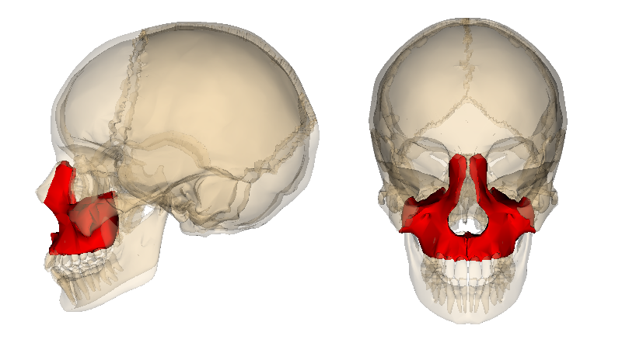](https://www.google.ca/url?sa=i&rct=j&q=&esrc=s&source=images&cd=&ved=0ahUKEwig-LzmgfvMAhUXDlIKHVvMAD0QjRwIBw&url=https://www.studyblue.com/notes/note/n/skeletal-bones-skull-/deck/14901336&psig=AFQjCNFA7rVnb1QV-Y2dJxRLcjtamxldYQ&ust=1464464499346673)

*Figure 1: Maxilla image – side view as well as the front view.*

*Source:* [*http://www.mindbds.com/wp-content/uploads/2015/08/Maxilla_image.png*](http://www.mindbds.com/wp-content/uploads/2015/08/Maxilla_image.png)

[](http://www.mindbds.com/wp-content/uploads/2015/08/Maxilla_close-up_animation.gif)

*Figure 2: Maxilla image – front view with the teet*

*Source:* [*http://www.mindbds.com/maxilla/*](http://www.mindbds.com/maxilla/)

**Word Origin and History**

*n.* "jaw, jawbone," 1670s, from Latin *maxilla* "upper jaw," diminutive of *mala* "jaw, cheekbone." " *Maxilla* stands to *mala* as *axilla*, 'armpit,' stands to *ala* 'wing'" [Klein]. Related: *Maxillar*; *maxilliform*.

**How does maxilla develop?**

Maxilla forms within the maxillary prominences extending from the underside towards the back of a much larger mandibular (lower jaw) swelling. Ossification of maxilla begins slightly later than in the mandible. The primary ossification centre appears for each maxilla in the 7th week during fetal development. (Bariker, 2012)

**What are the parts of the maxilla?**

The maxilla consists of the body which is large and pyramidal in shape and its four projections: the frontal, zygomatic, palatine and alveolar processes. (Figure 3)

Maxilla houses the largest sinus of the face, the maxillary sinus. (Medscape, 2013)

[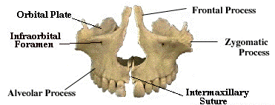](http://www.google.ca/url?sa=i&rct=j&q=&esrc=s&source=images&cd=&cad=rja&uact=8&ved=0ahUKEwiD0tWS8IrNAhVBFVIKHXOKBo8QjRwIBw&url=http://www.csuchico.edu/anth/Module/maxilla.html&psig=AFQjCNHpi7NB_AOotrYJrZePIk2_wD1Yow&ust=1465008544726840)

*Figure 3: Parts of the maxilla with its four projections.*

*Source:* [*http://www.csuchico.edu/anth/Module/maxilla.html*](http://www.csuchico.edu/anth/Module/maxilla.html)

**What is the role of the maxilla?**

The maxilla has several roles. It houses the teeth, forms the roof of the oral cavity, forms the floor of and contributes to the lateral wall and roof of the nasal cavity, houses the maxillary sinus, and contributes to the inferior (lower) rim and floor of the orbit (eye socket). Two maxillary bones are joined in the midline to form the middle third of the face. (Medscape, 2013)

**How is maxilla connected to the skull?**

Maxilla is connected to the cranium and the cranial base by a number of fibrous joints called sutures. These sutures include: fronto-nasal suture, fronto-maxillary suture, zygomatico-maxillary suture, pterygo-palatine suture, and zygomatico-temporal suture. (Anatomica, 2010) (Figure 4)

[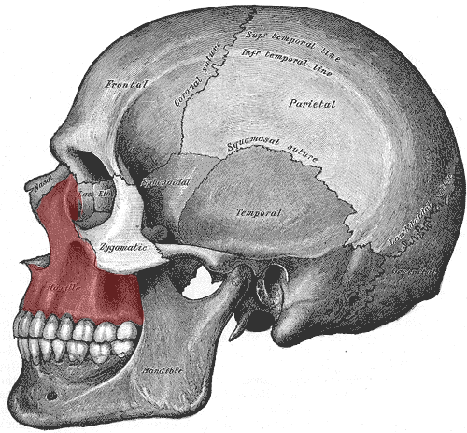](http://forensics.onlinesculptureclass.com/?glossary=maxilla)

*Figure 4: Maxilla – side view with identified bones of the face and skull, the sutures and the teeth. Source:* [*http://forensics.onlinesculptureclass.com/?glossary=maxilla*](http://forensics.onlinesculptureclass.com/?glossary=maxilla)

**Where do the teeth develop in the maxilla?**

The alveolar part of the maxilla, a rather porous inferior extension of the maxilla, which forms the maxillary dental arch, includes sockets (openings) for the teeth (alveolar sockets). The base of each socket contains a hole through which branches of alveolar nerves (superior and inferior) and blood vessels reach the inside (pulp cavity) of the teeth. In children, maxillary jaw contains sockets for 10 teeth, in adults for 16 teeth. (Anatomica, 2010)

**References**

Academic Dictionaries and Encyclopedias. Retrieved May 27, 2016 from <http://en.academic.ru/dic.nsf/enwiki/152037>

Anatomica. (2010). The complete home medical reference. NSW, Australia: Global Book Publishing.

Bariker, R. (2012). Growth & development of maxilla and mandible. Retrieved May 27, 2016 from

<http://www.slideshare.net/dr_abi/growth-development-of-maxilla-and-mandible>

maxilla. (n.d.). *Dictionary.com Unabridged*. Retrieved May 27, 2016 from Dictionary.com website <http://www.dictionary.com/browse/maxilla>

maxilla.2 ( n.d.) *Medical Dictionary for the Health Professions and Nursing*. (2012). Retrieved May 27, 2016 from <http://medical-dictionary.thefreedictionary.com/maxilla>

maxilla image (n.d.). Retrieved Jun 2, 2016 from <http://forensics.onlinesculptureclass.com/?glossary=maxilla>

maxilla image (n.d.). Retrieved Jun 2, 2016 from <http://www.mindbds.com/maxilla/>

maxilla image (n.d.). Retrieved Jun 2, 2016 from <http://www.mindbds.com/wp-content/uploads/2015/08/Maxilla_image.png>

MedicineNet.com.(n.d.). Retrieved May 27, 2016 from <http://www.medicinenet.com/script/main/art.asp?articlekey=4301>

Medscape. Maxilla (2013). Retrieved May 27, 2016 from <http://emedicine.medscape.com/article/835401-overview#a3>

Parts of the maxilla with its four projections (n.d.). Retrieved Jun 2, 2016 from <http://www.csuchico.edu/anth/Module/maxilla.html>