Representing – Lesson Plan
Understanding the Concept of Goal Setting

A topic my students struggled to understand in the past…

At the beginning of January, I taught a lesson to my grade 2 and 3 French Immersion class on goal setting, in which we tried to set our own New Year’s resolutions. I began the lesson by attempting to access my students’ funds of knowledge; I asked them if they had heard the term “New Year’s resolution” before, and if they had made any with their family this year. I was surprised to learn that none of them were familiar with the term, and that nobody had partaken in this tradition that was very popular with my family growing up. I continued the lesson by asking students to set goals for themselves. I provided scaffolding for this process by giving some suggestions of my own and then taking student suggestions and writing these on the board. Whenever a student suggested something that wasn’t a very appropriate goal (such as: “I’m going to play more video games this year”), I asked the other students what they thought about this goal. Usually another student in the class, with my help, was able to explain why this wasn’t an appropriate goal.

My follow up activity was to ask the students to write three New Year’s resolutions for themselves in their journals. During our brainstorm, I had written many ideas on the board, so for students that weren’t sure what to write, they were able to take ideas that we had discussed and adapt them if necessary. I asked the students to create at least one goal that was related to school in some way.

How would I change this lesson in the future?

The primary thing I learned from giving this lesson is that one hour is definitely not enough time to teach students how to set goals. I think that a series of at least 3 lessons would be required for students at this age to acquire a basic understanding of goal setting, followed by periodical check-ins; I will explain this later.

I also learned that I should not make assumptions about the funds of knowledge of my students. I designed my lesson on an assumption that most students would have an idea of what a New Year’s resolution is, and were somewhat familiar with the process of goal setting. This was an important lesson for me – if I did not teach it, why should I think that my students would know it? Furthermore, even if some of my students did have a better understanding of goal setting, without properly exploring the topic with my class I am putting those students that have not had experience with goal setting at a disadvantage. Therefore the most important aspect of this lesson for me to develop is the introduction: what is a goal, and how do we go about setting one?

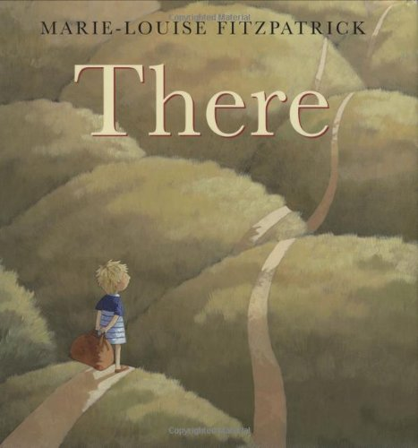
I would like to begin my first lesson with a book about goal setting, such as There by Marie-Louise Fitzpatrick. Reading this book would allow learners to engage with a text to help them understand the concept of goal setting and would give us the opportunity to discuss the process of goal setting. Picture books can be a great way to introduce a concept as they are engaging and use a story to demonstrate a specific process. After this, I would lead a discussion on goal setting. I would follow the same process of scaffolding the development of New Year’s resolutions, by explaining the term, relating it to goal setting, and providing examples. I would ensure I provided many examples that were particularly relevant to me, and make sure to explain the process of how I came up with these resolutions and why I thought they would be beneficial to me. I would also have a poster indicating what makes a goal “good”:
Good Goals
Specific: detailed
Attainable: doable, possible
Measurable: how will you know?
Rewarding: do something special!
Time: weekly (in one week, I will…)

We would discuss what this poster means in detail. I would provide examples and non-examples for each criterion, and ask my students to participate in this as well. For example, a non-example of “attainable” would be “I will grow 20 feet this year”. Giving humorous non-examples will hopefully allow my students to remember and understand each concept better.

When I delivered this lesson before, I asked students to raise their hand and give suggestions for a goal they could set for themselves. This can cause anxiety with some students, especially when discussing a new topic. Next time, I would start a second lesson with a Think-Pair-Share. I would ask students to get in to pairs and discuss possible goals they could set for themselves for the year, ensuring that they thought about the criteria on our “good goals” poster. I would provide them with Post-it notes on which they could write their suggestions and have them stick them on the board in three columns: “Home”, “School” “Other”. These categories would help later as we discussed the goals. I would ask students not to include their names on the Post-it notes. Acquiring suggestions in this way would provide more hesitant students an opportunity to participate in a lower-risk environment. Once all the students were finished brainstorming possible goals, we would discuss the suggestions as a class.

Following this, I would ask students to choose three New Year’s resolutions that they would like to set and write them in their journals. I would ask that one goal be school-related; this could be inspired from our “school” section of our Post-it note brainstorming activity. After, I would ask the students to get in to small groups, if possible with students that had a similar school-related goal, and choose one of their resolutions to represent in a tableau. The rest of the class would make guesses as to what goal was being represented in the tableau. In Ways of Knowing, Education Alberta states that: “the meaning of coming to know involves the body as a whole that is not disassociated from the brain”. By participating in the tableau activity, students act out the concept that they are in the process of understanding, thus providing an opportunity for embodied knowledge.

In my third lesson, I would have students look at their journal entry from the previous class and select a school-related New Year’s resolution. I would provide them with a worksheet to fill in, with the following questions:
- What is my New Year’s resolution?
- Is this a realistic goal?
- How will I know I am working towards accomplishing my goal?
- Why is this goal important to me?
- What will I do to track my progress?
I will scaffold this by completing a sample worksheet as a class. I will encourage students with similar goals to work together and help each other in their answers. By filling out this worksheet, we are returning to our criteria that we established for a “good” goal during the first lesson.

I would develop a system to track each student’s goal. I would explain to my students that at the end of each week, we would do a “check-in” to see if they were on track with their New Year’s resolutions. This refers to the concept of embodied knowledge, as the students are learning by doing.

Overall, I would spend much more time exploring this topic with my students. I would want to incorporate as many strategies as possible in order to allow for understanding of this difficult concept.

