Math 7: Area and Perimeter of Basic and Composite Shapes

Part 1: Basic Shapes

Instructions: find the perimeter and area of each figure. Round your answers to one decimal place if necessary. Use your formula sheet and a calculator, and be sure to complete every step of the problem to get full marks.

Figure 1:  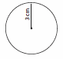 | Radius:  ______________  Diameter:  ______________ | What is the circumference of this figure? Be sure to write down your formula. | What is the area of this figure? Be sure to write down your formula.

Figure 2:  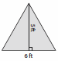 | Base:  ______________  Height:  ______________ | What is the perimeter of this figure? Be sure to show all work. | What is the area of this figure? Be sure to write down your formula.

Figure 3:  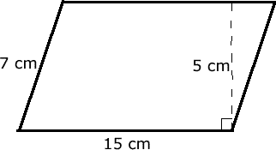 | Length:  ______________  Width:  ______________ | What is the perimeter of this figure? Be sure to show all work. | What is the area of this figure? Be sure to write down your formula.

Figure 4:  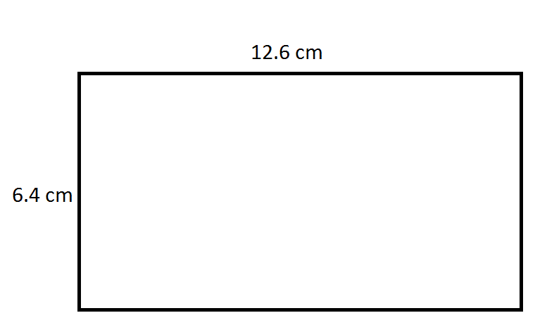 | Length:  ______________  Width:  ______________ | What is the perimeter of this figure? Be sure to show all work. | What is the area of this figure? Be sure to write down your formula.

Part 2: Compound Shapes

Instructions: find the perimeter and area of each figure. Round your answers to one decimal place if necessary. Use your formula sheet and a calculator, and be sure to complete every step of the problem to get full marks.

Figure 5:  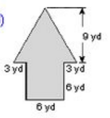 | What is the perimeter of this figure? Be sure to show all work. | What is the area of this figure? Be sure to write down your formula and show all work.

Figure 6:  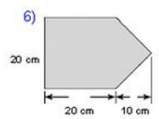 | What is the perimeter of this figure? Be sure to show all work. | What is the area of this figure? Be sure to write down your formula and show all work.

Figure 7:  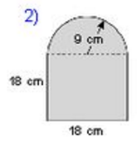 | What is the perimeter of this figure? Be sure to show all work. | What is the area of this figure? Be sure to write down your formula and show all work.

Figure 8:  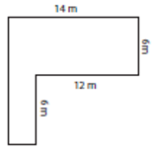 | What is the perimeter of this figure? Be sure to show all work. | What is the area of this figure? Be sure to write down your formula and show all work.

Part 3: Finding the area of the shaded region

Instructions: find the area of the shaded region. Round your answers to one decimal place if necessary. Use your formula sheet and a calculator, and be sure to complete every step of the problem to get full marks.

Figure 9:

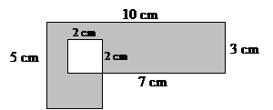

What is the area of the shaded part of this figure? Be sure to write down your formula(s) and show all your work.

Figure 10:

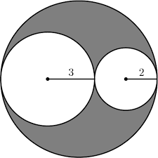

What is the area of the shaded part of this figure? Be sure to write down your formula(s) and show all your work.

Figure 11:

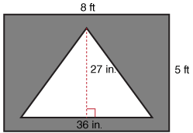

What is the area of the shaded part of this figure? Be sure to write down your formula(s) and show all your work.

Figure 12:
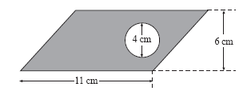
What is the area of the shaded part of this figure? Be sure to write down your formula(s) and show all your work.

