EDUC 500: Research Methodology in Education
Activities
Paradigms & Genres
Stephen Petrina & Franc Feng

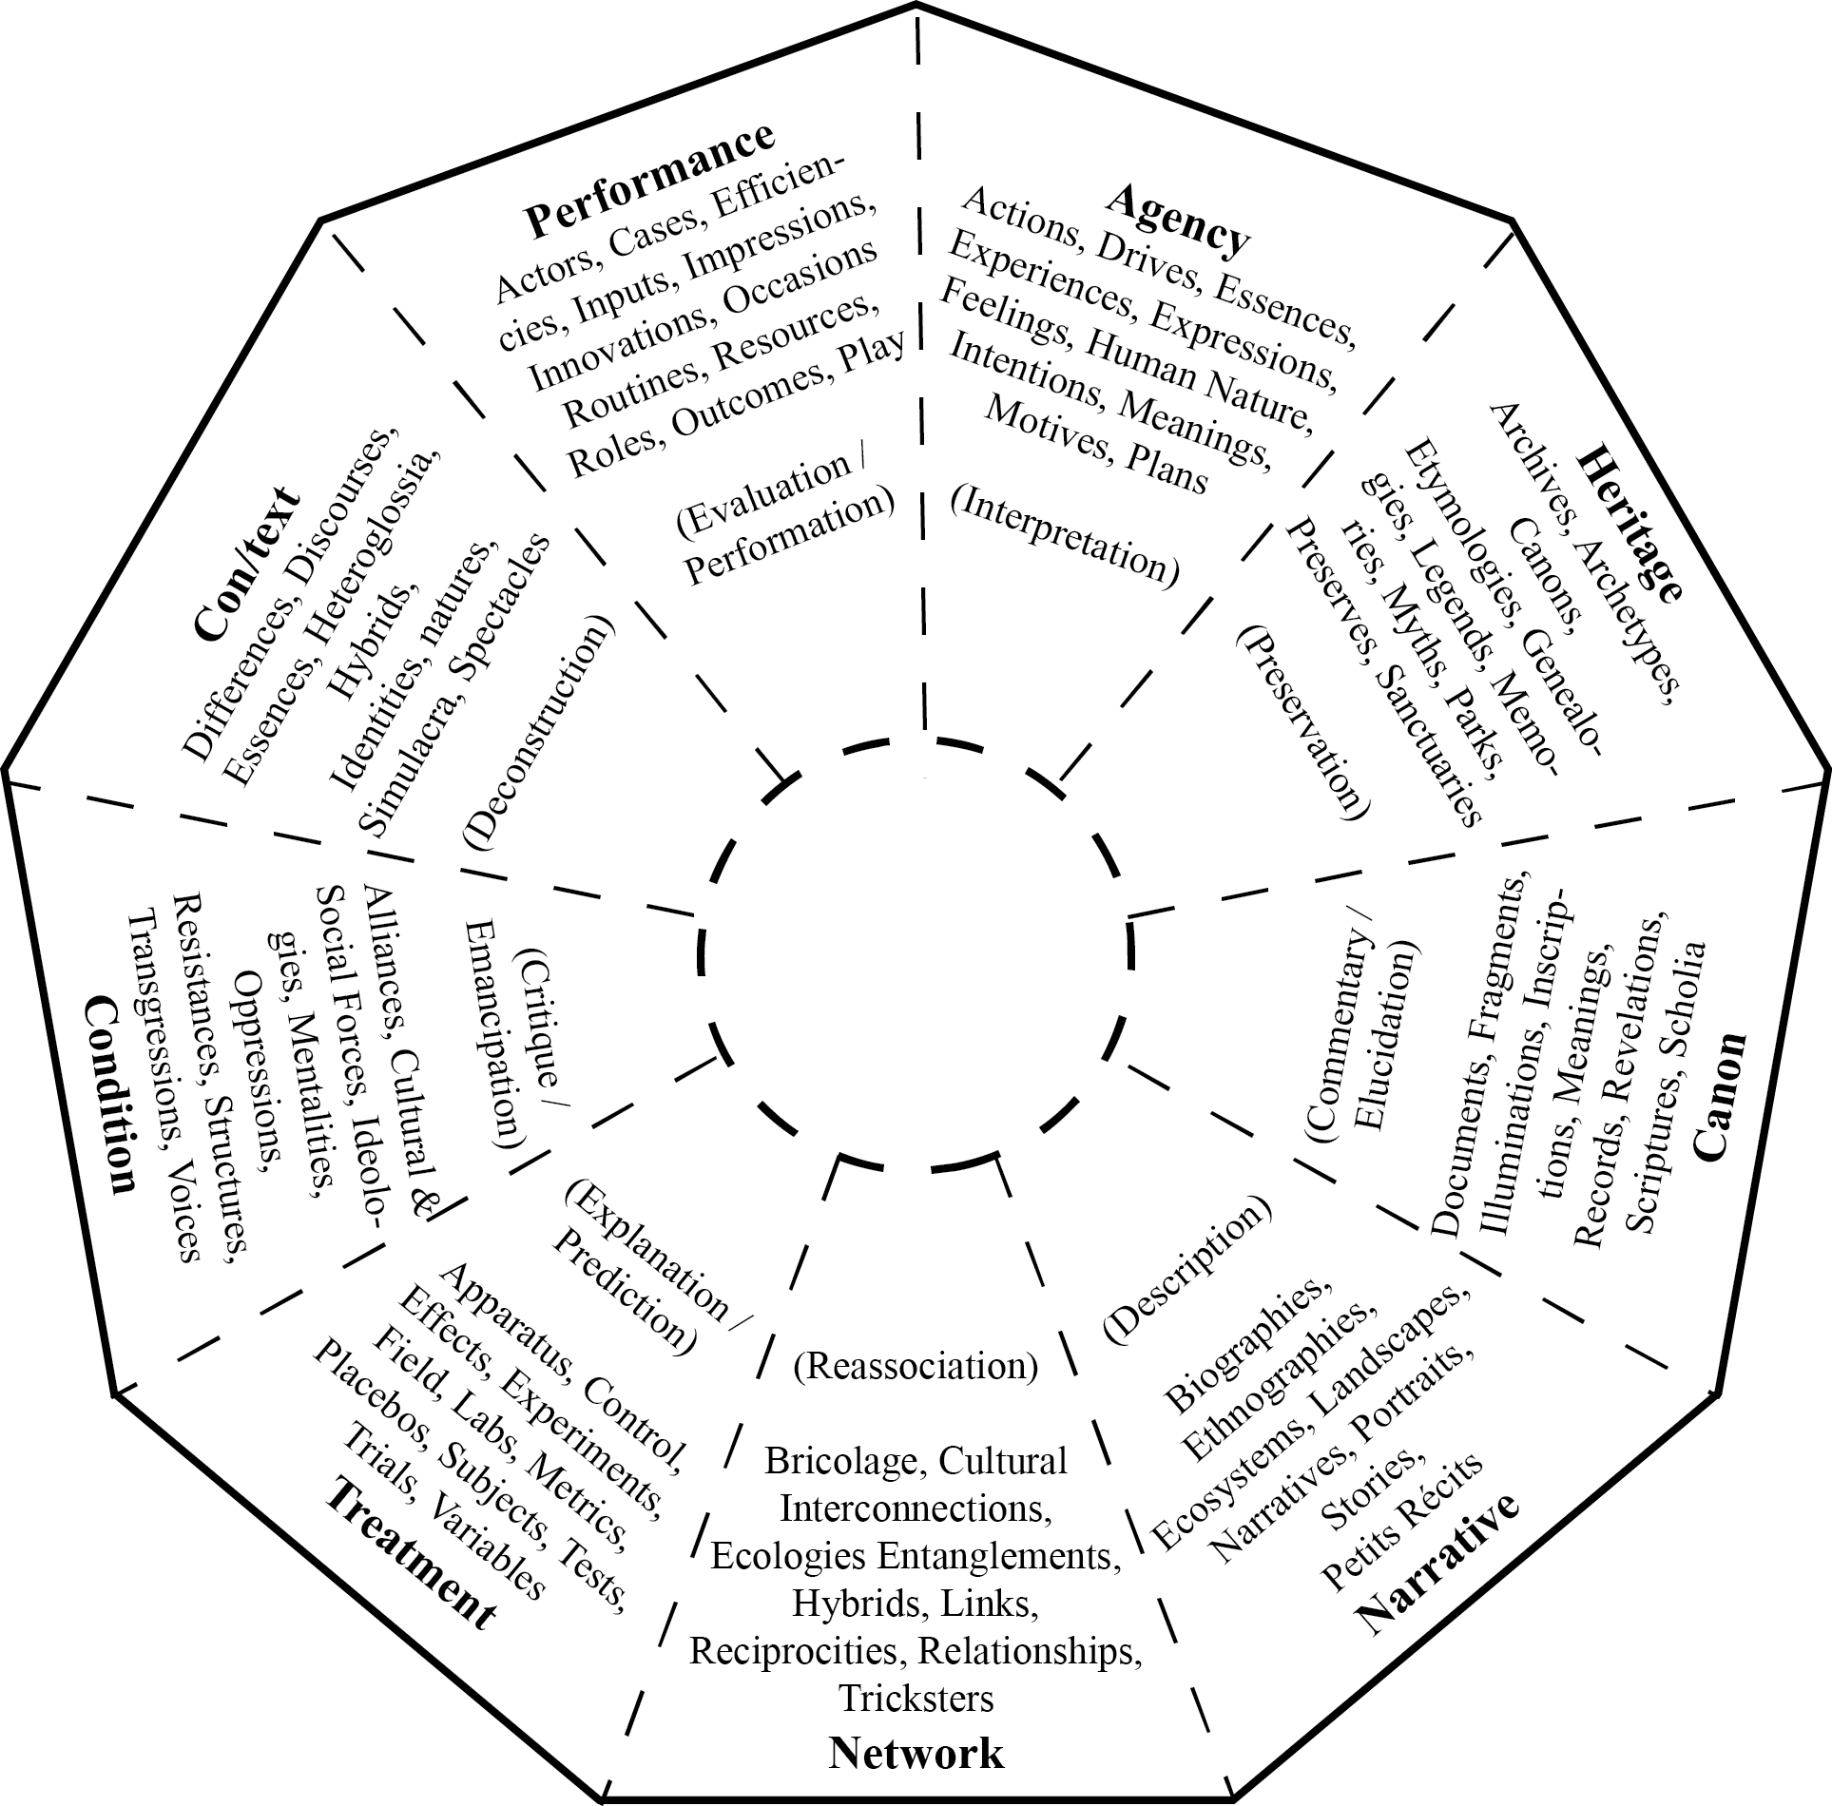

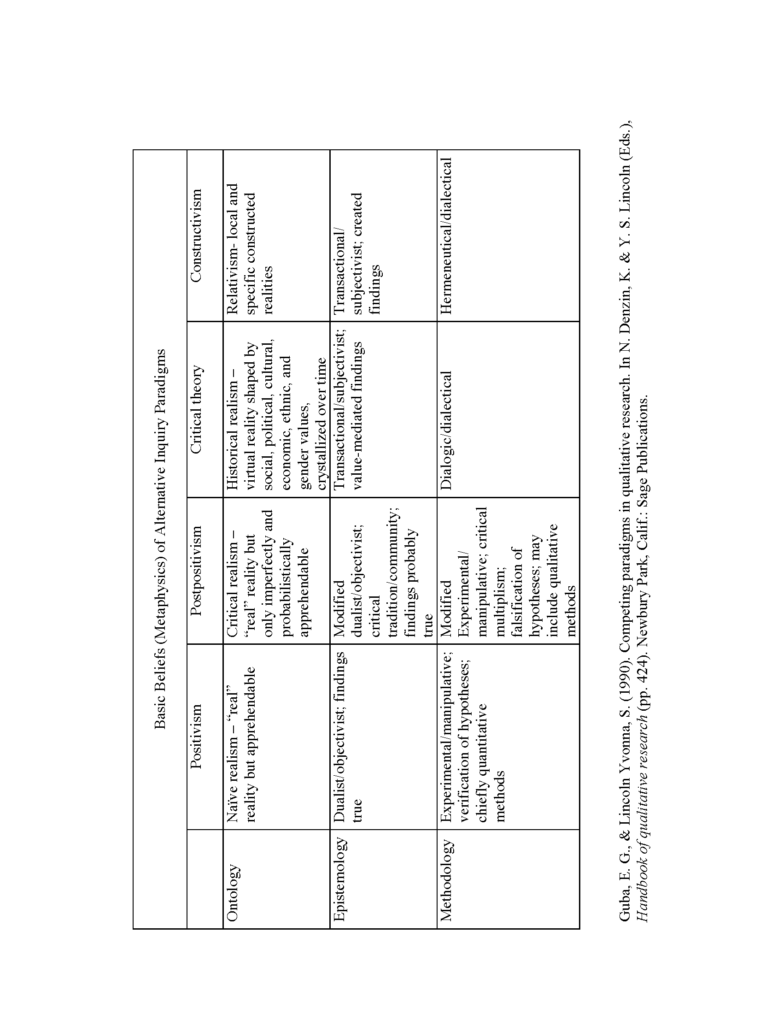

Positivistic Orientation
Main Concern—Inherent Aim:

Main Assumptions:

Focus of Investigation:

View of Values:

Research Guiding Interest:

Method of Validation

Theoretic—Philosophic Orientation:

Kinds of Questions:

Methodological Issues:
Interpretive Orientation
Main Concern—Inherent Aim:

Main Assumptions:

Focus of Investigation:

View of Values:

Research Guiding Interest:

Method of Validation

Theoretic—Philosophic Orientation:

Kinds of Questions:

Methodological Issues:
Critical Orientation
Main Concern—Inherent Aim:

Main Assumptions:

Focus of Investigation:

View of Values:

Research Guiding Interest:

Method of Validation

Theoretic—Philosophic Orientation:

Kinds of Questions:

Methodological Issues:
Postmodern Orientation
Main Concern—Inherent Aim:

Main Assumptions:

Focus of Investigation:

View of Values:

Research Guiding Interest:

Method of Validation

Theoretic—Philosophic Orientation:

Kinds of Questions:

Methodological Issues:
Poststructural Orientation
Main Concern—Inherent Aim:

Main Assumptions:

Focus of Investigation:

View of Values:

Research Guiding Interest:

Method of Validation

Theoretic—Philosophic Orientation:

Kinds of Questions:

Methodological Issues:
Art-Based Orientation
Main Concern—Inherent Aim:

Main Assumptions:

Focus of Investigation:

View of Values:

Research Guiding Interest:

Method of Validation

Theoretic—Philosophic Orientation:

Kinds of Questions:

Methodological Issues:

