Improving the Internship Program at L’Oreal Indonesia
For:
Indra Widiantara Dharma
Young Talent Program Manager
And
Indri Lastina Sudarmadji
Senior Recruitment Manager

by
Emily Jasmine Krisnamurti
ENGL 301 Student
December 3rd 2019
Table of Contents
Introduction 4
Purpose of Study 5
Methods of Research 5
Scope of Inquiry 6
Data Analysis 6
Results from Current Interns Survey 6
Results from Previous Interns Survey 9
Conclusion 11
Summary and Interpretations of Result 11
Recommendations 13
Works Cited: 13
Appendix 1. Survey Questions for Previous Interns 14
Appendix 2. Survey Questions for Current Interns 17
Appendix 3. Other Results from Previous Intern Survey 19
Appendix 4. Other Results from Current Intern Survey 20

Abstract

Introduction
L’Oréal is a well-known beauty company that started out in Paris, France. Initially, they cater to only hair care, but has now expanded to mass and luxury makeup. They have acquired over 20+ brands and has now opened a headquarters in most major cities in the world. One of the headquarters is in Indonesia, in which this research report will be focusing on.
On top of being known for their massive brand empire, L’Oréal Indonesia also provides prestigious work opportunities, including the Young Entrepreneurship Program as well as the Internship Program. Because they are a part of the Fast Moving Consumer Goods (FMCG) industry and has a reputable and global brand, they are able to attract thousands of applicants around Indonesia. These programs are known to be very challenging, fast-paced and demanding, and a very good stepping stone for any career in the FMCG industry, which is the main reason for the huge demand among young graduates.
The focus of the report will be on the internship program. It will focus on creating the best program possible for interns in order for them to be able to be prepared for work life after they graduate, or if they want to consider the Young Entrepreneurship Program (or the Management Trainee program) after they graduated in L’Oréal Indonesia. Internship is generally seen as a way for university students to gather real-life work experiences whilst being a full-time student. Research shows that students who partake in internship have a shortened the amount of time it took for them to get a job after graduation, in comparison to those who do not have an internship experience (Jung, J. & Lee, S). This is why it is important to create an internship program that best prepare a student to tackle a full-time job once they have graduated.
Purpose of the report
Although the internship program in L’Oréal is known to be a very useful learning experience from the outside, there are still a lot of improvements that can be made to the program once you have undergo the internship journey. The purpose of this report is to improve some aspects of the internship program (e.g. KPI, job descriptions) in order for the interns to benefit more from this learning experience and be apt enough once they graduate.
Method of Research
In order to determine the biggest issues in the internship program, getting feedback from interns would be the best way to determine factors that could make the internship experience better. To do this, the first step was to create two different surveys for current interns and previous interns. The second step is through secondary research, in order to understand the significant impact of the internship experience in determining future job prospects.
The survey is given to over 40 different interns that has spent 6 months in L’Oréal. All of which had experiences from different divisions like Marketing, Supply Chain, IT, Human Resource, E-Commerce, Corporate Communications, etc. There are 6-7 questions in each survey and all are in the form of close-ended questions (e.g. multiple questions, rankings, yes or no). All questions focuses on their expectations, challenges and improvements regarding their individual experiences. The survey remained anonymous and kept confidential for all participants of the survey.

Scope of inquiry
The scope of inquiry will be to assess the gaps between the existing module of the internship program and how it could be improved. This report will investigate what are the underlying problems needed for L’Oréal Indonesia to be able to make their internship program better for upcoming interns. The results of this report will then be used as a recommendation for revising the internship program.
Data Analysis
Results from Surveys for Current Interns
There are a total of 20 responses for this survey. The questions the participants were asked that is relevant to creating a recommendation for the internship focuses on:
- Initial expectations before starting the internship
- The reality of the experience
- Improvements for the program
- Whether or not they want to continue to work in L’Oréal Indonesia
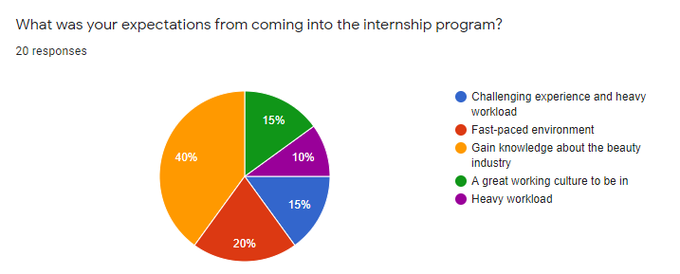
Figure 1. Expectations of the participants before they joined the internship program. As seen from above, most of the response was they expect to gain more knowledge about the beauty industry. They also expected that they will be working under a fast-paced environment.
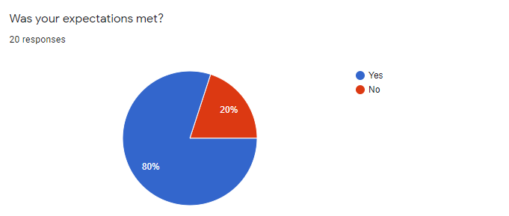
Figure 2. Participant’s initial expectations. Based on this chart, 80% of the participants had their expectations met.
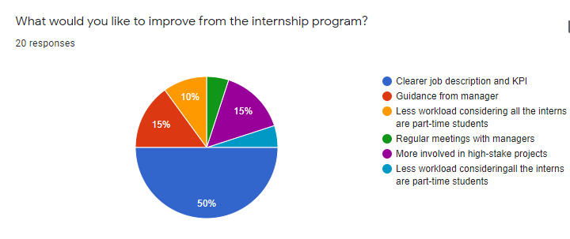
Figure 3. Improvements should be made for the programs. 50% of the participants of the survey agreed that the internship should have clearer job description and KPI that has been agreed upon with their managers or N+1 in the start of the internship.
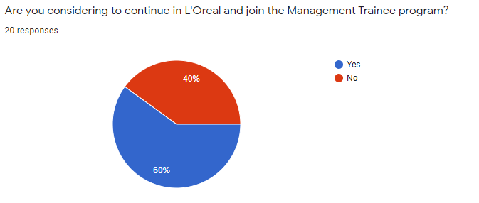
Figure 4. Participants’ willingness to continue in L’Oréal Indonesia and partake in the Management Trainee program. 60% of the participants are interested in applying for the Management Trainee program, but the difference between the amount of people who are and are not interested are not that significant, by only 20% difference.

Results from Surveys for Previous Interns
There are a total of 17 responses for this survey. The questions the participants were asked that is relevant to creating a recommendation for the internship focuses on:
- Reason for applying to the program
- The biggest skill gained from the internship experience
- Improvements for the program
- Whether or not they are still working in L’Oréal
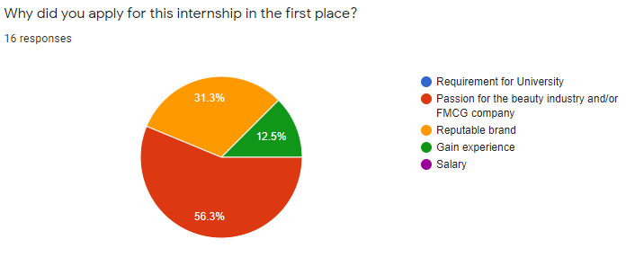
Figure 5. Reasons why previous interns want to apply for this program in the first place. 56.3% of them had a passion for the beauty industry and/or FMCG Company, which is why they wanted to apply to L’Oréal.
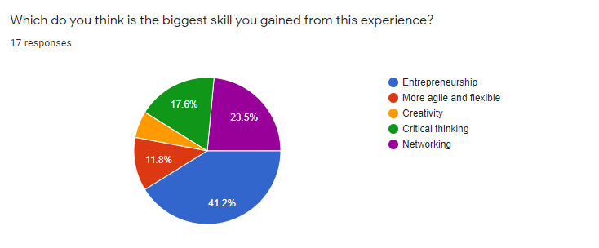
Figure 6. Skills gained by participating in the internship program. The most significant skill chosen was that they gained entrepreneurship skills, with as much as 41.2% participants choosing that choice.
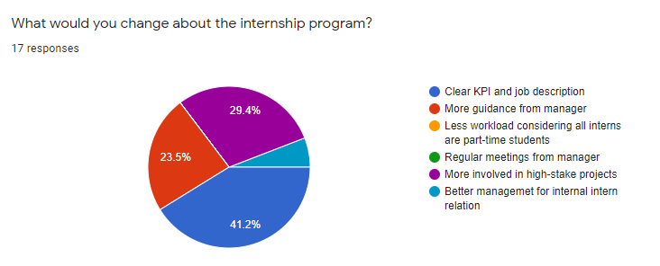
Figure 7. Improvement they want to see in the internship program. Similar to the previous survey, as much as 41.2% of the respondent indicated that a clear KPI and job description needed to be improved. Furthermore, participants from the previous intern group also agreed upon two other factors (more involved in high-stake projects and more guidance from manager) that could also improve the internship program. In comparison to the results from the current interns survey where, other than the ‘Clear KPI and Job Description’, all other factors were very much divided.
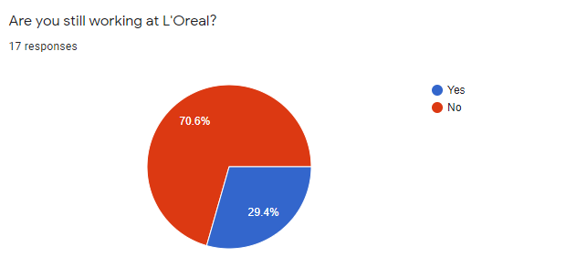
Figure 8. Percentage of previous internship that is still in L’Oréal. A total of 70.6% are not working in L’Oréal anymore after their internship period.
Conclusion
Summary and Interpretation of Findings
Based on the results of both surveys, the biggest improvement that needs to be made for the internship program is to provide interns with clear KPI and job descriptions. This means that coming into the internship, they agreed upon a set of KPI and job descriptions with their N+1, but after time goes on, the work they receive from the N+1 were far more than what they planned. In the first survey shown in figure 3, all other choices regarding on what to improve is pretty much divided into smaller parts. There are no other significant reasons other than “Clear KPI and job description”. Perhaps because this survey was catered to current interns, therefore they are still half way through their internship experience, and has yet to find other problems that would contribute to what they think should be improved. In the second survey however, figure 6 shows that other than “Clear KPI and job description”, there was an agreement in two different choices. The previous interns agreed that they wanted to be more involved in high-stake projects and have more guidance from the manager. This shows that although they knew coming into L’Oréal would be demanding and fast-paced, they still wanted more chance to be involved in big projects that impact the employees even more. Furthermore, perhaps there could be a connection between having clear KPI and job description and getting more guidance from the manager. So, because they don’t have enough guidance from their manager or N+1, they feel that their job description and KPI are not clear.
However, based on the survey with current interns, most of their expectations were met. They realize that interning in L’Oréal will be challenging and demanding, and that was exactly what they got. If it is any indication to the results seen from figure 8, most of the interns did not continue to work in L’Oréal. There can be several reasons to why this is the case, which are:
- They did not like the working culture of L’Oréal
- They found a better opportunity elsewhere
- They tried the Management Trainee program but did not go through
With the significant percentage that shows from the survey, whatever the reason will be, indicates that there could still be a gap between the internship program and being a full-time employee in the company itself.

Recommendations
Based on the data on the survey and after interpreting the results, these are some recommendations for the recruitment team in L’Oréal in order to improve the internship program:
- Provide a workshop where the recruitment team encourage N+1s (managers) who manages intern to create a module consisting of specific KPI and job description, so that the interns would be clear to what the scope of their job entails. If there are any workload that goes beyond what is agreed, the intern could report to the recruitment team to re-discuss the KPI and job description.
- Providing a high-scale projects for interns that allow them to impact the company in a much larger scale, and therefore could challenge their skills.
- Provide a coaching workshop for N+1 so they are more prepared to guide and coach interns that have little to no experience with work life, and has yet have skills that are needed to navigate in the workplace.

Works Cited
Jung, J. & Lee, S. (2017). Impact of internship on job performance among university graduates in South Korea. International Journal of Chinese Education, 5(2), 250-284.

Appendices
Appendix 1. Survey for Previous Interns
L'Oreal Internship Program Survey for Past Interns
Hello! Thank you for taking the time to fill this survey. My name is Emily, I am an undergraduate student from the University of British Columbia, and a current intern at L'Oreal Indonesia.
The purpose of this survey is primarily to gather data for my ENGL 301: Technical Writing Class, where I am making a formal report about improving the Internship Program in L'Oreal Indonesia. This survey is to help me gather data from past interns of L'Oreal Indonesia about their thoughts and experiences going through the Internship Program. This survey is done in hope to improve the Internship Program and ensure that upcoming interns would have a better learning and working experience.
This survey is not affiliated with L'Oreal Indonesia and will take around 3-5 minutes to complete. It is voluntary and autonomous. The results will remain anonymous and kept confidential. If you have any questions, input or comments about this survey, feel free to email me at emilyjasmine25@gmail.com.
Thank you for your time.
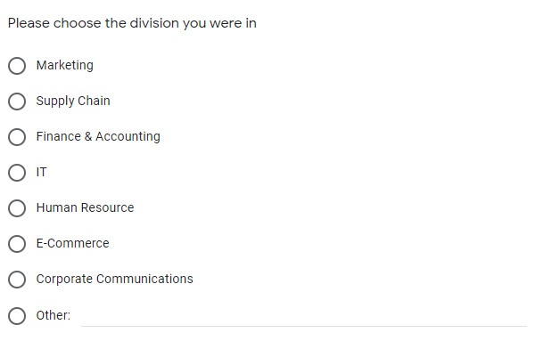
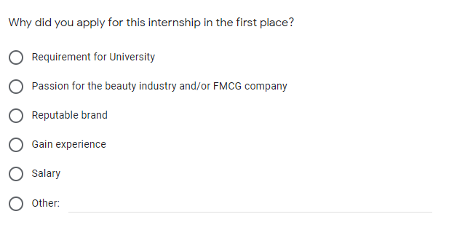
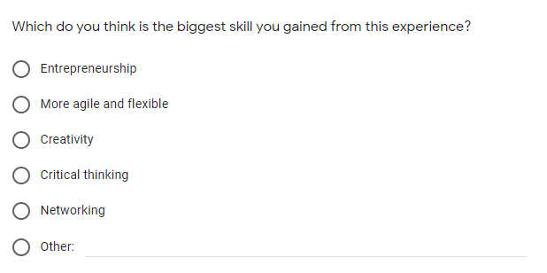
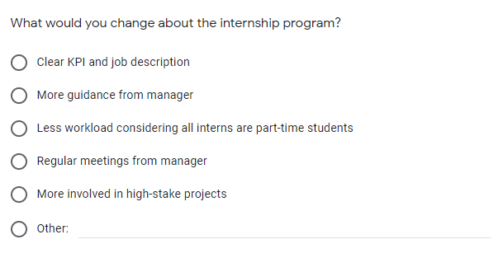
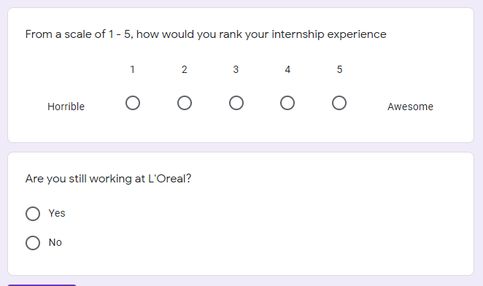

Appendix 2. Survey for Current Interns
L'Oreal Internship Program Survey for Current Interns
Hello! Thank you for taking the time to fill this survey. My name is Emily, I am an undergraduate student from the University of British Columbia, and a current intern at L'Oreal Indonesia.
The purpose of this survey is primarily to gather data for my ENGL 301: Technical Writing Class, in which I am making a formal report about improving the Internship Program in L'Oreal Indonesia. This survey is to help me gather data from current interns in L'Oreal Indonesia about their thoughts and experiences throughout the internship program thus far. This survey is done in hopes to improve the program and ensure that upcoming interns would have a better learning and working experience.
This survey is not affiliated with L'Oreal Indonesia and will take around 3-5 minutes to complete. It is voluntary and autonomous. The results will remain anonymous and kept confidential. If you have any questions, input or comments about this survey, feel free to email me at emilyjasmine25@gmail.com.
Thank you for your time.
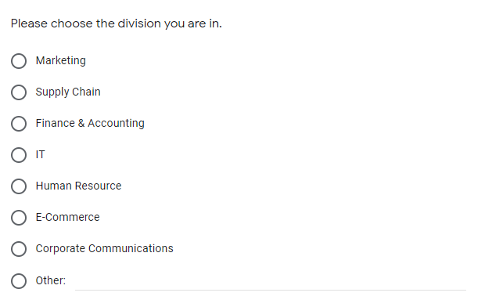

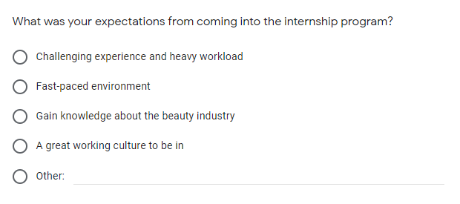
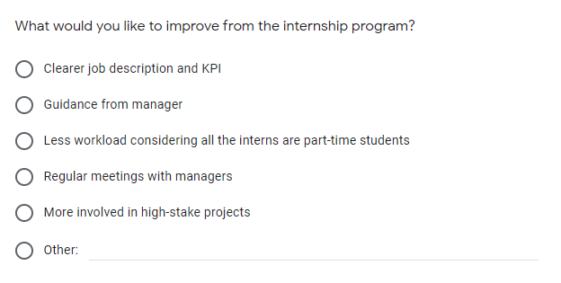
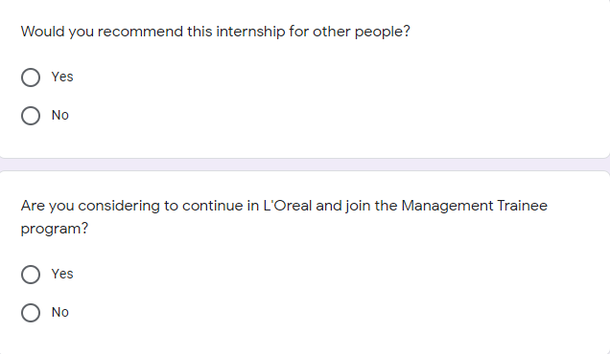
Appendix 3. Other results from Current Intern Survey
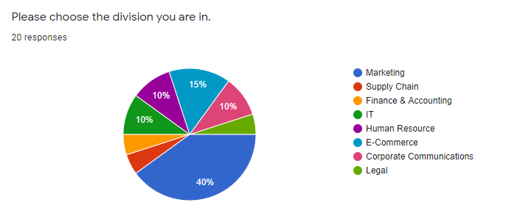
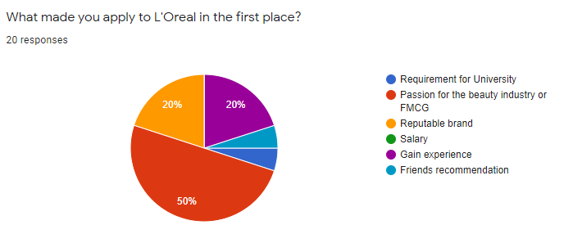
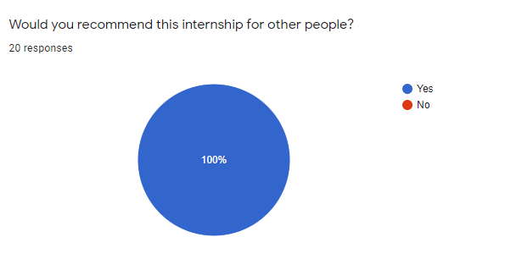
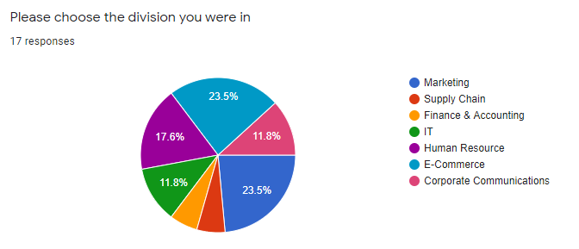
Appendix 4. Other results from Previous Intern Survey

