**Osteoarthritis**

By [William Ho](http://2014w2.engl301.sites.olt.ubc.ca/author/wilho/) on January 21, 2015

**Definitions: Osteoarthritis**

**Introduction**

The definitions blog assignment consists of a parenthetical, sentence and expanded definition for the term *Osteoarthritis*.  The objective of the assignment is to be able to communicate efficiently to a non-technical audience and be able to understand the different amounts of detail that are necessary for different situations.  Easy comprehension and understanding are the key for defining a complex term in straightforward sections.

**Parenthetical definition:**

Wear and tear through the aging process can lead to Osteoarthritis (wearing down of joint cartilage and bone).

**Sentence Definition:**

Osteoarthritis is the condition where there is a degeneration of the joint cartilage and bone underneath, most common in middle aged people.

**Expanded Definition:**

**What it looks like**

Osteoarthritis is a form of arthritis (joint pain) that is result of a wearing down of the cartilage in the joints.  Cartilage acts as the cushioning in the joint between bones so they function properly.  Osteoarthritis can affect any joint, but most commonly affect the hands and the weight-bearing joints that take the most pressure from the body (Osteoporosis and Osteoarthritis, n.d.).  Where the areas of cartilage have deteriorated, the bone becomes inflamed and can cause bone spurs (excess bone growth).

[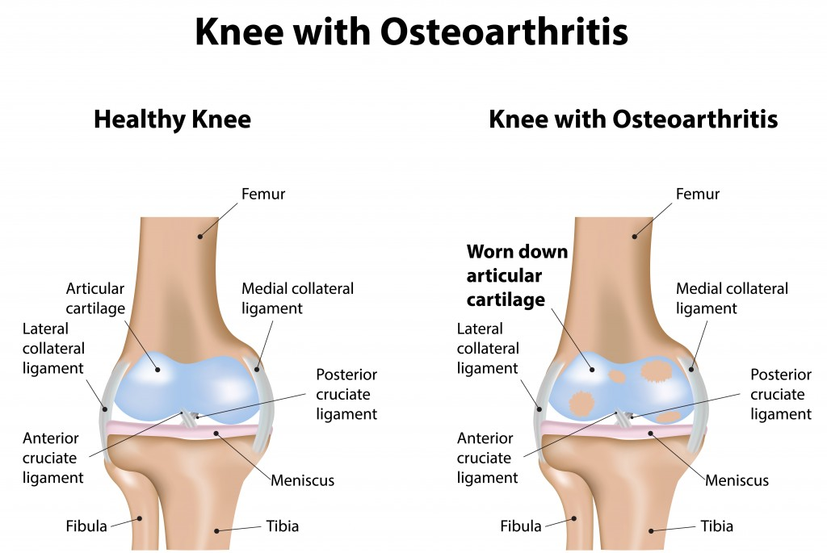](http://2014w2.engl301.sites.olt.ubc.ca/files/2015/01/Osteoarthritis.jpg)

*Figure 1.*Knee without Osteoarthritis versus Knee with Osteoarthritis

**Etiology**

The cartilage in between a joint allows the bones to move and absorb shock and friction.  Only when the cartilage has been worn down and the bones begin to grind against each other does an individual start to experience symptoms like pain and swelling.  Natural aging and family genes can lead to osteoarthritis.  Being overweight puts stress on the joints that bear the weight of the body like the hip, leg, and foot joints.  Trauma to the joint from a sudden injury can lead to osteoarthritis in younger patients.

**Etymology**

Osteoarthritis is formed from the combination of Greek words of *osteo-*, meaning “of the bone”, *arthr-*, meaning “joint” and *-itis*, meaning “inflammation.”

**Signs and Symptoms**

The signs and symptoms of osteoarthritis include: pain in affected joints, swollen joints, and stiffness of the joints after resting (Osteoporosis and Osteoarthritis, n.d.). Signs and symptoms may also include pain in joints after use, pain becoming worse at the end of the day, and loss of flexibility and strength in the affected joints.

**Treatment**

For mild cases of osteoarthritis, it can be managed through a decrease in the amount of work you put on your joint, exercise, and pain relief medication.  Physiotherapy or occupational therapy can help increase your joints’ level of function and strength.  For severe arthritis cases where daily chores cause severe frequent pain, surgery can be an option with the replacement of the joint entirely with an artificial implant (The Facts on Osetoarthritis, n.d.).  The artificial implants work as a fresh healthy cartilage joint that allows smooth motion and no pain.  Implants will require replacing after a few years as they will also wear out over time.

**Differences between Osteoarthritis and Rheumatoid arthritis**

Osteoarthritis is more common and involves the wearing down of the cartilage found in the joints between your bones whereas rheumatoid arthritis involves the inflammation of the synovial membrane (soft tissue found in the joint), which leads to pain and possibly joint erosion (Diseases and Conditions Osteoarthritis, n.d.).

[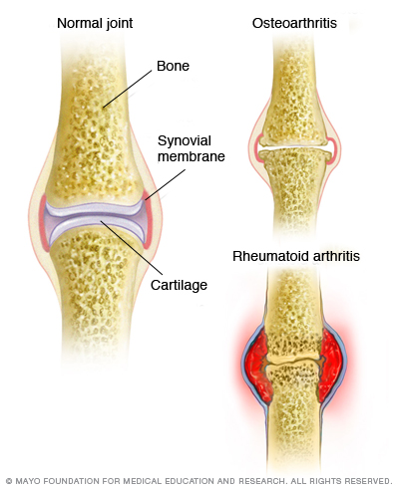](http://2014w2.engl301.sites.olt.ubc.ca/files/2015/01/osteoarthritis-versus-rheumatoid-arthritis.jpg)

*Figure2.*Osteoarthritis versus Rheumatoid Arthritis

**References**

Diseases and Conditions Osteoarthritis. (2001). Retrieved January 20, 2015                                                                                           from: http://www.mayoclinic.org/diseases-conditions/osteoarthritis/basics/definition/con-   20014749?p=1

Knee with Osteoarthritis [Online image].  (2008).  Retrieved January 21, 2015                                                                                         from http://www.painrelief.com.sg/wp-content/uploads/2010/08/Osteoarthritis.jpg

Osteoporosis and Osteoarthritis. (n.d.). Retrieved January 21, 2015  
from http://www.osteoporosis.ca/osteoporosis-and-you/osteoporosis-and-osteoarthritis/

Rheumatoid arthritis vs. osteoarthritis [Online image]. (2014). Retrieved January 21, 2015                                                                       from http://www.mayoclinic.org/diseases-conditions/arthritis/multimedia/osteoarthritis-vs-rheumatoid-arthritis/img-20008728

The Facts on Osetoarthritis. (n.d.). Retrieved January 20,2015  
from:http://chealth.canoe.ca/channel_condition_info_details.asp?disease_id=97&channel  
id=2 45&relation_id=33253#Causes