September 11, 2019

Technical Writing 301
397 1873 E Mall
Vancouver, BC V6T 1Z1

Dear Technical Writing 301 Class:

Thank you for the English 301 writing team invitation posting.

I am applying to be accepted into the professional writing team. After reading the requirements for the posting, I have decided that I am an excellent candidate for this role. Currently, I am a fourth year university student working towards my bachelor’s degree in the faculty of science. My previous experience as a writer for the Collingwood community Newspaper and Windermere Secondary Student Newspaper has well equipped me with the experience needed for this role. In addition to that, I also have experience conducting interviews, which could be a unique skill to add to the outstanding team.

As we may be working together for the remainder of the term, it might be helpful to get to know a little bit more about my personal life. In my spare time, I enjoy volunteering at senior homes and community centers as a way of giving back. I lead morning exercises and game activities every Saturday morning at my local senior care centre. In addition to care homes, I also have a great passion working with children, which is why I enjoy volunteering for sports camps every summer.

My learning philosophy is that practice makes perfect. Although realistically, it’s quite hard to achieve perfect, practice can definitely take one’s work a step closer to perfect. Some of my strengths that I can contribute are that I am a great team player and I am very well organized with my work. A skill that I will continue to improve on is self-editing. Hopefully we will be able to work as a team to compliment on each other’s strengths and weakness as professional writers. Should you have any questions, please contact me at lisaliang@alumni.ubc.ca.

Sincerely,

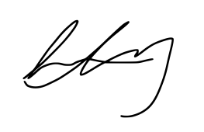
Lisa Liang

