Parenthetical definition: Radiotracer (substance with radioactive labels) are often used in cancer treatments.

Sentence definition: Radiotracer is a radioactive element that traces paths of elements and monitor biochemical reactions in cells

Expanded definitions:
Although nuclear medicine has only recently become a popular method of diagnosing and treating diseases, radiotracers, which are used in nuclear medicine, has been used in animals since 1924. It was not until 1964, when physicists and chemist Paul Harper and Katherine LathrupIn discovered radiotracer labels capable of studying the human brain, liver, and thyroid.

In the term radiotracer, radio comes from the word radioactive and tracer is a small molecule or antibody label. Since cancer cells are known to uptake glucose at a much faster rate, deoxyglucose (glucose molecules) are commonly used as tracers in cancer patients. Radiotracers are very useful in showing tissue functions, however, radiotracers cannot be used for necrotic tissues as they do not have any uptake capabilities. The picture below demonstrates a radiotracer label being injected into the patient for a brain scan.

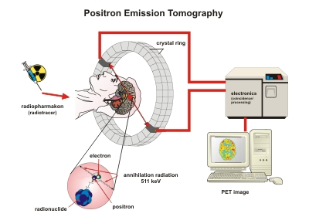

Reference:
Brazier, Y. (2017). What is Nuclear Medicine. Retrieved from https://www.medicalnewstoday.com/articles/248735.php</a
Helmenstine, A. (2018). Radioactive Tracer Definition and Examples. Retrieved from https://www.thoughtco.com/definition-of-radioactive-tracer-605582
Julich, F. (2019). How Does MRI and PET Work. Retrieved from https://www.fz-juelich.de/inm/inm-4/EN/Home/_Fokus/Informationen/_node.html
Tsopelas, C. (2014). Radiotracers Used for the Scintigraphic Detection of Infection and Inflammation. Retrieved from https://www.hindawi.com/journals/tswj/2015/676719/

