Reducing Commission for Complaints for Telecom-television (CCTS)
Complaints at the Telus Call Centre in Burnaby

For Jacquie Feichtinger, Operations Manager
Telus Call Centre
Burnaby, BC

By Lisa Liang
English 301 student

November 29, 2019
Table of Contents
Introduction 3
Purpose of Study 3
Methods 4
Data Analysis 4
Results from Front Line Agent Surveys 5
Results from Manager Surveys 6
CCTS Reports 7
Conclusion 7
Recommendations for Bridging the Gap 8
Expected Outcome 8
Appendix I: Agent Responses to other questions surveyed 9
Appendix II: Manager Responses to other questions surveyed 9
Works Cited: 10

Introduction

One of the main aspects that makes Telus stand out amongst the rest of the telecommunication companies in Canada is Telus’ excellence in customer service. For many years, Telus has maintained on the top of the list for holding the lowest number of CCTS filed complaints. However, over the last two years, Telus has received an increased amount of filed complaints from the CCTS. Within a short period of six months in 2018, CCTS has accepted a total of 511 valid complaints from Telus customers alone (“Mid-Year Report”). According to the CCTS annual report, Telus complaints have increased by 49.6% in comparison to the previous year (“2017-18 Annual Report”). If this increasing trend of CCTS complaint continues, Telus will lose their competitive edge against other service providers.

Purpose of Study

In order for Telus to keep its competitive edge, changes must be made in order to lower the number of CCTS complaints. The purpose of this study is to investigate the cause of the recent increased CCTS complaints filed by Telus customers and implement necessary changes in call handling procedures to combat this issue.
The current procedure in the Burnaby call centre allows front line agents to transfer calls to the manager team only when customers has explicitly request for a manager. All other calls, including unsatisfied customer experiences do not get transferred to the manager team. This flaw in call handling procedures inhibits call centre agents from resolving customers’ issues, which in turn leads unhappy customers to file complaints with the CCTS. Decreasing the number of CCTS complaints will require internal changes where issues of unhappy customers are resolved within the Telus call centre before they are escalated to CCTS.

Methods

To determine what changes are necessary in order to decrease CCTS complaints, understanding of common complaint triggers and call centre procedure gaps are essential. The first step involves analyzing mid-year and annual reports published by the CCTS to get a basic understanding of general customer complaint triggers. The second step will involve surveying both front line agents and managers to understand the limitations with the current call procedures that inhibits them from resolving customer issues at hand.
Two sets of distinct surveys were sent out to the call centre. The set of questionnaires that were sent out to front line agents consisted of 5 multiple choice questions and 2 short answer responses. All questions revolved the frequency of complaint calls, transferred calls, and complaint triggers. The set of questionnaires that were sent out to managers consisted of 5 multiple choice questions and 1 short answer response. All questions in this set revolved around calls that were transferred by front line agents.

Data Analysis

A total of 23 front line agents and 5 managers participated in this study. Although all questionnaires were completely voluntary, all participants responded to all of the multiple choice questions.

Results from Front Line Agent Surveys

The responses from front line agents show that 91.3% of agents transfers less than 10% of their calls to managers on average. However, over 65% of agents say that over 25% of their calls involves a customer complaint, but due to call centre procedures, they are unable to transfer calls to managers. These results show that there is an overwhelming number of complaint calls that are left unresolved due to call centre procedures.

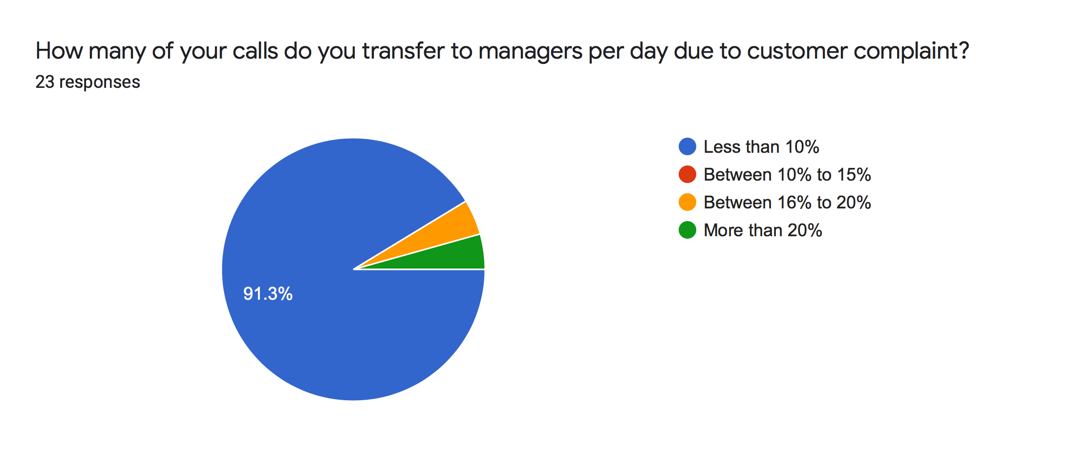
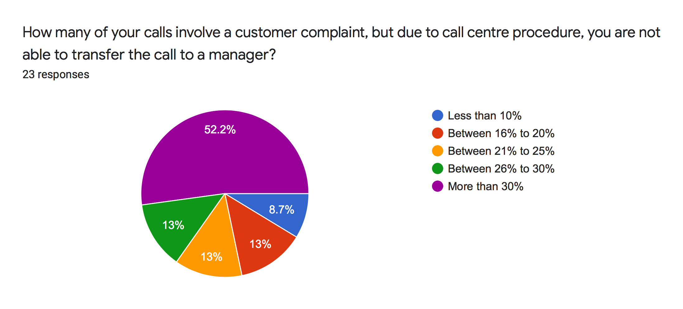

Results from Manager Surveys

In complementary, responses from managers show similar outcomes. Of the surveyed managers, 100% of them indicated that they take less than 10 calls per day and almost 80% of the responses indicated that less than 10% of the calls transferred to them are left unresolved. When asked if escalated calls being transferred to the manager team will decrease the likelihood of customers filing complaint with the CCTS, 100% of the responses said yes.
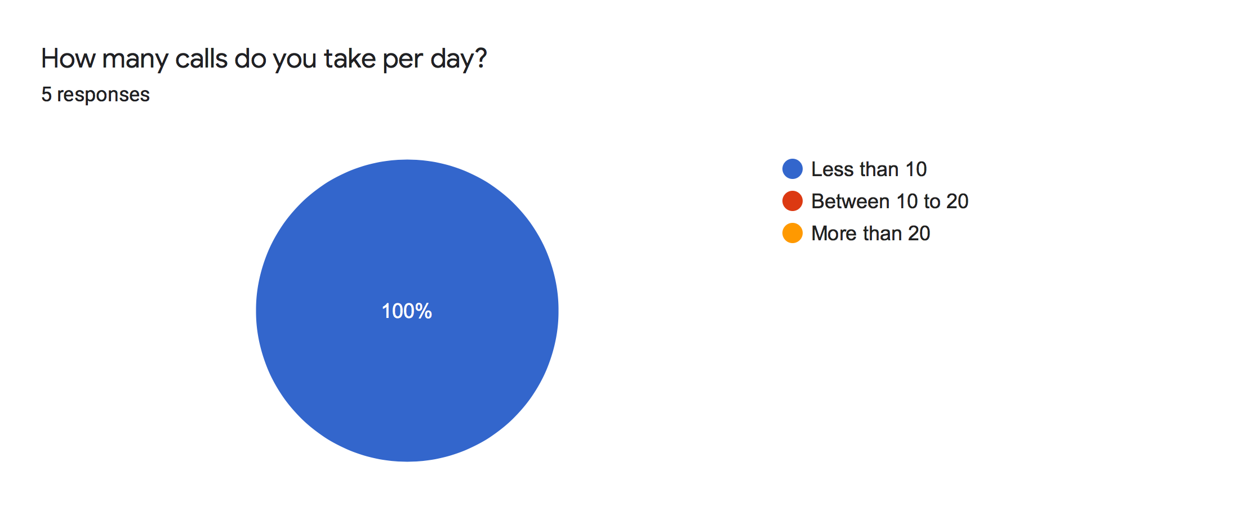

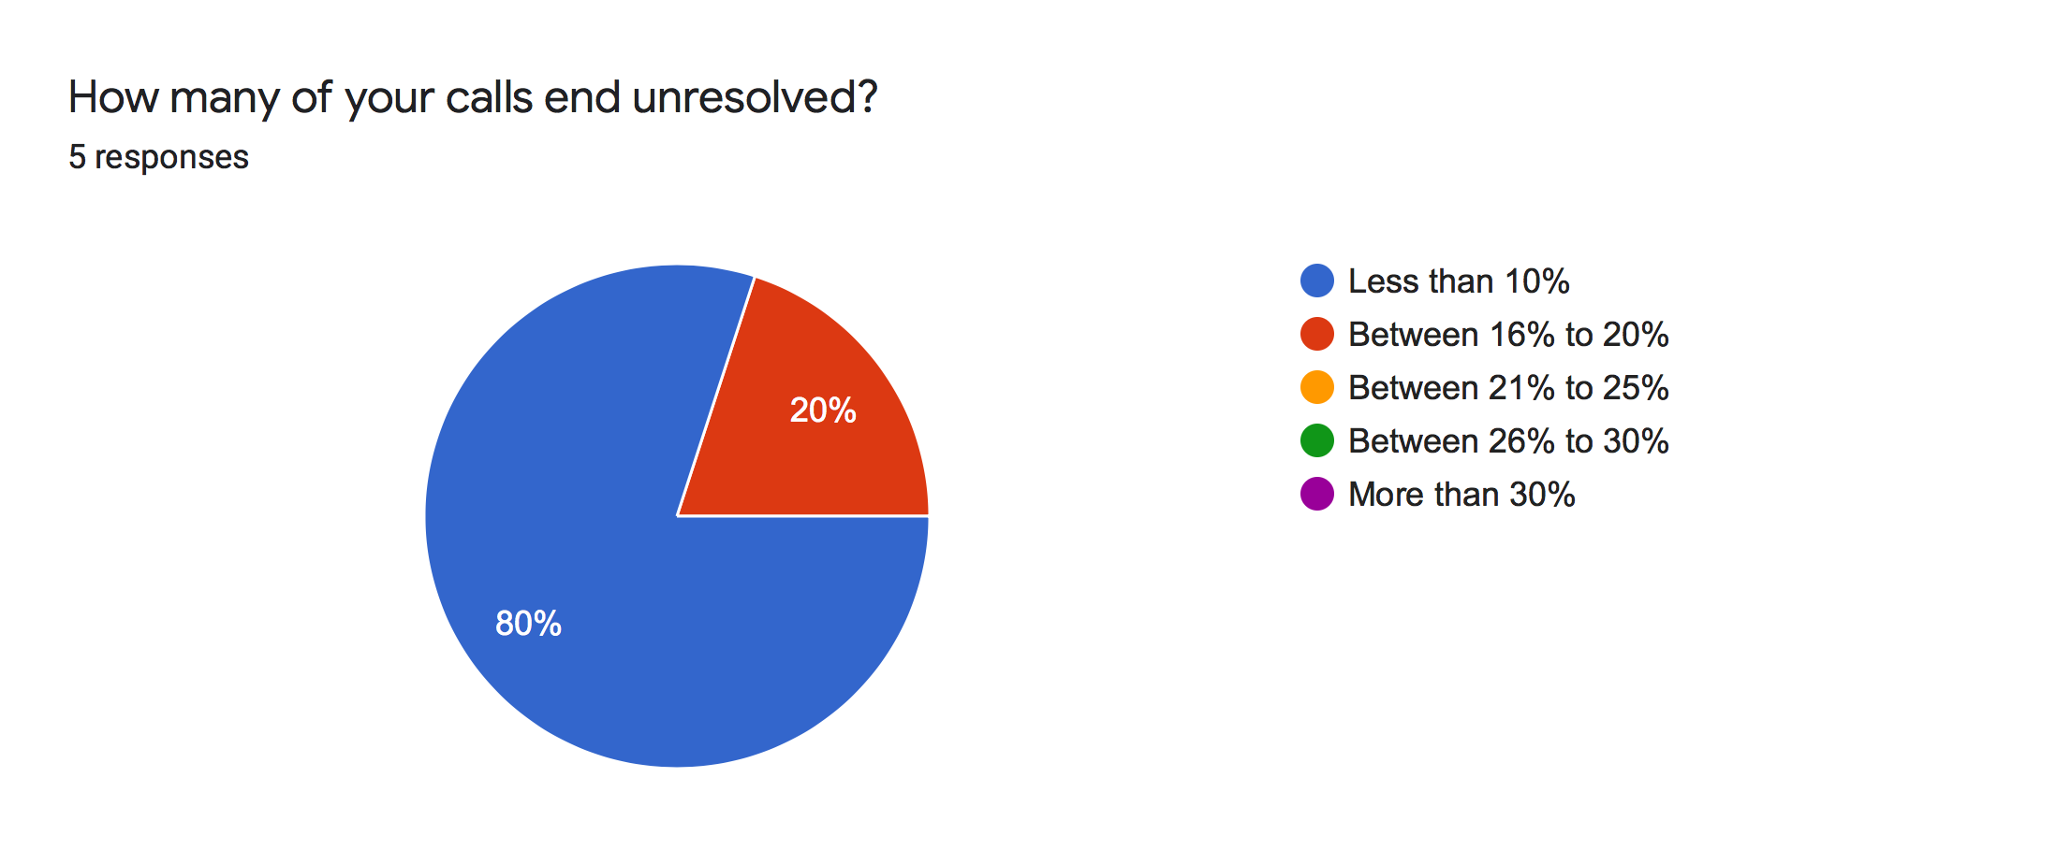

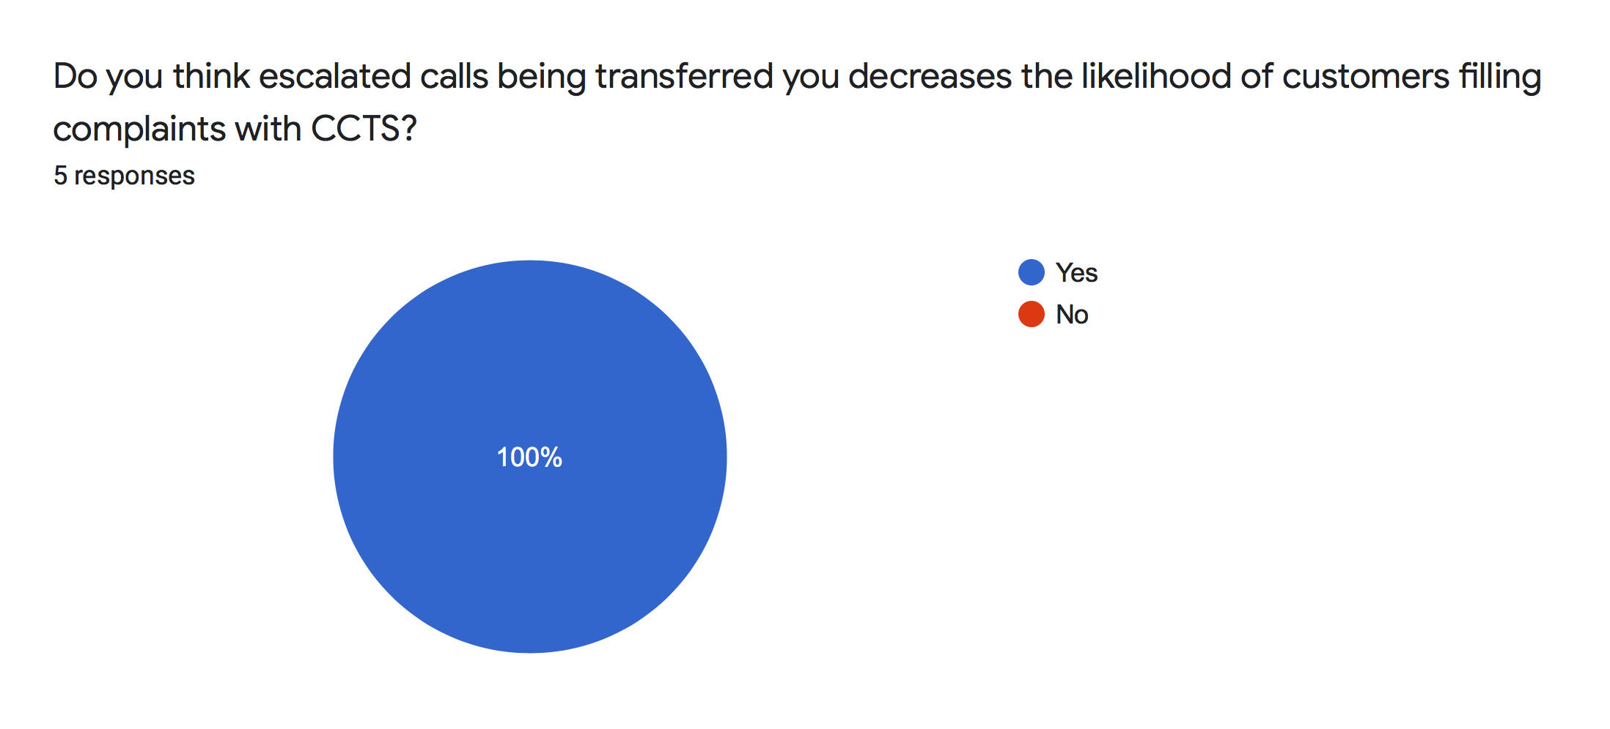

CCTS Reports

The annual CCTS report, it shows that there is a total of 944 accepted complaints from Telus customers, which has been increased by 49.6% in comparison to the previous year (“2017-18 Annual Report”). The top 3 complaints were regarding non-disclosure of terms, incorrect charges, and intermittent quality of service (“2017-18 Annual Report”).

Conclusion

The responses from both front line agents and managers show that the current call transfer procedure in the Burnaby call centre is preventing escalated calls from being resolved effectively with the manager team.
From the CCTS annual report, at least 2 of the issues experienced by Telus customers are resolvable within the call centre. Incorrect charges can be corrected by managers and intermittent service can be resolved by arrangement of technicians. The lack of follow up and communication is the number one trigger of filed customer complaints. Which again, indicates the lack of bridging between front line agents and managers.

Recommendations for Bridging the Gap

Reducing the number of CCTS complaints can be done in two ways: change call transfer procedure to allow more call flow to the manager team or integrate a CCTS prevention team allow customers complaints to be addressed immediately. When front line customer service agents are on the phone with a customer, agents will be required to ask probing questions to gage customer satisfaction. If the comments involve threatening of filling a CCTS complaint, threatening of posting on social media, complaining of incorrect charges, or if the caller is experiencing the same unresolved technical issue, agents are required to actively offer to transfer the call to the CCTS prevention team.

Expected Outcome

Integrating the recommended changes above will decrease the number of CCTS complaints, which will result in an increase of customer rating. By lowering the number of complaints, Telus will have an advantage over their competitors and as a result, this will also lead to a decrease of churning customers. The annual CCTS report shows that over 50% of compensations resolved by the CCTS fall within the range of $100 to $500 (“2017-18 Annual Report”). If Telus is able to address customer complaints internally, Telus will see a reduced compensation loss over the next few years.

Appendix I: Agent Responses to other questions surveyed

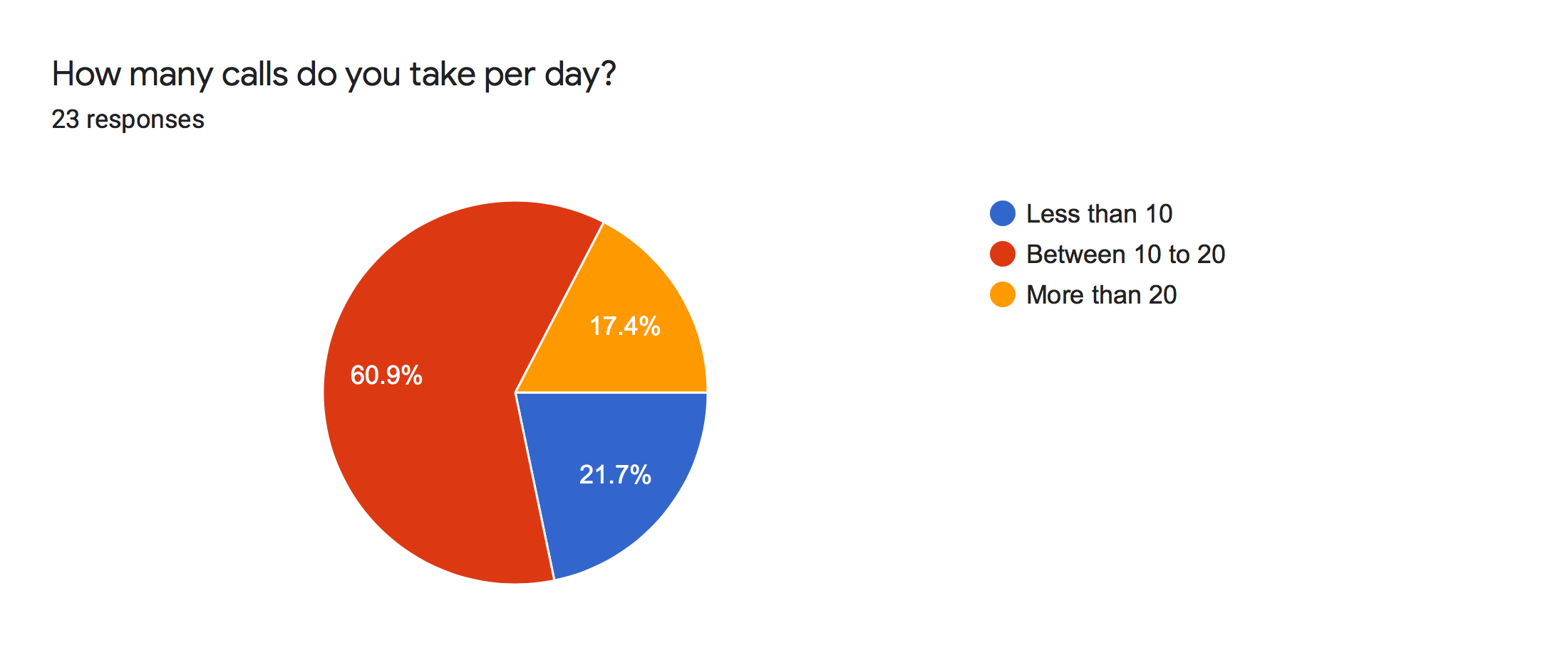
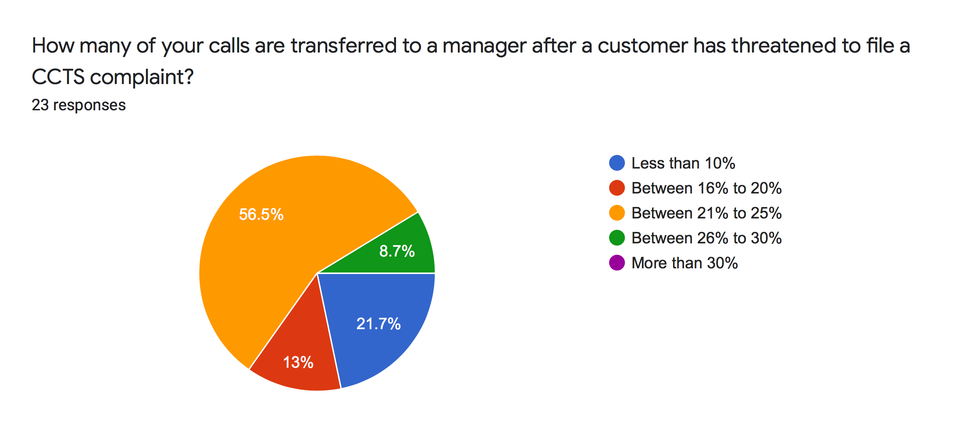

Appendix II: Manager Responses to other questions surveyed

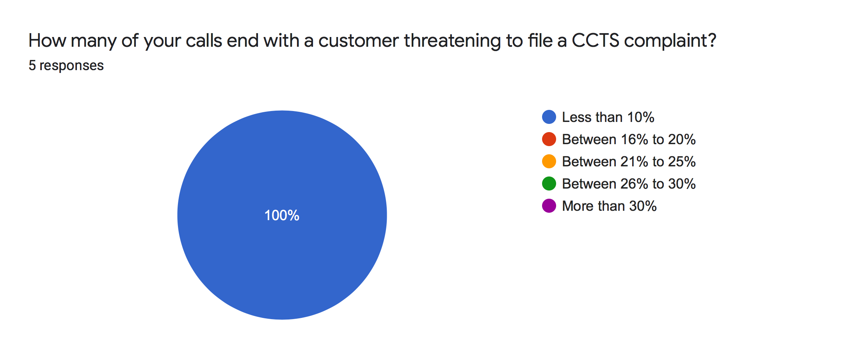
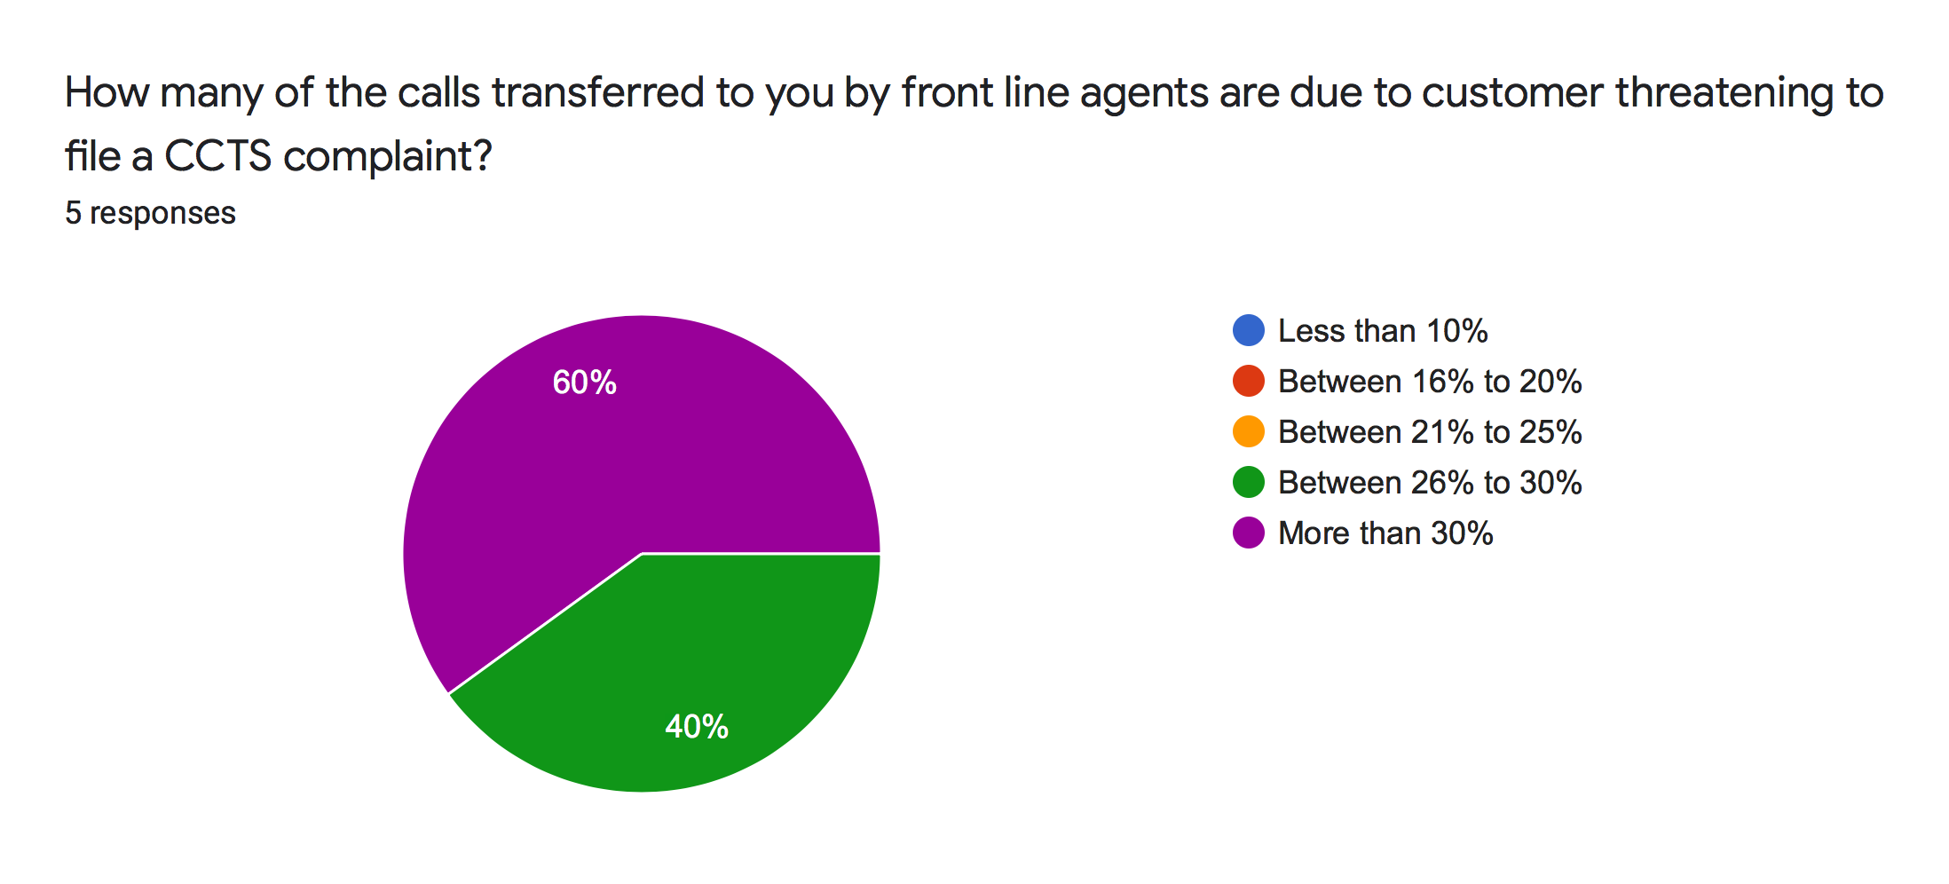

Works Cited:

“Mid-Year Report.” CCTS Reports, https://pub.ccts-cprst.ca/2018-2019-mid-year-report/.

“2017-18 Annual Report.” CCTS Reports, https://www.ccts-cprst.ca/wp-content/uploads/2018/11/CCTS-Annual-Report-2017-2018.pdf/.

