**Introduction**

The purpose of this assignment is to explore the different types of definitions, falling into three different categories: parenthetical, sentence and expanded. The type of definition used is dependent on how much additional information and explanation is required for a term.

**Term:** Gini Coefficient

**Parenthetical Definition**

A statistical measure of the degree of variation (difference) or inequality represented in a set of values, used most often to analyze income inequality (differences between individuals income levels).

**Sentence Definitions**

The Gini Coefficient is a statistical tool used to measure the difference between two or more variables or sets of values. Although a statistical tool, the primary purpose is to represent the wealth distribution of a nation or given area, particularly a measure of the inequality. The Gini Coefficient can also be referred to as Gini Index or Gini Ratio.

**Expanded Definition:**

**History of the Gini Coefficient:**

The Gini Coefficient is named after the Italian statistician Corrado Gini, Gini developed this coefficient in 1912. His work was building on the work of the American economist Max Lorenz, who depicted equality with a hypothetical straight diagonal line. It is the difference of this hypothetical line and the actual line that gives the Gini Coefficient.

**How it works:**

The Gini Coefficient is used to measure inequality; this is done on a scale from 0 to 1, where 0 indicates that the entire population has the same income and 1 means that one individual is earning all of the money. Therefore the higher the number is, the greater the income inequality of that area is.

**Similar Methods:**

The Gini Coefficient is a very effective tool when examining the income distribution of the entire population, however is not accurate when targeting a specific population, such as the highest earners in a population. The Palma ratio allows for a more specific view of a smaller population segment and measures the income difference of these more specific populations. If segment A has two times the wealth of segment B the Palma ratio is 2.

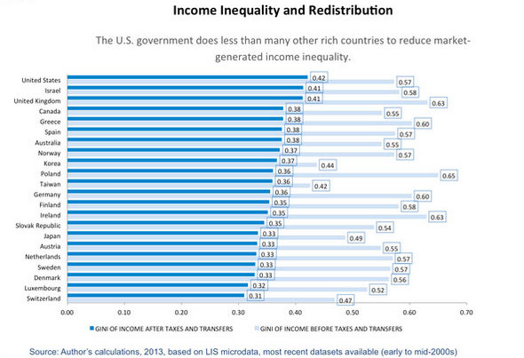

**Works Cited**

"Breaking the camel's back." N.p., 04 Oct. 2014. Web. 30 Jan. 2017.

"Gini in the bottle." N.p., 26 Nov. 2013. Web. 30 Jan. 2017.

"Who, What, Why: What is the Gini coefficient?" N.p., 12 Mar. 2015. Web. 30 Jan. 2017.