A/B Testing
The word I chose to explain in this assignment is ” A/B testing”. This term was frequently mentioned in my commerce class last semester, which shows the importance of this technical term.
Audience and Use profile :
A common dilemma that a company face, is that the product they sell does not meet the expectations of customers. They think they understand customer’s behavior, but customers always act differently than they think. Hence, knowing A/B testing is not only important to market managers but also important for marketing students.
Sentence Definition : A/B testing is a user experience research methodology that compares two variants, A and B (Young & Scott, 2014).
Parenthetical definition: ( Variant , also means change, the variants used in A/B testing are usually two versions of the same product)
What is A/B testing?
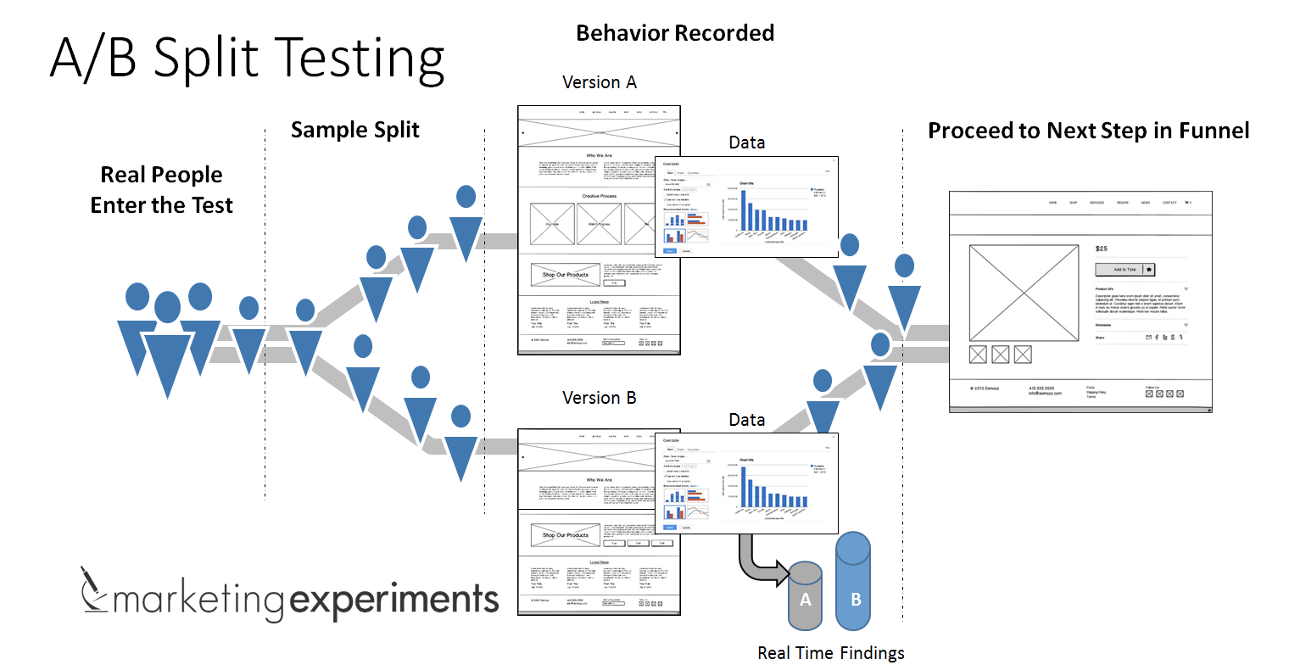
A/B testing is a statistical way to compare two or more versions of a product, the product can be a website, landing page, or other marketing assets. After the company has created variations, A/B testing helps to avoid unnecessary risks by allowing the marketing manager to use minimum resources to achieve maximum effect.

Figure 1: A/B testing used in a website (source :https://marketingexperiments.com/a-b-testing/ab-testing-email-subject-line-contes)
As indicated in figure 1, Website A and Website B all have the same content, but Website B changes the size of the font , which may or may not attract more users. The job of the marketing manger is to study the data that has been collected after the experiment, and come up with the best version that will attract as more as users/ consumers as possible.
How did it develop?
The concept of A/B testing was introduced by Claude Hopkins, an advertising pioneer in the early twentieth century (Much, 2018). Hopkins promotes a scientific approach to advertisement, he uses different versions of promotion coupons to test the effectiveness of his campaigns. Google engineers also used A/B testing in the year 2000, to determine the optimum number of results to display when people use their search engine. In 2011 alone, Google ran over seven thousand A/B tests to test their alternative versions (Kohavi et al., 2017).
How is it Used?
Modern A/B testing is used when companies are making marketing decisions. For example, large social media sites could either change the color scheme of their landing page or font of their logos and test which version of their landing page/ logos attract more users (Pardot,2012).
Another example is political A/B testing , for example, in 2007, when Barack Obama is running for president, his team uses A/B testing to find out which buttons on their website that will garner online attraction and lead them to sign up for newsletters (Siroke & Koomen, 2013).

References :
Kohavi, Ron; Thomke, Stefan (September 2017). "The Surprising Power of Online
Experiments". Harvard Business Review: 74–82.
Much M. (2018). Claude Hopkins Turned Advertising Into A Science, Brands Into Household
Names. Retrieved from https://www.investors.com/news/management/leaders-and-success/
claude-hopkins-scientific-advertising-bio/.
Young, Scott W. H. (2014). “Improving Library User Experience with A/B Testing: Principles
and Process”. Weave: Journal of Library User Experience. 1 (1). doi:10.3998/weave.
12535642.0001.101. hdl:2027/spo.12535642.0001.101. ISSN 2333-331
Pardot. (2012).The ABCs of A/B Testing. Retrieved from https://www.pardot.com/blog/abcs-ab-testing/
Siroker, Dan; Koomen, Pete (2013-08-07). A / B Testing: The Most Powerful Way to Turn Clicks
Into Customers. John Wiley & Sons. ISBN 978-1-118-65920-5.

