CAUSAL ANALYSIS

Causal Analysis
of Gathering in Common Areas
at Clinique Parodontologie CTH

for
Dr. Cartier D.D.S., DIPL. PARO. FICD
Dr. Talon D.M.D., M.SC., DIPL. PARO. FRCD
Dr. Hamel D.M.D., DIPL. PARO. FRCD
Mme. LaJoie, Administrative Director

by
Christina Hruby, RDH
English 301 Student

July 31, 2020
CAUSAL ANALYSIS
Table of Contents
Abstract…………………………………………………………………………………………………………………………………………………iii
Introduction…………………………………………………………………………………………………………………………………………….1
Data Section…………………………………………………………………………………………………………………………………………….2
Dimensions and Capacity of Public Areas at Clinique Parodontologie CTH………………………………….2
Staff and Visitor Volume……………..………………………………………………………………………………………………3
Sources of Congestion………………………………………………………………………………………………………………..4
Effect of Scheduling of Waiting Room Crowding…………………………………………………………………………5
Amenability of Personnel to Altered Schedule…………………………………………………………………………….5
Conflicting Interests.….……………………………………………………………………………………………………………….6
Available Facilities…………………………………………………………………………………………………………………….…6
One-way Direction of Traffic ………………………………………………………………………………………………………7
Budget………………………………………………………………………………………………………………………………………..7
Conclusion……………………………………………………………………………………………………………………………………………….8
Summary and Interpretation of findings……………………………………………………………………………………..8
Recommendations………………………………………………………………………………………………………….…………..8
Appendices …………………………………………………………………………………………………………………………………………….9
Survey…………………………………………………………………………………………………………………………………………9
Interview Questions……………………………………………………………………………………………………………….…11
References…………………………………………………………………………………………………………………………………………….12
Figures and Tables
Figure 1: Blueprint of Clinique Parodontologie CTH…………………………………………………………………………………2
Figure 2: Congestion at Clinique Parodontologie CTH……………………………………………………………………………..4
Figure 3: Peak Waiting Room Congestion Times………………………………………………………………………………………5
Figure 4: One-way at Clinique Parodontologie………………………………………………………………………………….……..7
Table 1: Breakdown of Staff Members…………………………………………………………………………………………………….3
Table 2: Daily Visitor Volume…………………………………………………………………………………………………………………..3 Table 3: Team Breakdown……………………………………………………………………………………………………………………….3
Table 4: Daily Team Schedules………………………………………………………………………………………………………………..5
Table 5: Available Facilities and Establishments………….……………………………………………………………………………6
CAUSAL ANALYSIS
Abstract
The Covid-19 pandemic has made social distancing a reality in public places and affected the practice of dentistry profoundly. The Ordre des Dentistes du Québec has specified protocols with which dental clinics must comply to avoid fines or forced closure.
Due to limited space, high patient volume, and a large staff, Clinique Parodontologie CTH faces the challenge of maintaining acceptable occupancy in public areas such as: the waiting room, corridor, lunchroom, sterilization area, periodontists office, as well as the lobby and hallway of the building in which the clinic is located.
Primary data collected, in the form of survey, interview, and suggestion box responses, guided analysis of causative factors of problematic crowding. Collaboration with nearby businesses and building administration revealed solutions to congestion affecting staff, patients, and chaperones.
Dental practices confronted with overwhelmed public areas should consider the following recommendations.
- Creating a one-way direction of traffic in corridors.
- Staggering appointment times, lunch times, and working times of staff members.
- Elongating duration of appointment.
- Providing patients and chaperones with secondary waiting areas.
- Billing patients prior to appointment to avoid returning to reception area after treatment.
- Encouraging patients to arrive to appointments punctually and to remain on the premises for treatment only.
CAUSAL ANALYSIS
Introduction
Transmission of the SARS-CoV-2 virus has been linked to saliva droplets and aerosols, two realities of dental treatment (Bertrand et al. 22) As a result, strict clinical protocols have been adopted in operatories. Dental offices are also public areas where contact occurs between co-workers, patients, chaperones, building administrators, and delivery personnel. Social distancing must be maintained between all points of contact to maintain public safety during the pandemic.
Inadvertent gathering is taking place in common areas of Clinique Parodontologie CTH. High patient volume is overwhelming the waiting room, the narrow corridor is unable to accommodate adequate space for two-way foot traffic, and the lunchroom is insufficient to host all staff members simultaneously.
The purpose of this inquiry is to identify the sources of gathering and assess potential solutions. The goal is to maintain the safety of all staff and visitors to the clinic while sustaining a patient turnover rate that does not significantly reduce profitability.

Surveys and interviews were conducted, and a suggestion box was installed to gather primary data for analysis of particular issues at Clinique Parodontologie CTH. Building administration, neighbouring tenants, and nearby local businesses were also contacted to uncover potential conflicts and solutions. The Phase 3 Covid-19 Buccodental Procedure Directives issued by the Ordre des Dentistes du Quebec were used as secondary reference and guidance.

The report concludes that staggering the opening hours of the three staff teams would offset gathering by reducing the volume of patients arriving at and departing from the clinic simultaneously. The lunchroom is alleviated by altering the start and end times of the staff and by hosting different lunch hours for each team. A list of alternative waiting areas has been compiled for chaperones, who are not accompanying minors.
CAUSAL ANALYSIS

Data Section

Dimensions and Capacity of Public Areas at Clinique Parodontologie CTH

According to data collected from surveys, interviews, and the suggestion box, the at the clinic experiencing problematic gathering include the waiting room, corridor, sterilization center, lunchroom, the offices of the periodontists and administrative director, and the laundry room. The dimensions have been calculated and square footage indicated on the diagram below (Figure 1: Blueprint of Clinique Parodontologie CTH). The operatories are not affected by social distancing issues because there are never more than 4 individuals in these rooms at any given time.
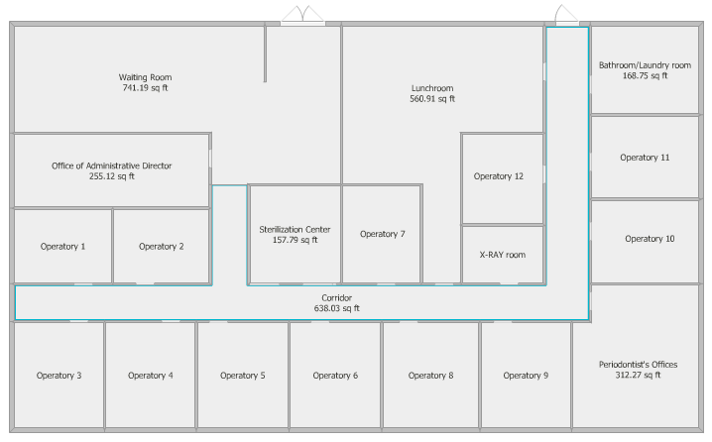
Figure1: Blueprint of Clinique Parodontologie CTH

The waiting room is adjoined to the entrance and houses the receptionist and three secretaries. Three billing stations are available and the number of chairs for waiting patients has been reduced to seven. Dental assistants and dental hygienists are also traveling in and out this room to greet patients and accompany them to and from operatories. The maximum capacity for this room, allowing 2 metre distancing, is fourteen individuals.

The corridor connecting the waiting room to all operatories, the x-ray room, the lunchroom, bathroom/laundry room, the sterilization center, and the offices is approximately five feet, or one and a half meters, wide.

The sterilization center, with a galley style set-up, can accommodate a maximum of four staff members. The sterilization clerk is occupying the space throughout the day, leaving room for only 3 other staff members at any given time.
CAUSAL ANALYSIS

The lunchroom table can seat a maximum of seven individuals to maintain six and a half feet, or two metres, between staff members. The distancing is particularly important in the lunchroom because masks cannot be worn while eating (Bertrand et al. 5).

Since staff lockers are located in the lunchroom, employees are now using the lunchroom as well as the laundry/bathroom to change into and out of uniforms before and after shifts.

Staff and Visitor Volume

Table 1: Breakdown of Staff Members
Job Title | Number of members | Cumulative Total
Periodontists | 3 | 3
Dental Hygienists | 9 | 12
Dental Assistants | 6 | 19
Sterilization | 1 | 20
Secretaries | 3 | 23
Receptionist | 1 | 24
Administration | 4 | 28
Accountants | 2 | 30

Table 2: Daily Visitor Volume
Type of Visitor | Average Daily Total | Cumulative Daily Total
Patient | 150 | 150
Chaperone | 20 | 170
Delivery Personnel | 5 | 175

Table 3: Team Breakdown
 | Team 1: Cartier | Team 2: Talon | Team 3: Hamel
Periodontists | 1 | 1 | 1
Dental Hygienists | 3 | 3 | 3
Dental Assistants | 2 | 2 | 2
Secretaries | 1 | 1 | 1
Patients | 50 | 50 | 50
Chaperones | 7 | 7 | 7
Total # of members | 64 | 64 | 64

Thirty staff members are present at the clinic each day treating one hundred and fifty patients and hosting twenty chaperones on average; however, both the staff and their associated visitors can be divided into 3 group of approximately sixty-four individuals. Managing each team separately will facilitate manipulation of the schedule and crowd control.
CAUSAL ANALYSIS

Sources of Congestion
Data collected from voluntary and anonymous surveys, voluntary and confidential interviews, and a suggestion box indicated causes of gathering at Clinique Paradontologie (Figure 2).

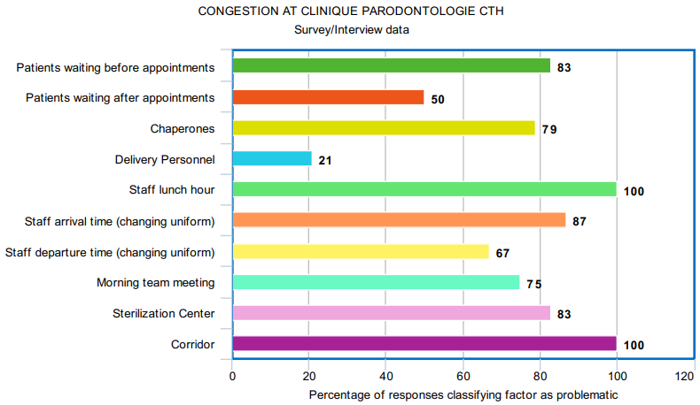
Figure 2: Congestion at Clinique Parodontologie CTH

- Since Covid-19 protocol mandated by the Ordres des Dentistes du Quebec indicates that staff members who are in close contact with patients (periodontists, dental hygienists, and dental assistants) must change into uniforms after arriving and before leaving the premises, (Bertrand et al., 28) and because these twenty individuals are arriving and departing at the same time, the bathroom and lunchroom areas are crowded at opening and closing times.
- Morning team meetings, which usually take place in the periodontist’s office, cannot host three teams concurrently while maintaining appropriate social distancing.
- Roughly 30 staff members are taking lunch between noon and one ‘o’clock, overwhelming the lunchroom.
- Patients are waiting on average ten to fifteen minutes before appointments and five to ten minutes after appointments. Consensus among survey and interview subjects indicates that due to additional Covid-19 screening and disinfection protocols, appointments lengths are now strained. Subjects also estimate that an extra ten minutes would be sufficient in resolving delays.
- Because all teams are commencing the workday simultaneously, appointment times are following similar schedules. Visitor arrival and billing is occurring across the three teams at the same time throughout the day.
- Chaperones are occupying space in the waiting room needed for waiting patients.
- Because appointments are generally ending at the same times, the sterilization center is congested alongside patient turnover patterns.
- Deliver personnel are occasionally arriving at inconvenient times, but the issue is generally not problematic.
- The corridor is a heavily travelled and struggling to accommodate two-way traffic.
CAUSAL ANALYSIS

Effect of Scheduling on Waiting Room Crowding
The following chart displays the patient flow throughout the workday. One hundred percent capacity implies that all seats and billing stations are occupied. The receptionist monitors the headcount of the area and asks additional patients to wait in the hallway until a space vacates.

Figure 3: Peak Waiting Room Congestion

Trends indicate that patients are arriving ten to fifteen minutes prior to their appointments, which usually begin at the half hour mark. Patients are completing treatments and escorted back to the waiting room within a twenty-minute interval that overlaps with the next wave of appointments. During this overlap, the waiting room is at one hundred percent capacity and there are often three to six additional patients in the hallway outside the clinic. The secretaries are experiencing a twenty-minute billing rush which is followed by forty minutes of minimal activity.

Amenability of Personnel to Altered Schedule
Presently, the workday schedule for all employees of Clinique Parodontologie CTH extends from 7:30 am to 4:00 pm, which includes a lunch hour from 12:00pm to 1:00pm. Primary data sources revealed unanimous approval for altering both lunch hours and workday opening hours. A staggering of team schedules would appear as follows:

Table 4: Daily Team Schedules
 | Team 1 | Team 2 | Team 3
Workday begins | 7:00 am | 7:15 am | 7:30 am
Lunch hour begins | 11:00 am | 12:00 pm | 1:00 pm
Lunch hour ends | 12:00 pm | 1:00 pm | 2:00 pm
Workday ends | 3:30 pm | 3:45 pm | 4:00 pm

Such an adjustment would result in offsetting patient flow between teams by fifteen minutes alleviating reception and sterilization areas. Spreading the influx of patients softens peaks and valleys, allowing better customer service and a less stressful environment. Separate lunch hours reduce lunchroom crowding significantly. The total number of employee working hours is not increased, leaving payroll costs unaffected.
CAUSAL ANALYSIS

Conflicting Interests

Complaints from fellow tenants and building administration voiced at tenant meeting on July 10, 2020 included:
- Fourth floor tenants inconvenienced by accumulation of patients waiting in the hallway to enter the clinic.
- Building administration displeased with crowding in lobby caused by visitors waiting for elevators, patients waiting to be called up to clinic, and overflow of chaperones.
- Tenants from all floors report patients not respecting two-person maximum in elevators.
Alternative waiting areas are required for patients and chaperones. Patients need to be informed regarding social distancing rules of the building.

Available Facilities

Meetings with building administration to request use of alternate facilities and with nearby business owners/management revealed the following options for secondary waiting areas and improved foot-traffic flow:

Table 5: Available Facilities and Establishments
Facility/Establishment | Status of Request
Use of rear door of clinic as exit for patients | Approved
Use of Café on ground floor to host chaperones | Denied: lease terminated
Placement of four chairs in hallway outside clinic as secondary waiting area | Denied
Use of seating in lobby as secondary waiting area | Denied
Starbucks | Approved
McDonald’s | Approved
Tim Horton’s | Denied: Take-out only
Chapter’s | Approved
Fairfield Shopping Center | Approved
Quesada Burritos & Tacos | Denied- Take-out only

Building administration will not support overcapacity needs of the clinic and does not accept taxing of hallway and lobby areas; however, reclassifying rear door for visitor use can be beneficial for foot traffic within the clinic. Businesses located within a five-minute walk of the clinic were visited. Because of social distancing constraints in public areas, not all establishments are prepared to host chaperones or waiting patients. A satisfactory list was compiled.
CAUSAL ANALYSIS

One-way Direction of Traffic
The rear door of the clinic was classified as a staff entrance; however, approval from building administrators to use it as an exit for patients, presents a solution to the close proximity of two-way traffic in the corridor of the clinic. Analysis of the floor plan and comments collected from the suggestion box have culminated in the following foot traffic plan (Figure 2). Please note that the floor colour of all areas where social distancing is problematic have been changed to highlight areas needing attention.

Entrance Exit
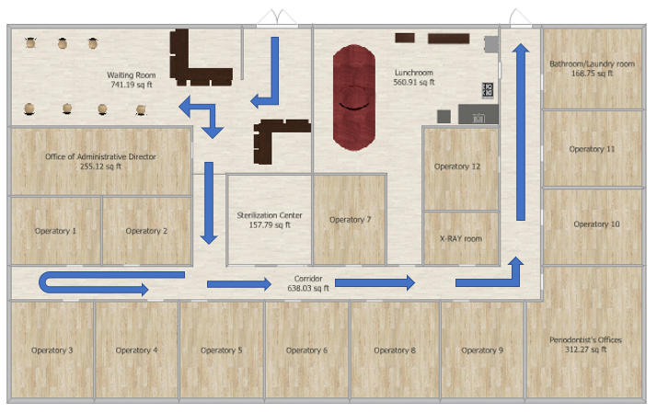
Figure 4: One-way at Clinique Parodontologie CTH

Budget
A budget of $400 is allocated to this inquiry. The funds are allotted to printing of surveys and signage indicating traffic flow throughout the clinic. Originally, flyers were to be printed advising chaperones of nearby businesses prepared to host them while waiting for patients. Brainstorming revealed that sending the list of establishments to the patients along with the confirmation of the appointment would be more cost effective. The list is also useful to unaccompanied patients who arrive early to their appointment. Addresses, distance on foot, and a small map of the area are attached to email and text confirmations 24 hours prior to appointments. Local businesses are appreciative that CTH clients are encouraged to frequent their establishments and hopeful that the visits will generate income. The budget is currently in a surplus of $250.
CAUSAL ANALYSIS
Conclusion
Summary of Findings
Clinique Parodontologie is a thriving practice that is striving to meet patient needs. Because of the twelve-week Covid-19 clinic closure, 1500 appointments were cancelled between March 16th and May 29th of 2020. Staff members are striving to accommodate clients, stressing the limits of the schedule and capacity of the premises. Areas of Clinique Parodontologie CTH experiencing congestion include: the waiting room, fourth floor hallway in front of clinic entrance, corridor inside the clinic, sterilization center, lunchroom, elevators, and lobby of the building. Individuals affected by social distancing challenges associated with the clinic are staff members, patients, chaperones, and fellow tenants.
Interpretation of Findings
Scheduling and congestion are complex and multifactorial issues. Appointment length, scheduling tendencies related to uniform opening and lunch hours, the presence of chaperones and waiting patients in the clinic, lobby, and hallways of the building, and two-way foot traffic in the narrow corridor of the clinic have been identified as the major sources of bottlenecking and excessive gathering at Clinique Parodontologie CTH.
Recommendations
To maintain 2 metre distancing between all staff and visitors of Clinique Parotontologie CTH, the following suggestions are recommended:
- Advising patients to arrive at the entrance of the clinic at the time of their appointment, but not earlier.
- Sending patients a list of establishments where they may wait for their appointment time and where chaperones may wait for patients during treatment.
- Staggering schedule hours of the three teams to manage smaller patient influx and alleviate sterilization center.
- Extending appointment length by ten minutes to ensure adequate time for additional Covid-19 screening and disinfection.
- Creating a one-way foot traffic direction in clinic corridor (Figure 2), displaying signage accordingly.
- Billing patients prior to treatment to eliminate return to reception area at the end of appointments.
- Escorting patients to the exit at the rear of the clinic at the end of appointments.
- Staggering working hours of the three teams to alleviate crowding in bathroom and lunchroom as staff change into and out of uniform at beginning and end of workday.
- Creating 3 separate team lunch hours and inviting periodontists and administrative staff eat in their offices to reduce lunchtime crowding.
- Hosting morning meetings in different locations: periodontists office, lunchroom, administrative director’s office.
- Voting on preferred workhour options to maintain fairness among teams.

Appendix
Survey
Public Gathering at Clinique Parodontologie CTH
I am a registered dental hygienist and an undergraduate student at the University of British Columbia currently working on a technical writing project. The purpose of this survey is to collect primary data that will be used to analyze and reduce gathering in public areas of Clinique Parodontologie CTH, as per Covid-19 social distancing mandates. The goal of this inquiry is to provide a safe environment for patients, visitors, and staff of Clinique Parodontologie CTH throughout the pandemic. The formal report will be presented to the shareholders, practicing partners, and office manager of the clinic. Together with the guidelines issued by the Ordre des Dentistes du Quebec, the data collected from this survey will serve to identify sources of congestion and problematic times in the schedule. The valuable information you provide will be used for analysis in proposing crowd control methods to ensure health and safety at Clinique Parodontologie CTH. The survey contains 9 multiple choice questions and it will take approximately 5 minutes to complete. Your responses are voluntary, anonymous, and greatly appreciated.
Thank you for your participation.

- Please indicate the number of visitors present in the waiting room area at the following times.
7:15 |  | 9:30 |  | 11:15 |  | 1:00 |  | 2:45
7:30 |  | 9:45 |  | 11:30 |  | 1:15 |  | 3:00
7:45 |  | 10:00 |  | 11:45 |  | 1:30 |  | 3:15
8:15 |  | 10:15 |  | 12:00 |  | 1:45 |  | 3:30
8:45 |  | 10:30 |  | 12:15 |  | 2:00 |  | 3:45
9:00 |  | 10:45 |  | 12:30 |  | 2:15 |  | 4:00
9:15 |  | 11:00 |  | 12:45 |  | 2:30 |  | 4:15

- Approximately how long do patients wait before being taken in to an operatory?
 | Often | Sometimes | Rarely
0-5 minutes
5-10 minutes
10-15 minutes
15-20 minutes
20-25 minutes

- Approximately how many chaperones visit the clinic per day?
5-10
11-15
16-20
21-25

- Approximately how long so chaperones wait in the waiting room?
 | Rarely | Sometimes | Often
15 minutes
30 minutes
45 minutes
Longer than 45 minutes

- When are patients more likely to wait?

Before appointment
After appointment
Equally before or after

- Time allocated for appointments:

Too long
Sufficient
Too short

- If answer to previous question was too short/too long, what adjustment to appointment length would be appropriate?

5 minutes
10 minutes
15 minutes

- Would temporarily altering the workday start and finish times (for the period of pandemic) be acceptable? The number of hours worked would not increase or decrease, but only be shifted. An earlier start would coincide with an earlier finish. A later start would coincide with a later finish.

 | Acceptable | Unacceptable
10 minutes
20 minutes
30 minutes

- Would temporarily altering lunch times (for the period of the pandemic) be acceptable?
 | Acceptable | Unacceptable
15 minutes
30 minutes
45 minutes
A suggestion box has been installed in the lunchroom. Please feel free to share any ideas or identify concerns you have regarding the current working environment.
Thank you

Interview Questions
Public Gathering at Clinique Parodontologie CTH
I am a registered dental hygienist and an undergraduate student at the University of British Columbia currently working on a technical writing project. The purpose of this interview is to collect primary data that will be used to analyze and reduce gathering in public areas of Clinique Parodontologie CTH, as per Covid-19 social distancing mandates. The goal of this inquiry is to provide a safe environment for patients, visitors, and staff of Clinique Parodontologie CTH throughout the pandemic. The formal report will be presented to the shareholders, practicing partners, and office manager of the clinic. Together with the guidelines issued by the Ordre des Dentistes du Quebec, the data collected from this interview will serve to identify sources of congestion and problematic times in the schedule. The valuable information you provide will be used for analysis in proposing crowd control methods to ensure health and safety at Clinique Parodontologie CTH. The interview consists 10 questions and it will take approximately 10 minutes to complete. Your responses are voluntary, confidential, and are greatly appreciated.
Thank you for your participation.

- Would you say that you have noticed instances when it has been difficult to maintain a 2-metre distance between individuals at the clinic: yes, no?
- Where in the clinic did this occur?
- At what time/times did this occur?
- Would you say that this occurs rarely, sometimes, or often?
- Since the reopening of the clinic, would you say that patients and chaperones are compliant with the addition of Covid-19 protocols: always, mostly, sometimes, rarely, never?
- Since the reopening of the clinic, would you say that staff members are compliant with the additional Covid-19 protocols: always, mostly, sometimes, rarely, never?
- Where do you typically spend your lunch hour: Inside the clinic, outside the clinic?
- Since the reopening of the clinic, where do you usually spend your lunch hour: inside the clinic, outside the clinic?
- Where would you prefer to spend your lunch hour: inside the clinic, outside the clinic?
- Do you have any comments or suggestions that you would like to share regarding social distancing at the clinic?
A suggestion box has been installed in the lunchroom. If you think of any recommendations going forward or if your patients comment on the matter, please feel free to share them in this manner. The box will be checked daily and all comments will remain anonymous.
Thank you

References
- Bertrand, Morneau, et al. Covid-19-Procédures Buccodentaires. Ordre des Dentistes du Québec, May 2020, http://www.odq.qc.ca/Portals/5/fichiers_publication/DossierSante/Coronavirus/COVID-19%20-%20PROC%C3%89DURES%20DENTAIRES%2022%20mai_rev.pdf.

- Mr. J. Lefebvre, Building Manager, 755 St. George Blvd, Montreal, Québec
- Ms. S. Bruneau, Manger, Starbucks, 955 St. George Blvd, Montreal, Québec
- Mr. G. Barnabis, Owner, McDonald’s Restaurant, 2600 St. George Blvd, Montreal, Québec
- Mr. G. Patel, Manager, Tim Horton’s, 305 Brunswich Blvd, Montreal, Québec
- Ms. A. Cormier, Manager, Chapter’s, 6321 Chemin Labrousse, Montreal, Québec
- Ms. R. Gentile, Manager de la service à la clientèle, Fairfield Shopping Centre, 6801 Chemin Labrousse, Montreal, Québec
- Mr. E. Hérault, Manager, Quesada Burritos & Tacos, 6361 Chemin Labrousse, Montreal, Québec

