Proposal to Increase Out of Province Seats to The Ontario Veterinary College

Prepared for
Dr. Jeffrey Wichtel
The Dean of Veterinary Medicine
The Ontario Veterinary College at The University of Guelph
Guelph, Ontario

And

The Ontario Veterinary College Admissions Committee
The Ontario Veterinary College at The University of Guelph
Guelph, Ontario

by
Sydney Storie
UBC ENGL 301 Technical Writing Student

August 1, 2020
TABLE OF CONTENTS
INFORMATIVE ABSTRACT………………………………………………………………3

INTRODUCTION………………………………………………………………...………………4
Overview…………………………………………………………………………..………4
Background………………………………………………………………………..………4
Statement of the Problem………………………………………………………………….4
Scope………………………………………………………………………………………5

ADMISSIONS CRITERIA……………………………………………………………………..…5
Academic Requirements…………………………………………………………………..5
Non-academic Requirements……………………………………………………………...5
Selection Process………………………………………………………………………….6

PROPOSED PLAN………………………………………………………………………….…….7
Feasibility………………………………………………………………………………….7
Seat Breakdown…………………………………………………………………………...8
Funding……………………………………………………………………………………8
Student Fees……………………………………………………………………………….9
CONCLUSION……………………………………………………………………………………9

APPENDIX………………………………………………………………………………………10

WORKS CITED…………………………………………………………………………………16

INFORMATIVE ABSTRACT
Veterinary Medicine is a rewarding career for those who are passionate about the care and well-being of animals. In Canada, a person must study for a minimum of 6 years to earn a doctorate in Veterinary Medicine, for some, it can be even longer.
Entrance into Veterinary Medicine is extremely competitive. Most Doctor of Veterinary programs require individuals to have a high GPA, obtain the necessary course prerequisites, obtain a minimum number of hours job shadowing and may even require you to be a resident of the province of study.
British Columbia residents pursuing a career in Veterinary Medicine face incredibly difficult challenges when it comes to applying to veterinary school in Canada. Considering there is only one veterinary school that accepts BC residents throughout Canada, competition is fierce. Due to tough competition, BC residents face challenges in career options, financial costs, and additional years of studying to upgrade their university GPA.
For anyone considering a career in veterinary medicine, it would be beneficial to research the appropriate schools you are eligible for, review out of province rules, evaluate the financial costs and speak with people who are working and studying within the field.

INTRODUCTION
Overview
Over the past couple of decades, there has been a significant increase in applications to veterinary schools across Canada. Veterinary medicine programs are one of the most competitive programs in Canada. Currently, there are five veterinary colleges in Canada, that being; The Ontario Veterinary College, the Atlantic Veterinary College, the Western College of Veterinary Medicine, the Université de Montréal, and the University of Calgary. The Ontario Veterinary College, located at the University of Guelph, is holding the title of the top veterinary school in Canada.
Veterinary schools in Canada are region-based, this means that a person can only apply to the school depending on their residence status. This is problematic for many applicants as there are limited seats available for some provinces and numerous seats available for other provinces. Primarily, residents from British Columbia, Manitoba, Saskatchewan, and the Territories face the biggest challenges as there are extremely low acceptance rates compared to the number of applicants each year.
According to the Western College of Veterinary Medicine (WCVM) statistics for 2019, there was a total of 396 applicants with a seat quota of 78. Of those 396 applicants, 123 were from British Columbia. Compared to 78 applicants from Saskatchewan, 140 applicants from Alberta, 53 applicants from Manitoba, and 2 applicants from the North West Territories, Yukon and Nunavut (“Veterinary Medicine”). There is a significant variation between applications per province while there is an indistinguishable amount of entrance seats.
Background
The Western College of Veterinary Medicine is the only school that accepts out of province residents. Each year there are 20 available seats for BC residents, 20 seats for Saskatchewan residents, 15 seats for Manitoba, and 1 seat for the Territories (“Admission Requirements”). Alberta residents are eligible to apply to both the University of Calgary, because it is Albertan based, and the Western College of Veterinary Medicine in Saskatoon, thus increasing their odds of acceptance. Whereas to apply to the Ontario Veterinary College, an individual must be a resident of Ontario. To apply to the Atlantic Veterinary College, it is required that the person is a resident from either Prince Edward Island, Nova Scotia, New Brunswick, or Newfoundland and Labrador. A solution is needed to increase the number of seats for applicants residing in British Columbia, Manitoba, Saskatchewan, and the Territories to be able to attend Canada’s top veterinary school, the Ontario Veterinary College at the University of Guelph.
Statement of the Problem
The admission criteria for veterinary school is extremely competitive. For example, the WCVM had an admissions average from 80.3% to 95% in 60 credits of post-secondary science courses in 2019 (“Veterinary Medicine”). Each school has specific admission criteria, however, most criteria overlap in the requirements, such as participation of job shadowing in a veterinary field or animal-related environment, pre-requisites of undergraduate courses in biological science and mathematics, and a cumulative average of at least seventy- five percent of the undergraduate courses, sometimes even a minimum of eighty percent. Each of these factors constructs to an even greater competitive entrance process. Extreme competitiveness can result in several repercussions for applicants. For example, applicants may have to study overseas which leads to additional costs as an international student. Students can increase their chances of burnout during the undergraduate years as well as there is an increase in financial debt as a result of retaking courses to achieve a higher grade average, and for some, a change in the career path is common.
Hundreds of applicants residing in British Columbia have applied to veterinary school over the past several years, with only twenty seats allotted in all of Canada for BC residents, the competition is fierce. British Columbia residents are facing the most repercussions when it comes to applying to veterinary school in Canada.
Scope
The following plan includes
- The admission criteria required for the Doctor of Veterinary Medicine (DVM) program at the Ontario Veterinary College
- The selection process for the DVM program at the Ontario Veterinary College
- The funding that is required to increase the number of seats for BC residents at the Ontario Veterinary College
- Survey results from BC residents interested in veterinary school
Admissions Criteria for the DVM Program at the Ontario Veterinary College
Academic Requirements
According to the Ontario Veterinary College, to be eligible to apply to the Doctor of Veterinary Medicine (DVM) program, the applicant must be an Ontario resident. As stated by the Ontario Veterinary College “a resident is an individual who has lived in Ontario for 12 months before January 1, not including time spent in post-secondary institutions” (“Canadian Students”). There are one hundred and twenty seats available, with a seat quota of one hundred and five for Ontario residents and fifteen seats available for international students.
The undergraduate prerequisites needed to apply to the DVM program at the Ontario Veterinary College consists of two biological sciences, one cell biology, one genetics, one biochemistry, one statistic’s, and two humanities or social science classes. Applicants are eligible to apply to the DVM program after completing two years of post-secondary studies. A minimum GPA of seventy-five percent is required before applying.
Non-Academic Requirements
To be considered in the DVM cohort of applicants, a student must participate in job shadowing of a veterinarian. There is no minimum number of hours needed, however, the more experience the better. Job shadowing can be done within a variety of places such as animal shelters, clinics, zoos, laboratories, and exotic wildlife centers (“Selection Process”).
In combination with the job shadowing, applicants are also expected to have volunteer or community work experience outside of the veterinary field. This is because veterinarians spend a lot of time interacting with owners and other coworkers. Veterinarians are expected to have excellent animal skills paired with excellent interpersonal skills.
Referees are also required; two of the three referees must be from a veterinarian whom the applicant has job shadowed.
Selection Process
Please refer to Figure 1 for a flow diagram.
- Stage 1: Calculate the admission average for applicants. A fifty-fifty ratio is used for academic and prerequisites courses for each applicant.
- Stage 2: The Ontario Veterinary College Committee reviews applications and determines which applicants will move forward to the interview stage.
- Stage 3: The interview process accounts for thirty-five of the final decision.
- Stage 4: Final review of selected applicants.
- Stage 5: Notification of acceptance.

- Calculation of admissions cohort
Calculation of Admissions Average

- A fifty-fifty ratio of academics
- Fifty percent of average taken from the last two full-time semesters
      - The other fifty percent is the average of the prerequisite courses.

Applications Review

- OVC committee reviews applicants.
- Selected applicants will move to the interview stage.

Interview Stage

- Top applicants are invited to the interview.
- The interview accounts for thirty-five percent of the final decision.

Final Review

- OVC committee reviews final documents and scores to determine acceptance.
- This is where most BC applicants are unsuccessful.

- Successful applicants are notified upon their acceptance.
Notification
- Unsuccessful applicants will also be notified and encouraged to reapply for the following year.

Fig.1. “Selection Process.” OVC Recruitment, www.ovc.uoguelph.ca/recruitment/en/applyingtodvm/selectionprocess.asp.

PROPOSED PLAN
British Columbia is facing a serious shortage of veterinarians and the demand for veterinarian services is rapidly increasing (“NDP Government Refuses to Fund Training Spaces to Help Tackle Veterinarian Shortage in B.C”). The statistics provided by the WCVM along with the shortage of veterinarians that BC faces is a serious indicator of the need to increase seats for out of province residents to Canada’s top veterinary school, the Ontario Veterinary College. A possible solution is to expand the admission criteria to allow seats for out of province residents.
Feasibility
A survey and interview questionnaire were distributed to British Columbia residents who have studied at the University of British Columbia. These participants are members of the UBC Pre-Veterinary Club. The survey and interview targeted British Columbia residents who have previously applied or are in the process of applying to veterinary school in Canada. The purpose of the survey and interview was to acquire primary data to determine the barriers that British Columbia residents face when applying to veterinary school and to determine possible solutions to each of the issues at hand. The interview consisted of five questions and it remained anonymous and was voluntary to participants. The survey contained thirteen multiple-choice questions and participation was completely voluntary and participants remained anonymous.
Please refer to Figure. 1.A. in the Appendix for full Survey results. A summary of the survey results are as follows:
- One hundred percent of participants are willing to relocate to another province or another country to attend veterinary school.
- The majority of participants hold a bachelor’s degree.
- Sixty percent of participants found the entry process to the DVM program at the OVC extreme.
- Eighty percent of participants thought it would very beneficial to add out of province seats to the Ontario Veterinary College.
- All participants found that applying to veterinary school is often difficult, unsuccessful, competitive and nearly impossible.
- One hundred percent of participants voted that applying to veterinary school in Canada is unsuccessful.
- Sixty percent of participants found that it is not so fair to have region-based veterinary schools in Canada.
- Eighty percent of BC residents said they would apply to the OVC if there was an opportunity available.
Please refer to Figure. 1.B. in the Appendix for full interview results. For the participants who participated in the interview the following summary applies:
- BC residents are willing to pay an extra $15,000 per year to be directly admitted into the DVM program, while others are willing to pay any necessary cost.
- BC residents are willing to attend veterinary school overseas if unsuccessful in Canada.
- All participants recommended for the BC government to provincially fund seats to DVM programs across Canada.
Recommendations for Increasing Out of Province Seats
Seat Breakdown
Revising the seat quota to one hundred and five Ontario residents, twenty BC residents, and twenty international students. Revising the seat quota allows for a substantial number of Ontario applicants to study the DVM program while permitting an additional twenty BC students the opportunity to study at OVC. Increasing the international seat quota by five allows for additional funding support for the OVC program as the amount being paid by international student fees will increase by five.
Funding
British Columbia funds $8.4 million annually to support BC students attending the WCVM (Holliday). To fund an additional 20 seats for BC residents at the Ontario Veterinary College, an additional $8.4 million will be required. To obtain the additional $8.4 million, an appropriate funding option can include provincial funding from the government of BC for an additional 20 seats to the Ontario Veterinary College. The majority of participants from the interview supports the idea of providing government funding. Following the government funding, the Corporate Partnership Program (CPP) associated with the Canadian Veterinary Medical Association may also be a contributor. The CPP is a sponsorship program that provides funding to the veterinarian community (“2018 Annual Report of the Canadian Veterinary Medical Association”).
Paying Similar Fees as International Students
Unsuccessful applicants applying to the DVM program at the WCVM are often unsuccessful due to the limited seats. Many unsuccessful applicants will often move overseas and pay international fees to attend a DVM program (Hill). The Ontario Veterinary College can provide a selected number of seats designated to Canadian students who reside in British Columbia who are willing to pay an increased amount in tuition fees, that similar to international fees. According to Freeman, if there was an opportunity to reserve seats at the DVM program for Western Canadians who are willing to pay an extra amount for tuition, many students would be eager to jump aboard (Hill).
A recommendation for the Ontario Veterinary College is to provide an additional five seats for Canadian residents who are willing to pay direct entry into the DVM program. Similar to that of the WCVM, Canadian students expecting to participate in the paid direct entry program can expect to pay up to $55,000 per year in addition to tuition costs (“Veterinary Medicine”). Results from the survey suggest that some students will pay any cost necessary to attend veterinary school in Canada as opposed to paying international fees overseas.
CONCLUSION
As an active UBC student looking to pursue a career in veterinary medicine, I strongly believe change is needed to allow more seats for residents residing in British Columbia to attend the top veterinary school in Canada. Each year the number of applications increases for veterinary school and more and more British Columbia residents are unsuccessful when applying, further resulting in financial barriers and career path changes. As a BC resident and UBC student, I respectfully urge the importance of increasing the seat quota at the Ontario Veterinary College to allow British Columbia residents to study the Doctor of Veterinary program.

APPENDIX
Survey Results from UBC Students
Figure. 1.A. Survey Results from British Columbia Residents
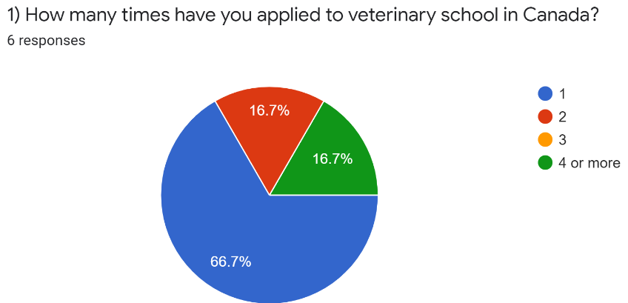
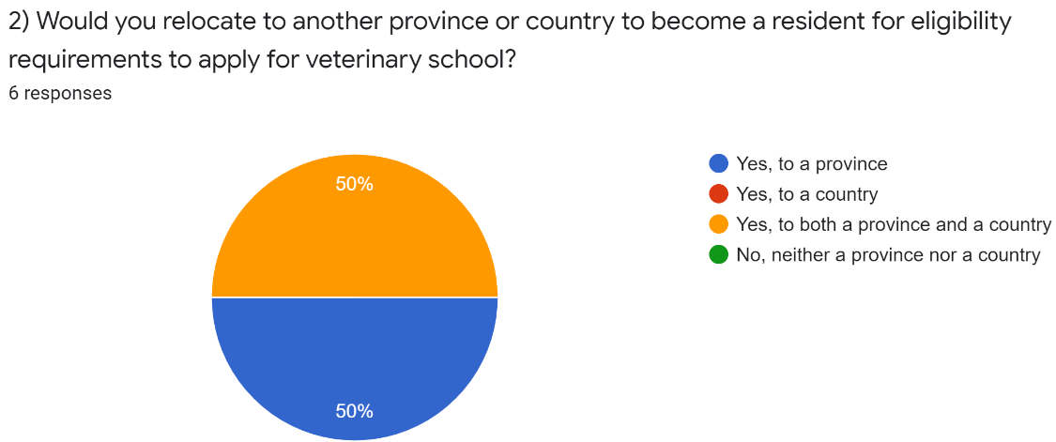
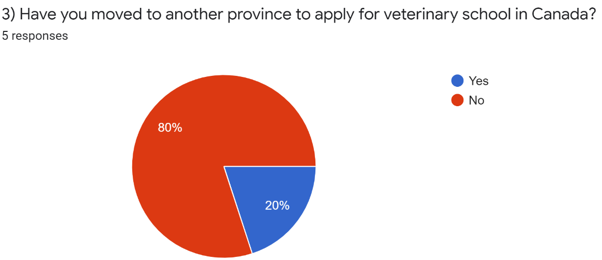
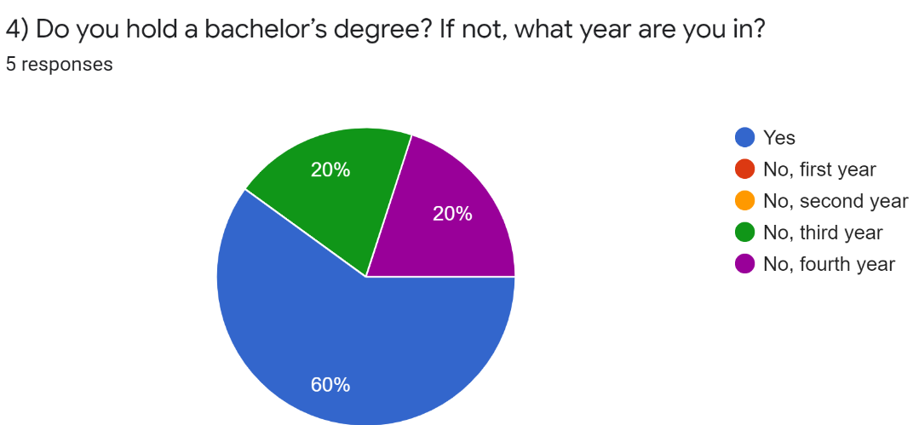
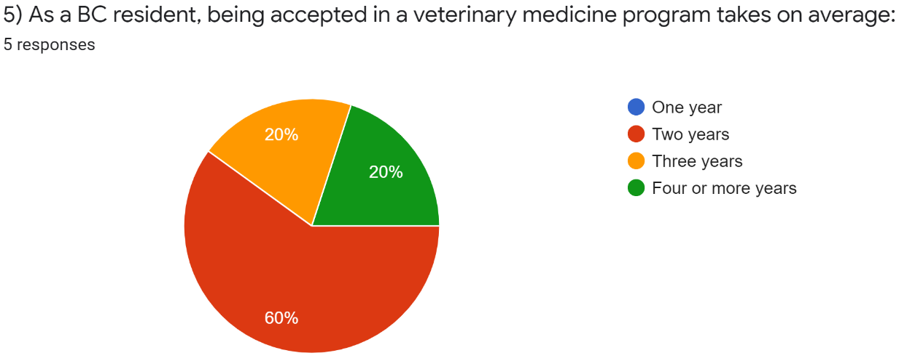
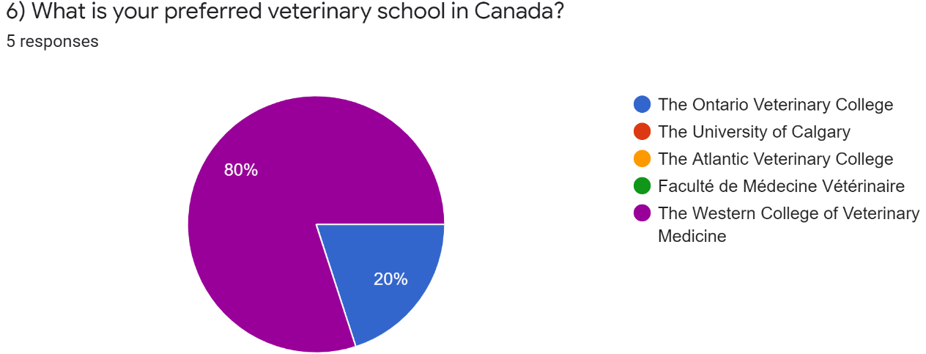
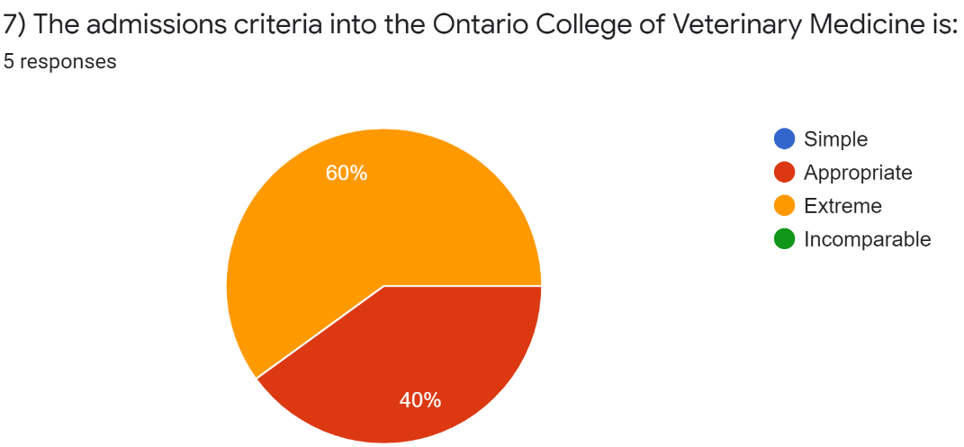
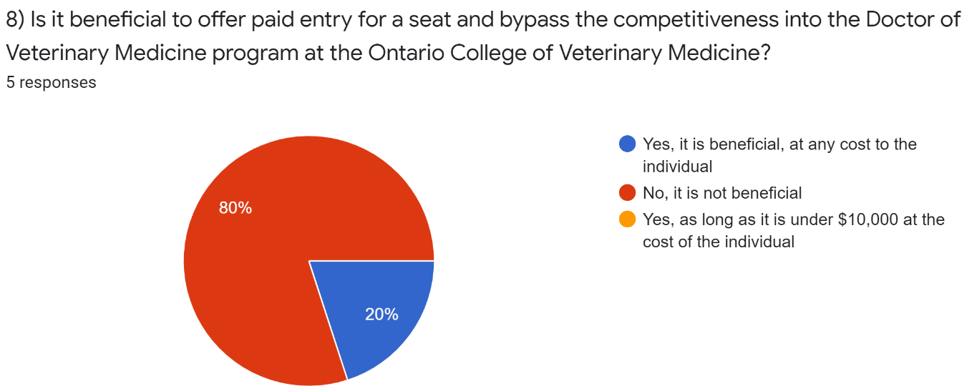
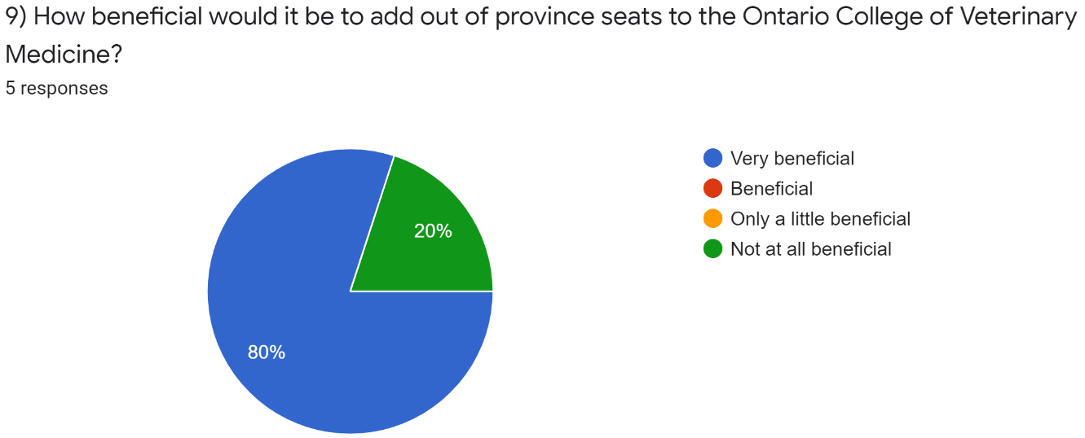
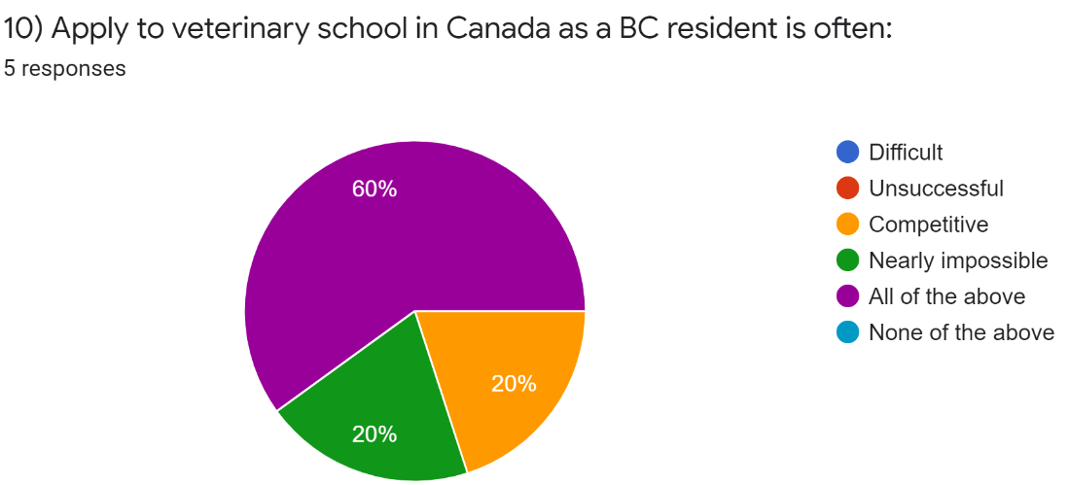
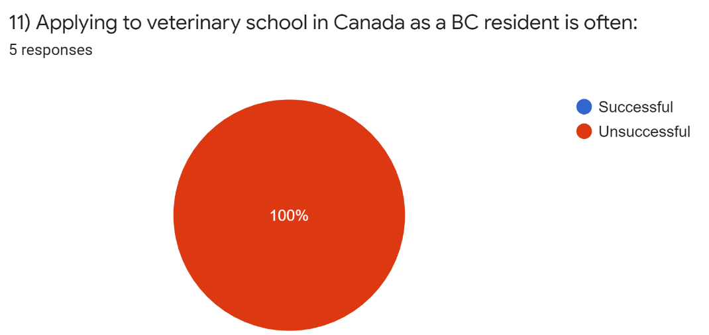
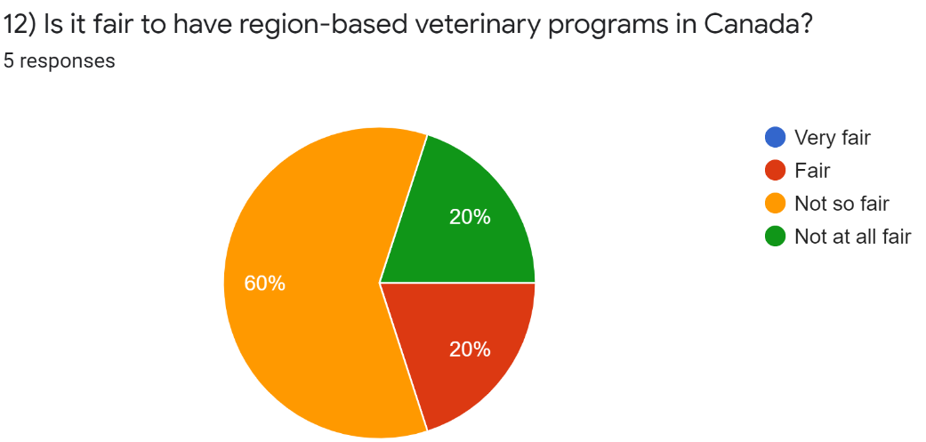
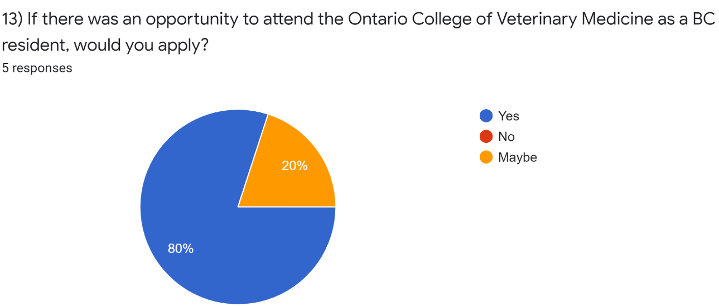
Figure. 1.B. Interview Results from British Columbia Residents
Question | Participant 1: | Participant 2:
- If there was an option to pay entry for a seat and bypass the competitiveness into the Doctor of Veterinary Medicine program at the Ontario College of veterinary medicine would you pay your way in? If so, at what cost? | Yes, $15,000CAD per year | Any
- How many times have you applied to veterinary school? If unsuccessful on your first attempt to apply to DVM school, how many more attempts do you plan to make? | Once, if I go back to school for an alternate career path, I would apply to the DVM program until my studies are complete | As many as it takes
- Would you consider studying the DVM program overseas if Canada is not an option? | No, because it is too expensive and the salary of a DVM does not compare to the amount of debt you would have from student loans. | Yes
- Did you become a resident of the province to apply to the DVM program? If so, how many years have you been a resident prior to applying? | I moved to BC 2 years ago to apply to WCVM. Moved from Ontario because Guelph application process is very selective on course load which I did not meet. In order to be considered I would have to repeat at least 2 years of understand to be even considered. | No
- Do you have any suggestions on how to make the entry process more feasible for BC residents or is there a change you would like to see in the Doctor of Veterinary Medicine program at the Ontario College of Veterinary Medicine? | I feel the government needs to fund a school for the province of BC or at least double the number of funded seats at WCVM. | The BC government should financially support more provincial seats at the WCVM.

Works Cited
“Canadian Students.” OVC Recruitment, www.ovc.uoguelph.ca/recruitment/en/applyingtodvm/canadianstudents.asp.
Holliday, Ian. “B.C. Veterinarians' Organization Says Province Isn't Doing Enough to Address Shortage.” Vancouver Island, CTV News, 15 Dec. 2019, https://vancouverisland.ctvnews.ca/b-c-veterinarians-organization-says-province-isn-t-doing-enough-to-address-shortage-1.4731154?cache=%3FclipId%3D89531%3FautoPlay%3Dtrue
Hill, Andrea. "Vet College could Admit Foreign Students to Help Ease Financial Crunch." Star - Phoenix, Nov 02 2018, ProQuest. Web. 25 July 2020, https://search-proquest-com.ezproxy.library.ubc.ca/docview/2128433335?accountid=14656&pq-origsite=summon
“NDP Government Refuses to Fund Training Spaces to Help Tackle Veterinarian Shortage in B.C.” BC Liberal Caucus, 17 Dec. 2019, https://bcliberalcaucus.bc.ca/ndp-government-refuses-to-fund-training-spaces-to-help-tackle-veterinarian-shortage-in-b-c/
“Selection Process.” OVC Recruitment, www.ovc.uoguelph.ca/recruitment/en/applyingtodvm/selectionprocess.asp.
“Veterinary Medicine.” Admissions, https://admissions.usask.ca/veterinary-medicine.php#Admissionrequirements.
“2018 Annual Report of the Canadian Veterinary Medical Association.” The Canadian veterinary journal = La revue veterinaire canadienne vol. 60,7 (2019): 697-720. https://www.ncbi.nlm.nih.gov/pmc/articles/PMC6563881/?tool=pmcentrez&report=abstract

