Feasibility Analysis of a CIBC Wood Gundy Transition to a Remote Workforce

for

Honourable John P. Manley, P.C., O.C., Chair of the Board, CIBC
Victor G. Dodig, President and Chief Executive Officer,
CIBC
Edward Dodig, Executive Vice President and Head of Private Wealth Management, CIBC

By:
Max Foran
English 301 Student

August 3rd, 2020
Table of Contents
Abstract…………………………………………………………………………………………….
Introduction………………………………………………………………………………………..
Statement of the Problem facing CIBC Wood Gundy………………………………...
Discussion about the Changing Workplace Environment……………………………
Purpose of this Report……………………………………………………………………
Description of Primary and Secondary Data Sources………………………………..
Data Section………………………………………………………………………………………
Presentation of Data……………………………………………………………………...
Discussion about Current Sentiment for Remote Work………………………………………
Proposed Plan for CIBC Wood Gundy…………………………………………………
The Transition to Remote Collaboration……………………………………….
Modification of Current Systems in Place……………………………………...
Analysis of Solution………………………………………………………………………
Cost-Benefit Analysis…………………………………………………………….
Feasibility of Plan…………………………………………………………………
General Application of Solution…………………………………………………
Conclusion…………………………………………………………………………………………
Summary and Interpretation of Findings……………………………………………….
Recommendations………………………………………………………………………..
References………………………………………………………………………………………...

Abstract
The COVID-19 Pandemic is beginning to present a new reality within the workforce. In the early months of 2020, hundreds of thousands of employees across the world were transitioned from working at the office to working in their homes as world governments tried to control a global virus. It has been the largest work-from-home experiment in recent history, and it has justifiably led to questions about the future of the workplace. Once believed to be necessary for companies and their employees, high rent offices in downtown locations are beginning to look increasingly expensive while the benefits of the office space are becoming less clear. To that effect, the COVID-19 pandemic has been the catalyst for many corporations to question whether it is possible for a business to run smoothly with the employees working from their homes. This report investigates whether CIBC Wood Gundy is one of those corporations that could feasibly make this transition.

INTRODUCTION
Statement of the Problem
CIBC Wood Gundy is the corporate and investment banking arm of the Canadian Imperial Bank of Commerce (CIBC). They are a full-service brokerage firm that employs thousands of people. To manage that staff, CIBC Wood Gundy occupies prime real estate locations all across Canada including in many in Canada’s downtown centres. The Bay-Adelaide branch in Toronto, the Réné-Lévesque branch in Montreal, and the Bentall branch in Vancouver are just a few examples of large offices in the premier sections of their city’s downtown. This begs the question: In today’s increasingly digital world, do the high rent costs of these locations justify the reasoning behind even having an office in the first place, that is, to cultivate company culture and employee productivity. In other words, is it feasible for the daily tasks of CIBC Wood Gundy to be executed with a remote workforce? The assumption has always been that a designated office is essential to a successfully run business operation. The COVID-19 pandemic is presenting an opportunity for that assumption to be challenged.

Discussion about the Changing Workplace Environment
Although COVID-19 has been most influential in accelerating a possible transition to the “at-home” economy, these trends are not entirely new. In a report commissioned by Gallup Inc., an American analytics and advisory company based in Washington, D.C., it was discovered that an increasingly larger number of companies are offering their employees the ability to work from home. In other words, companies are beginning to offer a more flexible working arrangement for their employees. Not only are employers becoming more flexible about where their employees work, but the traditional office structure of the Boomer generation is disappearing. In fact, many companies are now looking towards creating an “open-office” concept, giving their employees the ability to come and go as they please, and reducing the presence of private offices. The fact of the matter is that remote work has been on the rise for some time, and the COVID-19 Pandemic has brought the merits for that transition to the front of the minds of many corporations.

Purpose of this Report
The purpose of this report is to determine the current sentiment about working remotely. If it can be determined that employees generally support remote work, this will give corporations greater incentive to weigh the positives and benefits of such an operation. In turn, this will help corporations make decisions and or conclusions about the feasibility of transitioning their workforces online. That being said, every business has its own unique requirements in a working environment, and therefore, this report is written in the context of CIBC Wood Gundy. The aim, therefore, for the purposes of CIBC Wood Gundy, is to show that there are merits for transitioning the workforce to remote collaboration. CIBC Wood Gundy is a business that incurs millions of dollars in office space rentals each year and this report serves as an exploration into whether those costs can be mitigated.

Primary and Secondary Data
The primary data used in this report was gathered through surveys and interviews. The surveys were targeted to those who are currently employed as well as students that are on the brink of entering the workforce. Furthermore, interviews were conducted with current and former employees of CIBC Wood Gundy to understand whether they viewed it as feasible to conduct their job from home.
In addition to the primary data, two articles that investigate the current dynamics of the workplace were used. The first, previously alluded to, was a formal report commissioned by Gallup Inc. This report investigates many developing trends in the American workplace by surveying the wants and needs of employees across the country. The report is presented as a resource for “business leaders optimize their attraction, retention, engagement and performance strategies in a time of extraordinary change.” (Gallup, 1) The second article used was published in the Harvard Business Review and is titled The Implications of Working Without an Office. It was written by Ethan Bernstein, Hayley Blunden, Andrew Brodsky, Wonbin Sohn, and Ben Waber. This article is relevant to the report as it discusses current employee sentiment about remote collaboration with a focus on how employees have fared during the “work-at-home” measures of the COVID-19 pandemic. Furthermore, the article discusses the benefits, the drawbacks, and areas of improvement for remote collaboration, all of which are important considerations for any corporation looking to improve their corporate culture.

DATA SECTION
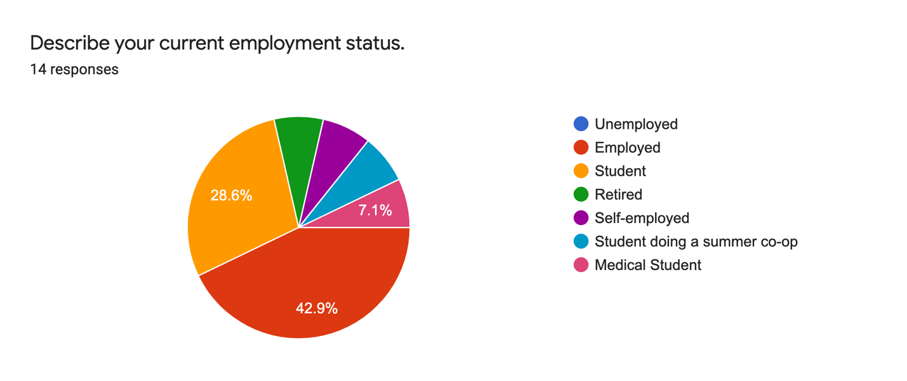
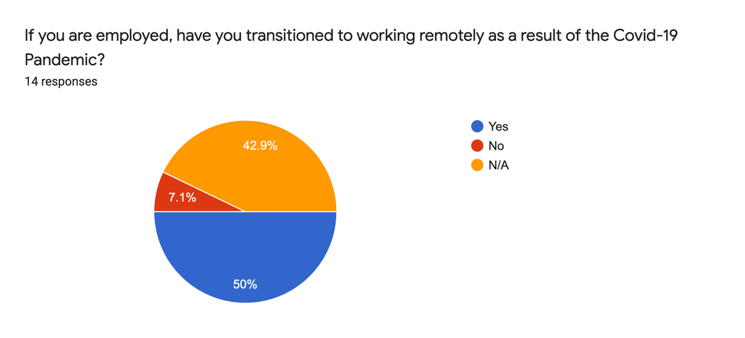
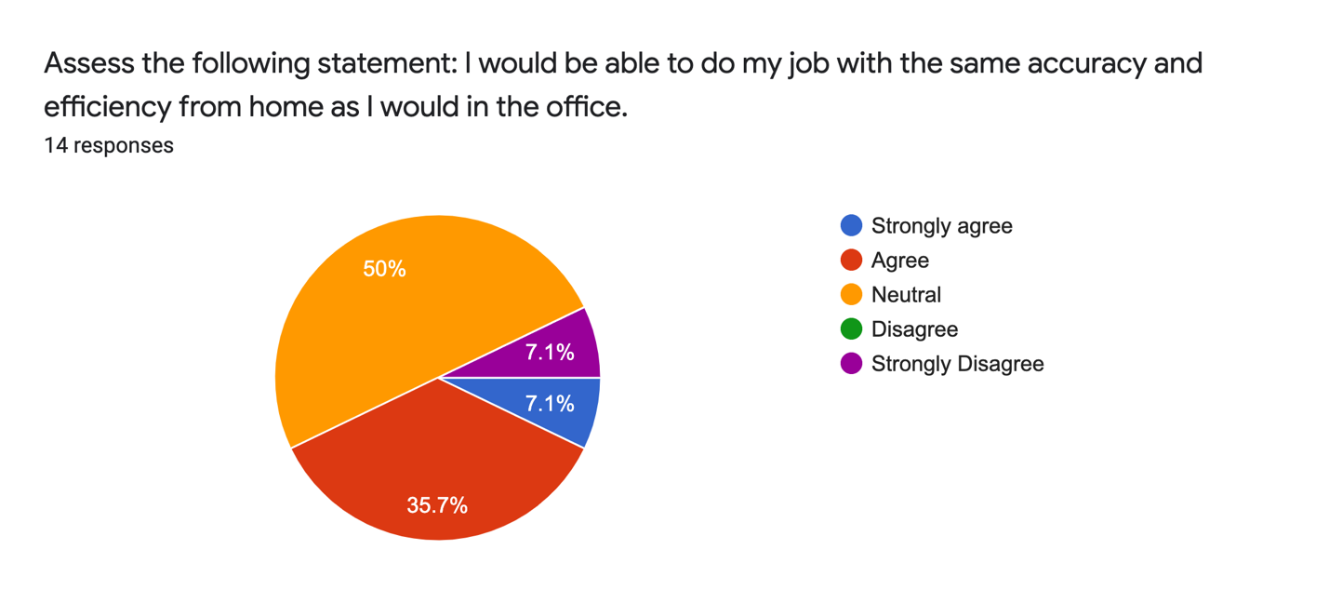
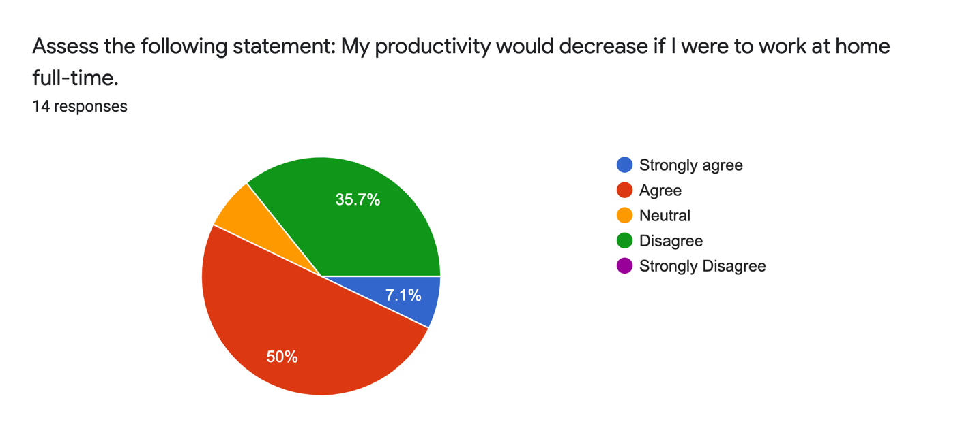
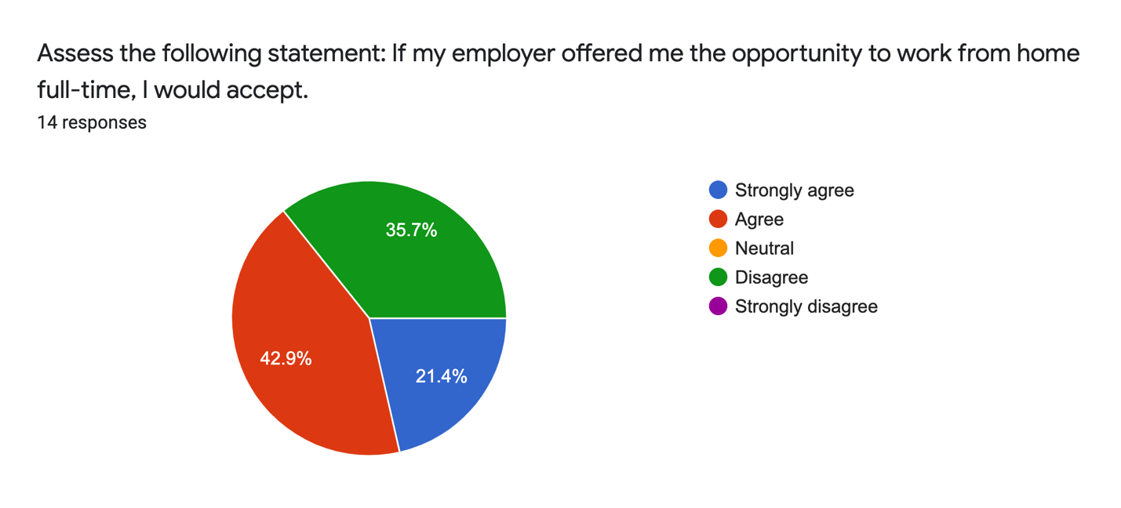
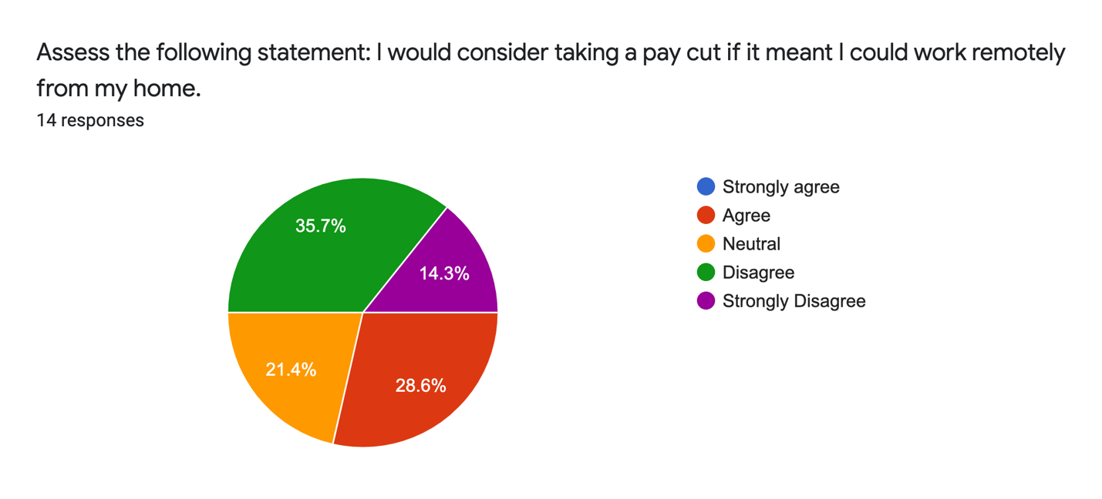
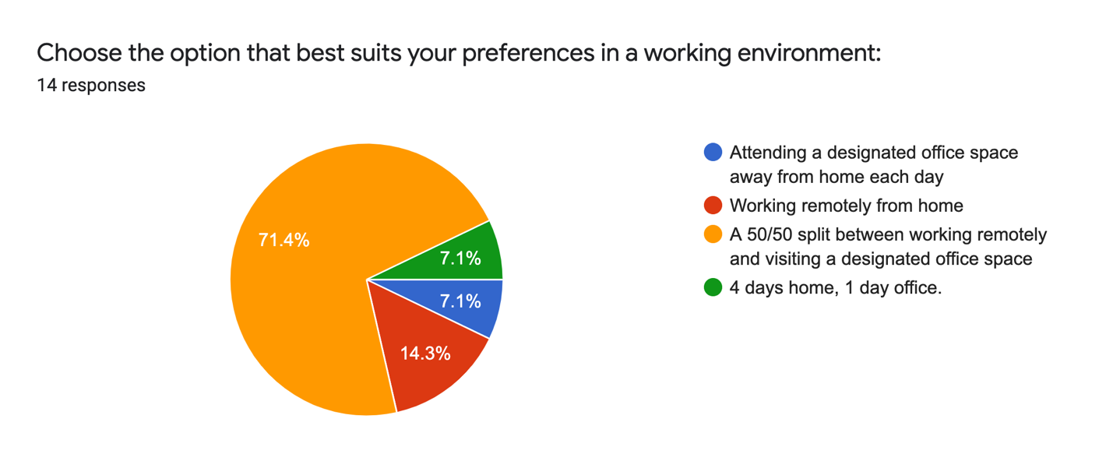
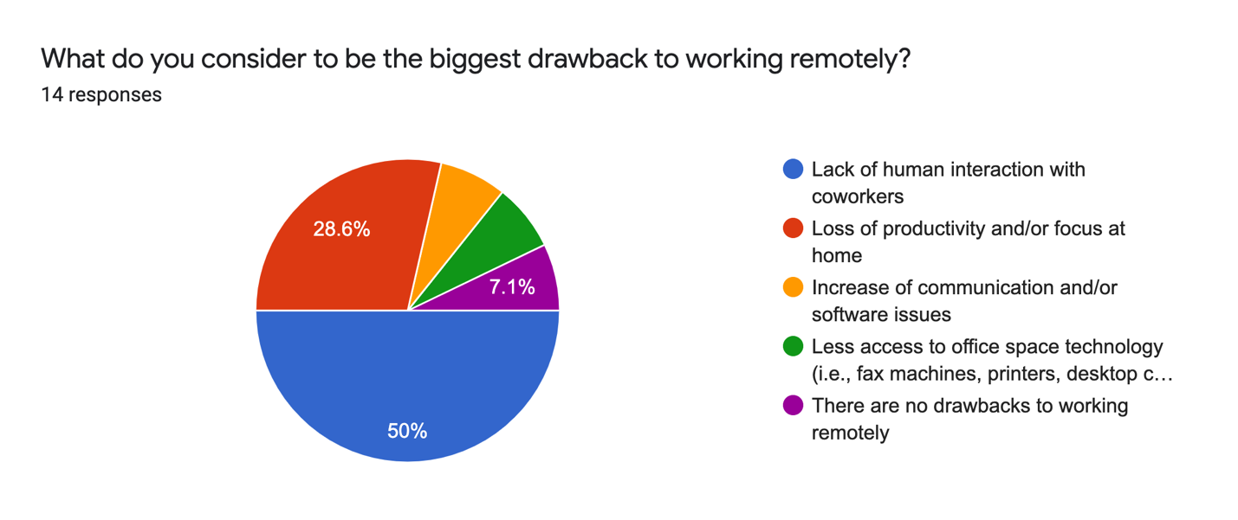

CONCLUSION

