Analyzing the Develop Trend of Human-Caused Wildfire Distribution within Okanagan Valley

Jiajie Xu
ENGL 301
UBC

To:
Government of British Columbia
Wildfire Service

August 3, 2020

Contents
Abstract 3
1.0 Introduction 4
1.1. Background information of human-caused forest fire 4
1.2. Identify the major problem and the potential solution 4
2.0 Method 5
2.1. ArcGIS spatial pattern analysis 5
2.2. Historical population density 6
2.3. Field observation 6
3.0 Result 6
3.1. ArcGIS Kernel Density Estimation 6
3.2. Population density in certain districts 14
3.3. Field Observation 14
4.0 Discussion 16
4.1. ArcGIS Spatial Analysis and the person-caused wildfire develop trend 16
4.2. Population develop trend 16
4.3. Field observations 16
4.4. Overall discussion 17
5.0 Conclusion 17
Reference 19
Appendix 20

Abstract

1.0 Introduction
Wildfires are resulting in a large amount of losses on both natural resources and human beings for a long-term period. Summer wildfires in North America have burned millions of hectares and forced evacuations up and down the continent. In British Columbia, the government spends more than three time of their budget on dealing with wildfires annually. Over 303000 hectares of landmass have been burned over, which is an area more than 26 times of the size of Vancouver. Approximately 50% of the province was covered in smoke. More family had been lost year by year since 2003 (VICE, 2015). In 2018, British Columbia experienced its worst fire season on record, with more than 2000 fires and 1.35 million hectares burned (NEWS 1130, 2020). Not only the climate change is playing an important role in the increasing number of forest fires, but also, human beings is another essential factor in causing wildfires.

Background information of human-caused forest fire
About 40% of wildfires in BC are caused by human beings. Those human activities can be either accidentally or intentionally, include irresponsible use of fire for burning, littering burning garbage, improper use of power generating equipment, and so on. These can become heat sources of forest fires. It is of great importance to notice that person-caused wildfires are preventable (BC Wildfire Service, 2020).

Identify the major problem and the potential solution
As the person-caused wildfires, such a big portion of wildfires, are being noted that they are preventable. It seems to be possible to move a step further and find ways to reduce their occurrence if people can identify the causal relationship and predict its development trend. This is believed to play a positive role in how wildfire managing department allocate limited resources to deal with wildfires and how government departments to spread awareness of wildfire prevention among the public.
The Okanagan Valley, which is a region in the Canadian province of British Columbia defined by the basin of Okanagan Lake and the Canadian portion of the Okanagan River. It has a population of 362258 according to the 2016 Canadian census. The region demonstrates a particularly dry weather and landscape in general (British Columbia Water Resources Service, 1974). In this report, the Okanagan Valley has been selected to become the study area due to its special environmental characteristic of highly sensitive to wildfires.

2.0 Method
Research from three major aspects have been done for this report. All of them were being processed within the Okanagan Valley area. They are the GIS map displaying the wildfires density and develop trend from 1950 to 2020, the population density and its historical change in different districts, and the field observation represent to the traces of human activity with climate data recording, respectively. Results from these research processes are going to be discussed individually, followed by combining them and discovering the connection between them. Conclusion and the potential solution will be provided based on the discussion.

ArcGIS spatial pattern analysis
Data from Government of British Columbia is being collected and the analysis has been processed by using ArcGIS.
- Data targeting and collecting
After selecting the study area and clearing the goal of the research. Datasets below were being collected from the website of Government of British Columbia:
- ok_landscape_units_boundary.shp: Boundaries of sub-districts within the Okanagan Valley area.
- Fire_Incident_Locations-Historical: Historical wildfire locations within the area of province of British Columbia from 1950 to 2019 (Noted: Data points relative to the approximate location of where the fire starts.).
- Fire_Locations-Current: Current wildfire locations within the area of province of British Columbia in 2020 (Noted: Data points relative to the approximate location of where the fire starts.).
- Data input and fixing
Above datasets were being input in ArcGIS. Wildfire locations to be analysis were being limited within the study area. The historical wildfire locations were being split by their causes into person-caused and lighting-caused wildfire. Then, only the person-caused wildfire locations were being extracted and further split into sections arranging by time (by each decade).
- Spatial pattern analysis
Person-caused wildfire locations in each decade from 1950 to 2019 was performed a spatial pattern analysis. The analysis method being used in this research was Kernel Density Estimation, which is a spatial pattern analysis that provide a smooth and continuous pattern related to the density of points within a area and allows to identify hotspots with high density of the input feature.
- Comparing analyzed pattern
Output patterns related to each period were being compared to conclude the develop trend and the hotspot of person-caused wildfire locations through the historical data.

Historical population density
Graph and data of population density displaying the change and develop trend of the population within some districts in Okanagan Valley. In addition, the annual population changes are being shown. Information will be related to the develop trend of the person-caused wildfire and determine if there is sufficient evidence to support there is a relation between them.

Field observation
Field trip was performed for obtaining the field observation and climate data. These were being done in three selected location, two of them were represented to the higher density wildfire locations, and the other is represented to the lower density wildfire location. The purpose of the field trip is to find out if a site which showing a clear sign of human activities or specific climate conditions tend to link to the higher probability of wildfires.

3.0 Result
Major result from each aspects of research are posting in this section. Further and detailed information are posting in the Appendix.

ArcGIS Kernel Density Estimation
Displayed figures are spatial patterns of person-caused wildfire locations related to the density of them. The deeper the colour it is for the centre of the pattern, the denser the wildfire locations were coming together within the specific area.

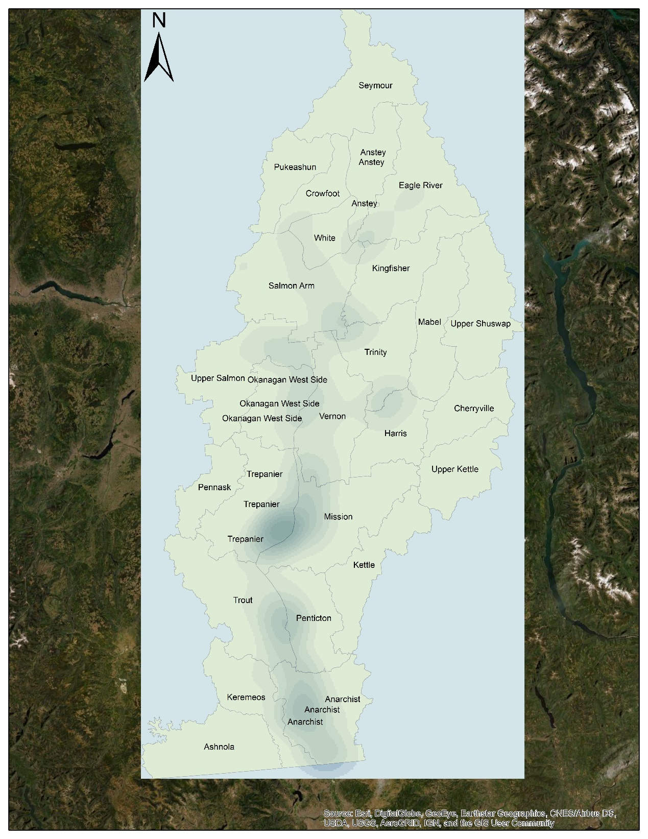
Figure 1. Spatial Patten of Person-caused Wildfire Okanagan Valley (1950-1959)

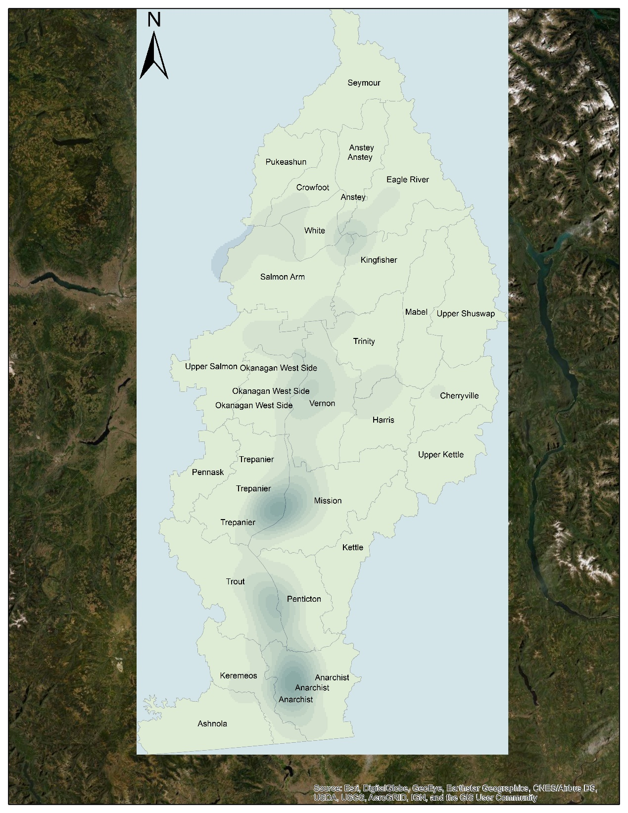
Figure 2. Spatial Patten of Person-caused Wildfire Okanagan Valley (1960-1969)

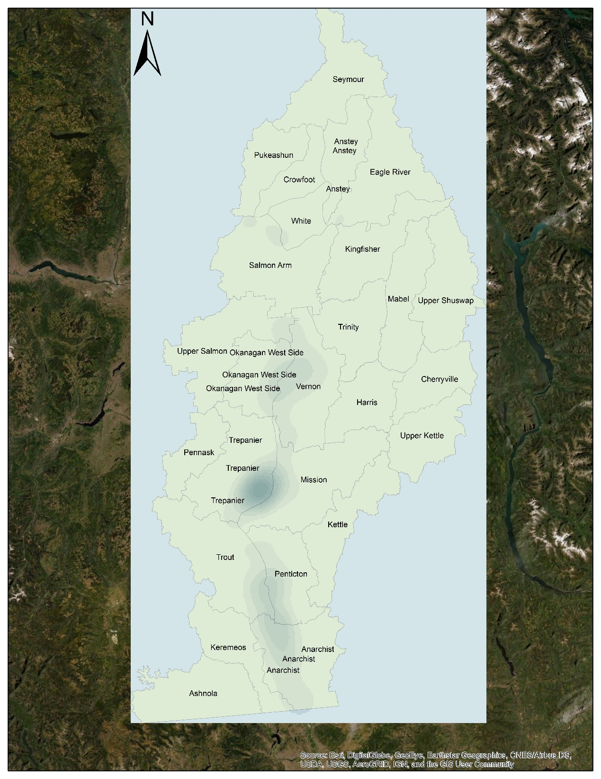
Figure 3. Spatial Patten of Person-caused Wildfire Okanagan Valley (1970-1979)

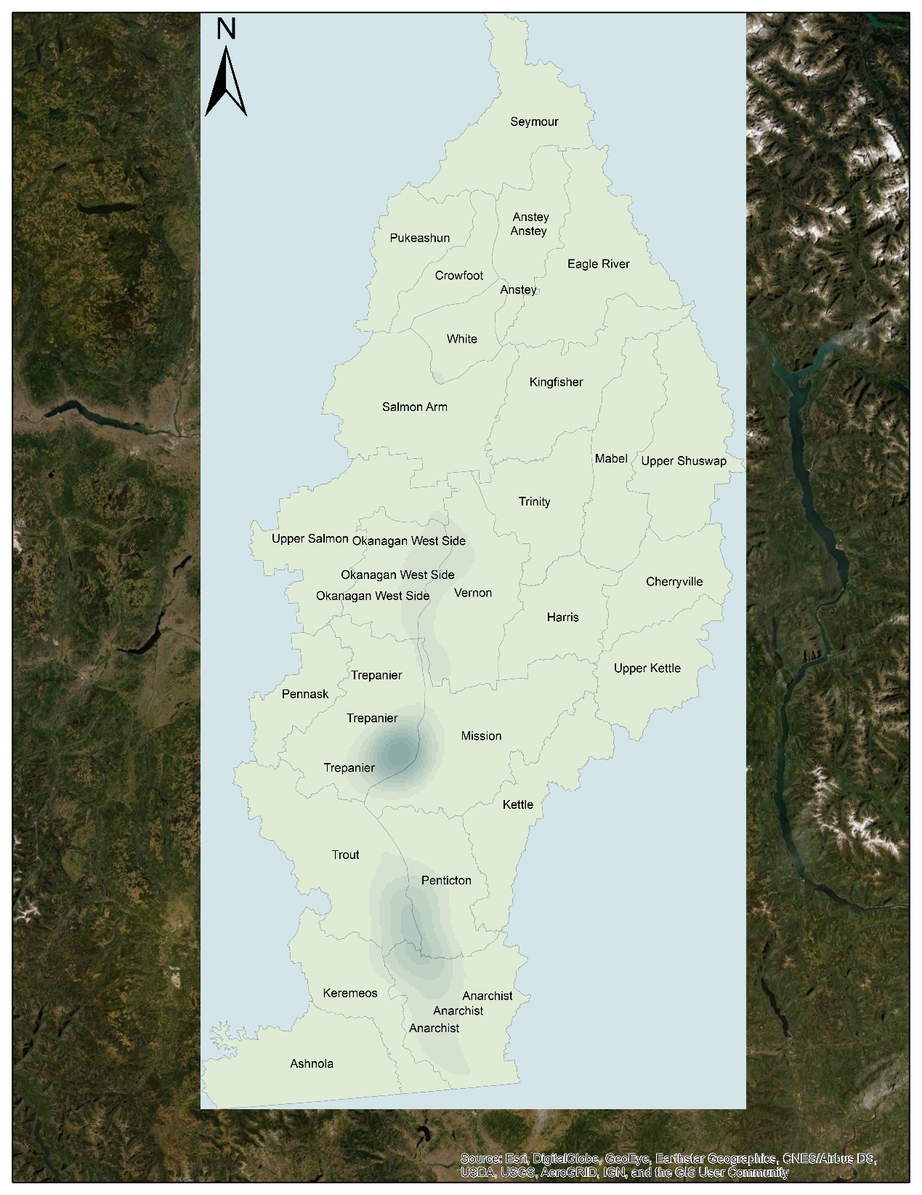
Figure 4. Spatial Patten of Person-caused Wildfire Okanagan Valley (1980-1989)

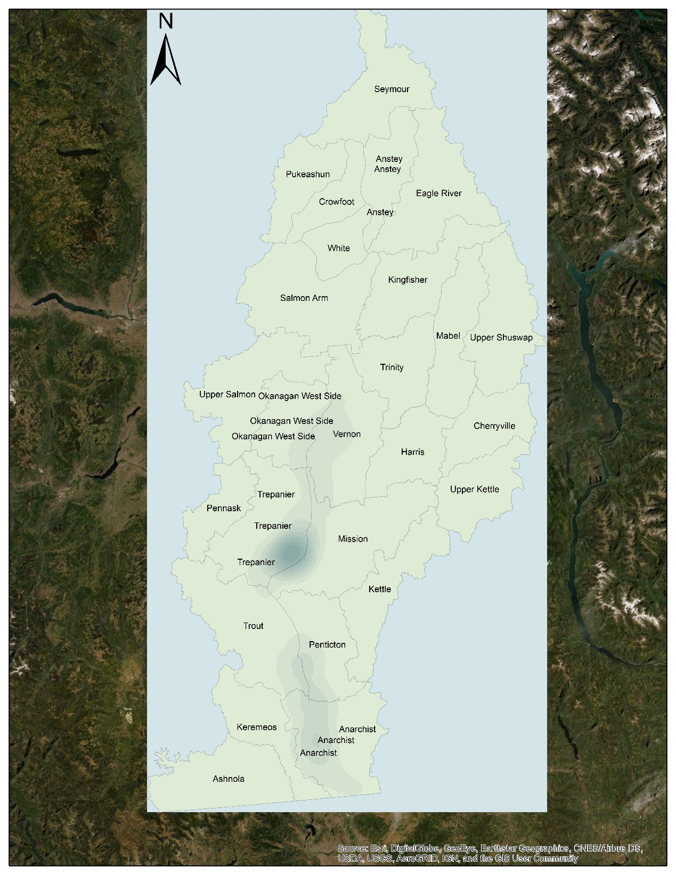
Figure 5. Spatial Patten of Person-caused Wildfire Okanagan Valley (1990-1999)

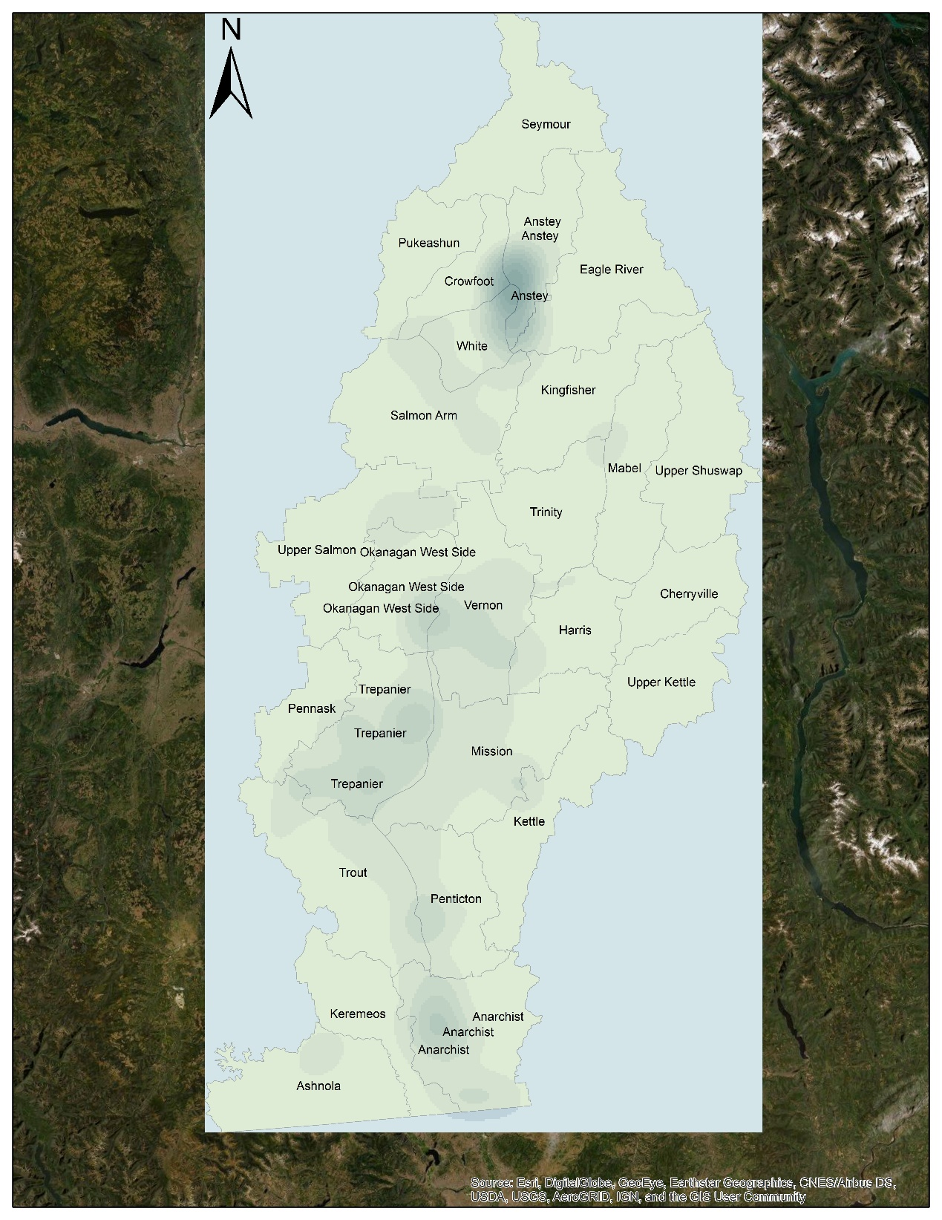
Figure 6. Spatial Patten of Person-caused Wildfire Okanagan Valley (2000-2009)

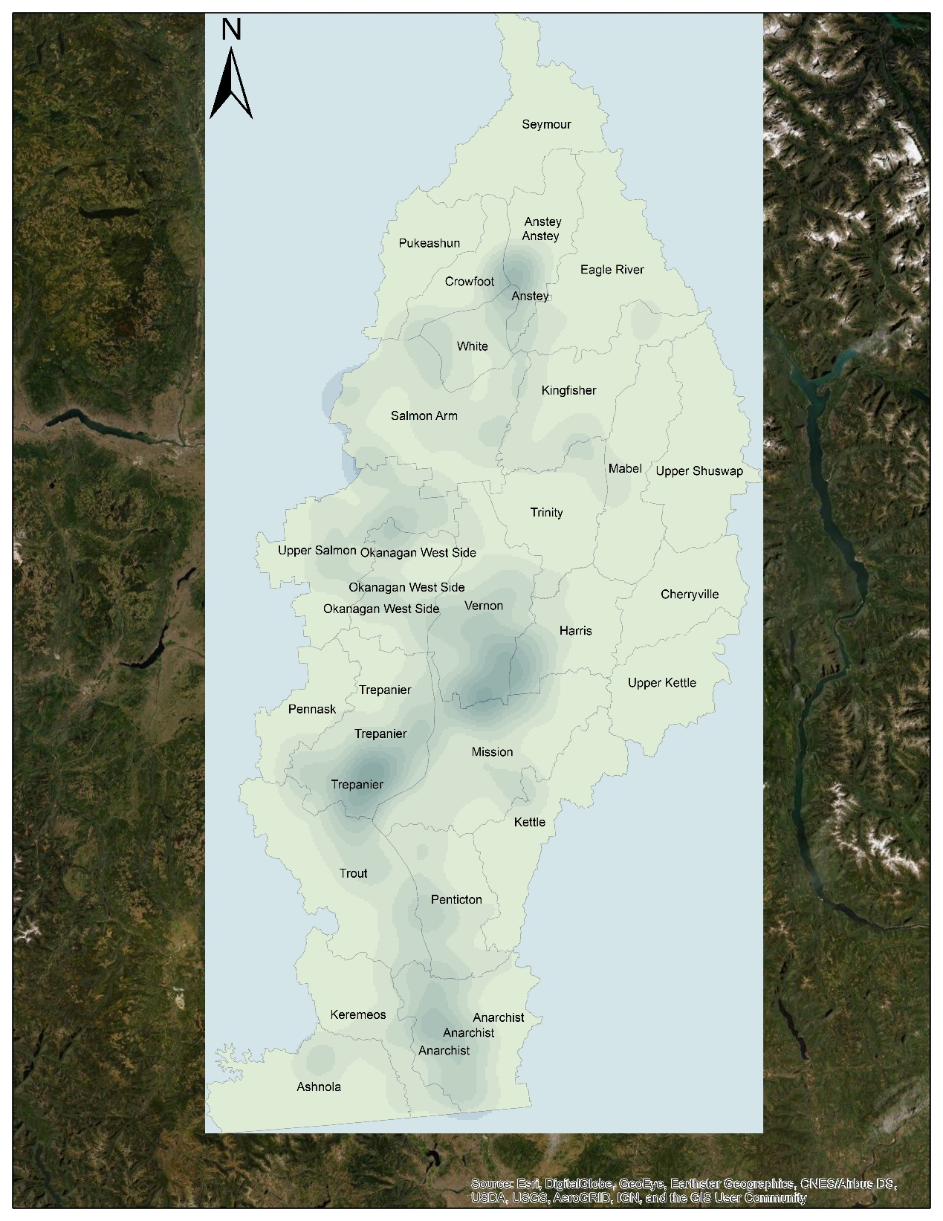
Figure 7. Spatial Patten of Person-caused Wildfire Okanagan Valley (2010-2019)

Population density in certain districts
Displayed are graph of developed trend of population density in certain district where contain human communities.

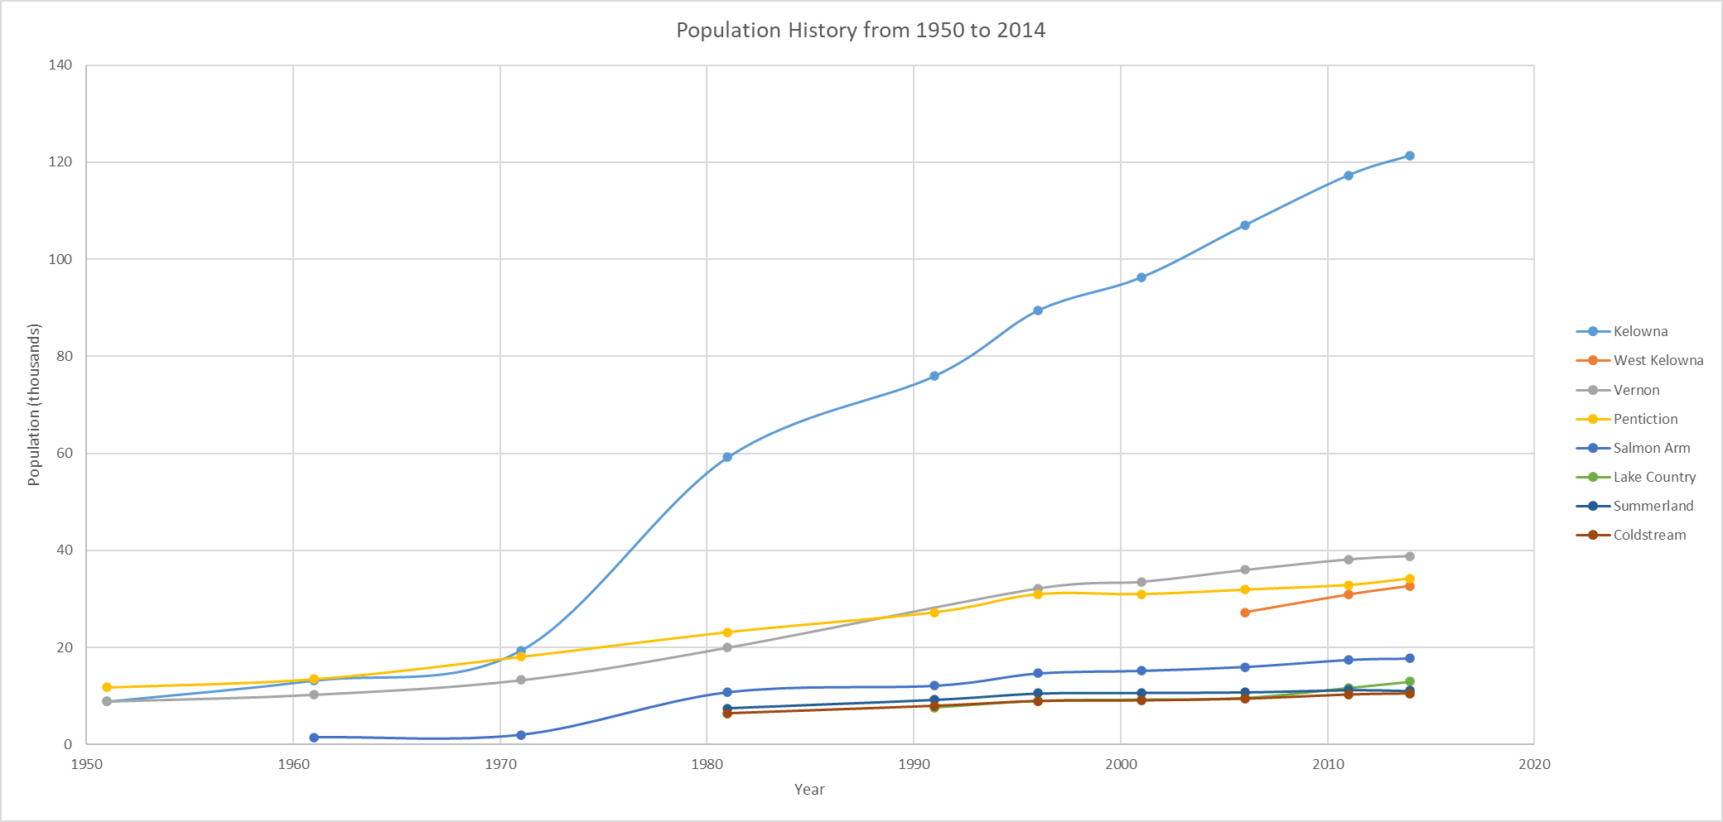
Figure 8. Population History from 1950 to 2014

Field Observation
Three field trips are completed. Field locations are showing as the yellow placemarks on the map below:
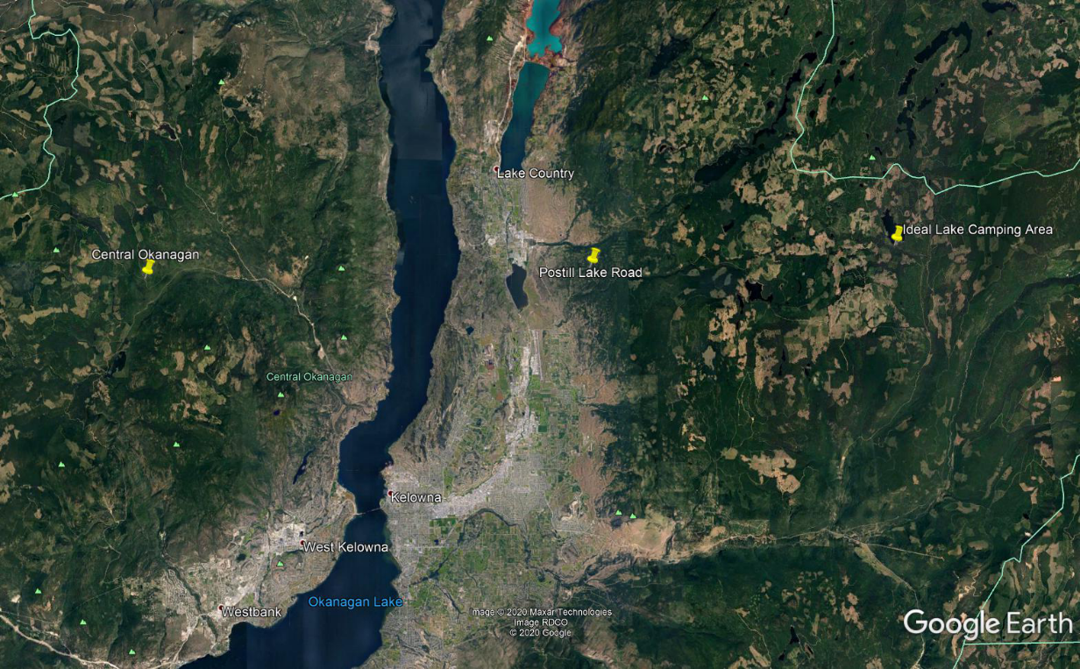
Figure 9. Field Locations
Three field locations were being chose based on the high or low density of person-caused wildfires from 2010 to 2020 within the representative area.
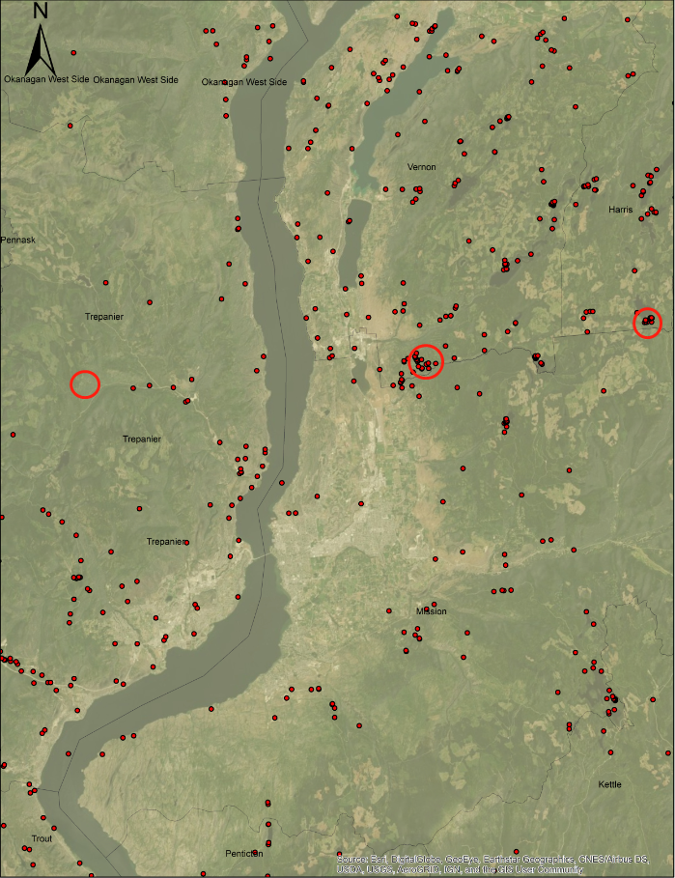
Figure 10. Density of Person-caused Wildfires on Field Locations (2010-2020)

Pictures of field observations and field data will be displayed in the appendix.

4.0 Discussion
Each section of research will be discussed independently. And trying to identify if there is sufficient evidence to prove the link between them.

ArcGIS Spatial Analysis and the person-caused wildfire develop trend
- Person-caused wildfire locations concentrated distributed along the midline position, where around the Okanagan lake from 1950 to 1959.
- Locations points started to gather toward area of Vernon, Mission and Trepanier (Where the city of Kelowna is.). In addition, some toward Penticton district and its southern area until 1999.
- The concentrated area distributed outward the density centre and gradually over spread within the whole Okanagan Valley area except the northeast part of the may from 2000 to 2019.

Population develop trend
- All major living areas demonstrated an overall trend of the population through 1950 to 2014
- From 1971 to 1981, city of Kelowna experienced a dramatic uplift on its populations which left other cities and became the primary city and population centre in Okanagan Valley
- The population increasing rate stay high in city of Kelowna and became the main driving force to push the population growth of the entire region

Field observations
- Postill Lake Road
The area exposes under a strong sunshine with high temperature and low moisture condition in summer days. There are evidences that some plant zones were being burned. Dead wood pieces laid on ground were in gray-black color in an extremely try condition with smokey smell.
There are obvious signs of human activities in the field. Significant amount of garbage being discarded everywhere, some with signs of being burned.
- Ideal Lake Camping Area
The area has a lower temperature and higher moisture condition compare to the first site. This is a location for camping with a lake nearby. No significant amount of discarded garbage. However, around this camping area, there are many traces of human fire, such as burned wood gathered and several campfire locations.
- Central Okanagan Region
Are shows lower temperature and higher moisture condition compare to the first site. There has no obvious sign of human activities. Wild animals in medium size was being encountered during this field trip.

Overall discussion
By linking the population develop trend to the wildfire development trend, it is not difficult to see that the person-caused wildfires locations start to concentrate toward the living area with high population density (such as Kelowna). As the population was growing rapidly within a major city, the density of person-caused wildfires was becoming more and more condense toward the surrounded area. It is noticeable that the person-caused wildfire keeps stay high-concentrated around the hotspot but also start to develop outward and distributed over the study area from 2000 to 2019. This situation is estimated to be caused by the sustained growth of population in major cities, which bring higher risk on wildfires to its surrounded area when people travel around.
By linking the field observation to the current wildfire locations from 2010 to 2020. It is noticeable that locations with higher density of person-caused wildfire shown significant signs of human activities compare to those have lower density. A broader and deeper research on this would indicate how those human activities can caused the wildfire and the frequency of them in much detailed.

5.0 Conclusion
The overall research shows there are evidences to identify that the develop trend of person-caused wildfire can be linked to the population density and human activities. However, these evidences only are only representing some conditions within the study area and being insufficient to support the argument that there are strong relationships between them.

The develop trend of the person-caused wildfires seems to follow the develop trend of areas of high population density. When the population reaches a certain threshold value, the wildfire locations start to spread outward from the hotspot centre and distributed over the area. This can be caused by many different possible reasons such as increase amount of traveling or uses of energy generating equipment and so on.
In addition, field trips and observations within this research indicated
places that shows significant sign of human activities usually easier to have a person-caused wildfire. Although it does not mean garbage from human being and their activities are the directly causes to the wildfire, but it is to be believed that they can become a potential risk to cause a wildfire.
By way of conclusion, it would be worth to produce a broader and deeper research to have sufficient evidence to clarify the relationship between the develop trend of person-caused wildfire and factors on human beings. In this stage, I suggest the Wildfire Service of BC to deploy more resources in area with high population density. At the same time, strengthen the education of citizens on fire prevention awareness and increase the monitor of forest areas with significant human activities.

Reference
VICE. (2015, October 1). British Columbia Is Burning. YouTube. https://www.youtube.com/watch?v=hJJM8TzVtt0

NEWS 1130. (2020, May 7). B.C.’s summer wildfire forecast. YouTube. https://www.youtube.com/watch?v=0h5S6Ay8y-A

BC Wildfire Service. (2020, May 25). Wildfire Causes - Province of British Columbia. Government of B.C. https://www2.gov.bc.ca/gov/content/safety/wildfire-status/about-bcws/wildfire-response/fire-characteristics/causes

The Main Report of the Consultative Board. Canada - British Columbia Okanagan Basin Agreement. Victoria, British Columbia: British Columbia Water Resources Service. March 1974. p. 11. Retrieved 2015-10-25. the region is both scenically attractive and climatically desirable, and has consequently experienced a rapidly expanding resident and tourist population growth

Appendix

