Increasing the Participants of the Annual General Meeting in Monet Community

for
Vivian Yang
Strata Manager
Vivian.Yang@fsresidential.com
Monet Community
Richmond, British Columbia

By Jie Su
ENGL 301 Student
Resident of Monet Community

August 1st, 2020

Table of Contents

Abstract 3
Introduction 4
Situation 4
Problems 4
Significance 4
Research Methods 4
Scope Of Inquiry 5
Data Section 5
Demographics 5
Data limitations 5
Key Factors 5
Meeting Time Conflict 5
Means of Giving Notice of the AGM 8
Timeline of Notice 8
Deemed vs Actual Notice 9
Feasibility Analysis 11
Online/Virtual Meeting 11
Technical Feasibility 11
Ethical Feasibility 11
Web Portal Notification 12
Technical Feasibility 12
Conclusion 13
Summary of Statistics 13
Summary of Problem Causes 14
Solutions 14
References 14
Figures 15

Abstract

This report shows the journey from discovering the phenomena and problems of low attendance for Monet Community meetings, putting forward the research and exploration of residents' willingness to participate in meetings, to working out effective methods to improve the proportion and substantive role of meeting participants through scientific methodology and statistics.

It is worth noting that this methodology is also applicable to a wider range of similar scenarios, similar statistics can be used to analyze the absence of various recurring events and meetings, and use similar solutions in the report to increase attendance. Through the analysis of the data, the main reasons for the low participation rate are analyzed. For the proposed solution, through an interview with Strata Manager the technical feasibility and ethical feasibility analysis are conducted.

Based on the analysis above, to increase the participation rate of AGM, the following methods are recommended:

- Choosing a more appropriate time to hold the meeting
- Setting up virtual/online meeting to deal with the time conflict and covid-19
- Diversifying notification methods, giving notice in person and sending emails to owners
- Advancing notice timeline, giving enough reaction time for residents

Introduction

Situation

The Annual General Meeting (AGM), normally held in the last week of November, generates the administrators to utilize the funds and facilities of the strata, driving and managing the strata affairs on behalf of the residents. According to the meeting minutes of 2019, a total of 30 voters represented last year, with 14 qualified voters and 16 voters of proxy. In the case where the total number of residents with voting rights is 143, this means that the participation rate is only 20% (30/143).

Problems
Residents being unclear about the managing representatives of this community induces a loose control of strata management; As a result, residents lack knowledge of who is utilizing the funds and facilities of the strata for the residential community. Furthermore, weakening self-management realization may result in less involvement in important council activities, and community participation and integration will reduce accordingly in turn.

Significance

Participation in the democratic election is one of the most effective ways to exercise residents’ rights. Effective promotion in the number of participants has a vital impact on the decision-making of democratic affairs within the strata.

Research Methods

To promote the number of participants and increase the attendance rate, this report explores the reasons for the decline in the attendance of the Annual General Meeting. A survey containing ten questions was distributed to community volunteers. The residents passing by the lobby of the residential buildings were given the survey form to collect an effective survey input. The survey used a random sampling method to sample weekday and weekend in July in summer 2020, and the sampling time was 9-11 am, 2-4 pm, 6-8 pm, so as to cover people of various ages and genders, different working status, and even diverse life clocks as far as possible.

Analyzing the reasons merely from the survey feedback may not be sufficient. Subsequently, an interview with the strata manager was conducted to confirm the feasibility of the potential solutions.

Scope Of Inquiry

Through the statistical analysis of the survey, this report will outline the reasons for absence, and the degree of acceptance of possible optimization for the meeting. Finally, these analyses will be summarized, and the conclusions and feasible suggestions will be given.

Data Section

Demographics
The data is divided into two parts: survey to residents of Monet Community and interview feedback with Strata Manager, in which survey is multiple, and manager interview is singular.

Survey collected 45 valid feedback in total, of which 25 (55%) were female, and 20 were male. The survey was primarily conducted in Monet Community's main building (35 units in main buildings), while ten were performed at villa buildings. Weekday has more input, which is 28 (62%) and weekend only 18 input.
The survey takes more at daytime, which leads to 27 (60%) inputs collected during daytime hours and only 18 volunteers at night.

Data limitations
Because of the COVID-19, wearing masks and trying to keep social distance makes it difficult to communicate with volunteers. This also leads to collecting less feedback, and the time volunteers receive interviews tend to be shorter.

For safety reasons, we actively do more surveys during the daytime, which makes the statistics with some bias. One argument could be that residents who travel at daytime may have more leisure time, and they tend to have different reasons for being absent in annual meetings than residents that travel at night after work.

In the interview with the manager, because of the single quantity, there may be the manager's subjective judgment, with a certain degree of bias.

Key Factors

Meeting Time Conflict

The questionnaire collected 45 valid questionnaires, Ninety-five percent of the residents felt that AGM was important, with over half of them (51% percent) felt that AGM was extremely important (Figure 2). However, eighty-two percent among them have not attended the Annual General Meeting once, and only 18% have participated (Figure 1). These data indicate that people have realized the importance of AGM for community management, but for certain reasons, the gap between recognition and participation occurs. Thus, it is necessary to explore the reasons for this inconsistency.

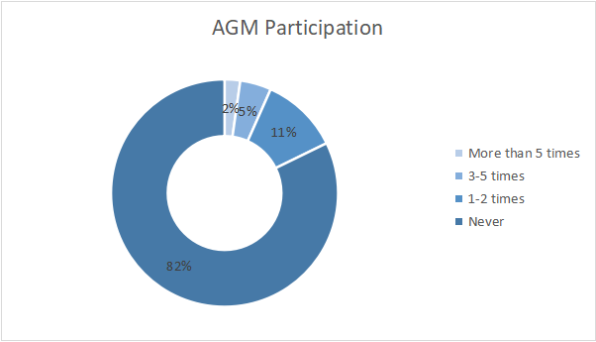
Figure 1 Residents’ Participation of AGM Distribution.

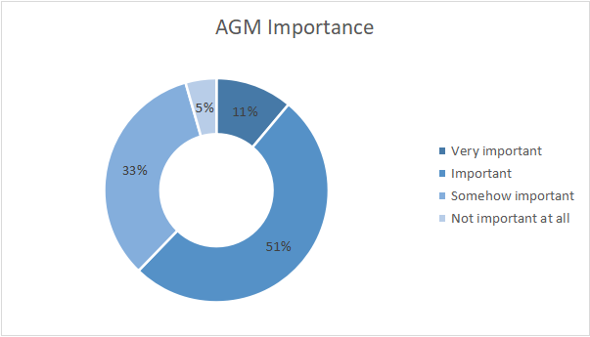
Figure 2 AGM’s Importance to Residents

In order to investigate the difference between the recognition of the importance of the annual general meeting and the degree of participation, this survey puts forward some potential reasons, including the influence of time conflict. Eighty-eight percent of residents believed that time conflict hindered their participation, and more than one-third considered that time conflict seriously affected their participation in AGM, according to Figure 3.

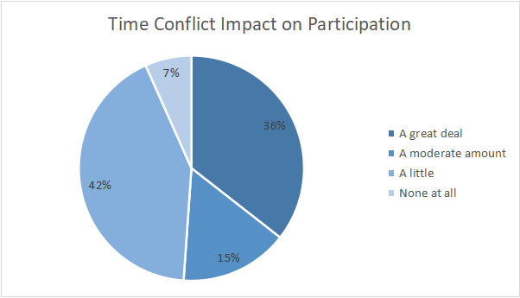
Figure 3 The Impact of Time Conflict to AGM’s Participation

AGM’s general meeting time is the weekday of the last week of November. As compared to the normal meeting time, residents tend to be more inclined to weekend time. The table shows that only eight people want it to be held on weekdays, and thirty-four people of the remaining, accounting for 75.6%, hope it to be held on the weekend.

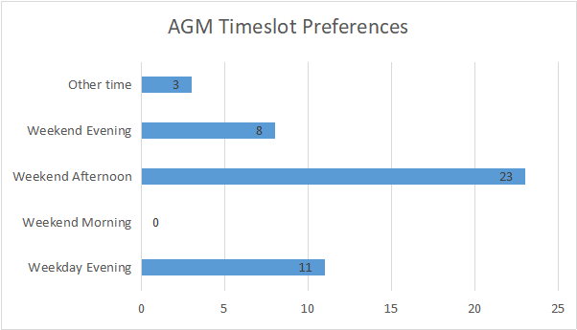
Figure 4 AGM Timeslot Preferences

Means of Giving Notice of the AGM

Another factor that may affect the participation in the giving of AGM Notice includes the time of giving and the form of distribution. The form of giving notice consists of two types, "Deemed Notice" and "Actual Notice." Deemed refers to the use of posters, e-mails, and mails to notify. It only confirms that the notice is issued, not affirming residents know the notice. The actual notice refers to the delivery to the resident in person and confirms the residents notice the meeting.

Timeline of Notice

According to the requirements of BC Strata Management, 14 days' notice in advance is required (VISOA 2013). Monet Community adopts the way of deemed notice to give our notice. Figure 5 shows the time when the residents were notified of the notice.There are 74% of the people learning the AGM time for less than 10 days.

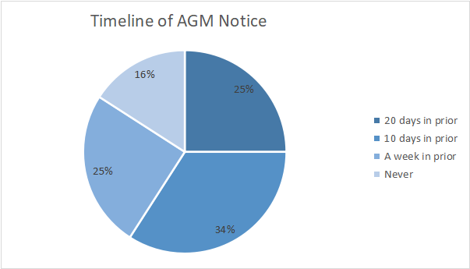
Figure 5 Timeline of Resident Got Notified of AGM

Deemed vs Actual Notice

As stated in Figure 6, the main way for residents to get notified is by notices placed at the main hall or in the elevator. Under Figure 7, over fifty percent of residents want to get noticed by more than one single way. According to Figure 8, one of the two more preferred ways is to add one actual notice way of sending notices, which is Monet Concierges hand out the notice form in person. The other is to utilize email notification; people would like to have the notification via email from Strata Manager.

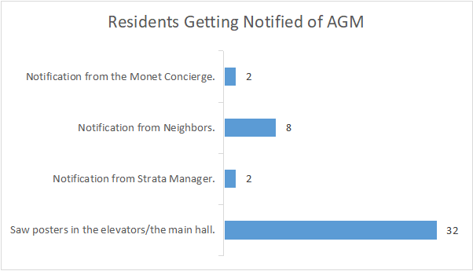
Figure 6 Ways of Notice Residents Received.

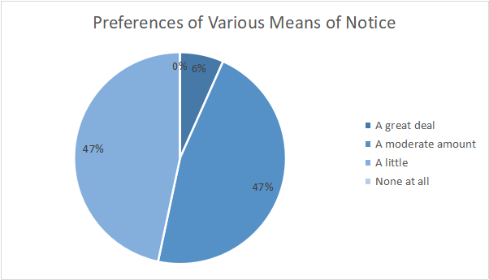
Figure 7 Resident Preferences to Different Means of Notice

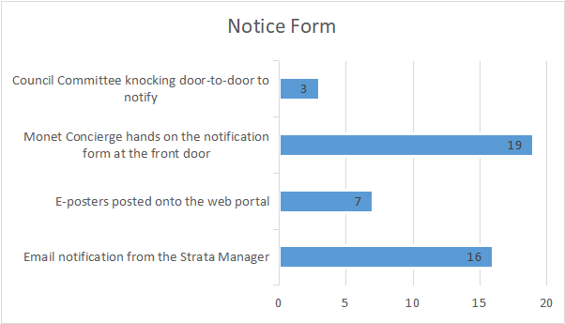
Figure 8 New Notice Form Residents Prefer

Feasibility Analysis

The feasibility analysis is mainly based on the questionnaire survey and the interview of Strata Manager.

Online/Virtual Meeting

Figure 9 shows that people's acceptance of a virtual online meeting is particularly high. More than 35 people hope to conduct online meetings, accounting for 77% of the total.

Technical Feasibility

According to Strata Manager’s interview, due to COVID-19, the plan for 2020’s AGM will be online/virtual. Setting up a means of electronic communication is fairly easy. Therefore, the technical difficulty of online/ virtual meetings is addressable.

Ethical Feasibility

Firstly, electronic communication is only permitted if you have a bylaw that permits general meetings being held electronically and addresses the issues of voter registration identity, proxies, and counting votes (Gioventu 2020). Secondly, online meetings are approved and supported by most residents, as reported by the statistics in Figure 9. Therefore, the feasibility of online meetings at an ethical level can also be realized.

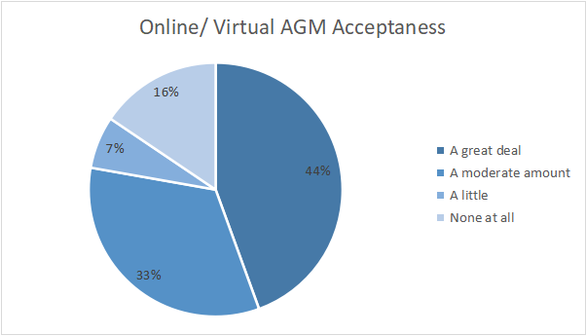
Figure 9 Online/ Virtual AGM Acceptance

Web Portal Notification

Technical Feasibility

According to Figure 10, the use of Web Portal is not high. Eighty-two percent of people never used it before. At the same time, according to the interview with Strata Manager, Web Portal currently does not have the function of publishing notifications and utilizing a web portal to post e-poster as the notice cannot be supported in terms of technical implementation.

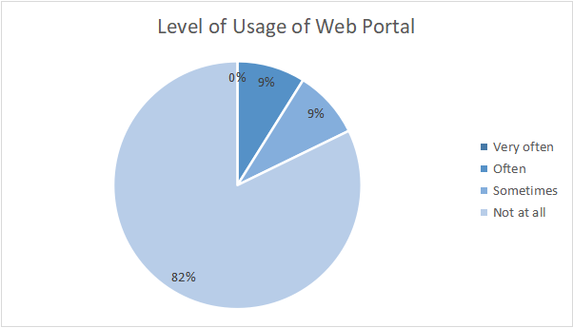
Figure 10 Residents’ Use of Web Portal

Conclusion

Summary of Statistics

From the data analysis, it can be seen that the majority have not participated in annual meetings, but most of them believe that annual meetings are of importance. Most people (74%) agreed that they had been notified of the annual meeting at least ten days in advance.
Here are interesting figures. One third (36%) of residents claimed that meeting time conflict mostly prevented them from participating in the annual general meeting; While about half (42%) pointed out that meeting time caused the conflict to a moderate level. Statistics show that people have different views on the expected meeting holding time, with half of the people (75%) wanting to have meetings on weekends.
Most people (71.1%) made it clear that they received meeting notifications from poster notice in the buildings. If there is an alternative notification, people prefer email notification (35.6%) and apartment administrators to deliver a paper notice in person(42.2%). People generally say (77.8%) that they are very willing to participate in the online virtual annual meeting if it is possible.

Summary of Problem Causes

From the analysis of the statistical results, it can be concluded that people are aware of the importance of annual meetings, some people fail to participate because of time conflict, and another main reason is the way of a notification, which is easy to be ignored by the residents.

Solutions

The Annual General Meeting can be held via electronic means as other alternative options. One reason is to avoid conflicts with work and meet the needs of most people; the other one is to make some shy people feel relaxed, primarily to deal with the exceptional circumstances of COVID-19.

Besides, make full use of as many notice forms as possible to notify owners because many owners may forget the time. One good way to do so is to utilize the Monet Concierge to hand on paper notice in person. The other effective way is to let the Strata Manager send out the notice via emails.

It is very important to choose a more appropriate time to hold the meeting, which can be arranged in the weekend afternoon suggested by most people, or it is better to provide 2-3 time slots at a time for residents to vote. The way of adding notifications will undoubtedly increase attendance, and people are happy to receive notifications from apartment administrators. After all, the meeting is an important thing.
Using the latest IT technology, live streaming offline meetings, and online virtually at the same time will greatly increase the attendance rate. This change not only provides convenience for residents but also saves each resident's time, which will be the best way to improve the attendance rate.

References

Gioventu, Tony. “When large gatherings are prohibited, how do we make decisions?” TheProvince.com, March 19, 2020 https://theprovince.com/life/homes/condos/condo-smarts-managing-through-a-crisis

Russell, Charles. “Deemed delivery of notice” Lexology.com, May 8 2018
https://www.visoa.bc.ca//wp-content/uploads/2019/04/All-About-Strata-AGMs.pdf

VISOA Editor “How much notice is required before holding an Annual or Special General Meeting?” Visoa.bc.ca , June 11, 2013 https://www.visoa.bc.ca/?visoa_faqs=how-much-notice-is-required-before-holding-a-special-general-meeting

Figures

Figure 1 Residents’ Participation of AGM Distribution.

Figure 2 AGM’s Importance to Residents

Figure 3 The Impact of Time Confliction to AGM’s Participation

Figure 4 AGM Timeslot Preferences

Figure 5 Timeline of Resident Got Notified of AGM

Figure 6 Ways of Notice Residents Received.

Figure 7 Resident Preferences to Different Means of Notice

Figure 8 New Notice Form Residents Prefer

Figure 9 Online/ Virtual AGM Acceptaness

Figure 10 Residents’ Use of Web Portal

