Transmission Letter

Determining the Feasibility of Switching to
More Environmentally Friendly Take-Out
Food Containers at Shota Sushi

for
Mr. Dan Han
General Manager
Shota Sushi
August 1, 2020

by
Joanna Yu
English 301 Student

Table of Contents
I. Abstract--------------------------------------------------------------------------------------------------------------- 1
II. Introduction--------------------------------------------------------------------------------------------------------- 2
- Background and Problem Statement------------------------------------------------------------------- 2
- Purpose of the Report and Intended Audience------------------------------------------------------ 2
- Scope of Inquiry---------------------------------------------------------------------------------------------- 3
- Methods-------------------------------------------------------------------------------------------------------- 3
III. Data Section --------------------------------------------------------------------------------------------------------- 4
- Food Items Packed in Styrofoam Take-Out Food Containers -------------------------------------- 4
- The Effects of Styrofoam on the Environment-------------------------------------------------------- 4
- Alternative Environmentally Friendlier Food Take-Out Containers------------------------------ 6
- Challenges in Switching to More Environmentally Friendly Take-Out Food Containers at Shota Sushi ----------------------------------------------------------------------------------------------------- 7
- Research and Analysis---------------------------------------------------------------------------------------- 10
- Research Methods--------------------------------------------------------------------------------------- 10
- Survey Background--------------------------------------------------------------------------------------- 10
- Consumer Trends and Behaviour--------------------------------------------------------------------- 10
IV. Conclusion------------------------------------------------------------------------------------------------------------ 13
- Summary of Findings------------------------------------------------------------------------------------------ 13
- Analysis of Findings-------------------------------------------------------------------------------------------- 13
- Recommendations--------------------------------------------------------------------------------------------- 13
V. References------------------------------------------------------------------------------------------------------------- 14

Figures and Tables
Figure 1: Food Items Packed in Styrofoam Containers------------------------------------------------------------ 4
Figure 2: Paper Bowl------------------------------------------------------------------------------------------------------- 6 Figure 3: Dimensions and Prices of Paper Bowl--------------------------------------------------------------------- 6
Figure 4: Paper Box--------------------------------------------------------------------------------------------------------- 7
Figure 5: Dimension and Price of Paper Box-------------------------------------------------------------------------- 7
Figure 6: Compostable Clamshell Container ------------------------------------------------------------------------- 8
Figure 7: Dimension and Price of Compostable Clamshell Container------------------------------------------ 8
Figure 8: Sugarcane Container------------------------------------------------------------------------------------------ 9
Figure 9: Dimension and Price of Sugarcane Container----------------------------------------------------------- 9
Figure 10: Factors Affecting Customer Purchasing Decision ---------------------------------------------------- 11
Figure 11: Effect of Companies’ Environmental Commitment to Consumers ------------------------------- 11

I. Abstract

II. Introduction
A. Background and Problem Statement
According to Statistics Canada, businesses in BC produced about 1.7 million tonnes of wastes in 2016 (Statistics Canada: Canada's National Statistical Agency / Statistique Canada : Organisme Statistique National Du Canada). It is estimated that there are about 11,000 restaurants operating in BC (Foodservice Industry Research. (2019). Restaurants make up one of the biggest industries in the business sector. Shota Sushi is a popular Japanese restaurant for dine-in and take-out. Most of their take-out orders are packaged in Styrofoam take-out containers. Styrofoam is made from polystyrene, which typically insulates better, keeps food fresher and cost efficient (What is Polystyrene?: Uses, Benefits, and Safety Facts, 2020). Since Shota Sushi serves an average of forty-eight take-out orders per day, this translates to about 120 containers daily which equals to 43,800 containers annually that weigh about 1200 pounds. These wastes eventually end up in landfills which can have a quite significant effect on the environment.
Styrofoam is not biodegradable. When disposed in landfills, it causes harm to our health and the environment. Removing Styrofoam from landfills and exposure to sunlight can benefit our health and the ozone layer. Improving the existing use of Styrofoam take-out food containers at Shota Sushi will not only contribute to a better environment and health, it may also potentially attract environmentally conscious customers and increase business, especially during this unprecedent time of the pandemic where take-out orders are thriving.
B. Purpose of the Report and Intended Audience
The purpose of this report is to assess the feasibility of switching to more environmentally friendly take-out food containers at Shota Sushi which reduces the amount of Styrofoam that end up in landfills. Improving the choice of take-out food containers at Shota Sushi will not only reduce harmful toxins that are environmentally degrading and hazardous to people’s health but also help Shota Sushi’s business retain and attract environmentally conscious consumers.
The intended audience of this report are:
- Mr. Dan Han, general manager of Shota Sushi.
- Staff at Shota Sushi responsible for fulfilling take-out orders.

C. Scope of Inquiry
To assess the feasibility of the proposed solutions for switching to more environmentally friendly take-out food containers at Shota Sushi, I plan to pursue five areas of inquiry:
- What benefits, if any, can a business realize in switching to more environmentally friendly food take-out containers from Styrofoam based containers?
- What are the types of Styrofoam food container substitutes available in the market which are environmentally friendlier?
- What are the costs of such environmentally friendly food container products?
- What is the minimum order required by suppliers for environmentally friendly food containers?
- Are environmentally friendly food containers readily available from suppliers?

D. Methods
An interview was conducted with Mr. Dan Han, the general manager of Shota Sushi to better understand the company’s current food take-out business and guidelines. Additionally, observations were made at the Shota Sushi to gain insight of the current take-out business and procedures. Moreover, an interview was conducted with a sales representative at Eco-Packaging regarding the choices, availability, minimum order quantity and prices of packaging products that are environmentally friendlier than Styrofoam. Customers of Shota Sushi were also randomly surveyed to gather information regarding consumer preference and behaviour towards environmentally responsible companies. Finally, information from secondary sources such as websites were used to support the information gathered.

III. Data Section
A. Food Items Packed in Styrofoam Take-Out Food Containers
Figure 1 shows which food items for take-out use the most Styrofoam based containers at Shota Sushi.
Noodle Soup | Main Dishes
Set Meals | Sashimi
Sushi | Appetizers
Figure 1: Food Items Packed in Styrofoam Containers
B. The Effects of Styrofoam on the Environment
Styrofoam is made from polystyrene, a non-sustainable material which has long term impact on the environment. Further complicating the problem is when Styrofoam ends up in landfills and waterways, which causes further environmental and health issues.
- Styrofoam’s basic raw material is derived from petroleum, a non-sustainable and non-biodegradable resource.
- When Styrofoam ends up as trash, it is typically sent to landfills. Styrofoam could also end up in our seas. In either case, it causes environmental and health problems.
- Humans can be harmed when consuming fish and seafood. Since Styrofoam can end up being eaten by fish where it absorbs collects its toxins and chemicals.
- Styrofoam takes about 500 years to decompose which creates harmful air pollutants that deplete the ozone layer (Little).
- Styrofoam makes up one of the main components of debris in our seas because it floats and accumulates along the earth’s bodies of water.
- The longer Styrofoam stays in our waters, it breaks into small pieces and ingested by aquatic animals. This leads to the death of their death because their stomachs get clogged which causes them to stop eating (The Environmental Impact of Food Packaging, 2020).

C. Alternative Environmentally Friendlier Food Take-Out Containers
One possible strategy to lower Styrofoam waste by Shota Sushi is to use alternative take-out food containers that are environmentally friendlier. According to Eco-Packaging, one of the biggest suppliers of food compostable wares in BC, items such as compostable paper, clear, and sugarcane containers can be used for packaging of take-out food orders instead of Styrofoam.
Paper containers are ideal for food items that are warm and/or with liquid such as noodle soup. Paper is derived from trees that are harvested and re-planted, which already makes it a more renewable option than Styrofoam. Additionally, paper is endlessly recyclable. It won’t degrade despite being recycled a dozen times and it can safely rot in a landfill. Figure 2 and 3 show an example of a take-out container made from paper and its price respectively.
.
Figure 2: Paper Bowl (PFC12 - 12 oz)

Size | Price
12 oz | $141/1000 pcs
Figure 3: Dimensions and Price of Paper Bowl

Another packaging alternative to Styrofoam take-out food containers are paper based food boxes. Paper food boxes are specifically designed to store food to protect food from being exposed to harmful substances from the environment. It has a secure folding and locking tab, leakproof and comes in various sizes. The food stored in eco-friendly packaging boxes can retain its freshness by absorbing the temperature contents. Figure 4 and 5 show an example of a paper box take-out container and its price respectively.
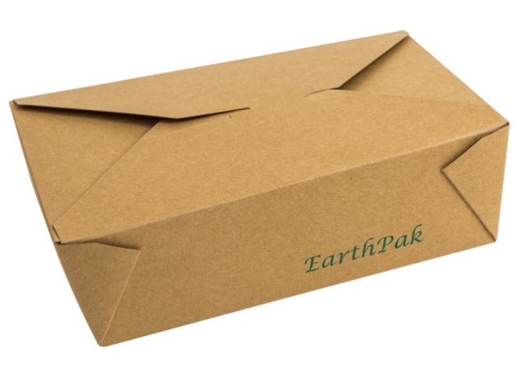
Figure 4: Paper Box (EP#-N3)

Size | Price
7 3/4 x 5 1/2 x 2 ½ inches | $77/200 pcs
Figure 5: Dimensions and Price of Paper Box

Another alternative are compostable clamshell containers which are ideal for displaying food that are visually attractive like sushi and sashimi. Compostable clamshell containers are also be lined with a thin sheet of polylactic acid (PLA) material that prevents moisture and grease from reaching the shell. The lining gives the container superior grease and moisture resistance and ensures it retains its original shape and rigidity when in contact with hot, wet foods. This product addresses the issue of bio-based containers softening and losing their structural integrity when serving hot and moist food. Figure 6 and 7 show an example of a clamshell take-out container and its price respectively.

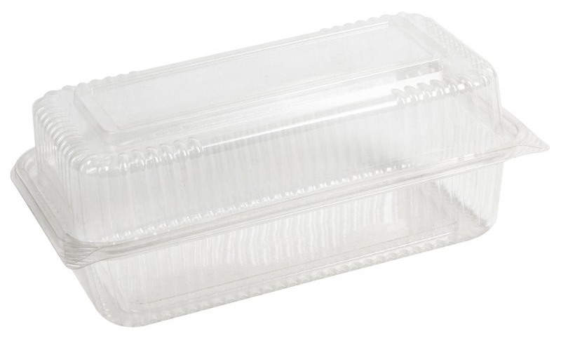
Figure 6: Compostable Clamshell Container (EP-KHC951)

Size | Price
8 x 8 x 3 inches | $108/172 pcs
Figure 7: Dimensions of Compostable Clamshell Container

Another option would sugar cane food containers. Sugar cane is a very versatile plant. It is not only used as a source of sugar and biofuel for vehicles but also to produce take-out food containers. The material has plenty of benefits, ranging from high temperature tolerance, biodegradable and high durability. Also, the material is fully-recyclable, allowing companies to reuse the material multiple times. Figure 8 and 9 show an example of a clamshell take-out container and its price respectively.
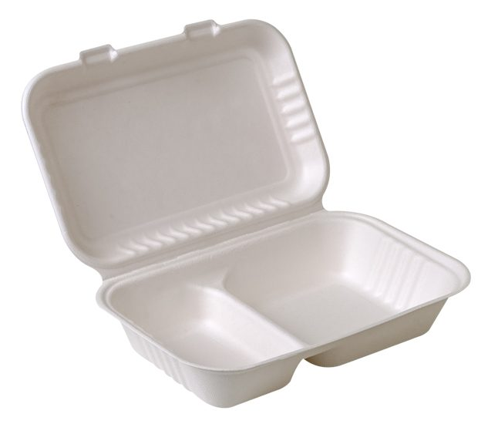
Figure 8: Sugarcane Container (EP-A9632)

Size | Price
9 x 6x 3 inches | $132/200 pcs
Figure 9: Dimensions of Sugarcane Container

D. Challenges in Switching to More Environmentally Friendly Take-Out Food Containers at Shota Sushi
In improving Shota Sushi’s choice of take-out food containers, Mr. Dan Han, anticipates three main challenges. First, Styrofoam alternatives have to be able to maintain the food temperature and freshness for a reasonable time, especially during colder months. Second, environmentally friendlier take-out food containers may have higher costs than Styrofoam based containers. Last, the stability of prices and supply of environmentally friendly take-out food containers.

E. Research and Analysis

1.) Research Methods
Fifty customers at Shota Sushi participated in a short random survey designed to analyze the current trends on consumer preference and behaviour towards environmentally responsible companies. Interviews with Mr. Dan Han, staff of Shota Sushi, and a sales representative of Eco-Packaging were conducted to determine background information on Shota Sushi’s food take-out business and procedures and alternative packaging products to Styrofoam respectively. Finally, research from credible websites were conducted.

2.) Survey Background
The survey was conducted randomly in two days among customers of Shota Sushi. Due to the unprecedented coronavirus situation, only fifty respondents were surveyed. This may not be fully representative of consumers’ different behaviours towards environmentally responsible companies. Therefore, a certain degree of discrepancy may occur in the data gathered.

3.) Current Trends and Behaviour
Figure 10 below shows thirty-four out of the fifity respondents said that a company’s commitment to environmental sustainability influences their decision whether to patronize a restaurant. Additionally, the bar graph in Figure 11 shows eighteen out of the fifty respondents are likely to not to buy a product from less environmentally committed. Moreover, Butler argues that, 87% of consumers would consider buying a product with an environmental benefit(s) given the opportunity.

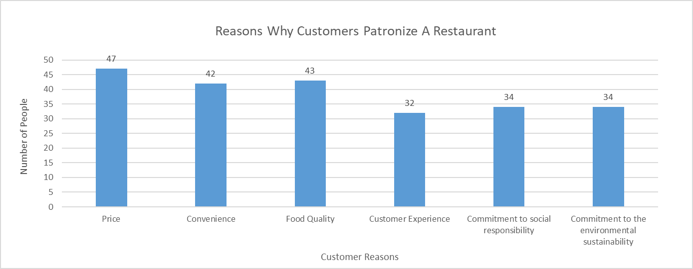

Figure 10: Factors Affecting Customer Purchasing Decision

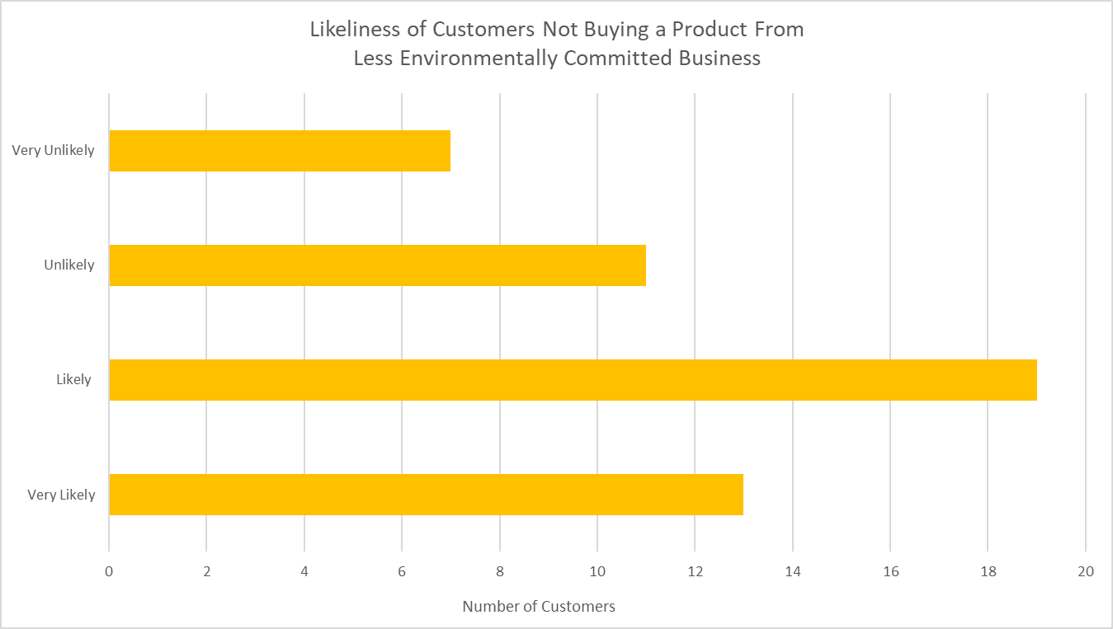

Figure 11: Effect of Companies’ Environmental Commitment to Consumers

IV. Conclusion
A. Summary of Findings
Shota Sushi serves an average of forty-eight take-out orders a day using close to 120 Styrofoam take-out food containers in the process. These orders make up a good portion of Shota Sushi’s business but also produce a significant amount of Styrofoam waste that pollute the environment and harm our health.
Food packaging suppliers like Eco-Packaging offer a wide range of environmentally friendly take-out food containers. These alternative environmentally friendlier products to Styrofoam are designed to maintain the freshness of food, cost effective, and readily available in the market.
Finally, most of the survey respondents’ decision whether to purchase a product can be influenced by a company’s environmental commitment. Furthermore, research from secondary sources is consistent with respondents’ survey results.
B. Analysis of Findings
The present packaging being used for take-out food containers at Shota Sushi has room for improvement to curb environmental pollution. Replacing Styrofoam take-out food containers at Shota Sushi will help eliminate 43,800 containers that weigh about 1200 pounds from ending up in landfills annually, which can have a quite significant effect on the environment. The move to more environmentally friendlier take-out food containers will cost the restaurant about twenty cents for each container. However, many consumers do not mind paying more for products that are committed to environmental sustainability and many would likely not purchase a product that harms the environment. Being an environmentally committed company can lead to an increase in business by maintaining and attracting environmentally conscious customers.
C. Recommendations
The purpose of this report was to determine the feasibility of switching to more environmentally friendly take-out food containers at Shota Sushi. Based on the findings of this report, there are three recommendations for Shota Sushi to consider.
- There are several environmentally friendly take-out food containers that are readily available in the market to choose from. Choosing the most suitable container for each type of food item will help control costs and ensure that the freshness of food is maintained.
- Educating restaurant staff on which environmentally friendly take-out food container to appropriately use will ensure that company goals on cost control and food quality are met.
- Passing half of the additional packaging costs to customers for the first three months and the full costs after will help cover the higher costs of environmentally friendly take-out food containers and maintain the company’s target profit.

V. References
Works Cited
Butler, Adam. “Do Customers Really Care About Your Environmental Impact?” Forbes, Forbes Magazine, 21 Nov. 2018, www.forbes.com/sites/forbesnycouncil/2018/11/21/do-customers-really-care-about-your-environmental-impact/#652d7367240d.
Foodservice Industry Research. (2019, August 21). https://www.restaurantscanada.org/research/.
Little, Mark. “Facts About Landfill & Styrofoam.” Sciencing, 25 July 2020, sciencing.com/facts-about-landfill-styrofoam-5176735.html.
Statistics Canada: Canada's National Statistical Agency / Statistique Canada : Organisme Statistique National Du Canada, www150.statcan.gc.ca/t1/tbl1/en/tv.action?pid=3810003201.
The Environmental Impact of Food Packaging. FoodPrint. (2020, March 30). https://foodprint.org/issues/the-environmental-impact-of-food-packaging/.
What is Polystyrene?: Uses, Benefits, and Safety Facts. (2020, May 08). Retrieved July 31, 2020, from https://www.chemicalsafetyfacts.org/polystyrene/

