University of British Columbia
Vancouver, BC V6T 1Z4

August 17, 2020

Paul Whitaker
Store Manager
London Drugs #006
Burnaby, BC V3L 5H1

Dear Mr. Whitaker
Here is my report

My Qualifications
A staff member of 5 years I am familiar with London Drugs procedures, policies, and practices in regard to business to consumer interactions and can use this in the development of the research methods to be in line with company policies. As an economics and business student, I have insight into marketing tactics that improve engagement. Additionally, as a consumer myself, I have the experience to help direct my research from both perspectives, the business, and the consumer.
I have thoroughly enjoyed creating this report and would be happy to answer any questions. Please phone at 778-302-3928 or email at meerapatel049@gmail.com anytime.

Sincerely,

Meera Patel

Comparative Analysis
of Consumer Engagement Techniques
and their Feasibility with Add-On Selling Procedures at London Drugs

Prepared for
Paul Whitaker
Store Manager
London Drugs 006
Burnaby, BC V3L 5H1

And

Clint Mahlman
Chief Operating Officer
London Drugs Head Office
Richmond, BC V7A 4X5

By
Meera Patel
English 301 Technical Writing Student
University of British Columbia
Vancouver, British Columbia

August 1, 2020

Table of Contents
Abstract 4
Introduction 5
London Drugs Background 5
Add-on Selling and its Place within London Drugs 5
Techniques of Add-on Selling 5
Add-on Selling Initiatives in the Store 6
Statement of Problem 6
Scope of the Report 6
Purpose of the Report 6
Methodology 7
Data Section 7
Current Situation (Control) 7
Technique One 7
Technique Two 7
Technique Three 7
A Comparison of Procedural Changes 7
Procedure A 7
Procedure B 7
Procedure C 7
Conclusion 8
Summary and Interpretation of Findings 8
Ranked by Conversion Rate 8
Ranked by Feasibility 8
Limitations of Study 8
Recommendations 8
Appendix 8
Survey Design 8
Glossary 8
References 8

Figures and Tables
No table of contents entries found.

Abstract
To be added

Introduction

London Drugs Background
London Drugs is a 100% Canadian owned, privately held Western Canada retailer of consumer products and services. The company began as a drugstore in 1945 and since have expanded the business to over eighty stores with more than 8000 staff. The London Drugs chain sells small appliances to more individuals than any other place in Western Canada and serves 45 million-plus customers every year, presenting ample opportunity to capitalize on add-on sales with every transaction.

Add-on Selling and its Place within London Drugs

Techniques of Add-on Selling
Add-on products are a selling tactic aimed at increasing a company’s sales and ultimately a company’s bottom line.

Cross-selling
Cross-selling is where a firm suggests a complementary product or service in addition to the original product being sold. This product or service is of value to the customer yet differentiated from the original item. In the case of London Drugs, cross-selling is commonly seen in departments like technology and cosmetics. If a customer purchased a new camera the Service Specialist can attempt to cross-sell by adding value for the customer with their expert recommendation of rechargeable batteries or the best memory cards to expand storage capacity in the customers new device. Cosmeticians can share the best suggestions for SPF products following a customer purchasing a facial treatment or mask, as it is widely recommended by Dermatologists to use SPF everyday and especially following harsher treatments. These are just a few examples of cross-selling London Drugs staff practice daily to enhance a customer overall experience.

Upselling
Upselling is commonly mistaken for cross-selling. The feature that sets upselling apart is that it adds value for a customer by “adding to the product you already have.” For example, a customer buying a 6 pack of Coca-Cola may be offered to upsize to a 24-pack case, offering the customer more bang for their buck. Similarly, upselling is witnessed when a customer comes in for a basic toaster oven but is explained the benefits of purchasing the slightly more expensive option which compensates for the added cost by the three added heat settings the original product did not have. Both methods increase a retailer’s overall profits as well as add value for consumers.

Add-on Selling Initiatives in the Store
Specific to London Drugs is the add-on products offered next to the till at each point-of-sale (POS). These products are commonly small, useful, and targeted towards a wide audience. Occasionally, staff can recommend these as a product that is either a cross-sell or upsell to what the customer is already purchasing, however in most cases the products are unrelated and standardized across the chain.

Deal of the Week
Deals of the Week are random add-on products at the POS, often standardised across the chain for the full duration of the week with special signage as marketing. Staff are encouraged to highlight the deal as customers pass through the POS, however there is no formal/standardized method to do so.

Non-profit/Charity
Most London Drugs POS terminals have a space to include not-for-profit campaigns. This can be a product or simply a monetary donation added to the customers purchase, in exchange for an object that signifies a donation by the customer. For example yellow daffodils during the Canadian Cancer Society campaigns, or Remembrance Day poppies sales. These campaigns give back directly to local communities and are constantly changing across stores depending on community need, geographic location, and size of the organizations wanting to partner with London Drugs locations.

Statement of Problem

Scope of the Report
The scope of this report is to evaluate the impact of varying marketing techniques on add-on product sales to ultimately determine new long-term procedures London Drugs can utilize. In doing so this report will examine the impacts of the current product placement. How does verbal exposure influence the consumer’s decision to purchase, relative to no verbal exposure? And whether the customers respond positively or negatively to the procedural changes implemented, as measured via survey responses.

Purpose of the Report
The finding of this assessment will allow Mr. Whitaker to institute a more effective procedure to increase the number of add-on units sold. It will increase sales and improve the store’s performance relative to other stores in the chain, as well as relative to the stores’ past performance. Based on Mr. Whitakers 32 years of expert experience and discretion, this report can be made available to Mr. Mahlman to the of benefit 80+ London Drugs locations. This report’s purpose is to assess the impact of 3 methods of improving the add-on product sales numbers and consumer perception of London Drugs, to determine the most effective and feasible approach for long-term implementation by store management.

Methodology
Identift current addo
Observe London Drugs current add-on selling strategies as a control. (explain positive and negative)
Implement the 3 methods of potentially increasing add-on product sales based on research from secondary sources into retail environments, marketing and consumer psychology.
Invite customers to complete the survey post-implementation of 3 methods during a week in July.
Analyze collected data
Form conclusion based on analysis to recommend most effective method of increasing the sale of add-on products.

Limitations of Study
Private business, confidentiality, and restrictions in obtaining and sharing of quantitative sales data.
Study limited to one location, and time of year. A more longitudinal and study can suggest more accurate trends.
Unusual economic situation (pandemic) that may affect/bias consumer spending habits, and hence the survey results.

Data Section
Note:

Current Situation (Control)
-> Pie graphs to display current nonremoved sumer perception of add-on selling procedures
I suggest 3 methods to improve add-on sales.
These solutions include:
• Service specialist and cashiers offer the add-on with each transaction
• Service specialist briefly highlight the organization mission, in turn raising awareness
• More visibility of product and signage towards customers
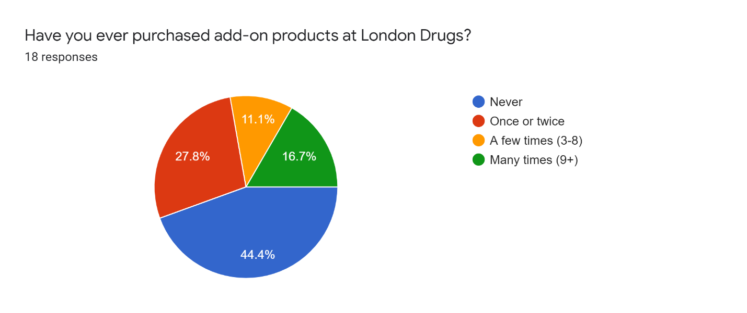
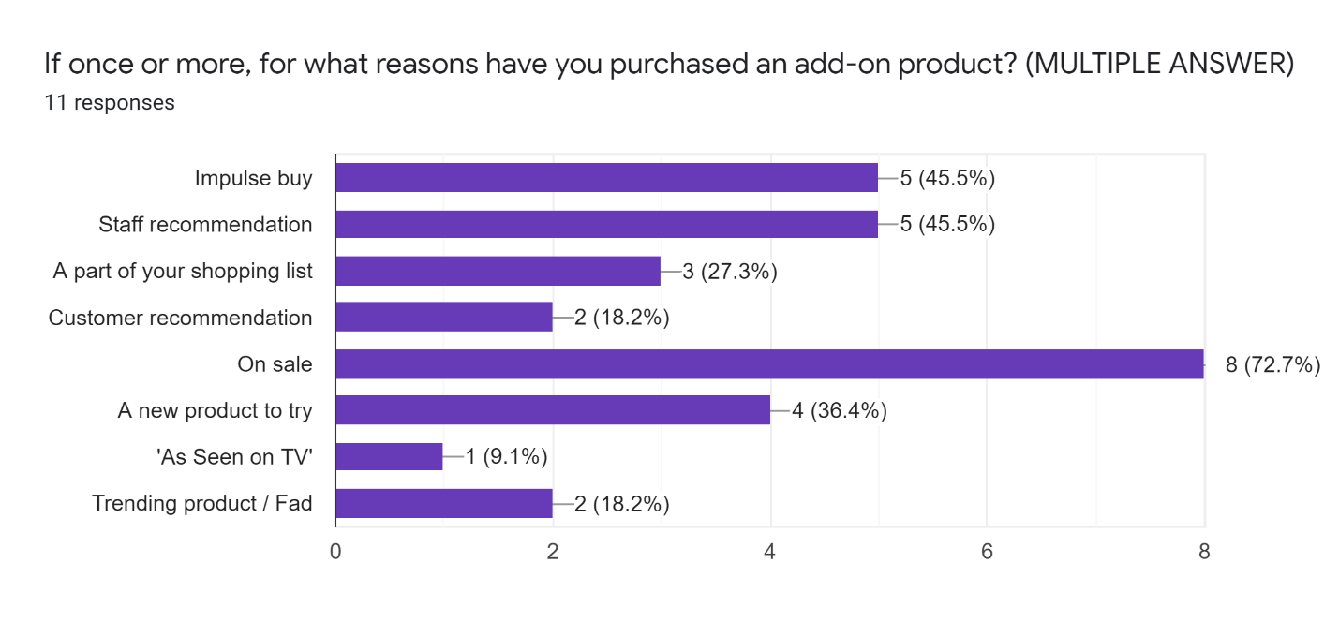

Technique One

Survey
-> pie graph (survey question

Advantages

Disadvantages

Technique Two
-> pie graph (survey question

Advantages

Disadvantages

Technique Three
-> pie graph (survey question

Advantages

Disadvantages

A Comparison of Procedural Changes

Procedure A

Procedure B

Procedure C

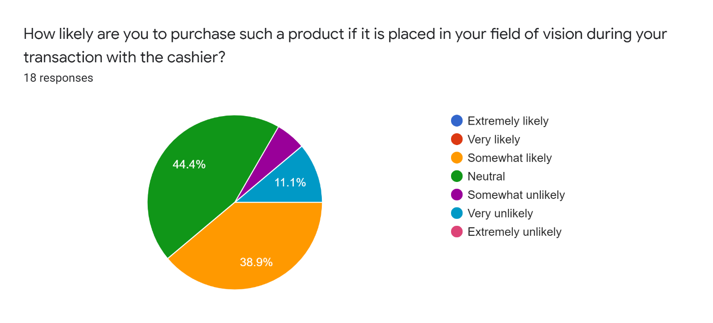
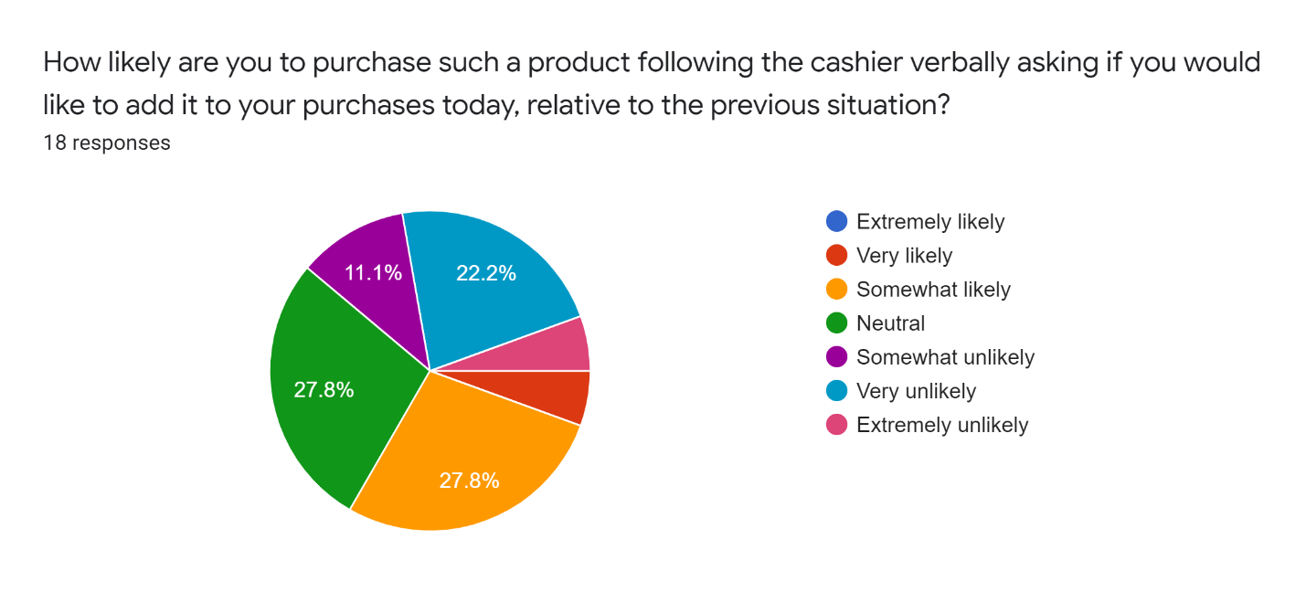
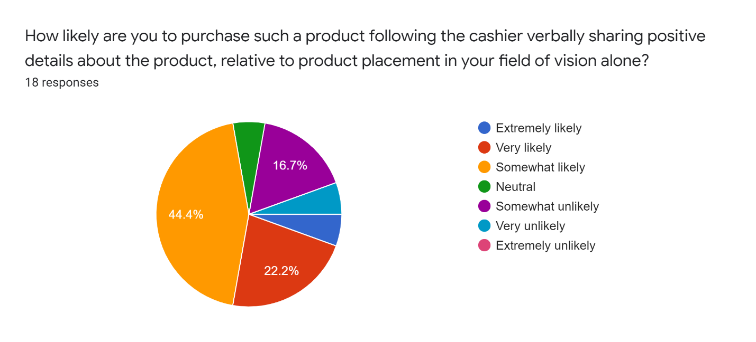

Conclusion

Summary and Interpretation of Findings

Ranked by Conversion Rate

Ranked by Feasibility

Recommendations
-> Recommend revising add-on procedure to reflect outcome of this study, and increase overall sales without harming customer satisfaction.

Appendix

Survey Design
I am an undergraduate student at UBC engaged in a technical writing project. The purpose of this survey is to obtain primary data for analysis and investigation that aims to evaluate your response to varying techniques of add-on selling. The final formal report will be addressed to the management staff of London Drugs. The data I gather from this survey will serve the ultimate purpose of providing recommendations for increasing add-on product sales. The survey contains 12 multiple-choice questions that should take approximately 5 minutes of your time. Your responses are voluntary and anonymous. Thank you, I appreciate your generous participation in my survey.
Please note: add-on products are those offered at the point-of-sale (where you pay for your purchases).

- Have you shopped at London Drugs before? *
- Yes
- No
- Don’t remember
*Survey question 1’s purpose is to screen out participants who don’t have standing in this study. If they answered ‘No’ or ‘Don’t remember’ to having shopped at London Drugs before, all their responses to the following survey question were removed from the final data set. Thus the data, figures, and conclusion analysis are based on the responses of 18 out of the 19 surveys completed – 1 participant’s response have been excluded.

- Are you familiar with the variety of products offered at the London Drugs point-of-sale?
- Familiar
- Somewhat familiar
- Unfamiliar

- Have you ever purchased add-on products as London Drugs?
- Never
- Once or twice
- A few times (3-8)
- Many times (9+)

- If once or more, for what reasons have you purchased an add-on product? (MULTIPLE ANSWER)
- Impulse buy
- Staff recommendation
- A part of your shopping list
- Customer recommendation
- On sale
- A new product to try
- ‘As seen on TV’
- Trending product / Fad

- How likely are you to purchase such a product if placed in your field of vision during your transaction with the cashier?
    - Extremely Likely
    - Very likely
    - Somewhat likely
    - Neutral
    - Somewhat unlikely
    - Very unlikely
    - Extremely unlikely

- How likely are you to purchase such a product following the cashier verbally asking if you would like to add it to your purchases today, relative to the previous situation?
    - Extremely Likely
    - Very likely
    - Somewhat likely
    - Neutral
    - Somewhat unlikely
    - Very unlikely
    - Extremely unlikely

- How likely are you to purchase such a product following the cashier verbally sharing positive details about the product, relative to product placement in your field of vision alone?
    - Extremely Likely
    - Very likely
    - Somewhat likely
    - Neutral
    - Somewhat unlikely
    - Very unlikely
    - Extremely unlikely

- Are you satisfied with these products purchased at the London Drugs point-of-sale?
  - Often
  - Sometimes
  - Not often

- How do you view add-on products offered at the London Drugs point-of-sale?
  - Negatively
  - Neutral
  - Positively

- What is your preference for add-on products at London Drugs point-of-sale?
  - Offer less
  - Keep it the same
  - Offer more

- How do you view the London Drugs Brand for offering add-on products at the point-of sale?
  - Negatively
  - Neutral
  - Positively

- Should London Drugs alter the products they offer?
  - Less variety
  - Keep it the same
  - More variety

Glossary
Point of sale
Add-on product
Till
Service Specialist
Aisle Person

References
https://www.londondrugs.com/corporate-information/corporate-info.html

https://www.londondrugs.com/about-london-drugs/about-us.html

https://www.londondrugs.com/london-drugs-in-your-community/ComInvolve.html

Cowley, Elizabeth, and Chris Barron. “When Product Placement Goes Wrong: The Effects of Program Liking and Placement Prominence.” Journal of Advertising, vol. 37, no. 1, 2008, pp. 89–98. JSTOR, www.jstor.org/stable/20460830. Accessed 7 Aug. 2020.

https://mapmycustomers.me/blog/the-importance-of-upselling-and-cross-selling-in-sales/

Methods
I will conduct the research via communication with my coworkers. The sample will be a London Drugs location in Burnaby over the course of 2 weeks in July. My coworkers will monitor the engagement with these fundraisers via a tracking sheet during their shift, before and after implementing these changes to see how consumer engagement has changed in regard to the specific campaign at that time. The calculation of customers that contribute to the campaign divided by the customers that go through the point of sale will determine the conversion rate for each week.
Conclusion
In conclusion, I hope to evaluate 3 methods that London Drugs can utilize long-term in its mission to support local community initiative through monetary point-of-sale campaigns. These methods will be ranked via the greatest to least increase its conversion rate (as defined above).

