14917 95 Ave
Surrey, BC

August 17th

Mark Chambers, Service Manager
White Rock Honda
2466 King George Blvd
Surrey, BC V4P 1H5

Dear Mr. Chambers,

Here is my report, Cost-Benefit Analysis of an Automatic Car Wash for White Rock Honda. The report addresses the cost of the current car washing method and the alternative automatic wash option.

Although manually washing cars has been adequate, there are some clear advantages to installing an automatic system. Although there is a large upfront cost, the operating costs are much lower than hiring a lot attendant. Based on interviews with lot attendants, quality is also more consistent with automatic systems. It will also be able to clean significantly more cars per hour.

Lastly, and most importantly, car owners lean towards receiving an automatic wash over a hand wash. Switching to an automatic system could be what pushes customers to choose White Rock Honda over another dealership. Along with the consistency of the washes, customers will likely benefit from this switch.

It has been a pleasure working on this report and I hope it helps with future decision making at White Rock Honda. Please feel free to email me at money_sd@hotmail.com for any questions or clarification.

Sincerely,

Money Dhaliwal

Cost-Benefit Analysis
of an Automatic Car Wash
for White Rock Honda

for
Mark Chambers
Service Manager
White Rock Honda
Surrey, BC

by
Money Dhaliwal
English 301 Student

August 1, 2020

Table of Contents
Abstract 4
Introduction 5
Data Section 6
Comparison of Key Measures 6
Cost 6
Speed 7
Quality 8
Customer Preferences 8
Value of Car Wash 8
Preference of Car Wash Method 9
Conclusion 11
Summary and Interpretation of findings 11
Recommendations 11
References 12

Figures and Tables
Figure 1 The Importance of Car Washes to Car Owners 9
Figure 2 Car Owner Preferences of Car Wash Methods 9
Figure 3 Most Popular Car Wash Methods 10

Abstract

Deciding on a method to wash customer cars at a dealership depends on numerous factors. These key factors are cost, quality, speed, and customer preference.

Phone Interviews were conducted with White Rock Honda lot attendants to determine flaws in the current car wash method. Online surveys were distributed to research car owner preferences of car wash methods. Secondary research was also done to aid with cost estimates.

Automatic car wash systems were found to offer clear benefits over the traditional method of hand washing. These benefits include cheaper annual operation costs, consistency, speed, safety, and ease of use.

White Rock Honda should consider these recommendations regarding car washes:
- Receive a quote for an automatic car wash system
- Switch to a two-bucket method if continuing to wash cars by hand.

Introduction

As with any business, operating a dealership like White Rock Honda (WRH) requires careful moderation of costs to remain in business and maintain profit margins. Washing customers’ cars is one such cost. Currently, WRH uses the traditional hand wash method. An alternative to this, that will be looked at in this report, is an automatic car wash

The purpose of this report is to analyze differences in cost, speed, quality, and car owner preferences to determine the feasibility of an automatic car wash.

There are multiple limitations to this study. Firstly, the sample size of the survey is limited to only 11 participants and the sample size for the employee interviews is also limited with only 2 participants. This makes the data hard to extrapolate to the general population. Another limitation is the distribution method of the surveys. They were sent to mainly younger adults which may not be an accurate representation of White Rock Honda’s clientele. Lastly, the research sources used are car washing websites, blogs, and companies. Information on these sites is not vetted and there may be errors.

The scope of this inquiry includes the following:
1. Cost comparison between automatic and manual car washing
2. Survey of car owner’s views on automatic car washes
3. Interview of employees to determine speed and quality of current hand wash system

Data Section

Comparison of Key Measures
The differences in cost, speed, and quality of a wash needs to be considered when deciding whether to install an automatic car wash system. These three metrics are analysed below using secondary data and interview responses.

Cost - The upfront cost to install and the cost to operate.

To estimate cost, only factors that will be different between the two wash methods will be looked at. For example, chemical and water costs will not be analysed and will assumed to be similar or negligent differences between automatic versus hand washes.

Hand Washing: Annual Labour Cost Estimate

Based on interviews done with two current lot attendants at White Rock Honda, there are 25 to 35 cars washed per day at White Rock Honda. The lot attendants also say that they can wash a car in 10-20 minutes. Assuming there is 1 lot attendant to solely wash cars, 24 to 48 cars could be washed in a shift. It can be assumed that the dealership must have 1 lot attendant at all times to wash cars every day. However, dealerships usually will have more than one lot attendant since car washes are not evenly spread out throughout the day. During busy times there may be much more cars to be washed than possible by one lot attendant. Therefore, one extra lot attendant will be assumed to be required. An hourly wage of $15 will be used with a 1.2x multiplier to estimate benefits and other expenses to hire an employee (ADD SOURCE). This leaves an estimated hourly cost per lot attendant at $18. Following are the calculations made to estimate the annual labour costs of manual car washing:

(wage cost) x (hours per day) x (# of lot attendants) x (days open per year) x
= (estimated annual labour cost)

$18/hour x 8 hours x 2 lot attendants x 313 days
= $90,144

Automatic Wash System: Initial Cost + Annual Operating Cost Estimate

According to Just Better Soap Industries the equipment cost for a single automatic car wash system is between $31,000 to $49,000. For this approximation we will use the mid point of $40,000 (“Starting A Car Wash”).

A (ADD INFO ON AUTOMTIC OPERATING COSTS)
The operating cost for the automatic car wash system comes out to approximately $1.09 per car (“Car Wash Business Profit”). This will be multiplied by the number of cars washed per year to get the yearly operating cost.

(variable cost per car) x (days open per year) x (cars per day)
=Annual operating cost

$1.09 per car x 331 days x ~30 cars
= $10,823.70

One lot attendant will still be required to run cars through the system and handle miscellaneous tasks around the dealership. Adding the annual operating cost of the automatic car wash to the labour cost of a single lot labour gives us $55,895.7 per year. This is significantly less than the cost of two lot attendants. With an initial investment of $40,000, breakeven should be reached optimistically in a year and conservatively in two years.

Note

The calculations above do not include opportunity cost of the space required to install the car wash. The car wash would likely fit in place of the current two wash bays; however, this requires further analysis. The calculations are based on data found on car wash websites, this data is subject to error and exact numbers should be found by contact manufacturers. Lastly, the cost of water and chemicals is omitted as those will be used regardless of manual or automatic washing

Speed – The amount of time it takes to wash a single car.

Hand Washing

Hand washing a car varies greatly. The lot attendants interviewed noted a range of 10-25 minutes per car depending on the size, shape and dirtiness. This comes out to 2.4 to 6 car per hour.

Automatic Wash System

In contrast, an automatic wash takes a few minutes to clean a car. Some automatic systems can push out 50 cars per hour (“In-Bay Express Mini Tunnel).

Quality – The cleanliness and safety of the wash.

When asked “How would you prefer to have your own car washed” both lot attendants said they would prefer an automatic wash. There were two reasons they mentioned. First, White Rock Honda, does not use the two-bucket method. The two-bucket method requires a separate bucket for rinsing off the brush/mitt and another bucket for the cleaning agent. This reduces the chances of something getting stuck in the brush and scratching the car. Currently, White Rock Honda uses a single bucket to both rinse the brush and to soap and lather the car. Secondly, the lot attendants prefer the consistency of an automatic wash. Although a higher quality wash is possible by hand, it is not always guaranteed and there is the chance of mistakes and missed spots.

Another issue with hand washing is that spots can be missed due to human error. This leads to cars being sent back and upset customers. Automatic car washes can also struggle with certain stains, but they are much more consistent and can simply be run through twice to ensure cleanliness.

From the lot attendant interviews, it was clear that they were not fans of hand washes and preferred automatic washes.

Customer Preferences

Value of a Car Wash

Respondents were asked how important a car wash is when taking their car in for service. Responses were on a 1-5 scale. More than half the respondents rated “4” or above on the scale.

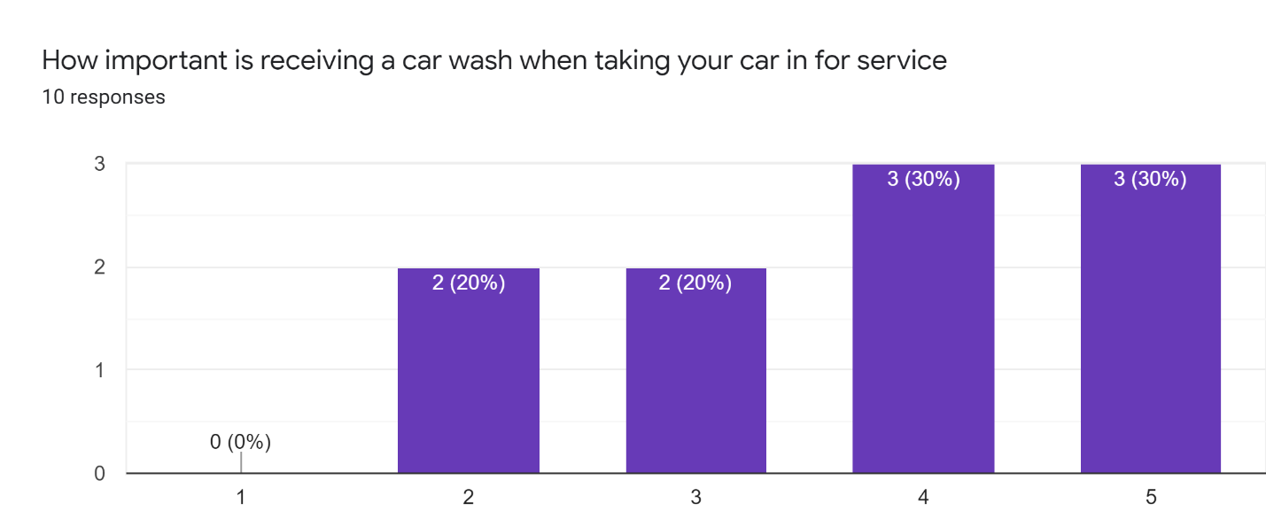
Figure 1 – The Importance of Car Washes to Car Owners

Preference Between Car Wash Methods

Out of the 10 individuals surveyed only 1 response indicated a preference for hand washing over any other method. Five respondents indicated a preference for automatic washes. The remaining 4 respondents did not indicate a preference. Figure 2 below shows the data.
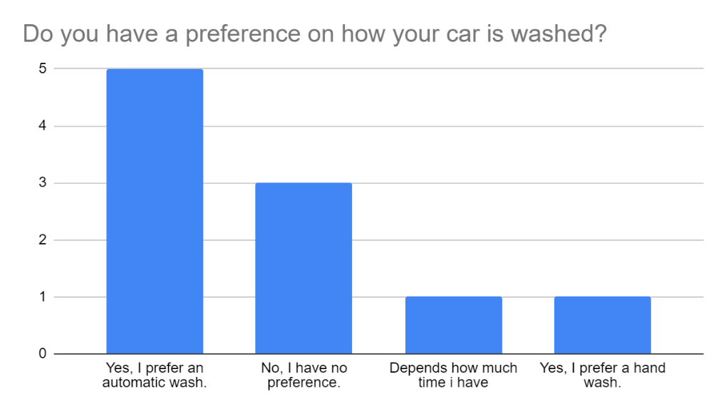
Figure 2 – Car Owner references of Car Wash Methods

Additionally, figure 3 below shows that only 6 of the 10 respondents have received an automatic car wash. In contrast, 9 respondents have gotten a hand wash. Despite this, we see in figure 1 above that automatic washes are strongly favored.

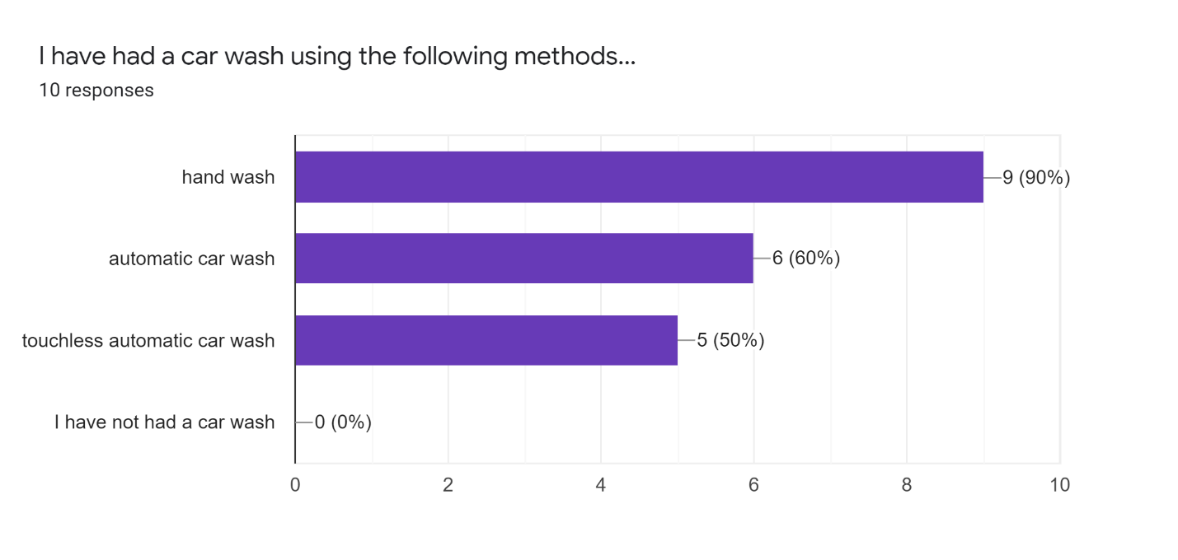
Figure 3 – Most Popular Car Wash Methods

Conclusion

Summary and Interpretation of Findings

Installing an automatic car wash system has numerous benefits. Financially, the annual costs are much lower than hand washing cars. The initial investment cost is high but can be expected to pay itself off one to two years in. Washes take less time and can be completed by any employees, not only lot attendants. The quality of washes is also more consistent and safer for the vehicle’s paint.

Additionally, based on survey results, car owners value a car wash when bringing their vehicle for service and prefer automatic over hand washes. This is true even though more individuals had received a hand wash than automatic wash. In the realms of cost, speed, quality and car owner preferences, automatic car washes come out ahead.

Recommendations

This report has highlighted a few areas of improvement. Consider these suggestions.
- Consider getting a quote for an automatic car wash, it may lead to significant improvements in cost, efficiency, and customer satisfaction
- If an automatic system is not feasible, switch to using the two-bucket method for washing cars

References

Abraham, Bud. “What Dealers Need To Know About Automatic Car Washes.” Dealer Ops – Auto
Dealer Today, 30 Aug. 2006, www.autodealertodaymagazine.com/308154/what
dealers-need-to-know-about-automatic-car-washes.
“In-Bay Express Mini Tunnel.” MacNeil Wash, www.macneilwash.com/systems/in-bay-express
mini-tunnel/.
“The Car Wash Business Profit You Should Expect.” Nulook.com, www.nulook.com/car-wash
business-profit-expect/.
“What Is Everything You Need to Know About Starting A Car Wash.” JBS Industries, 29 June
2020, jbsindustries.com/starting-car-wash/#:~:text=The average price for a,car wash
is nearly $1,500.
“Working Days Calculator: Business Days Between Two Dates.” Timeanddate.com,
www.timeanddate.com/date/workdays.html?d1=01&m1=01&y1=2020&d2=31&m2=1
&y2=220&ti=on&.

