Studying and Increasing Information and Support Surrounding Homelessness In Communities such as The Calgary Drop-In & Rehab Centre (CDIRCS)

For
The Drop-In Communications - Public Relations & Media
The Calgary Homeless Drop-In & Rehab Centre (CDIRCS)

by
Cynthia Li
English 301 Student

August 4, 2020
Table of Contents

Abstract……………………………………………………………………………………………3

Introduction………………………………………………………………………………………..4
  - Background Information………………………………………………………………….4
  - Statement of Problem……………………………………………………………………..5
  - Purpose of The Report………………………………………………………………….5-6
  - Methods & Scope…………………………………………………………………………6
Data Section……………………………………………………………………………………….7
  - Changes Implemented At The Centre In Response to COVID-19………………………..7
  - Summary of Changes and Their Effectiveness……………………………….…………..8
  - Consistency and Challenges……………………………………………………………8-9
  - Survey Results…………………………………………………………………………9-10
Conclusion………………………………………………………………………………….……11
  - Analysis of Findings…………………………………………………………………….11
  - Summary of Findings……………………………………………………………………11
  - Recommendations……………………………………………………………………11-12
References……………………………………………………………………………………..…13

I. Abstract

II. Introduction:
A. Background Information & Statement of the Problem:
According to The Canadian Encyclopedia, there are approximately 35,000 Canadians every night who experience homelessness. In Calgary alone, the latest statistics from Homelesshub (2018) show there are 2911 people out of approximately 1.2 million people in the city experiencing homelessness with an average rate of 68% of those, experiencing chronic homelessness. This counts toward 51% of homelessness in Alberta. Due to the high percentage, Calgary implemented a 10-year plan to end homelessness back in 2008 which ended in 2018, led by the Calgary Homeless Foundation (CHF). There was a drop of more than 15% in homelessness since then even with an increasing population.
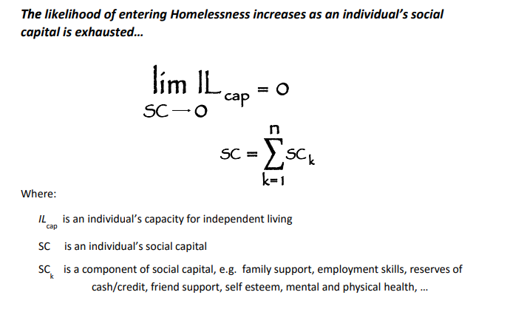
The Calgary Drop-In & Rehab Centre (CDIRCS) was established to alleviate poverty in the city for all. The centre focuses on ways to establish social capital, which includes health, support, resources and other factors to increase a person’s capacity for independent living. Figure 1 shows how the centre can calculate social capital and an individual’s capacity for independent living.
Figure. 1 Calgary Drop-In & Rehab Centre (Strategic Plan 2017)

B. Statement of Problem
People at risk of homelessness or in homeless centres are some of the most vulnerable and at risk of contracting COVID-19. This is because of limited access facilities such as bathrooms to wash hands and less able to stay inside and self-isolate from others. Supplies such as cleaning materials and masks are also less available. There are also medical conditions to consider such as respiratory issues or low immune systems that require monitoring. The Canadian Medical Association Journal (CMAJ) states that homeless centres are at high risk of transmission of COVID-19. “Infectious disease epidemics and pandemics have a disproportionate impact on people experiencing poverty, marginalization, stigmatization and discrimination” (Perri et. al). The social distancing rule and other public health directives become difficult to follow. Since COVID-19 also affects business and other centres, if those services close they may also impact those in need of them to maintain a capacity for independent living. There are many funds set up on Canadahelps.org for different parts of the country as well as on the Calgary Homeless Foundation website.
In Calgary, since the beginning of April 2020, more people have been testing positive for COVID-19 at Calgary homeless centres. Many efforts have been made to prevent the spread such as setting up isolation centres or providing more testing. However, more support would greatly benefit with protecting those in homeless centres including those at risk of homelessness and front-line workers. (https://globalnews.ca/news/6873088/calgary-homeless-shelters-positive-for-covid-19/)
C. Purpose of The Report
The purpose of this report is to gather data and research for analysis. The research is in hopes of having a better understanding of the goals and challenges of homeless centres, especially in times such as a global pandemic and to study the effectiveness of current practices. The pandemic has shown ways in which communities can come together to support those more vulnerable and has highlighted how housing can improve in the future whether through government or local involvement. The data as well as information can be used to further study trends in challenges and solutions, for educational purposes and in proposing and creating strategies and ways to support housing.

D. Methods & Scope
An interview with Kala, part of the Public Relations & Media department was conducted in parts. This was to clarify important questions and information. A survey was handed out to those in the department as well to gather data. Secondary research included the website itself, news articles and official statistics. I researched questions ranging from small details to more general inquiries to identify some of the main challenges, including:
- What are the main changes to the centre since COVID-19?
- What would be most beneficial for the centre as of now, that the general public could support in?
- Is extending information and educating the general public a concern and has social media been helpful/effective in doing so?

III. Data Section
A. Changes Implemented At The Centre In Response to COVID-19
Major Changes | Details
Cleaning and Health Protocols | - Wearing of masks at all times  - More hand washing stations  - Mandatory hand washing or sanitizing before entering  - Screening of clients for symptoms before entering  - Increasing cleaning times in high risk areas  - Travelling on floors changed to adhere to social distancing recommendation  - Social distancing implemented in different parts such as dining areas  - Tested positive or suspected of testing must isolate in a separate centre
Support in and for the Centre | - Two Satellite Shelters opened for more services and spacing  - Calgary Telus Convention Centre (CTCC)  - Donations  - Social Media usage
Staffing and Volunteering | - Increase in staff members in all departments  - Hiring of more licensed practical nurses (LPN)  - Closing of non-essential areas and volunteer programs

B. Summary of Changes and Their Effectiveness
The sudden global pandemic has been a challenge to adapt to, especially concerning the unknown around the newness of COVID-19 and it’s infection rate. In response, the centre and organization has been successful in adhering to health directives to reduce the spread and continue operations as normal and effectively as possible. The spread of COVID-19 in the centre has been limited due to the hiring of LPN’s, leading health physicians, mandatory sanitization and wearing of masks, testing and temperature monitoring. The two alternative shelters opened have also provided more services in response to social distancing and also helps as organization for different departments such as emergencies or isolation. Though extra volunteer programs are currently closed, staff has increased out of necessity and importance. All of these changes have been greatly beneficial to reduce the spread of COVID-19, with very few people testing positive.

C. Consistency of Strategic Priorities & Challenges During COVID-19
Many operations in the centre have been and continue to be altered to ensure the safety of clients and staff. These changes are implemented to also ensure the centre can continue operations as much as possible. The strategic priorities include providing services and support whether medical, social or other. The centre continues to search for affordable housing for clients.
Much of the challenges during the pandemic still include housing goals such as helping a set number of people in a set period of time find affordable housing. As done normally, those who can provide affordable housing can contact the centre at landlords@thedi.ca. There is also a current program on Tuesdays called #GivingTuesdayNow posted on social media to reach donation goals. These continue to be a challenge and main focus.

D. Survey Results
Increase or Decrease in Clients

Busiest Time’s of the Year Before COVD-19 Since COVID-19
Most Common Donations prior to COVID-19

Most Wanted/Needed Donations

IV. Conclusion
A. Analysis of Findings

B. Summary of Findings

C. Recommendations
Some of the recommendations provided to me as well as from the analysis of the findings from the survey and interview include:
- Increase in social media presence
  - This includes popular platforms such as Twitter, Instagram and Facebook. These platforms offer a variety of ways to deliver information which can then reach a larger audience. Sharing pictures, videos is included as visual stimuli. Short blurbs that capture a reader’s attention can be used on Twitter. Links are easy and convenient to add on to any post for users on these sites.
  - The purpose of a stronger social media presence is to gather more support such as donations, partnerships, volunteers etc. through sharing online and making connections. Events and programs can become especially popular.
- Education
  - Bringing awareness to homelessness in communities is vital in providing support. Misinformation around homelessness can be present. Providing education on the reasons behind homelessness, effects and consequences of homelessness, ways in which it can be solved, to a mass audience, especially specific to a location or city, creates understanding within communities and willingness to help.

References
“Community Update Re: COVID-19.” Calgary Drop-In &amp; Rehab Centre, 2020, www.calgarydropin.ca/march-27-community-update-re-covid-19-may1/.

Kneebone, Ron, et al. “Who Are the Homeless? Numbers, Trends and Characteristics of Those Without Homes in Calgary.” Who Are the Homeless? Numbers, Trends and Characteristics of Those Without Homes in Calgary | The Homeless Hub, 2015, www.homelesshub.ca/resource/who-are-homeless-numbers-trends-and-characteristics- those-without-homes-calgary.

Perri, Melissa, et al. “COVID-19 and People Experiencing Homelessness: Challenges and Mitigation Strategies.” CMAJ, CMAJ, 29 June 2020, www.cmaj.ca/content/192/26/E716.

Rech, Nathalie. “Homelessness in Canada.” The Canadian Encyclopedia, 29 Apr. 2019, thecanadianencyclopedia.ca/en/article/homelessness-in-canada.

