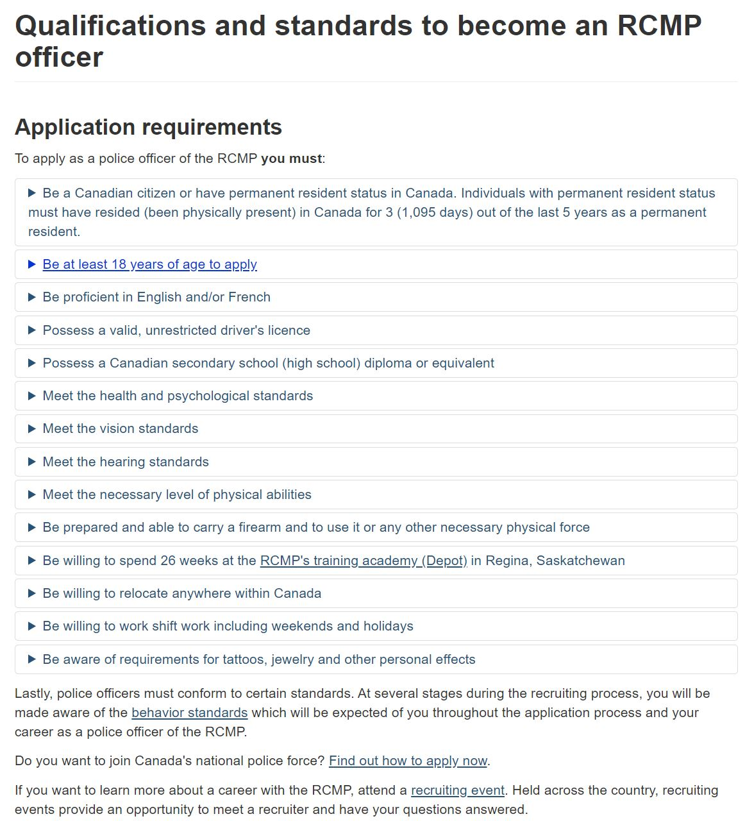
MLA Source: RCMP. “Qualifications and standards to become an RCMP officer”. Royal Canadian Mounted Police, https://www.rcmp-grc.gc.ca/en/qualifications-and-requirements
Luke Jang
Security Officer at Vancouver General Hospital
Luke.J93@hotmail.com
778 926 2580
10 August 2020

Recruiting Department of RCMP
14355 57 Ave, Surrey, BC V3X 1A9

Re: Police Officer

Dear recruiting officer,

As an individual with a particular interest in working in policing, I was immediately drawn to choose my career for the RCMP. I am currently a student at University of British Columbia, specializing in Forestry, however, I always had the passion to become a police officer ever since I was a young kid. My previous experience in various industries such as sales, banking, manufacturing and logistics as well as my current experience in the security industry will combine to fit the qualification for the RCMP police officer recruitment.
Currently, I am finishing off my bachelor’s degree in Forestry at a university, however, in the past, I have gone through an intensive training program at BCIT for the aircraft maintenance sector. Also, I have worked in many different places while dealing with different types of people. My experiences in the maintenance sector as well as sales industry which entailed residential security products confidently makes me a well-rounded person with variety of life experiences. This is especially advantageous for me because as a police officer, the importance of having an ample amount of life experience is always emphasized. Also, I am currently at the age of 27, so I can say that I am mature enough to be in policing to serve the community and the citizens of this country.
My most recent work experience is at Vancouver General Hospital as a security guard, contracted through Paladin Security. As for my duties at Paladin Security, I am currently assisting the clinical staff with their medical duties involving mental and aggressive patients. For example, whenever there are highly violent patients coming in for medical services, I stand by while the clinical staff carries out their duties. If, in case where a patient decides to escalate and become physically aggressive, I evict them out of the hospital property for the safety of everyone at the hospital. My duties at Paladin Security is very similar to what the police officers do on a daily basis but the environment is solely the hospital for me.

I would welcome the opportunity to apply my skills and experience with the RCMP. I thank you in advance for your consideration of my application.

Sincerely,
Luke Jang
Luke Jang
4291 Beatrice Street, Vancouver, BC
Luke.J93@hotmail.com
778-926-2580

Summary of Qualifications

- Fluently speak, write and read an advanced level of Korean
- Currently certified for Standard First Aid with CPR-C and AED
- Is currently volunteering for a senior home as a communicator
- Is currently volunteering for the South Vancouver Community Policing Centre as a community patroller
- Have previously took a course in BA Tutoring 12 in high school to help and act as a mentor for teenage students with learning disability
- Have previously volunteered for a preschool as a child support assistant
- Have previously volunteered for a soccer class as an assistant instructor for elementary school children
- Have previously volunteered for ‘Cultural Buddy’ program for new immigrant students in elementary schools

Professional Experience
Paladin Security, Vancouver, BC
Healthcare Security Officer Jan 2020 – Present
- Providing safety and peace of mind to the general public in healthcare facilities
- De-escalating situations when there is a conflict between healthcare staff and the patients
- Assisting the healthcare staff with their duties involving patient interaction
PowerWood Corporation, Surrey, BC
Quality Control Assistant, Production Assistant Jan 2019– Apr 2019
- Revised and improved the company’s maintenance log program to the millwright’s convenience
- Measured the moisture content for the lumbers being dried in the kiln drier and reported to the Quality Control Supervisor
- Operated the kiln drier according to the kiln drying schedule provided by the Quality Control Supervisor
PowerWood Corporation, Surrey, BC
Project Assistant, Production Worker May 2018 – Aug 2018
- Developed the company’s maintenance schedule for the millwrights for improved and organized maintenance in the facility
- Developed the company’s lockout procedure for every machinery in the plant for the safe operation for the workers
- Developed the company’s fire safety map for the proper evacuation for everyone’s safety
Sharons Credit Union, Vancouver, BC May 2015 – Aug 2015
Banking Intern
- Assisted customers with their financial needs that resulted in their satisfaction
- Performed customer satisfaction survey by phone calls that improved the bank’s brand reputation
- Sold installment premiums to customers in need which helped them save money and at the same time, aided the bank raise its revenue and profit
- Performed credit checks for the customers for their loan needs which resulted in improved loan approval rate that raised customer satisfaction

ADT Reliance Protectron, Surrey, BC April 2013 – Nov 2013
Residential Security Consultant

- Arranged meetings with customers and businesses for product demonstration that led to sales most of the time and improved company’s revenue
- Performed traditional sales tactics such as door-knocking method that helped market the brand, products and services which led to more business inquiries for the company
- Interacted with customers regarding their residential security concerns which resulted in brand’s improved reliability and better reputation
- Performed visual presentations to local builders about the company and the products and services that resulted in higher proportion of market share against competitors by having more sales in local area

Education

University of british columbia, Faculty of Forestry, Vancouver, BC Sept 2015 - April 2020 (expected)

Bachelor of Science

BCIT, Aircraft Maintenance Engineer, Richmond, BC Nov 2011 – July 2013
Diploma, Aircraft Maintenance Engineer Category ‘M’
Certification
- Standard First Aid with CPR-C and AED
- Completion of Canadian Firearms Safety Course for ‘Possession and Acquisition License’ for both restricted and non-restricted firearms (PAL & RPAL)
- Completion of Basic Security Training (BST) at Justice Institute of British Columbia
- Completion of MOAB (Management of Aggressive Behavior; Introduction with Strategies for Managing Physical Confrontations)
- Completion of PVPC (Provincial Violence Prevention Curriculum and the Advanced Team Response in the capacity of Support)
- Completion of HUFT (Healthcare Use of Force Training)

Luke Jang
4295 Beatrice Street
Vancouver, BC, V5N 4H9
10 August 2020
Trevor Hein, CEO of Hein Group of Companies
Hein Group of Companies
Dear Trevor,
Hi Trevor, thank you for speaking with me last time on the phone. I appreciate it very much because I am aware how busy you are all the time. I had such a great time speaking to you in a very long time. If I remember it correctly, it has already been 9 years since I have worked for you in the past but you still remembered me. I already have asked you regarding providing a reference for me, however, I am writing to you again formally to ask for another reference for the RCMP application that I am submitting.
If you are ok with providing me a reference again, please let me know. In case you need more information about me, please do not hesitate to contact me at Luke.J93@hotmail.com
Thank you so much Trevor,
-Luke-

Luke Jang
4295 Beatrice Street
Vancouver, BC, V5N 4H9
10 August 2020
Craig Osborne, plant manager of Atlas Roofing Corporation
Atlas Roofing Corporation
Dear Craig,
Hello Craig, I sincerely thank you for your response when I previously requested a reference check. This time, I polite request another reference check for the RCMP application that I am submitting soon. I always appreciate the fact that you are always responsive to my requests and I am already grateful.
If you are ok with providing me a reference again, please let me know. In case you need more information about me, please do not hesitate to contact me at Luke.J93@hotmail.com
Thank you so much Craig,
-Luke-

Luke Jang
4295 Beatrice Street
Vancouver, BC, V5N 4H9
10 August 2020
Hae Soo Lee, CFO of Sharons Credit Union
Sharons Credit Union
Dear Hae Soo,
Hi Hae Soo, it has not been too long ago that we have met in a while. It was such a pleasure to meet you for a conversation and a reference request. I am aware that you are always busy with your tasks at the bank and I appreciate that you are always willing to respond to my requests.
This time, I am formally writing to you again for another reference check and I hope this would not bother you. This would be for the RCMP and I will appreciate so much again if you would be willing to provide another reference.
If you are ok with providing me a reference again, please let me know. In case you need more information about me, please do not hesitate to contact me at Luke.J93@hotmail.com
Thank you so much Hae Soo,
-Luke-

