Proposal for a Tobacco Free Campus
at North Island College’s Comox Valley Campus

for
John Bowman – President and CEO
North Island College
Courtenay, British Columbia

and
Carissa Wilson – College Relations North Island Student Union
North Island College
Courtenay, British Columbia

by
Glen Kavaliunas
UBC English 301 Student

July 30, 2020

Table of Contents
- ABSTRACT . . . . . . . . . . . . . . . . . . . . . . . . . . . . . . . . . . . . . . . . . . . . . . . . . . . . . . . . . i
- INTRODUCTION . . . . . . . . . . . . . . . . . . . . . . . . . . . . . . . . . . . . . . . . . . . . . . . . . . . . 5
- Purpose of this report . . . . . . . . . . . . . . . . . . . . . . . . . . . . . . . . . . . . . . . . . . . . . . . . . . 5
- Background on tobacco health risks . . . . . . . . . . . . . . . . . . . . . . . . . . . . . . . . . . . . . . 6
- Description of current tobacco policy at North Island College (NIC) . . . . . . . . . . . . . 7
- Impact of current tobacco policy at NIC . . . . . . . . . . . . . . . . . . . . . . . . . . . . . . . . . . . 8
- Tyee building designated smoking area . . . . . . . . . . . . . . . . . . . . . . . . . . . 8
- Portable Village designated smoking area . . . . . . . . . . . . . . . . . . . . . . . . . 9
- Proposed solution . . . . . . . . . . . . . . . . . . . . . . . . . . . . . . . . . . . . . . . . . . . . . . . . . . . . 10
- METHODS . . . . . . . . . . . . . . . . . . . . . . . . . . . . . . . . . . . . . . . . . . . . . . . . . . . . . . . . 10
- DATA SECTION . . . . . . . . . . . . . . . . . . . . . . . . . . . . . . . . . . . . . . . . . . . . . . . . . . . . 11
- Location of Designated Smoking Areas at NIC Courtenay . . . . . . . . . . . . . . . . . 11
- Interview Summaries . . . . . . . . . . . . . . . . . . . . . . . . . . . . . . . . . . . . . . . . . . . . . . 12
- Survey Summaries . . . . . . . . . . . . . . . . . . . . . . . . . . . . . . . . . . . . . . . . . . . . . . . . 13
- NIC students and staff . . . . . . . . . . . . . . . . . . . . . . . . . . . . . . . . . . . . . . . . . . 13
- Beaufort Children’s Society Staff and Parents . . . . . . . . . . . . . . . . . . . . . . . 16
- Conflicting interest regarding study . . . . . . . . . . . . . . . . . . . . . . . . . . . . . . . . . . . 18
- CONCLUSION . . . . . . . . . . . . . . . . . . . . . . . . . . . . . . . . . . . . . . . . . . . . . . . . . . . . . 18
- Summary of Findings . . . . . . . . . . . . . . . . . . . . . . . . . . . . . . . . . . . . . . . . . . . . . . 18
- Recommendations Based on Findings . . . . . . . . . . . . . . . . . . . . . . . . . . . . . . . . . 18
- REFERENCES . . . . . . . . . . . . . . . . . . . . . . . . . . . . . . . . . . . . . . . . . . . . . . . . . . . . . 33

FIGURES AND TABLES
Figure 1: Tyee Building designated smoking area and proximity to Beaufort Children’s Society play space . . . . . . . . . . . . . . . . . . . . . . . . . . . . . . . . . . . . . . . . . . . . . . . . . . . . . . . . . . . . . . . . . . . . 9
Figure 2: Portable Village designated smoking area and entrances and exits . . . . . . . . . . . . . . . . 9
Figure 3: Break down of survey response to areas of second-hand smoke exposure . . . . . . . . . 12
Figure 4: Do you smoke? . . . . . . . . . . . . . . . . . . . . . . . . . . . . . . . . . . . . . . . . . . . . . . . . . . . . . . . 14
Figure 5: Do you wish to quit smoking? . . . . . . . . . . . . . . . . . . . . . . . . . . . . . . . . . . . . . . . . . . . 14
Figure 6: Would removing designated smoking areas help you quit smoking? . . . . . . . . . . . . . 14 Figure 7: Smoking Cessation support . . . . . . . . . . . . . . . . . . . . . . . . . . . . . . . . . . . . . . . . . . . . . 15
Figure 8: How many designated smoking areas are essential? . . . . . . . . . . . . . . . . . . . . . . . . . . 15
Figure 9: Location of exposure to second-hand smoke . . . . . . . . . . . . . . . . . . . . . . . . . . . . . . . . 17

ABSTRACT
To be written later

INTRODUCTION
North Island College (NIC) is located on Vancouver Island, British Columbia, with their main campus located in the Comox Valley. NIC Comox Valley campus has three designated smoking areas located outside of main buildings. The purpose of this report is to highlight health risk posed to NIC students and staff, and the children at Beaufort Childcare Society through the exposure to second-hand smoke. The designated smoking area outside of the main entrance of Tyee building and one at the entrance to Portable Village are locations of common second-hand smoke exposure. The designated smoking areas are the legally required distance from building entrances, but they are roofed structures which hold the smoke down. If there is a slight wind, the smoke carries outside of the designated smoking area to surrounding areas.
The designated smoking area for the Tyee building is extremely close to Beaufort Children Society’s daycare outdoor play space and directly outside of the bookstore and the cafeteria. This creates a concern over exposure of young children to second-hand smoke and health-related conditions and problems associated with the use of tobacco (including smoking, chewing and vaping).
This report and its findings are timely as North Island College is in the planning phase of an expansion which could see an increase in tobacco use, making now an ideal time to move towards a tobacco free campus.
Background on Tobacco Health Risks
Society is aware of the negative health affects of smoking and second-hand smoke. Unfortunately, smoke is not selective and even non-smokers exposed to second-hand smoke risk diseases and disabilities. The Center for Disease Control states, “Smoking causes cancer, heart disease, stroke, lung diseases, diabetes, and chronic obstructive pulmonary disease (COPD), which includes emphysema and chronic bronchitis. Smoking also increases risk for tuberculosis, certain eye diseases, and problems of the immune system, including rheumatoid arthritis.” (Centers for Disease Control Health Effects)
While the effects of smoking are well known, “Second-hand smoke exposure [still] contributes to approximately 41,000 deaths among non-smoking adults and 400 deaths in infants each year.” (Centers for Disease Control Health Effects). This is an alarming number as second-hand smoke exposure can be out of the control of non-smokers as is the case of students at NIC. “Second-hand smoke causes stroke, lung cancer, and coronary heart disease in adults.” (Centers for Disease Control Health Effects) The second-hand smoke exposure of children at Beaufort Children’s Society’s daycare is concerning because “Children who are exposed to second-hand smoke are at increased risk for sudden infant death syndrome, acute respiratory infections, middle ear disease, more severe asthma, respiratory symptoms, and slowed lung growth.” (Centers for Disease Control Health Effects) This exposure over the four years they are at the daycare can have lasting repercussions throughout their life, impacting their health and costing taxpayers thousands of dollars in medical expenses.
Description of the Current Tobacco Policy at NIC
Currently NIC is a smoke free campus other than in designated smoking areas, as explained in the North Island College handbook of policies and procedures, “Smoking, including e-cigarettes, is permitted in designated areas only” (Policy & Procedures Manual - North Island College). According to VP Fowler, NIC requires five designated smoking areas for the population and layout of the college. (interview July 22, 2020), but currently there are only three designated smoking areas on NIC Courtenay campus.
Impact of Current Tobacco Policy at NIC
The health and welfare of students, staff at NIC and the infants and toddlers at Beaufort Children’s Center is of utmost importance. Specifically, the negative health impacts of first and second-hand smoke. Although North Island College has made some steps toward reducing exposure to second-hand smoke on campus, the designated smoking areas do little to protect to non-smokers. Some students start using tobacco products to make friends and others continue out of convenience or to help reduce stress, yet all students and staff are exposed to it as a result. Investigating the use of tobacco on campus and the impact on students is vital, especially with the increase in vaping and the unknown health results.
Tyee Building Designated Smoking Area
In order to enter the Tyee building main door to attend classes or go to the cafeteria/ bookstore, students must walk through the second-hand smoke from the designated smoking area. Another concern with the location of the Tyee building smoking area is the proximity to the Beaufort Childcare outdoor play space. This proximity means children ages eighteen months to five years old are exposed to second-hand smoke daily and witness the unhealthy activity of college students. On many occasions the staff of Beaufort Children’s Society have commented on the smoke blowing over to the play yard, and the children have asked why the air smells like candy when the vape smoke blows over the play area.
This same designated smoking area for the Tyee building forces any student who needs to buy textbooks or food to walk through the smoke to get to their destination. This is consistent across campus at the main entrance of all buildings.
Fig. 1 Tyee Building designated smoking area and Beaufort Children’s Society play space
Portable Village Smoking Area
The designated smoking area in the area known as Portable Village is the other troublesome area. There are about ten portables together in a group with a ramp system connecting them. There are two staircases up to this area, one at either end. The entrance/it closest to the rest of the campus leads directly into the designated smoking are for this section of campus. This means everyone entering/exiting leaving Portable Village by the main entrance/exit is exposed to second-hand smoke.
Fig. 2 Portable Village designated smoking area and entrances and exits
Proposed Solution
A solution for the second-hand smoke from the Tyee building would be to move the smoking area to the other side of building and away from the main entrance. This would mean smoking, or inhaling second-hand smoke, would once again be a choice for students. Moving the designated smoking area away from the daycare would also reduce the children’s exposure to second-hand smoke.
The full solution is for North Island College to become a tobacco free campus. This would limit the number of students who start smoking due to stress or to build friendships, and it would eliminate the exposure of other staff and students to second-hand smoke. “Comprehensive smoke-free campus policies make it easier for people to resist and quit smoking and can have a tremendous impact on the health of an entire campus community!” (Smoke-Free Campuses) An additional benefit for North Island College would be a possible reduction in medical and employee and family assistance expenses. “Everyone deserves to breathe clean air where they live, work, study, and play. Tobacco-free policies decrease costs for schools without impacting enrollment.” (Smoke-Free Campuses)
METHODS
Primary data sources will include consultations with Amanda Peters – Executive Coordinator of Beaufort Children’s Society and interviews with John Bowman - president of NIC, Colin Fowler – NIC VP Finance and Facilities, Echo Hope – Comox Valley Director of NIC Student Union, and Carissa Wilson – NIC Student Union - Organiser, College Relations & Services Coordinator. I will explore the appetite from students for North Island College to become a tobacco free campus, as the smoke is not healthy for any student. Primary research will be rounded out with surveys to current NIC students.
Secondary sources include publications on the effects of second-hand smoke on young children, and a review of North Island College’s smoking policy. The Tobacco Free Campus movement is also a valuable resource. (Tobacco Free Campus Guide, 2011)

DATA SECTION
Location of designated smoking areas
NIC currently has five designated smoking areas. The locations are: Komox Hall, Trades building, Tyee building, Portable Village, and Discovery Hall. The survey and interviews indicated the only the designated smoking areas at Tyee building and Portable Village are a major source and concern for second-hand smoke.

Fig. 3: Break down of survey response to areas of second-hand smoke exposure
Interview Summaries
To gather critical information regarding second-hand smoke and tobacco use at NIC Comox Valley campus three pivotal people were interviewed:
- Colin Fowler – Vice President Finances and Facilities
- Echo Hope - Director of the North Island College Student Society
- Carissa Wilson - North Island College Student Union - Organiser, College Relations & Services Coordinator
All interviewed parties agreed that the designated smoking area by Tyee building is a concern due to both the proximity to the main entrance to Tyee and the proximity to the outdoor play space at Beaufort Childcare Society daycare. There seem to be no support, outside of MSP, for students who wish to stop smoking or using tobacco, but NIC employees do have support both financially and emotionally through the employee family assistance program. There was a divide in the number of smoking areas required for NIC. The VP stated that five designated smoking areas were required, but both student union representatives stated that one or zero designated smoking areas were required.
Survey Summaries
Two surveys were conducted. One survey was presented to parents and staff of Beaufort Children’s Society daycare. The other survey was presented to students and staff at NIC. Survey responses in the second set were minimal as no on-campus courses are currently operating, all staff are working from home, and students are on summer vacation. As a result, the information is not necessarily representative of the full NIC Comox Valley student body.
Student and Staff Survey
Students and staff were asked to complete this survey online. Due to limited access to staff and student emails and many people eon summer holidays there were only ten respondents. To make decisions based on this data many more students and staff need to be surveyed.
When students and staff were asked if they smoke forty percent said yes, while sixty percent said no (Fig. 3). The next question asked if they would like to quit. Of the forty percent who indicated they smoke, seventy-five percent said they would like to quit (Fig. 4). Looking at it another way, that means out of the ten people surveyed, only four smoke and three of those four want to quit.
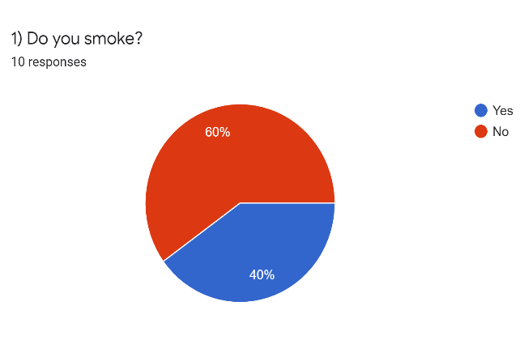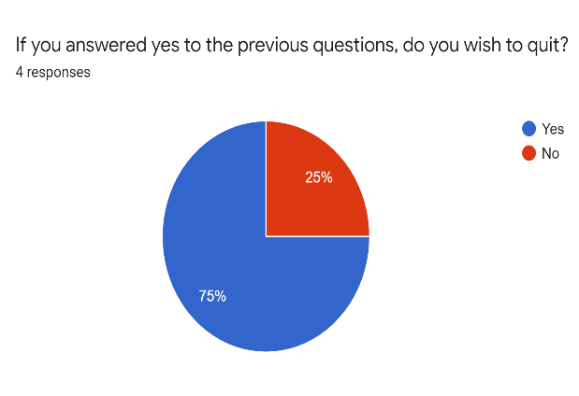
Fig. 4: Do you smoke? Fig. 5: Do you wish to quit smoking?
When asked if the removal of the designated smoking areas would help students and staff quit smoking the responses were completely split (but there were only three responses). (Fig. 6)
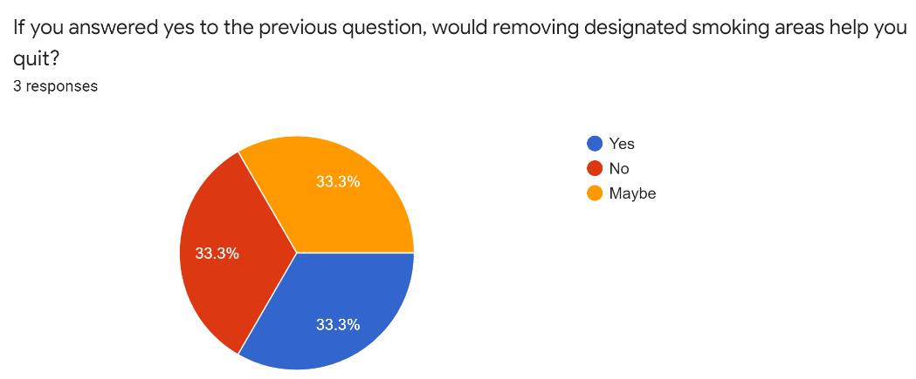
Fig. 6: Would removing designated smoking areas help you quit smoking?
The number of students and staff who are interested in quitting smoking was high, yet smoking cessation help / programs were sparse or unknown. Students have few options. MSP will assist with the cost and they can call the nurses hotline (811) for emotional assistance and advice. Staff have the support of the North Island College Employee and Family Assistance program as well as extended medical benefits. (See Fig.7)
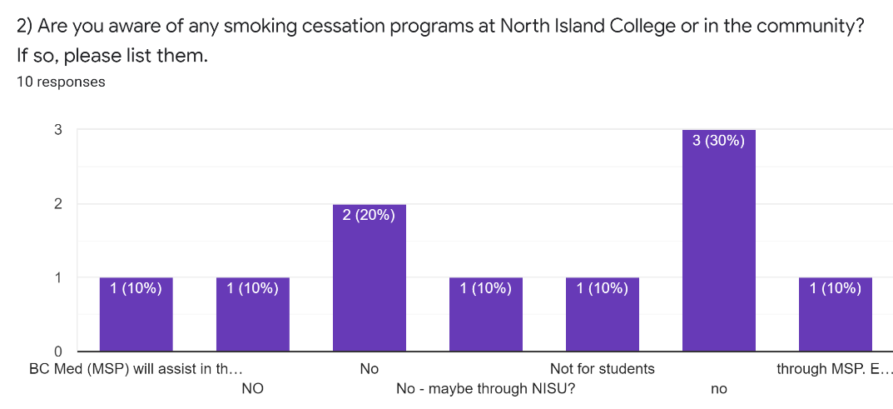
Fig. 7: Smoking Cessation support
When looking at the possibility of going to a completely tobacco free campus, forty percent of the students surveyed said no designated smoking areas were essential at NIC. Ten percent of student said five or more designated smoking areas were needed, while another ten percent said only one designated smoking area was essential. The last forty percent said two or three smoking areas were essential. NIC would need to do more research, but according to those polled the number of designated smoking areas could be reduced from five to three or fewer.
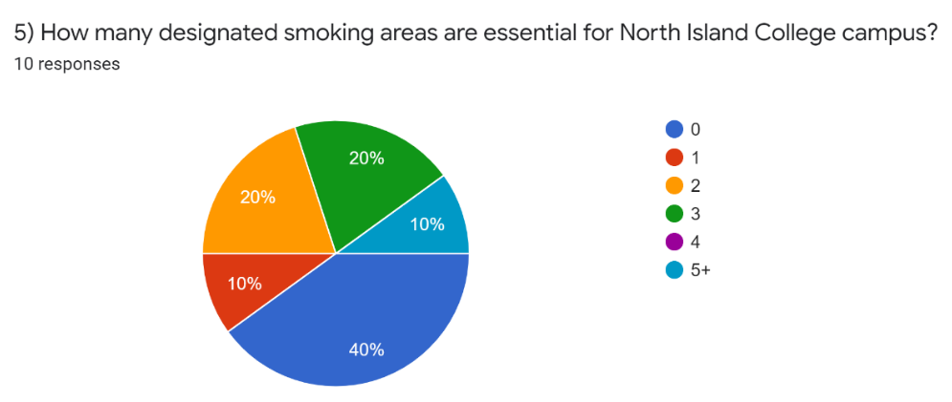
Fig. 8: How many designated smoking areas are essential?
Of those surveyed, eighty percent said they had heard of Beaufort Children’s Center, but of those surveyed sixty percent of respondents said they were concerned about the proximity of the designated smoking area at Tyee to the childcare outdoor play space.
The other comments and suggestions coming from the survey included:
- moving smoking areas away from main buildings (anonymous)
- It would be unfair to remove the ability to smoke on campus as it is a method of stress relief. (anonymous)
Beaufort Staff and Parent Survey
Of the eleven people who responded to the Beaufort Parent and Staff Survey, sixty-four percent indicated that they were also student or staff at NIC. This group indicated that eighty-two percent of them have be exposed to second-hand smoke when performing their day-to-day activities at NIC. Sixty-four percent of respondents indicated this happened “often”. The main areas of exposure indicated were outside the Tyee building, Portable Village, and at Beaufort Children’s Center play area. (see fig. 9)

Fig. 9: Location of exposure to second-hand smoke
When asked if the location of the smoking area at the Tyee building and the proximity to the childcare outdoor play space was a concern, one hundred percent of the respondents answered yes. These thoughts were also reflected in the respondents’ final comments. The main ideas behind the comments were:
- there is any room for a smoking area so close to where the children play. This is especially the case when we are outside all day during this COVID 19 pandemic. (anonymous)
- The smoke can travel easily into the children's play yard from the smoking area. It is certainly noticeable every time someone is smoking. (anonymous)
- There should be no smoking in NIC property. (anonymous)
- I’ve had toddlers ask me why it smells like candy outside when they are breathing in the vape smoke. (anonymous)
- Consider time limitations to the smoking site near Beaufort; i.e.: smoking allowed evenings, weekends, stats. (anonymous)
Conflicting Interest Regarding Study
Criticism from students who use tobacco is a conflicting interest. Some saw a threat to smoking on campus, instead of multiple options. There are no other apparent conflicting issues in this study.
CONCLUSION
Summary of Findings
Second-hand smoke exposure is an issue for staff, students and Beaufort Children’s Society parents and staff as indicated in surveys and interviews. The most problematic areas are the designated smoking area at the Tyee building, especially as it pertains to Beaufort Children’s Society outdoor play area, and the designated smoking area outside Portable Village.
Most students and staff who indicated they use tobacco were interested in quitting. Smoking cessation help is available for NIC employees, but students do not currently have access to a program to aid in smoking cessation outside of MSP or 811, the nurse’s hotline.
Recommendations Based on Findings
Centered on the findings of this study the following actions are recommended:
- Based on the interviews and surveys conducted, NIC and North Island Student Union should take on a more in-depth survey of students as, due to COVID online class delivery and summertime, the one conducted for this project did not generate enough responses to represent the student voice.
- A smoking cessation program or support be made available to NIC students.
- Designated smoking areas be located away from main entrances to make exposure to second-hand smoke an option.
- The designated smoking area at Tyee building be moved to an area at the back of the building. (*I have learned since starting this project that for the 2020-21 school year the designated smoking area at the Tyee building has been moved to the back of the building. The old smoking area has become a bike lock-up area. This limits the impact on students and staff and removes the exposure to second-hand smoke on the children at Beaufort Childcare from this location.)
- The designated smoking area a Portable Village be moved to the other side of the back-parking lot.
- NIC should become a tobacco free campus if a further student survey shows support.

REFERENCES
Fowler, Colin. Personal interview. 22 July 2020.
“Health Effects.” Centers for Disease Control and Prevention, Centers for Disease Control and Prevention, 28 Apr. 2020, www.cdc.gov/tobacco/basic_information/health_effects/index.htm.
Hope, Echo. Personal interview. 16 July 2020.
“Policy & Procedures Manual - North Island College.” North Island College, Executive Vice President Academic & COO, 12 May 2018, www.nic.bc.ca/pdf/policy-3-06-community-code-of-academic-pers-and-prof-conduct.pdf.
“Smoke-Free Campuses.” Smoke Free Campus, Simcoe Muskoka District Health Unit, 2019, smokefreecampus.ca/.
“Tobacco Free Campus Guide.” Non-Smokers’ Rights Association & Smoking and Health Action Foundation, 2011, https://nsra-adnf.ca/wp-content/uploads/2011/05/tobacco_free_campus_guide_web_finalb.pdf.
“University and Colleges 100% Smoke Free Campuses in Canada: National Report.” Canadian Cancer Society, 14 September 2018, https://www.cancer.ca/~/media/cancer.ca/CW/for%20media/Media%20releases/2018/University-college-100-percent-smoke-free-campus-national-report-2018-09-14.pdf?la=en.
Wilson, Carissa. Personal Interview. 29 July 2020.

