Cost-Benefit Analysis
of an Automatic Car Wash System
for White Rock Honda

for
Mark Chambers
Service Manager
White Rock Honda
Surrey, BC

by
Money Dhaliwal
English 301 Student

August 1, 2020

Table of Contents
Abstract 3
Introduction 4
Data Section 5
Comparison of Key Measures x
Cost x
Speed x
Quality x
Customer Preferences x
Value of Car Wash x
Preference of Car Wash Method x
Conclusion x
Summary and Interpretation of findings x
Recommendations x
References x

Figures and Tables
Figure 1 4
Figure 2 5
Figure 3 6
Figure 4 6
Figure 5 6
Figure 6 6

Abstract

Introduction

Operating a car dealership requires careful moderation of costs to maintain profitable margins. Washing customers cars is one such cost. If dealerships choose to wash cars themselves, they have two options to choose from, hand washing or an automatic car wash.

The purpose of this report is to analyze differences in cost, speed, quality, and customer preferences to determine the feasibility of an automatic car wash.

There are multiple limitations to this study. Firstly, the sample size of the surveys is limited to only 10 participants. The sample size for the employee interviews is also limited with only 2 participants. This makes the data hard to extrapolate to the general population. Another limitation is the distribution method of the surveys. They were sent to mainly younger adults which may not be an accurate representation of dealership clientele.

The scope of this inquiry includes the following:
1. Estimated annual cost comparison between automatic versus hand car washes
2. Survey of customer views on automatic car washes
3. Interview of employees to determine speed and quality of current hand wash system

This report concludes that an automatic car wash is a viable option financially and preferred by customers. Specific recommendations

Data Section

Comparison of Key Measures
The differences in cost, speed, and quality of the wash needs to be considered when deciding to install an automatic car wash system.

Cost –The upfront cost to install and the cost to operate.
There

Speed – The amount of time it takes to wash a single car.

Quality – The cleanliness and the safety of the wash.

Customer Preferences

Value of Car Wash

Respondents were asked how important a car wash is when taking their car in for service. Response were on a 1-5 scale. More than half the respondents rated “4” or above on the scale.
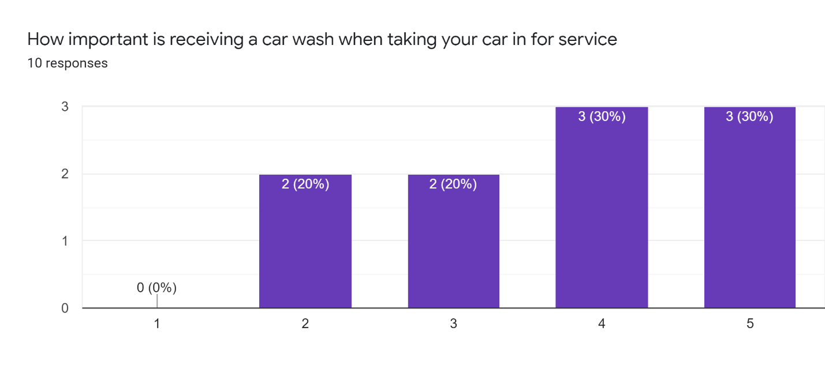
Figure 1 – Respondents were asked on the importance of having their car washed

Preference Between Car Wash Methods

Out of the 10 individuals surveyed only 1 response indicated a preference for hand washing over any other method. Five respondents indicated a preference for automatic washes. The remaining 4 respondents did not indicate a preference. Figure 1 below shows the data.

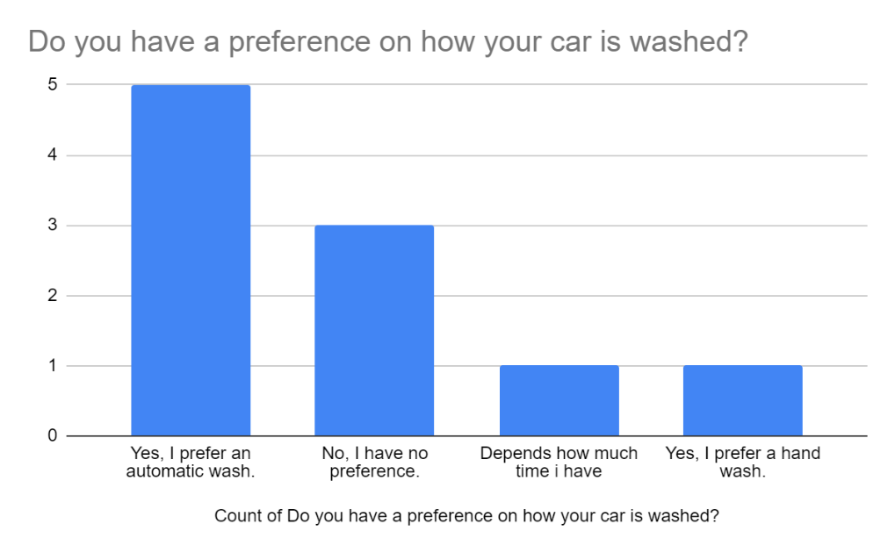
Figure 2 – The majority of survey respondents prefer automatic washes over hand washes

Additionally, figure 2 below shows that only 6 of the 10 respondents have received an automatic car wash. In contrast, 9 respondents have gotten a hand wash. Despite this, we see in figure 1 above that automatic washes are strongly favored.

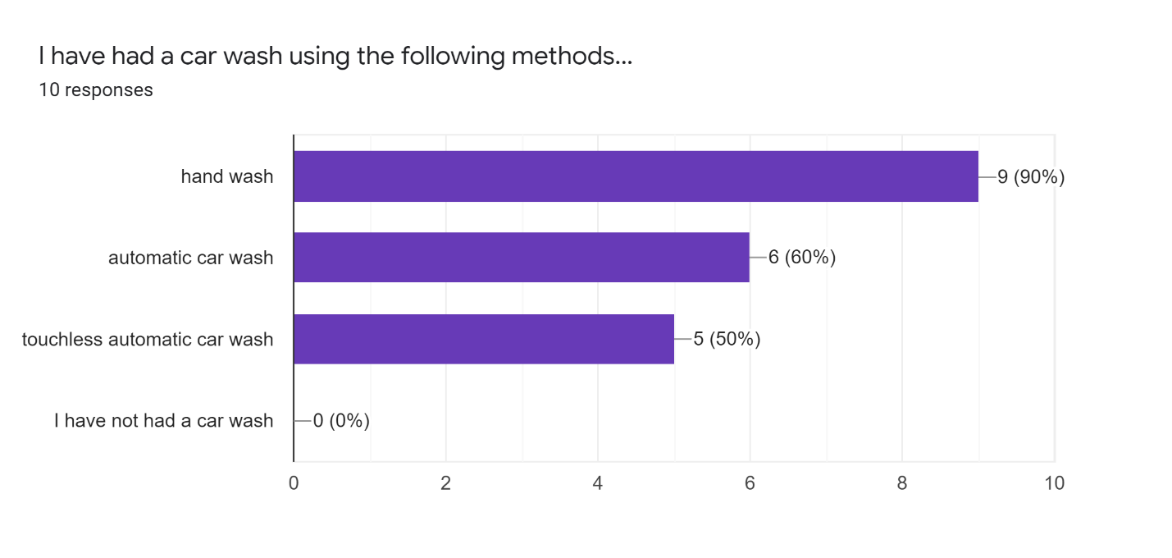
Figure 3 – Nearly all survey respondents had received a hand wash but only 6 had received an automatic wash.

Conclusion

Summary and Interpretation of Findings

Based on survey results, customers strongly prefer automatic car washes over hand washes. Automatic car washes are also cheaper to operate in the long run

Recommendations

This report has highlighted a few areas of improvement. The following are some suggestions based on the data collected.
- Assuming space is available on the lot, an automatic car wash should be strongly considered for the dealership.
- Customers value car washes and that is service that should continue to be provided.
- The best automatic system would be a tunnel system as it allows multiple cars to be washed and untrained users to wash the car. This would allow one less lot attendant to be working.
- If not changing wash systems then a two-bucket method should be used in stead of the current one bucket method

References

(add later)

