Business Plan For Developing Official WeChat Account
Submitted by
Hangwei Bao
ENG301 UBC Student
Table of Contents

Introduction 4
Procedure 6
Data Section 6
Limitation of the proposed solution……………………………………………………………..18

Recommendation 18
Conclusion 19
References 21

List of Figures

Table 1:Shareholders’ interview response.………………………………………….7
Table 2: Online survey long question result………………………….……….…………15
Chart 1: When do customers go to Leletea. …………………………….……….…………12
Chart 3:Do customers have WeChat account …………………………………………….13
Chart 4 :when do customers typically visit Leletea ……………………..……….…………14
Chart 5 :How many people need assistance while waiting for their drinks………………15
Chart 6 :Do people think it is safe in crowed indoor space ……………………..……….15
Figure 1: CAICT WeChat Economic and Social Impact Report 2017 ……………………..…16
Figure 2 : Ipsos 2018 Q4 Third-party Mobile Payment……………………..… 17
Figure 3 : System Architecture…………………..……….……………….…………19

I. Introduction:
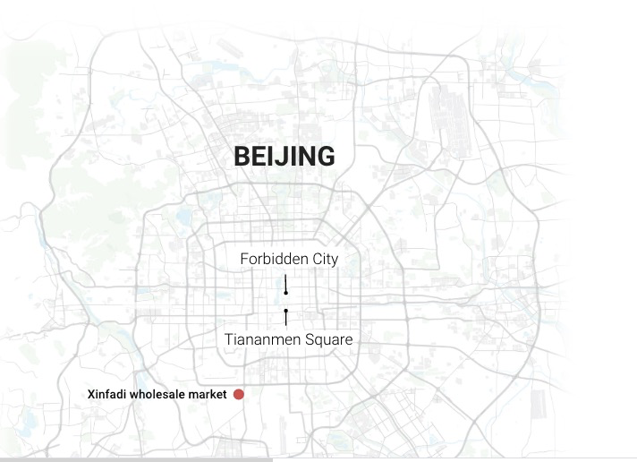
In 2019, the outbreak of Coronavirus in Wuhan city has rapidly evolved affecting the parts of China and outside the country. Coronaviruses is a large family of viruses that can cause people to have severe cold symptom, people who have weak immune system such as the elders, the children are most vulnerable to this disease (Chan et al.,2020) After Human-To-Human transmission has been confirmed, Chinese government was desperate to contain the disease during the early stages, it locks down the entire Wuhan city and requires all citizens to quarantine themselves to prevent the diseases from spreading (Qin, 2020). Currently, the disease has been contained in China, and the country is opening up; however, the threat of COVID-19 is still present in Beijing, China, with a new outbreak reported this July.
Map 1: Beijing Coronavirus outbreak in July, the location of the centre of the outbreak. (retrieved from https://multimedia.scmp.com/infographics/news/china/article/3090290/beijing-coronavirus-outbreak/index.html)
When China was thought to be coronavirus-free, a second wave of infection occurred in Beijing. Xinfadi wholesale market (as indicated in this map); is very close to the most populated area such as Sanlitun road; it was identified as the centre of the second wave infection, and the “ market is Asia’s biggest wholesale market. With more than 2,000 stalls selling everything from meat and seafood to fruit ad vegetables” (Huang, 2020). Lele tea used to purchase fruits to make fruity drinks in Xinfadi, but according to shareholders, their store must abandon any product that purchased from Xinfadi. Here is a time line of Beijing’s second wave infection
Despite the continuing risk, businesses have reopened in Beijing, and people have eagerly begun to return to their regular lives as much as possible, after months of isolation and social distancing. However, if businesses allow customers to gather in crowds, particularly indoors, the risk of another COVID-19 outbreak will increase significantly. Letea (the name means “happy tea” in Chinese) is a very successful tea shop in China that often has long lines of customers that extend out the door. Businesses like Letea must consider how to change their operations to effectively deal with the risks of COVID-19.
Although online food delivery services are available in China, people who leave their houses and venture outside do not use such services. Instead, they are visiting stores and restaurants in person, which potentially exposes them to other people infected by COVID-19. Stores must adapt and consider ways to limit the amount of time spent in crowded indoor spaces by executing sale transactions much more quickly and efficiently. Limiting the time spent in stores also limits the exposure to people with COVID-19, which is a crucial part of containing the virus. For stores like Letea that have very high volumes of customers, it is particularly important to properly manage the risk of in-store COVID-19 infections.
In order to safely reopen high-volume stores like LeLetea, the businesses should employ technology to reduce the time customers are in the stores. One way to reduce the time spent in the stores is develop an official WeChat account for online orders. WeChat is estimated to have over 1 billion accounts, and practically every young adult with a smartphone in China has Wechat. To maintain the safety of its customers, LeLetea can allow customers to pre-order and pay for their drinks using the app, which can be done at home or by using QR codes outside the stores. By ordering and paying for drinks through the app online before they go inside the stores, customers would not have to wait in long crowded lines indoors for long, if at all. In addition, because COVID-19 transmission risk is highest for crowds inside stores, the drinks could be placed at tables outside the store, where transmission risk is lower. This also makes it more convenient for customers by substantially reducing the time people spend at the store waiting, which is particularly helpful for customers like pregnant women, people with disabilities, and seniors.
To access the feasibility of the proposed solutions, my plan to focus on gathering more information on the following: 1) What additional resources would the store need in order to implement the online ordering system? For example, would they need extra staff to track and reply to online orders? 2) What are the shop owner’s concerns about online ordering? Are they intimidated by the prospect of using new technology? 3)What do the customers think of using the app? 4)Will customers use it if it is available? Do they already use similar apps for other stores?
Procedure :
- Personal interview questions :
To collect the data I needed, I reached out to the shareholders of Leletea store and asked their opinions on re-opening the store during the pandemic, their concerns about online ordering, and the feeling towards using new technology. All ten questions are related to the proposed solution, such as their thought on customer’s option of using this WeChat account, or do they think it is more safe to use QR code and reduce customer’s waiting time in the crowed store. Shareholders were also invited to
2. Online survey
The intended audience for this survey is the Leletea customers. There are in total 10 questions for them to answer. Their answers include the waiting time at Leletea store in Sanlintun; what time of the day do they usually visit Leletea; the payment methods they prefer; whether they need special assistance while waiting; their experiences with the sale transactions in Leletea store, and how easy for them to oder online.

Data section
- Shareholders’ interview response.

Questions | Shareholder A | Shareholder B | Shareholder C
Question 1: What are your biggest concern of re-opening the store during the Pandemic. | My biggest concern of re-opening is the safety of our customers and our staffs | My biggest concern of re-opening is how can we make customer’s safe | My biggest concern of re-opening is how can the store operate without putting customers at the risk of contracting the business
Question 2 : Although the country is encouraging small business to re-open, the COVID-19 transmission risk is still high for crowds inside stores. Do you have any plans to mitigate the situation? | We have been encouraging customers to order online through apps such as Eleme, and Meituan. | We also provide customers discounts if they chose to order online, it can decrease the number of people at store and therefore reduce their risks of contracting the virus | We discovered that although we have a lot of online orders, our revenue hasn’t go up yet. Partly because we are working with contractor, and we have to pay them. We also have to give customers’ coupons such as “buy one get one”, this marketing strategy is not ideal in the long term, but can help our business running during this pandemic. We don’t have further plan expect for continuing the operation mode that we have right now, because we think the pandemic should be soon over.
Question 3:Do you think my proposed solution could work? | I think it is a nice suggestion, not only can it help the business during pandemic, I think it could also be used as a long term strategy. | If the target audience are young customers, then this strategy could work, because most people are comfortable with online payments, we accept WeChat pay as well, so it should be no problem during the transaction process. | We also need to think about other customers such as elder customers. Although our main customers are young customers, we don’t want to be exclusive. This is not how we want to operate our business
Question 4 : What are your concerns about online ordering? Will you feel intimated by the prospect of using new technology? | My biggest concern is updating the system. For example, we have to hire a staff watching out how many items we still have in the store. If we put wrong numbers of items on the app, we could irritate the customers. | Yes, as said, we need to have a staff that keep tracks of the orders regularly, currently we have zero employee who can do this, and we might need to hire someone to do it. | Moreover, we have to consider how we can train the staff to accommodate this new operation process, and this could cause time and money, besides, we don’t when will this pandemic end.
Question 5: Do you think Wechat-Pay is a useful tool? What kind of paying methods do you prefer? | I do agree that Wechat-pay is useful, especially when we need to be more careful with personal transaction these days. | A lot of young customers don’t carry cash nowadays, so we are very familiar with this paying method. | We would prefer non-personal translations during this outbreak, to reduce the risks of contracting the virus
Question 7: What your thoughts on customer’s opinion of using this account if it is available. Do you think they will accept or reject to use? | Most customers would accept I think, because we are already utilizing the online payment tools. | Again, we have to consider people who are not comfortable with online payment tools, we could lose some customers because of this | There could be some transaction problem that will occur, and we don’t know at this stage if we have the technicians ready to fix that
Question 8 : Is there any other stores you know are using the official account? For examples, your rivalries, how do they adapt to new changes in the operating environment. | Yes, but not restaurants.  Restaurants typically forbids too many customers inside of the store in the same day, and that cuts revenue too. Some restaurants such as hotpot, are not able to work with take-out companies, and they are experiencing some difficult times right now | Not many people are using official account right now, they prefer working with take-out company as said, but again, they are working on a different mode as us, and therefore, is incompatible. | If you think about other boba tea stores you will see a similar pattern, they are all working with a take-out company and offering discounts just like we do. If we price our products higher, we may lose some customers. Our products are unique but not irreplaceable. We are in a competitive market, and normally we don’t take any risks.
Question 9: Do you think it is more safe to use QR code and reduce customer’s waiting time in the crowed store? | I would agree this is more safe, because we would reduce people’s waiting time in the store | Yes, it’s safe, and convenient for the customers, but not necessary convenient for the store | I agree it is safer than normal payment methods.
Question 10：What are the pros and cons of having an official account, could you please elaborate for me? | First of all, having an official account helps us promote our products, with many WeChat users, we can easily promote our new products by just posting our pictures. That will save a lot advertising fees. Secondly, it helps with our brandname. | There are pros and cons, for example, people don’t regularly check official account unless they want to purchase something, having an official account doesn’t guarantee that we would have more customers. | It could start another competition if we develop our official account. We need to hire designers to design the page, other stores may want to compete with us on WeChat, and that just create another batter-field, we need to worry about more things if we really created this account.

Table 1 : Shareholder’s interview answers.

B. Online survey data summary.
This online survey has collected respondence from 42 Leletea customers’. The data bellow will be showing the results of different question . Short questions’ respondence were presented in pie charts, and the long questions’ respondence were presented in table 2:

Chart 1: When do customers go to Leletea.

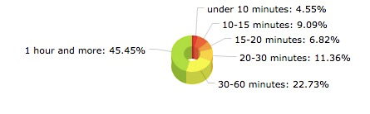

Chart 1 : customers’ typical waiting time at Leletea store in Sanlitun.

Chart 2: Do customers have WeChat account
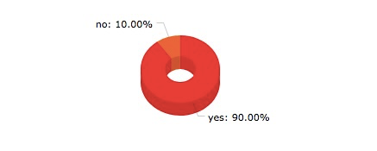

Chart 2 : How many customers have weChat account.
Chart 3: Payment methods that customers prefer :
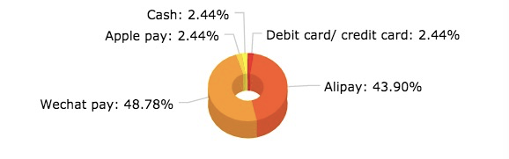
Chart 3 : the type of payment methods that customers prefer.

Chart 4 when do customers typically visit Leletea

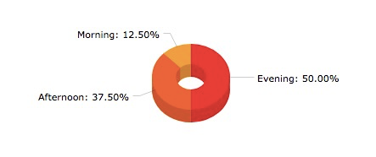

Chart 4 : At what time of day do people like to visit Leletea
Chart 5: How many people need assistance while waiting for their drinks

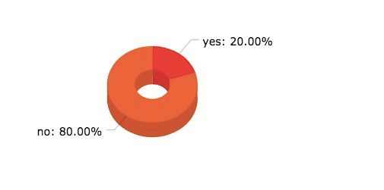

Chart 5 : People that need and don’t need special assistance while waiting for their drinks.

Chart 6: Do people think it is safe in crowed indoor space :

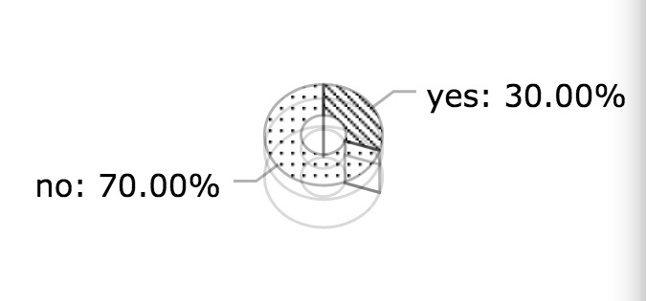
Chart 6: The percentage that people think it’s safe or unsafe in crowed stores.

Table 2: Online survey long question result
Question | Answer 1 | Answer 2 | Answer 3 | Answer 4
Sale Transactions in Leletea store is | Easy and convenient  45% | Sometimes difficult and inconvenient 25% | Always difficult and inconvenient  10% | N/A  20%
Online ordering for you is | Always convenient and easy 60% | Sometimes inconvenient and difficult 30% | Always difficult and inconvenient  10% | N/A  0%
Create physical barriers between employees/clients during pandemic is | Important and necessary  55% | Preferable  45% | Not necessary  0% | N/A  0%

C..Proposed Solution
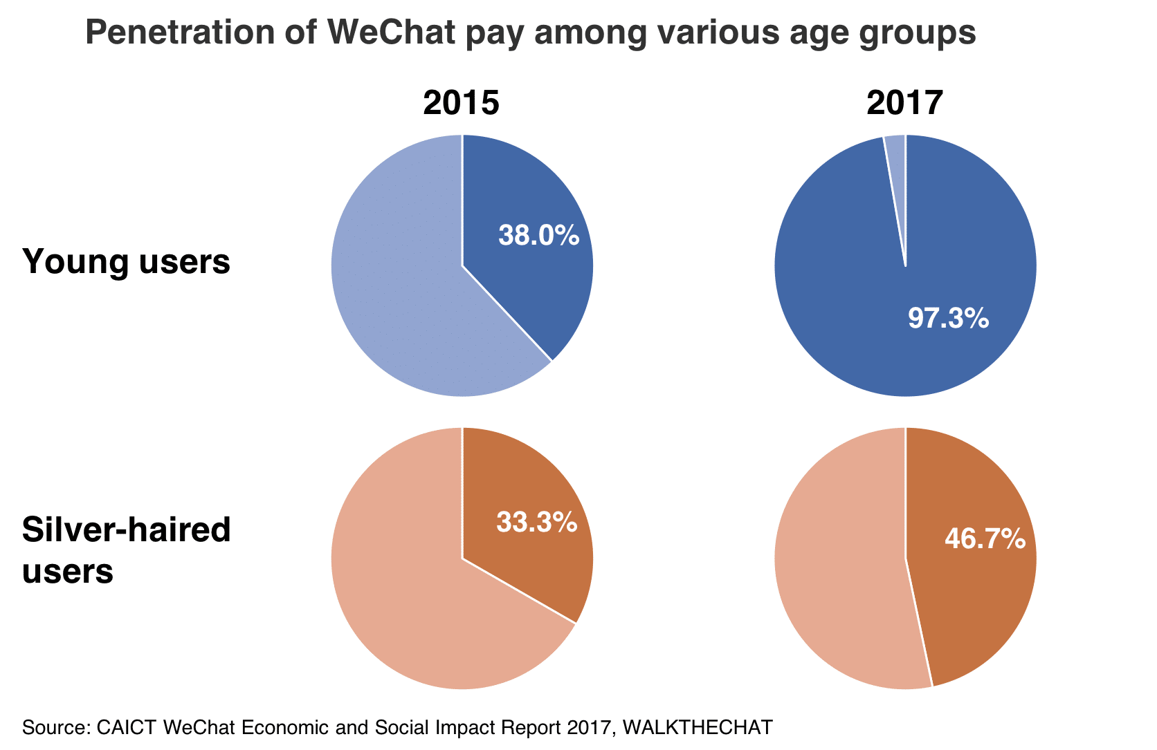
a. Developing an official WeChat account for online orders
Figure 1: CAICT WeChat Economic and Social Impact Report 2017 (source:https://1z1euk35x7oy36s8we4dr6lo-wpengine.netdna-ssl.com/wp-content/uploads/2017/08/wechat-penetration-by-age.png)

As shown in figure 1, we can see a huge increase in young WeChat users and silver-haired users. However, young users outweighed silver-haired users. WeChat not only have payment function, it is also widely used as a communication app. Although China has other online payment available (such as Alipay in figure 2) , but only WeChat has the communication function, users can use WeChat to call and FaceTime ( like skype), they can also share their daily life in Friend circle ( like Facebook).
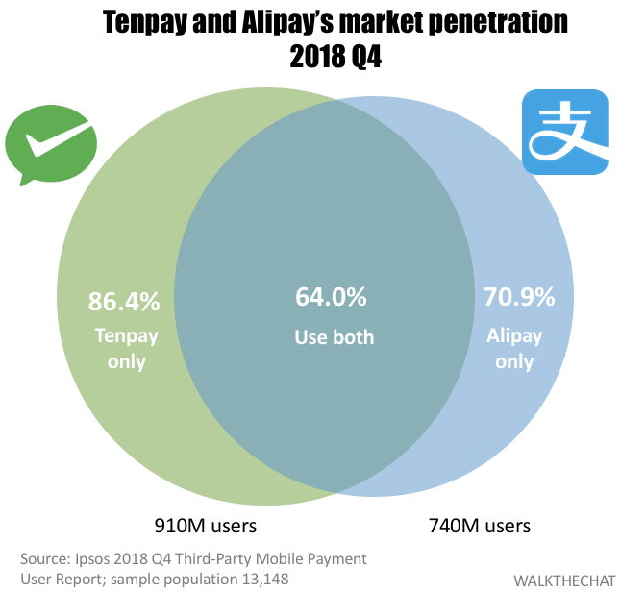

Figure 2 : Ipsos 2018 Q4 Third-party Mobile Payment ( source: https://walkthechat.com/wp-content/uploads/2019/02/payment-war3.png)

Currently, WeChat is widely used as a platform of promoting products (Yang et al., 2016). “ In WeChat business, firms have developed customer relationships along two distinct ways : business relationships and friendships. However, research on the combination of business relationships and friendships is relatively nascent” (Yang et al., 2016). There are much research available that study the WeChat business, many WeChat business entrepreneurs have succeeded because they rely on their expanded social network to promote their products (see Yang et al., 2016; Chen et al., 2017). Unlike other online business, such as Taobao, WeChat business is a new e-business model. Young et al (2016) aims to explore how WeChat business is distinguished from that in offline business, and how they use network to build up their business.
Young et al (2016) first examined the business relationships of WeChat business, and they discovered that the relationship between sellers and buyers were complexed by WeChat’s communication function. In traditional business “the majority of customers are focused on getting down to the business by obtaining functional benefits from the service provider, and are not concerned with developing friendships with the service provider” (Yang et al., 2016). WeChat business facilitate friendship between buyers and sellers. This is new kind of relationship for both buyers and sellers. Yang et al. (2016) suggests that “ the customers and service provider become more trusting and dependent upon one another over time” (Yang et al., 2016). This new relationship between buyers and sellers cannot be formed in other online business platform such as Alipay, this is one of the reason why building a WeChat account can be beneficial to Leletea store.

Limitation of the proposed solution
1. the potential drawbacks to online ordering

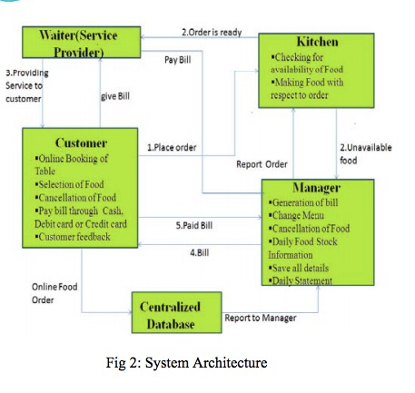
— Developing centralized database could be difficult

Figure 3 : System Architecture (source:http://ijiset.com/vol2/v2s4/IJISET_V2_I4_112.pdf)

As you can see, the system architecture for online ordering is very complex. From shareholders’ interview, we can also be inferred that there’s a need for hiring new technician to train the staffs, or hire a staff that have the digital literacy. Creating an official WeChat account is easy, but developing the “ centralized database” requires time preparing. The problem is, no one knows how long will the pandemic last, and if it is necessary to develop the centralized database.

— Too many orders.

It is possible that the store will have too many orders because it is facing wider range customers. The store is no longer limited by physical constrains, but employees might be overwhelmed because of new operating system. It is unsure if the store will be needing more employees, and if hire more employees that could increase variable costs.

2. cost analysis ( Still waiting for the Shareholders to share some financial problems with me )
Recommendation : (based on cost analysis, in progress)
Low promotion fee: Lele tea has gained good reputation in China, and with WeChat, the store can

Conclusion (Incomplete)
Businesses must continually adapt to new changes, opportunities and threats to their operating environment. They must always question how they can serve their customers better. During this critical time, it is important that everyone pitches in and helps society contain COVID-19. Operating businesses in a safe manner for consumers is an important part of the solution, and customers will be appreciative of businesses that show genuine concern for their and society’s well-being.

References:
Chen, Y. R. R. (2017). Perceived values of branded mobile media, consumer engagement,
business-consumer relationship quality and purchase intention: A study of
WeChat in China. Public Relations Review, 43(5), 945-954

Chan, J. F. W., Yuan, S., Kok, K. H., To, K. K. W., Chu, H., Yang, J., ... & Tsoi, H. W.
(2020). A familial cluster of pneumonia associated with the 2019 novel coronavirus indi
cating person-to-person transmission: a study of a family cluster. The Lancet,
395(10223), 514-523.

Huang, H. (2020). “Beijing’s coronavirus outbreak”. Retrieved from https://multimedi
a.scmp.com/infographics/news/china/article/3090290/beijing-coronavirus-out
break/index.html

Qin, A. (2020). China May Be Beating the Coronavirus, at a Painful Cost. The New York

Times. Retrieved from https://www.nytimes.com/2020/03/07/world/asia/china-coronavirus-cost.html
Yang, S., Chen, S., & Li, B. (2016). The role of business and friendships on WeChat
business: An emerging business model in China. Journal of Global Marketing,
29(4), 174-187.

