Searching for the ideas and methods to reduce homelessness in Vancouver during COVID-19 pandemic

Ideas presented to Head of the Homelessness Prevention Program at BC Housing
Ideas presented by Luke Jang at University of British Columbia in ENGL 301

Table of Contents
ABSTRACT 3
INTRODUCTION 4
METHOD 6
BODY……………………………………………………………………………………………………………………………………………………….7
CONCLUSION…………………………………………………………………………………………………………………………………………12
REFERENCES………………………………………………………………………………………………………………………………………….13

Abstract

Introduction
In 2020, the world has shut down due to a widespread virus so called COVID-19. It has killed a lot of people so far and the lifestyle changed due to restrictions that the virus has caused. COVID-19 definitely impacted many people in a different way. For example, people who go to the gym regularly are now facing the challenges of having to book their workout sessions and are restricted to only certain amount of time per session. Restaurants are heavily relying on takeout orders for the revenue stream. Hospital workers are now wearing masks 24/7. Business people who need to travel frequently are now reducing their number of business trips. Just by looking at these examples, it is possible to realize the impact of this worldwide pandemic. Due to the impact of the virus, almost everyone is suffering in some form at least and some people are facing the challenge more harshly than others; the ones who are declaring bankruptcy and becoming homeless. Vancouver has always been a city that suffers from homelessness due to a very high living cost and also the issue of widespread illegal drug abuse. On top of the pre-existing problems, COVID-19 has definitely added more oil to the fire, worsening the issue.
In 2019, “The number of people experiencing homelessness in Vancouver has hit its highest level in nearly two decades, the latest homeless count shows” and “The early results of the count released Wednesday identify 2,223 homeless people living in Vancouver, marking the highest number since the survey began in 2002” (Boynton, 2019). As seen from the homelessness count survey conducted in 2019, the number was already record-breaking. Imagining how much the number should have grown since last year until now, in the midst of COVID-19, it is predictable that the extent of the issue worsened. For 2020, the homelessness count survey for Vancouver was conducted in March 2020, but the results are currently not available online due to an unknown reason. Instead of the result for Vancouver, the homelessness count result for Fraser Valley is available to the public and it shows that “There are 895 homeless individuals in the Fraser Valley”, which “is a significant increase from 2017 when the count revealed 606 homeless individuals throughout the region living in shelters, transition houses, service centres and outside” (fvrd, 2020). By observing the survey result in Fraser Valley area, it is possible to predict that the number of homeless in Vancouver definitely increased because Vancouver is a bigger and denser city than the rural cities in Fraser Valley. Also, the survey in Fraser Valley was conducted in March this year which was the beginning of COVID-19 lockdown, so the number of homeless people definitely should have increased by now compared to March.
The sudden spike in number of the homeless in 2020 was caused by the COVID-19 outbreak but the homeless population is not the only number that increased during this challenging time. The crime rate during the COVID-19 pandemic has witnessed a “120 percent increase in business break and enters in Vancouver” (Mollison, Gagnon, Mannoe, 2020) and “break-ins had increased by 567 percent in Victoria and Esquimalt and 120 percent in Kamloops.” (Mollison, Gagnon, Mannoe, 2020). Aside from business-related crimes, also the safety of the general public is being endangered as Vancouver Police Department witnesses “police have seen an increase in complaints related to street disorder, thefts from cars, open drug use, violence on the street and discarded needles” and “it started when homeless people were moved from areas like Oppenheimer Park in the Downtown Eastside to downtown community centres and hotels as a response to the coronavirus pandemic” (Britten, 2020). Due to this happening in the community, Vancouver Police Department is “getting hundreds of emails from concerned citizens” (Britten, 2020) and unfortunately, this is just a reality of the homelessness in Vancouver, of them being involved in “violence and crime and carrying weapons” (Britten, 2020). Due to these issues arising during the COVID-19 pandemic, there must be a method to mitigate the negative impact on the homeless being caused by it. In this report, negative impact mitigation methods will be discussed utilizing the data collected from the internet and the related responses collected from the people that I have interviewed for this report.

Method
For the purpose of generating this report, I have created and distributed a questionnaire regarding the issue being addressed here to people who have knowledge and experience in dealing with homeless people. These people include police officers, psychiatric nurses and individuals working in the law enforcement sector. The questionnaire was distributed via email to the individuals. The responses to the questionnaire were completely voluntary and anonymous. I have sent out the questionnaire to 7 people, however, I only received 2 responses. The report will be based on those 2 responses.
The responses to the questionnaire from the participants were sufficient to generate the report, however, any supplementary information that helped in the writing were gathered through web research on Google by referencing statistical data and quoting relatable articles.

Homelessness – Pre-COVID19
Homelessness is becoming a major problem in many big cities around the globe. Vancouver has been suffering from the steadily-rising homeless population since a long time ago, in the pre-COVID19 era.
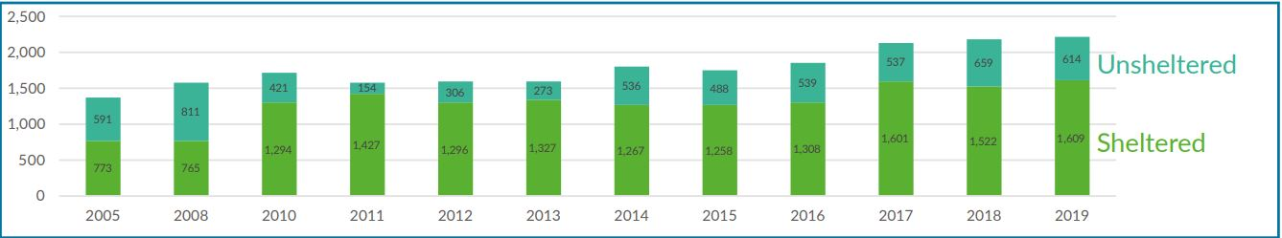
Figure 1 https://vancouver.ca/files/cov/vancouver-homeless-count-2019-final-report.pdf
Figure 1 shows the number of homeless people in Vancouver since 2005. The number has always been increasing every year and 2019 is the highest so far. According to (HomelessnessHub, 2017), homelessness is a “symptom of other underlying problems” which that “An estimated 80% of homeless people suffer a chronic health issue. 49% have an addiction and 34% suffer from mental illness”. These are definitely one of the causes, however, these causes all lead to one major cause: economic issues. People who suffer from such underlying problems of health issues, addiction and mental issues are mostly unable to work due to their condition. Therefore, it all funnels down to economic problems. Now, with the COVID-19 pandemic happening around the globe, there are people that are declaring bankruptcy and losing jobs. These are the people who are becoming homeless without the ‘symptoms of other underlying problems’. COVID-19 has created a new trend of homelessness.
Homelessness – During COVID19
From the responses gathered for the questionnaire, all the participants agreed that homelessness was already a problem in the city of Vancouver, however, they agreed that COVID-19 definitely worsened the case. One of the participants for the questionnaire states “I believe that covid-19 has worsened the already troubling homeless concerns in Vancouver” and “I am certain that homelessness will be increasing now that there are economic hardships. It would be especially difficult for those who live paycheque to paycheque”. Another participant to the questionnaire emphasizes that “This is an on-going social issue that also was affected by this pandemic, but because of it, the awareness level of those who can affect change were heightened”. As already described, homelessness has always been the problem in the city of Vancouver, however, now it is becoming even worse due to the economic challenges being pushed against people who are no longer employed, causing them to become unable in paying their rent and mortgages. Even with the government support, some people are being kicked out to the neighbourhood streets.
COVID-19 outbreak started in December 2019 and it officially started affecting the province of BC in March 2020. The homeless count for 2020 has been done in March 2020, however, the result is not available to the public just yet. However, it is predictable that 2020 will be the new highest record for the number of the homeless by the observation of the population growth in the past ,however, the severity of the increase will be greater this year especially with the pandemic happening right now.
Assuming that the homeless population grew even more with the effect of COVID-19, the homeless population is not the only number that grew bigger. The crime rate involving the homeless has increased by a big fold in 2020 since the beginning of the pandemic. Looking at a case of Lahna Tran, a business owner in Downtown Vancouver, had her store main door smashed in July 2020 and has been noticing “more disturbances since the pandemic began: smash and grabs at other shops and loitering” (Britten, 2020). Also, according to (Britten, 2020), Vancouver Police Department inspector Rob Clarke “believes violence has increased during that time” of COVID-19, therefore, VPD will “redeploy an extra 14 officers to join 145 already in the area” (Britten, 2020) that have a lot of criminal-related complaints. Homeless-related crimes in the city is not the only concern at this challenging time but the possible outbreak of the virus among the homeless community is also very concerning. There must be a solution to solve all these issues simultaneously.
Potential solution to solving the homeless-related crimes as well as community outbreak among the homeless during COVID-19
First of all, it is essential to define the homelessness. Homelessness is a phenomenon happening to people who have no stable or established dwelling place. As discussed earlier, homelessness could be a ‘symptom of other underlying problems’ such as mental or physical illness. As we can see in the table below, there is a number of homeless people whether sheltered or unsheltered who are suffering from variety of illnesses.
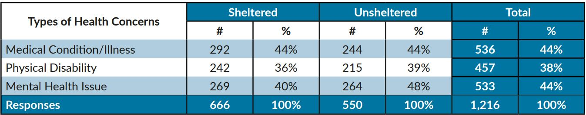
Figure 2 https://vancouver.ca/files/cov/vancouver-homeless-count-2019-final-report.pdf
Fortunately, there are lots of homeless people who are sheltered but there are as many as homeless people that are not sheltered. It is not possible and unfair to assume that the unsheltered homeless people would be involved in more crimes, however, there could be a higher probability where they could be more tempted to or be involved in criminal activities due to their living environment. If we agree that this assumption is convincing enough, we can also agree on the fact that if we could shelter as many homeless people as we can, then we can definitely reduce the homeless-related crimes as well as the potential outbreak situations among the homeless. However, this is not an easy solution to find. One of the participants to the questionnaire states that their biggest concern for the homeless people at this time is “staying healthy during this difficult times”, however, “We are told that we must stay at home to prevent the spread of the virus but the same logic would not apply to the homeless. Shelters have always been full and turning away people. Now at high time all the homeless resources are probably struggling to provide essentials to everyone. Not everyone is lucky to keep a quarantine supply of food stashed in their basement or stay inside in the comfort of their home”. It is agreeable that the rules do not apply the same to the homeless as to people with homes and proper income. The people who have homes and proper income get the opportunity to work from home in a comfortable house and still get their income while avoiding any chance of catching the gruesome COVID-19 virus, however, the homeless people are still on the streets, being very vulnerable to the virus. For this issue, is the government really doing their best to accommodate the homeless? The question was asked to the participants to the questionnaire and one of the participants disagreed and stated “I have only seen the government helping those who lost jobs. Although certain municipalities are providing temporary hotels as homes for the homeless, it is not enough support” while the other participant was on a neutral stance saying “To my understanding, leadership plays a big role when assisting the homeless people. The COV is a task in helping the homeless and addressing the concerns of the residents. I am not well versed with the financial standing of the city of Vancouver, but they are assisting the homeless with whatever resources available to their disposal”.
What is the Government doing at this time for the homeless ?
At this difficult time, government is doing their best to accommodate everyone, including the homeless. An example of the Government’s work is in closing down a well-known homeless town, the Oppenheimer Park in Vancouver Downtown, to move the homeless people out of there to a secure place to avoid the virus outbreak. Oppenheimer Park has always been a place of conflict due to frequent serious crimes occurring within the park, mostly involving the homeless people. In January 2020, a man was brutally attacked and murdered in the park by a resident of the homeless camp in the park. In June 2020, a woman was held at gunpoint and was forced into a tent in the park by a homeless person and eventually was sexually assaulted. These two cases are just a few cases being mentioned here, however, the reality of what had been happening in the park was far more serious and more frequent than what we hear from the media. By the Government’s action in closing down the park, both the issue of criminal activities and the potential outbreak could be at least temporarily prevented. Now, the former residents of the Oppenheimer Park are sheltered in “more than 600 spaces in hotel rooms and community centres” that are “secured for homeless people in Vancouver” (McElroy, 2020). As of July 2020, no further housing or living spaces have been secured after the hotel rooms being secured in May 2020. Government is doing their best to find solution to reduce homeless-related crimes and avoid the COVID-19 outbreak among the homeless people, however, it seems like the 600 spaces are not sufficient to house every homeless in the city. What else could be done to accommodate the homeless the best we can to avoid a community outbreak as well as reducing the crime rate in this difficult time ?

Other possible solutions to accommodate the homeless
As of right now, the government has provided only one solution for the homeless so far, which is the acquisition of old hotels to accommodate living spaces for the homeless. This is not only a temporary solution and it does not target the entire population of the homeless. One of the participants to the questionnaire states “I have only seen the government helping those who lost jobs. Although certain municipalities are providing temporary hotels as homes for the homeless, it is not enough support”. The hotel acquisition could be a good solution, however, it is important to note that not all homeless people agree on being moved into a hotel. Let’s look at this table below to get more insight to why some of the homeless people are not sheltered.
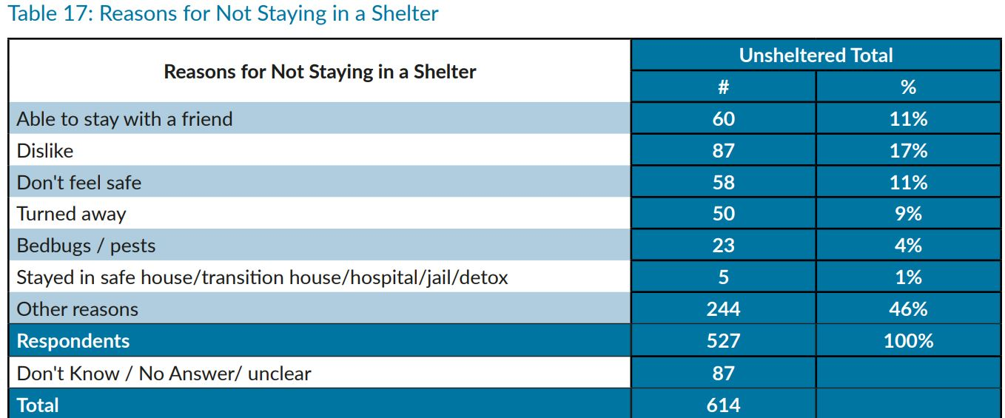
The highest percentage occupies the ‘other reasons’ and the second highest is the ‘dislike’. It is difficult to predict the actual reason or thought behind the other reasons or the reason of dislike, however, these reasons might be related to their addiction problems or simply because they do not have to ability to make proper decisions due to their mental condition. One of the participants to the questionnaire stated that the homeless people really need from the government of the “Safe place to live (not just temporarily stay) and essential supplies to support them”, which is currently being done by our government. On the other hand, another participant stated “I believe, having professional outreach workers out on the road to help the homeless is the first step”. This response basically provides a solution to helping out the ones who have “other reasons” or “dislike” towards being sheltered. From my personal experience, I have seen big hospitals with abandoned buildings on the hospital property with lights and heating that are still functional. Hospitals are facilities that are fully equipped with devices, necessary amenities and the right human resource on site to support the ones that are ill and are in need. If hospitals could utilize the ‘still-functional’ abandoned buildings to house the homeless people to be treated and fed during the COVID-19 crisis, it might be feasible to make positive impact on those who are homeless that are in many needs. Recently, in the beginning of July 2020, Victoria’s municipal government implemented a housing plan for the homeless utilizing a hospital care-home facility in Oak Bay. If Victoria took an initiative in the hospital conversion plan, Vancouver should definitely consider similar solution other than the hotel acquisition plan which do not possess the adequate human resources and other amenities for a full support even for those who are not in favour of being sheltered. As this is an extremely difficult time for not just the homeless people but for everyone in the society, it is absolutely crucial that the government, as a leader of the society, make decisions for the safety of everyone even if it takes a huge cost.

Conclusion
Homelessness is one of the biggest problems in many cities. It is a serious concern because there is not much that the government nor the society can do to completely end the problem. As it has always been a concerning problem, having to suddenly house the homeless into facilities is even more difficult due to the conflicts in budgeting and also the fact that a lot of the homeless people can be difficult to persuade to be sheltered, because for a lot of them, it is their ‘way of living’ and a lifestyle that they would like to pursue. However, as everyone in the society is doing their part in reducing the spread of the virus by executing social distancing and wearing proper Personal Protective Equipment (PPE) , homeless people should cooperate during this difficult time. It could be tedious and inconvenient for them to be suddenly sheltered without their will, but everyone is social distancing and wearing proper PPE even if we think it is uncomfortable. Unfortunately, it is not a choice at this moment but a responsibility as a member of the society. The government is currently doing their best to accommodate living spaces for the homeless people by purchasing old hotels to house them, however, it is not yet enough space for every homeless in the city nor it is the best environment to prevent further issues within the facilities as conflicts between the homeless can be incurring and might lead to other criminal activities in these facilities. In order to prevent such potential problems, government should also look for other supplemental resources like the right human resource (social outreach workers, psychiatrists etc) along with more spaces as a lot of the homeless people may and do have mental illnesses. Facilities that might have such resources can be hospitals and often the hospitals, especially big hospitals which are very old, do have old facilities that they do not no longer use, however, with fully functioning heating and lighting inside. They also have the right type of people within reach, therefore, might be a viable solution. One of the participants for my questionnaire stated that if the government has the right funding to address the homelessness issue during the COVID-19 crisis, they should be looking at “More housing units and support programs (job search, rehab, mental health etc) to help people get back on their feet”. This adds another reason to house the homeless in a proper facility with the right human resource because if this is feasible, the government can use this adverse situation in even partially ending the homelessness by helping them get back into the society.

References
Britten, L. (2020, July, 03). Police, business group and opposition link Yaletown crime concerns to social housing, CBC.
https://www.cbc.ca/news/canada/british-columbia/yaletown-crime-police-1.5637661
Guest (2020, May, 27). COVID-19: How mainstream-media coverage of pandemic crime rates is getting it wrong, The Georgia Straight.
https://www.straight.com/news/covid-19-how-mainstream-media-coverage-of-pandemic-crime-rates-is-getting-it-wrong
Boynton, S. (2020, June, 12). Vancouver homeless numbers rise to highest levels since 2002, latest count shows, Global News.
https://globalnews.ca/news/5383602/vancouver-homeless-count-results/#:~:text=The%20early%20results%20of%20the,2%2C181%20homeless%20people%20were%20identified.
Fraser Valley Regional District (2020, June, 24)
https://www.fvrd.ca/EN/meta/news/news-archives/2020/2020-homeless-count-shows-increase-in-the-fraser-valley.html
Howell, M. (2020, June, 12). Vancouver’s record-breaking homeless population at 2,223 people.
https://www.vancourier.com/news/vancouver-s-record-breaking-homeless-population-at-2-223-people-1.23853962
McElroy, J. (2020, April, 29). Vancouver hotels being used for homeless should be bought by government, advocates say.
https://www.cbc.ca/news/canada/british-columbia/vancouver-homeless-hotels-bc-government-covid-19-coronavirus-1.5549370
Buffam, R. (2020, July, 10). CRD mulls converting old Oak Bay care-home into temporary homeless shelter
https://vancouverisland.ctvnews.ca/crd-mulls-converting-old-oak-bay-care-home-into-temporary-homeless-shelter-1.5019009
Vancouver Homeless Count 2019.
https://vancouver.ca/files/cov/vancouver-homeless-count-2019-final-report.pdf

