Improving The Productivity Levels on Online Orders at Richmond Golf Town
Prepared for: Mr. Derrick Tiu (General Manager), Mr. Nigel Chang (Assistant Manager)

July 15, 2021

Abstract
Will be added later

William Jackson, ENGL 301, 40583726
Wcjackson99@gmail.com
Table of Contents

Letter of Transmittal …………………………………………………………………………………………

List of Illustrations …………………………………………………………………………………………….

Introduction …………………………………………………………………………………………………..3

Data (Body) …………………………………………………………………………………………………..4
First Topic of Investigation………………………………………………………………………….4
Second Topic of Investigation…………………………………………………………………….5
Third Topic of Investigation………………………………………………………………………..6
Fourth Topic of Investigation………………………………………………………………………7

Conclusion……………………………………………………………………………………………………..8

Recommendations…………………………………………………………………………………………..8

References…………………………………………………………………………………………………….8

- Introduction

Definition, Description, and Background
We may be slowly coming out of the COVID-19 pandemic, but the effects it has left on businesses will be present for a very long time. Businesses of all shapes and sizes were hurt dramatically, and the way they go about business in the future will need to change as a result of the pandemic. Here at Golf Town, we had to shut our doors for almost two months at the peak of the pandemic. Usually, we ship all of our online orders out from our warehouse in Toronto, where we have a fair amount of product. However, to maintain some sort of business, we started offering online orders through each store around the country, multiplying the amount of inventory we have to offer so as to maintain with the increased amount of online orders. Finally, when we were able to open our doors again, the amount of online orders slowed down again, and we were able to focus on our customers in store.
A couple months later, due to the COVID-19 pandemic, all of our stores in Ontario were forced to close after a state of emergency was placed on the province. This caused the majority of online orders to flood into the Richmond store specifically, as we hold the most inventory in the company. Even now that the Ontario stores are open again, they still are not taking many online orders due to very low inventory. This has caused employees at the Richmond store to struggle heavily with keeping up with the online orders being given to them. The Richmond store has gotten to the point where an order is not fulfilled until nearly a week after the order has been placed. Factor in shipping times and the orders are not fully completed until a minimum of two weeks after being ordered.
Our current online order process is inefficient. Generally, we have anywhere from 1-3 employees working on completing online orders in a day. Some days its just one-person, other days we may have up to three, but it is never consistent. These employees will print out the online orders, find the product in the store, collect the product(s), bring them to the back to verify the order, then finally pack the product so it is ready to ship. We have different employees working on online orders each day, some will work on it as little as once a month and be expected to carry out the same efficiency as other employees who work on it more regularly.

Purpose of the Report, and Intended Audience
The purpose of this report is to identify and suggest a more productive method in completing online orders at the Richmond Golf Town. The intention is to improve customer satisfaction by providing quicker response times, as well as to increase sales numbers with the ability to fulfill more orders than what is currently being completed. This report carries extreme significance because implementing a new, more productive method of completing online orders can have tremendous implications to the stores, and the companies, overall success, by way of improving customer satisfaction and increasing sales.
The audience targeted in this report is the overseeing managers at Richmond Golf Town, but it will also have use to all of the employees in the store, as well as managers in other stores. The reader will be able to read the findings from surveys conducted in the Richmond store, and view graphs and charts showing the results.
Method of Inquiry
The report will cover the productivity levels of the current method of completing online orders in the Richmond store. It will also cover research findings about the productivity levels of the online ordering system acquired through surveying the employees at the store. The purpose of these findings is to find a new method to completing online orders with more productivity.
The current productivity levels will be measured to see what the current benchmark is in terms of online orders completed on a daily basis. Then, from the suggestions made through the anonymous online survey conducted amongst the employees, a new method will be tested out and the productivity levels will be tested and compared to the original method.
This study is to show the need of a new online order method, and to point out a strong direction to lead the way. The limitation of the study is that the new proposed method will be tested under limited time. The results shown from the new method will have been compiled quickly, and observation must remain continuous.

II. Collected Data
1. First Topic for Investigation

In order to fix a problem, the problem has to first be identified. Our current online ordering system is not much of a system as it is. It has never been a focal point in the store operations, yet it contributes to a large number of our sales.
Figure 1 illustrates the responses of a number of current employees when asked how productive they thought our current sales order method was, from a scale of 1-5 (1 being very unproductive, 5 being very productive).
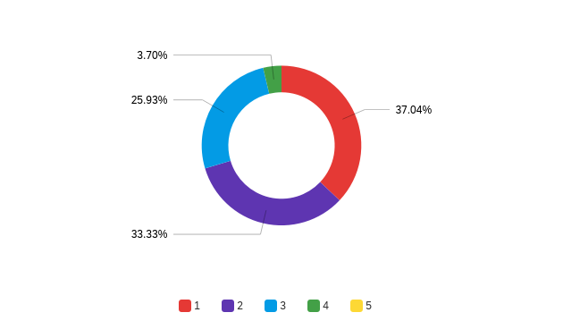

Figure 1: How productive do you think the current sales order methods are? 1 being very unproductive, 5 being very productive.
As Figure 1 indicates, an overwhelming amount of the staff believe the current methods used for online ordering is largely unproductive. 70% of the employees believe the current methods not productive whatsoever, with only 3.7% of the employees rating the online ordering methods as a 4 or better on the productive scale.

2. Second Topic for Investigation

In the same survey asked to the same employees, there were a few questions asked that suggested directions to go in when creating a more productive online ordering method. The specialization of tasks being mentioned here refers to employees being divided and focusing on certain tasks within the online ordering process. Rather than an employee picking the products out, then verifying the order, then packing, each employee can focus on one task themselves.
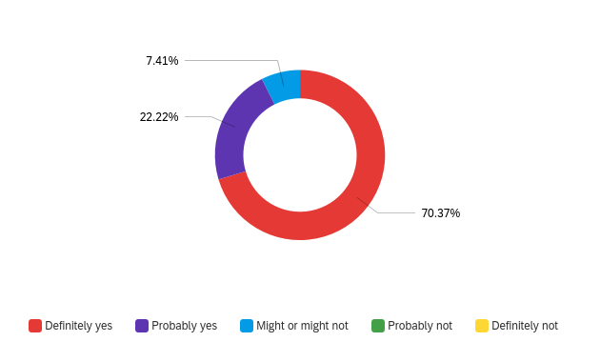

Figure 2: Do you think employees should specialize on certain tasks when completing online orders?
As Figure 2 shows, over 90% of employees in the store think that the specialization of tasks in the online ordering process will most likely increase productivity. 70% claimed this will definitely improve productivity, while 7% said it may or may not. Another take away is that not one employee thought the specialization of tasks would not result in a more productive online ordering process.

3. Third Topic for Investigation

Another question that was asked to the employees in the survey was if they thought the same group of employees should continue to work on the online ordering process, so as to increase the productivity of the overall system. The purpose with this question was again to see if there was any continuity among staff as to what they thought a good direction would be for the advancement of the online ordering system.
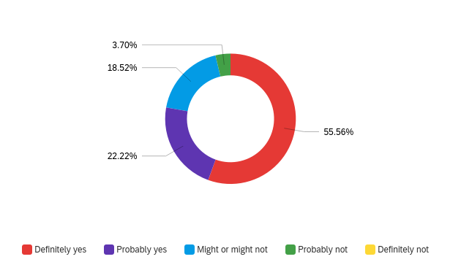

Figure 3: Do you think the same group of employees should do online orders?

Figure 3 shows the majority of the staff believe making the online ordering team consistent would produce greater productivity in online orders.

4. Fourth Topic for Investigation

- This will be focused on the results from implementing new strategies into the online ordering system, creating a new method. Results pending…
- Will illustrate productivity levels of current and new online ordering systems and compare.

III. Conclusion
A. Summary of Findings
B. Overall Interpretation of Findings (as needed)
C. Recommendations (as needed)

Conclusions:
- The overwhelming majority of the staff believe the current online ordering system is inefficient.
- The employees believe specialization of tasks within the online ordering system will improve efficiency.
- Employees also believe consistency in the workers within the online ordering system will also improve efficiency.

- After implementing these procedures into the online ordering system for 7 days, the system has become more productive (waiting on results)

Recommendations
- To continue using these two recommendations (specialization and consistency among staff) to provide efficiency in the online ordering system
- To continue monitoring the productivity of the new online ordering method.
- To continue to attempt to improve productivity. To think of more ways to improve efficiency for the online ordering process.

