DEFINING SOCAPEX
Parenthetical Definition
Synonyms: Soca, 19-pin, multiconductor cable, a large power connecting cable ranging from 25 to 500 feet.
Sentence Definition
Socapex, or Soca, is a large multiconductor power cable with 19-conductive prongs; it is often used in film, television, and stage lighting to connect lighting fixtures on stage to power distribution equipment off stage.
Expanded Definition
What is Socapex?
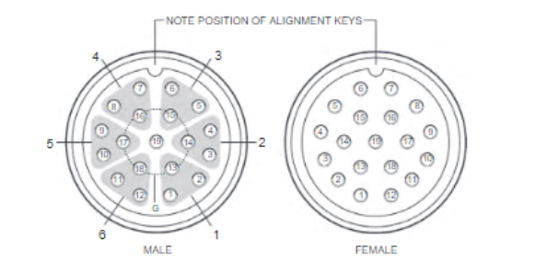
Socapex, also known as Soca, 19-pin and Multiconductor cable for its characteristic multi prong connection design, is a large, multicore power cable containing 6 individual 20 A (Amp) circuits (see fig. 1) (Box 353; Cadena 67).
Fig. 1 Close up of 19 pin configurations on the tail ends from: Box, Harry C. “Chapter 13: Distribution and Dimming Equipment.” Set Lighting Technician's Handbook: Film Lighting Equipment, Practice, and Electrical Distribution, p. 354, fig. 13.14.
Where is it Used?
This heavy-duty cable is often used in film, television, and stage lighting to connect lighting fixtures on a stage rig to the power distro off stage. There are two ratings this cable falls under #12 AWG (American Wire Gauge) for 20 A per circuit or #14 AWG for 15 A per circuit, which provides fulfills many power demands for a variety of fixture types (Box 356).

How Do You Use it?
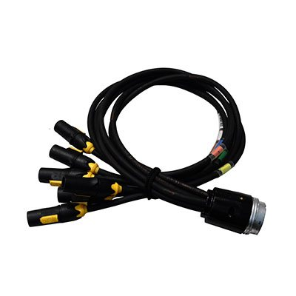
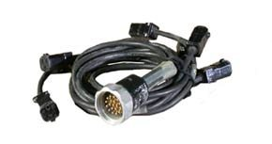
When breaking out circuits from Soca, there are various splays and adapters to choose from when converting the multicore cable into individual branch circuits (see figures 2 and 3 (Cadena 68).
Figure 2
Figure 3
Figure 2 True1 connection 6 circuit Socapex splay adapter from Christie Lites, www.christielites.com/true1-splays/228w2w17w148w1013. Accessed September 23, 2019.
Figure 3 Male Edison AC connection 6 circuit adapter from: Christie Lites, www.christielites.com/5-15-12-3-edison-splays/228w2w17w85w1017 Accessed September 23, 2019.
These 6 circuit breakouts can be adapted to a variety of connections such as Edison, a standard AC outlet; Powercon, a twist-lock connection, and a universal plug; True1, the newest standard plug that offers voltages from 120 to 208 volts (Monk).
Precautions to Take?
A principle to follow when balancing power across Soca circuits is the 80/20 rule. This principle asks you to never put more than 80% of the total available amps on one circuit. For example, a 20 A circuit should never have more than 16 A on it at a time, leaving 4 A to allow room for the heat energy produced not to affect the conductivity of the cable. This practice is called de-rating currant-carrying conductors based on the number of current-carrying conductors in contact with each other (Cadena 67).

Works Cited
Box, Harry C. Set Lighting Technician's Handbook: Film Lighting Equipment, Practice, and Electrical Distribution. Focal Press, 2010, www-taylorfrancis-com.ezproxy.library.ubc.ca/books/9780080928081.
Cadena, Richard. "Stage-Lighting Systems Overview." Routledge, 2018;2010;.
Monk, Elliott. Personal Interview. September 23, 2019.
“True1 14/3 Break-in.” Christie Lites, www.christielites.com/true1-splays/228w2w17w148w1013. Accessed September 23, 2019.
“5-15 12/3 Edison Break Out.” Christie Lites, www.christielites.com/5-15-12-3-edison-splays/228w2w17w85w1017 Accessed September 23, 2019.

