Assignment 4:1 / 4:2
Application Package

Meagan Rosenberg

ENGL 301 99A
Dr. Erika Paterson
19 December 2019
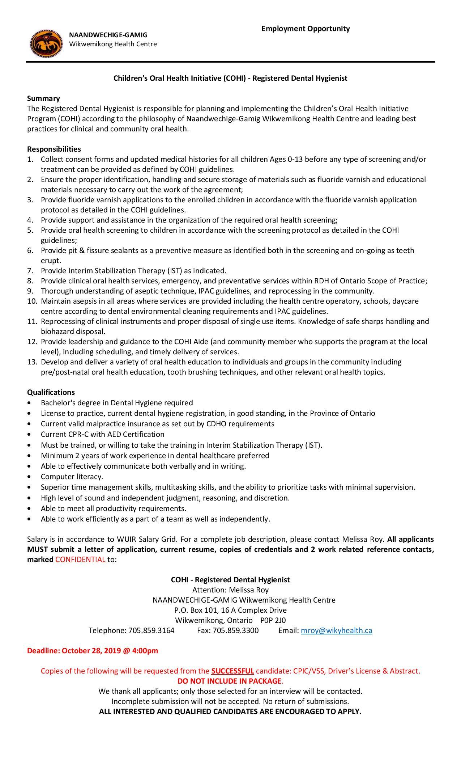
Citation:
“Children's Oral Health Initiative (COHI) - Registered Dental Hygienist.” Wiikwemkoong Unceded Territory, 15 Nov. 2019, https://wiikwemkoong.ca/job/childrens-oral-health-initiative-cohi-registered-dental-hygienist/.
455 Albert Street
Stratford, ON N5A 3L3

Dec 19, 2019
Ms Roy
Executive Assistant
Wikwemikong Health Centre
Wikwemikong, ON POP 2J0

Re: Application for Dental Hygienist
Dear Ms Roy:
Please accept my application for the position of a Registered Dental Hygienist at the Wikwemikong First Nation health centre, as advertised on the Wikwemikong community website. I am currently enrolled with the University of British Columbia to obtain my Bachelor of Dental Hygiene and am seeking a more rewarding career.
As you can see from my enclosed resume, I have worked as a dental hygienist for over four years, including practicing on a First Nations reserve. I am self-initiated for the province of Ontario and in the past year have received by certificate to practice Interim Stabilization Therapy. The experience I have gained as a Dental Hygienist combined with my compassion for helping others has given me the desire to provide services for those who have limited access to care.
As a dental hygienist, I’m aware of the multi-tasking, fast pace, attention to detail and organization required to meet the demands of providing exceptional service to every patient. Furthermore, my experience with children, applying fluoride varnishes and providing pit and fissure sealants may be an asset to your health centre’s dental program.
Overall my work and life experiences has led me to enhance my skills as dental hygienist. With my education and background, I am prepared to be a part of a great team and ready for new challenges within my scope of practice.
If you believe I would be a good fit for the dental hygienist position at your health centre, please contact me by phone at 519-555-1234 or through email at m.rosenberg@alumni.ubc.ca. I am looking forward to hearing from you!
Sincerely,
Meagan Rosenberg
Encl. Resume

Meagan Rosenberg
455 Albert Street
Stratford, ON N5A 3L3
Phone: 519-949-1911
E: mail: m.rosenberg@alumni.ubc.ca
Objective |  | Dental Hygienist for a First Nations Reserve, implementing Children’s Oral Health Initiative Program
Education  2019-2024  2012-2014  2011-2012 |  | University of British Columbia: Dental Hygiene Bachelor’s Degree in Dental Sciences.  Georgian College: Dental Hygiene Advanced Diploma. Dean’s list and honour roll.  Georgian College: Pre- Health Diploma.
Employment  2015- Present  2015-2018  2015 |  | Arden Park Dental – Stratford, Ontario  Full Time Dental Hygienist  New patient exams including EO/IO assessment, taking social, medical and dental histories, periodontal assessment, digital radiographs, working interprofessionally with the dentist, dental assistant and receptionist to meet needs of clients, debridement, polishing, fluoride, sealants, intra-oral camera, oral health education, invoicing, booking back patients for continuing care appointments and proposed treatment, sterilization, zoom whitening, taking impressions, and using goccles( preventative oral cancer screening glasses).  Dominion House Tavern- Stratford, Ontario  Part Time Bartender  Welcome and greet patrons, take food and beverage orders, make beverages, keep place clean, stock beer fridge and polish and roll silverware.  Dove Dental Centers – Parkhill and Kettle and Stoney Point First Nation, Ontario  Full Time Dental Hygienist  New patient exams including EO/IO assessment, taking social, medical and dental histories, periodontal assessment, digital radiographs, recall appointments, working interprofessionally with the dentist, dental assistant and receptionist to meet needs of clients, debridement, polishing, fluoride, sealants, oral health education, invoicing, booking back patients for restorative and continuing care appointments, working with client’s insurance companies to check eligibility, answering phone calls, and sterilization.
Personal |  | Awards  Recipient of the Sunstar preventative award for dental hygiene, 2014; Honour roll and dean’s list student for dental hygiene program.  Skills  Strong and accurate computer and data entry skills; team player; effective communication; punctual; strong ability to prioritize shifting deadlines.  Volunteer Experience  Heart& Stroke foundation chili cook-off competitor (2 years); presenter of oral health information at Community Living (1 year); Health Missions Outreach Dental Hygiene provider (1 year); Peer mentor for Georgian College (2 years); Meals on Wheels worker (1 year).
References |  | Available Upon Request

455 Albert Street
Stratford, ON N5A 3L3

December 19, 2019

Sarah Brears
Manager
Dominion House Tavern
3 Guelph Street
Stratford, ON N5A 3P1

Subject: Request for Reference

Dear Mrs. Brears,

I hope everything is running smoothly at the Dominion House since the new owners have taken over. I am reaching out to you in hopes of being able to use you as a reference for a new opportunity in my career.

The role I am applying for is located on a First Nations reserve on Manitoulin Island, and I would be the primary Dental Hygienist running the Children’s Oral Health Initiative program. Having you as a reference would be very valuable as you have helped to strengthen my skills in both customer service, and time management.

Please let me know if you are comfortable with being a reference for me, as I am planning to apply mid December. I have attached a copy of my resume for your convenience. If you have any questions, please don’t hesitate to call me at 416-555-4854 or you can reach me through e-mail at m.rosenberg@alumni.ubc.ca.

Thank you for your time and consideration, I am looking forward to your response.

Sincerely,

Meagan Rosenberg

Encl: Resume

455 Albert Street
Stratford, ON N5A 3L3

December 19, 2019

Dr. Mace Abdul
Dentist
Eastbridge Dental
14 Clarence Street
Kitchener, ON M7A 4F6

Subject: Request for Reference

Dear Dr. Abdul,

I am hoping you are adjusting well to the new office you have moved to. As per conversations in the past, I have been looking for a new challenge within my career and am hoping you would be one of my references.

The role I am applying for is located on a First Nations reserve on Manitoulin Island, and I would be the primary Dental Hygienist running the Children’s Oral Health Initiative program. This would mean I would have to relocate and endure intensive training for the program, but I know it would be worth it if I can make a difference for the children on this reserve.

After working closely with you at Arden Park Dental, I have gained very valuable experience with both soft and hard skills as a Dental Hygienist. I appreciate everything you have taught me and would be thrilled to have your credit as a reference.

Please let me know if you are willing to be a reference for me, as I am planning to apply mid December. I have attached a copy of my resume for your convenience. If you have any questions, please don’t hesitate to call me at 416-555-4854 or you can reach me through e-mail at m.rosenberg@alumni.ubc.ca.

Thank you for your time and consideration, I look forward to hearing from you.

Best,

Meagan Rosenberg

Encl: Resume

455 Albert Street
Stratford, ON N5A 3L3

December 19, 2019

Shana Koch
Office Manager
Woodstock Dental
845 Laurentian Street
Woodstock, ON W95 2Y9

Dear Mrs. Koch,

I hope this e-mail finds you well, and that your promotion to management has brought you career satisfaction. As you may know, I myself have been seeking a more challenging job within the field of Dental Hygiene and was reaching out to request a reference on your behalf.

The role I am interested in applying for is on a First Nations reserve, Wikwemikong which is located on the beautiful Manitoulin island in northern Ontario. There I would be working out of the main health centre and running the Children’s Oral Health Imitative program and providing dental hygiene therapies.

Without your guidance as a leading administrator at Arden Park Dental, I wouldn’t have had the opportunity to grow my skills and passion for my career as a Dental Hygienist. You have helped to guide and direct my abilities to provide better care for all my patients, and for that I believe it would be very valuable to have you as a reference.

If you are willing to be a reference for me, please let me know at your earliest convenience. I have attached my resume for your consideration. If you have any questions, please don’t hesitate to call me at 416-555-4854 or you can reach me through e-mail at m.rosenberg@alumni.ubc.ca.

Thank you for your time and consideration and am looking forward to your response.

Warm regards,

Meagan Rosenberg

Encl: Resume

