How to Decrease Needlestick Injuries at Arden Park Dental
for
Dr. Raphael Jankowski
Owner and Dentist
Arden Park Dental
Stratford, Ontario

And

Tammy Stoddart
Office Manager
Arden Park Dental
Stratford, Ontario

by
Meagan Rosenberg
English 301 99A Student

December 19, 2019
Table of Contents
Figures List 3
I. ABSTRACT 3
<to be completed closer to submission of final draft> 3
II. INTRODUCTION 4
Needlestick Injury Problem at Arden Park Dental 4
Background on Health Issues Related to Needlestick Injuries 4
Purpose of Report 5
Description of Data Sources 5
Method of Research 5
Scope of Inquiry 6
III. DATA SECTION 6
Sources of Needlestick Injuries 6
Health Effects After Needlestick Injury Occurs 7
What Practices Does Arden Park Dental Currently Have in Place for Prevention of Needlestick Injuries? 8
Survey Results 9
Interview Results with Health and Safety Representatives 12
Interview Results with Employees who Have Previously Incurred a Needlestick Injury 12
IV. CONCLUSION 13
Summary and Interpretations of Findings 13
Recommendations 14
VI. Works Cited 16
VII. Appendices 18
<all to be added in closer to submission of final draft> 18
Appendix A. Survey questions to all clinical employees of Arden Park Dental 18
Appendix B. Interview questions for health and safety representatives at Arden Park Dental 18
Appendix C. Interview questions for employees who have incurred a needlestick injury at Arden Park Dental 18

Figures List
<list to be completed closer to submission of final draft>

ABSTRACT

<to be completed closer to submission of final draft>

INTRODUCTION

Needlestick Injury Problem at Arden Park Dental
Among many healthcare workers, dental professionals are at the top of the list when it comes to profession that are most at risk for contracting diseases (Kiersz). With this statistic dental employers and employees should adhere to all precautionary measures when working with a needlestick. At Arden Park Dental, there are more than 20 clinical staff who are at risk for needlestick injuries. Like other healthcare professions there are certain policies and guidelines set in place to avoid needlestick injuries from occurring, but it remains to be an issue. Arden Park Dental is a very busy practice with 7 different operatories. They provide dental services such as: cosmetic, restorative, endodontic, orthodontics, oral surgeries and preventative therapies such as cleanings- which means there are many sources of needlesticks. The dental clinicians schedule can see upwards of 15 patients a day, with multiple clinicians working at the same time. This makes for a long, busy day and may contribute to the amount of injuries caused by needlesticks.

Background on Health Issues Related to Needlestick Injuries
The most prevalent blood borne diseases that are contracted when working in the dental field are: HIV, Hepatitis C and Hepatitis B, which we will take a more in-depth look at later. Though the risks are low, it is still possible to contract these diseases, no matter what experience or skills the dental clinician has. It is apparent that every clinical member working at Arden Park Dental must follow strict procedures to protect themselves from contracting a disease caused by a needlestick injury.

Purpose of Report
The purpose of this report is to examine and evaluate Arden Park Dental’s policies and guidelines that are currently in place to prevent their clinical employees from needlestick injuries. After investigation and data collection, recommendations will be provided to help decrease the rate of incidences of needlestick injuries from occurring.

Description of Data Sources
The sources investigated in this report include both primary and secondary data. Primary data will consist of surveys to all clinical employees, as well as interviews with the health and safety representatives and employees who have incurred a needlestick injury. Also included in the primary data will be the policies and guidelines that Arden Park Dental currently has in place for the prevention of needlestick injuries. Secondary data will consist of existing academic literature, as well as government publications that are relevant to needlestick injuries in the dental profession.

Method of Research

Twenty-one employees of Arden Park dental responded to a short survey designed to analyze needlestick injuries at Arden Park Dental, as well as gauge their interest in a potential training solution. An analysis of employee awareness regarding needlestick injuries was performed to determine the feasibility of implementing a solution to help with needlestick injuries. In addition, interviews were conducted with two health and safety representatives and two employees who had incurred a needlestick injury at Arden Park Dental to help understand the cause of why needlestick injuries are still occurring.

Scope of Inquiry
The scope of inquiry will be to assess the possibility of decreasing the amount of needlestick injuries that occur at Arden Park Dental. This report will investigate the policies and procedures set in place already by Arden Park Dental and gain insight from the clinical employs on their experiences with needlesticks. From there recommendations will be given on how to possibly decrease needlestick injuries.

III. DATA SECTION

Sources of Needlestick Injuries
Needlesticks are found in every operatory, sterilization centre, storage closet and even in the back office at Arden Park Dental. This makes it a risk for everyone at the office, not just clinical employees.
- Needles- used for giving patients local anaesthesia
This type of needlestick was found in all operatories, including sterilization centre, and the storage closet. They come in an assortment of sizes and do have a protective capping on them. This needle is very common in this dental practice as most patients seeing the dentist requires local anaesthesia.
- Scalers - used by hygienists to clean teeth
This type of needlestick was found in all hygiene operatories and the sterilization area. The sterilized ones are in a puncture proof pouch, containing about five in each package. A hygienist will use two pouches per person on average for the appointment.
- Scalpels – used for dissection of tissue by dentists and oral surgeon
This type of needlestick was found in the storage closet only. It is only used in certain cases and comes packaged in single use and the cutting edge is covered by plastic.
- Suture Needle – used for suturing by dentists and oral surgeon
This type of needlestick was found in the storage closet and in 2 operatories. It is only used in certain cases such as: suturing tooth extraction site, suturing after a biopsy or a wound.

Health Effects After Needlestick Injury Occurs
A common scare in any dental practice for clinicians is contracting a disease. The most common types of disease one can contract by a needlestick injury include: HIV, hepatitis C and hepatitis B. Though the transmission rate with contracting these diseases are very low, clinical employees must not take any chances.
- HIV – studies have shown that there is a 0.3% transmission rate when a healthcare worker incurs a needlestick injury from a needlestick used on an infected person (Sawyer M et al. 7). If HIV goes untreated, it will attack the immune system and develop into AIDS which will then allow different life-threatening diseases and cancers to develop which leads to death (“HIV Basics”).
- Hepatitis C- the rate of transmission is 1.8%, and seems to be an insidious, mild and slow progressing infection (Sawyer M et al. 7). There are some cases where people who are exposed to hepatitis C and they have a short-term infection as the virus clears from their body without any treatment, but for others it can be a lifelong infection that can lead to other health problems such as liver damage, liver cancer and even death (“Hepatitis C Questions and Answers for the Public”).
- Hepatitis B- the transmission rate is 6-30%, making it the highest rate and is dependent on that state of the carrier (Sawyer M et al. 7). Much like hep C, some cases of hep B will only be an acute infection, but for others it will become a lifelong infection that can lead to liver damage, cirrhosis, liver cancer and death (“Hepatitis B Questions and Answers for the Public”).

What Practices Does Arden Park Dental Currently Have in Place for Prevention of Needlestick Injuries?
Arden Park Dental does have a policy statement in place that ensures a safe and healthy working environment for all clients and staff. They demonstrate their commitment by providing financial, physical and human resources to reduce to the risks of injury from needlestick injuries and will implement the use of safety engineered medical sharps and other safe work practices aimed at reducing the risks of a needlestick injury wherever possible. (Jankowski Corp.)
Currently, Arden Park has committed to resources such as: personal protective equipment (including safety glasses, masks and gloves), tray covers with locks, puncture proof sterilization gloves, puncture proof pouches for sterilization of instruments, a medical sharps container in
every operatory and a sharps disposable program.
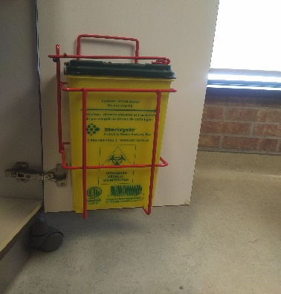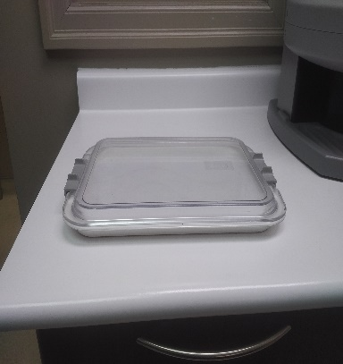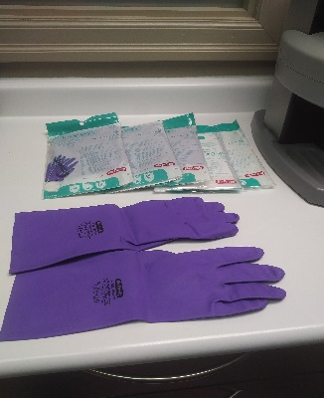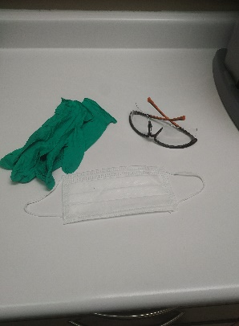
Figure 1. Images of Preventative Measures at Arden Park Dental. Left to right. Sharps disposal in operatory room, tray cover, puncture proof gloves and personal protective equipment including mask, gloves and safety glasses.

Survey Results

Figure 2. Evaluation of Employees Opinion on Having Adequate Training. Only 62% of employees are confident to agree that there has been adequate training provided.

Figure 3. Evaluation of Employees Familiarity with Health Effects Associated with Needlestick Injuries. Over 90% of the employees are confident with their understanding of known health effects associated with needlestick injuries.

Figure 4. Evaluation of Needlestick Injuries of Employees at Arden Park Dental. Almost 30% of employees have incurred a needlestick injury while working at Arden Park Dental.

Figure 5. Evaluation of Adequate Measures Available to Prevent Needlestick Injuries. 90% of the employees feel there are adequate measures set in place at Arden Park Dental to prevent needlestick injuries.

Figure 6. Evaluation of Protocols and Guidelines Being Followed Regarding the Prevention of Needlesticks Injuries. Just about 50% of employees recognize that all protocols and guidelines are not being followed to prevent needlestick injuries at Arden Park Dental.

Figure 7. Evaluation of Employees Knowledge of Post Exposure Protocol After Needlestick Injury Occurs. Just over 50% of employees don’t have confidence in the post exposure protocol after a needlestick injury occurs.

The survey had a total of 21 responses by employees at Arden Park Dental, including participation from dentists, dental hygienists, dental assistants and sterilization technicians. About 38% of the employees who filled out the survey feel that adequate training has not been provided by Arden Park Dental on the handling on needlesticks (Figure 2). A great number of employees -90% + feel confident in their familiarity with health risks associated with needlestick injuries, meaning less than 10% of employees aren’t familiar with the associated with the risks
(Figure 3). About 30% of the employees who responded have incurred a needlestick injury while working at Arden Park Dental (Figure 4). Overall, over 90% of the employees believe there are adequate measures and resources available provided by Arden Park Dental to prevent the injury of a needlestick (Figure 5), but just under 50% of the employees report that all protocols and guidelines are not being followed thoroughly (Figure 6). Lastly, there were just over 50% of employees who expressed their lack of confidence with the post exposure protocol of a needlestick injury occurrence.

Interview Results with Health and Safety Representatives
After completing two separate interviews with each of the health and safety representatives of Arden Park Dental, there was a bit of discrepancy noted with the answers to the questions. The highest number of needlestick injuries noted from either representative was two. The representatives concurred that most of the training is done at the dental clinicians’ school for the prevention of needlestick injuries, but when first hired the employee will get a quick refresher of the preventative measures. There were different answers for how often the protocols and guidelines for needlestick injuries are updated, one representative answered with ‘as needed’ and the other wasn’t aware of it ever being updated. Both representatives agree that all staff at Arden Park Dental have proper equipment and training to prevent needlestick injuries from occurring.

Interview Results with Employees who Have Previously Incurred a Needlestick Injury
Following the answers of two employees who have incurred a needlestick injury while working at Arden Park Dental, it is reported that in either case the proper protocols were not being followed. In one case the needlestick injury was reported to the health and safety representative in a timely manner, but it wasn’t reported at all in the second case. Both employees believed that the post exposure protocol was easy to follow, but agreed it was rather annoying to get blood work done and wait for the results. The answers as to why they feel the injury happened were from rushing and not paying attention. In the one case, the employee stated they are now stricter on making sure the proper protocols are being followed because they do not want to go through the experience of incurring a needlestick injury again. The second case, the employee expressed that only sometimes they are a bit more cautious of following the proper protocols on
this matter. Lastly, both employees feel that Arden Park Dental could not have helped in anyway to prevent this from happening – as they both take responsibility for not following the protocols and guidelines.

CONCLUSION

Summary and Interpretations of Findings
As seen under the results of the surveys and interviews conducted, there seems to be a deficit of understanding the importance of preventing needlestick injuries from occurring. While most employees have never incurred a needlestick injury at Arden Park Dental, six employees admitted to experiencing one. After careful data analysis, it seems that most employees are confident and knowledgeable of the protocols, guidelines and preventative measures set in place at Arden Park Dental for needlestick injuries but adhering to these protocols and measurements is not always the case for about half of the employees. There was also a gap in the reporting of needlestick injuries. After collecting the data from the surveys and interviews, there are only two reported cases of needlestick injuries to the health and safety representatives, yet there were six employees who have experienced a needlestick injury- meaning four cases were not reported. Another issue noted was that just over half of the employees are lacking confidence regarding the steps for post exposure protocol following a needlestick injury. Lastly, there was an inconsistency noted between the health and safety representatives and the roles and
responsibilities they have in the policy on the needlestick injury program at Arden Park Dental. In the policy, it states that ongoing staff training is to be provided and that the needlestick injury program should be evaluated and updated annually, but in the answers collected from the health and safety representative interviews – they admit to not following their roles and responsibilities as laid out in the policy.

Recommendations
Based on the findings from all surveys and interviews conducted, it is suggested for Arden Park Dental to consider the following recommendations to help decrease the amount of needlestick injury occurrences and keep their employees safe.
- Update the needlestick injury program policy that is in place. With having a revised policy in place, it will help to refresh the health and safety representatives and the employer responsibilities which will ultimately help the safety of the employees at Arden Park Dental.
- Provide annual training to all staff in the prevention of needlestick injuries and review the protocols and guidelines with them. Have each employee sign off each year that they have received adequate training and are aware of the protocols, guidelines and preventative measures in place for their safety.
- Check annually that employees Hepatitis B vaccination is up to date. This would be an easy step to make sure all employees are protected against contracting Hepatitis B if a needlestick injury were to occur.
- Have the health and safety representatives strongly enforce the policy and protocols for prevention of needlestick injuries. If an employee is seen not adhering to the protocols and policy, remind them the proper way of doing so. If problem persists then management should become involved.

Works Cited
“Hepatitis B Questions and Answers for the Public.” Centers for Disease Control and Prevention, Centers for Disease Control and Prevention, 10 Sept. 2019, https://www.cdc.gov/hepatitis/hbv/bfaq.htm.
“Hepatitis C Questions and Answers for the Public.” Centers for Disease Control and Prevention, Centers for Disease Control and Prevention, 10 Sept. 2019, https://www.cdc.gov/hepatitis/hcv/cfaq.htm.
“HIV Basics.” Centers for Disease Control and Prevention, Centers for Disease Control and Prevention, 6 Aug. 2019, https://www.cdc.gov/hiv/basics/index.html.
“Needlestick Injury- S.E.N.S Program.” Jankowski Corporation, Arden Park Dental, October 2009.
Kiersz, Andy. “The 27 Jobs That Are Most Damaging to Your Health.” Business Insider, Business Insider, 2 Nov. 2015, https://www.businessinsider.com/the-most-unhealthy-jobs-in-america-2015-11.

Sawyer, Mel et al. “Preventing Needle Stick Injuries and the Use of Dental Safety
Syringes” Formal Report, The University of British Columbia, Vancouver, BC, Oct. 2010

Appendices

<all to be added in closer to submission of final draft>

Appendix A. Survey questions to all clinical employees of Arden Park Dental

Appendix B. Interview questions for health and safety representatives at Arden Park Dental

Appendix C. Interview questions for employees who have incurred a needlestick injury at Arden Park Dental

