Analysis on Participation Rates in the
Science Undergraduate Society at the
University of British Columbia

for
Julia Chai
President
Science Undergraduate Society
Vancouver, British Columbia

by
Jobina Tamminga
ENGL 301 Student

November 29, 2019
Table of Contents

Abstract…………………………………………………………………………………………...iii
Introduction………………………………………………………………………………………..1
Data Section……………………………………………………………………………………….2
Overview of SUS………………………………………………………………………….2
Organization Structure…………………………………………………………….2
Importance of Participation for SUS………………………………………………2
Benefits of Participation for Students……………………………………………...3
UBC Election Data………………………………………………………………………...3
Recent SUS Elections……………………………………………………………...3
Recent Elections in Other UBC Organizations……………………………………4
Survey on Student Participation in SUS…………………………………………………...5
Reasoning Behind Participating or Not……………………………………………5
Overall Feedback on Participating in SUS………………………………………..6
Research on Current Practices at SUS……………………………………………………..7
Possible solutions for increasing student participation……………………………………7
Short Term Solutions………………………………………………………………7
Long Term Solutions………………………………………………………………8
Conclusion………………………………………………………………………………………...9
Summary and Overall Interpretation of Results……………………………………………9
Recommendations…………………………………………………………………………9
References………………………………………………………………………………………..10

Figures and Tables

Figure 1. Election data for the Science Undergraduate Society (SUS)……………………………..4
Figure 2. Survey results for why students did not attend a SUS event……………….……………5
Figure 3. Survey results for why students did not vote in a SUS election…………………….…….5
Figure 4. Results on why student had never volunteered with SUS…………………………….…6
Abstract

Introduction
The Science Undergraduate Society (SUS) at UBC is a student organization that aims to promote academic, physical, and social wellbeing to science students at UBC. The organization is comprised of elected positions and volunteer positions, thus requires participation from students. SUS is made up of many positions of individuals who organize events, liaise between students and faculty, change school policy and much more. In recent years, student participation rates have been declining. Improving the participations by improving voter turnouts, improving number of filled positions, and improving event turnouts will help to keep the organization going and create a stronger community among science students.
This report will conduct an analysis on the current participation rates among the organization and propose possible solutions. By surveying science students, interviewing current members of SUS, collecting election data, and researching comparable participations rates, this report will establish possible strategies for the organization to improve participation.
The following topics will be addressed in this report: the importance of participation to the organization, how the voter turnout for SUS compares to other student governments at UBC, how the voter turnout compares to previous years, possible reasons why students may not wish to participate, and what SUS is currently doing to increase participation rates.
This report concludes that improving marketing strategies and changing various aspects of events to be more inclusive to students will help to improve the stigma associated with the organization. Improving the stigma and getting more feedback from students will ultimately create an organization the more students will want to be a part of.

Data Section

Overview of SUS
Organization Structure
There are currently over 8206 students in the faculty of science which the Science Undergraduate Society serves. (“Enrollment Statistics 2018/2019”). All science students have access to all meeting minutes and elect their own representatives. The Science Undergraduate Society is designed to represent the students and changes as the interests of the students change. The organization itself has a team of eight core executives including the President, VP Administration, VP Finance, VP Student Life, VP Internal, VP External, VP Academic, and VP Communications. These roles are elected once per year by all science students and they oversee all committees and running of the organization. Other elected positions include two AMS representatives who represent SUS in the AMS (UBC-wide) council, one Science Student Senator who represents all science students in the UBC Senate, two First Year Representatives who help run the First Year Committee, and 22 Councillors who are elected by science students in second year and up to represent all students in that major in SUS. Additionally, there are at least 19 committees with 15 of them requiring volunteers to be on them.
Importance of Participation for SUS
The Science Undergraduate Society is an organization that thrives on participation. All positions are either elected or volunteer positions, which require students to participate. The purpose of SUS is to bring students in the same faculty together and only fulfills this goal when students engage. The councillors within SUS represent each major and are elected to liaise between students in their department and the organization. Effective participation allows students to vote in councillor meetings according to the interests of their peers. Without engagement in just one part of the process from running for an elected position, to voting for the representatives, to attending and engaging in meeting, to student feedback on certain issues, the organization cannot fulfill its intended purpose. Another aspect is that in order to pass motions in councillor meetings, more than half of members must vote for it. If students do not fill positions or do not attend meetings, motions will not pass.
Benefits of Participation for Students
The Science Undergraduate Society manages a $220,000 budget every year, from the $26.69 fee included in tuition from each student in the faculty of science. By default, every science student contributes money and is a member of the organization. The organization is structured around the wants of the students and has multiple strategies to get opinions from the students. If students voice what they would like to get out of the organization, they not only get events that they enjoy but they are allocating their own tuition money that they want.
UBC Election Data
Recent SUS Elections
The most recent election in the Science Undergraduate Society (Fall 2019) had a 10.5% voter turnout. Though this number is slightly higher than previous years, only 9 out of 22 councillor roles were filled, with 7 out of 9 of the filled positions only having one person running. In 2018, there was a slightly lower voter turnout of 6.2%, though 11 out of 22 councillor positions were filled with 5 out of the 11 positions having one person running. 2017 had a 7.9% voter turnout, with even more of the councillor positions filled at 17, with 11 of them with one person running. Within just three years, even though the voter turnout increased slightly, the percentage of filled roles decreased significantly from 77% to 40% and the number of positions with only one nominee also increased as seen in Figure 1.
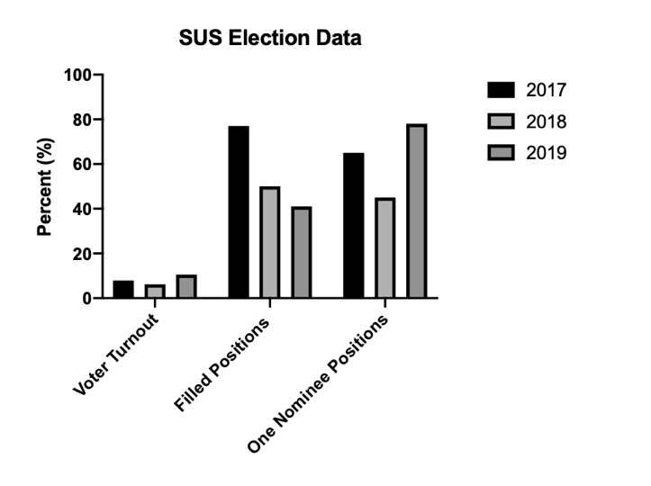
Figure 1: Election data for the Science Undergraduate Society (SUS)

Recent Elections in Other UBC Organizations
The Alma Mater Society (AMS) at UBC is a student run organization that organizes events for UBC students and aims to liaise between all UBC students and faculty. All UBC students are a member of this organization, thus, has a much larger voter base. The AMS general voting results from 2019 had a 21.7% voter turnout, 2018 had a 20.4% voter turnout, and 2017 had a 20.7% voter turnout. All of these years have than double the voter turnout for SUS, even though it has significantly more members.
The Engineering Undergraduate Society (EUS) is another student run organization with the same duties as SUS but in the engineering department. EUS has over 4500 members, which is just over half of the number of students in SUS. The EUS general election in 2019 had a 12.9% turnout, 2018 had a 20.9% turnout, and 2017 had a 14.9% voter turnout. The engineering department has significantly less members, though had at least a 2.4% higher turnout than SUS.

Survey on Student Participation in SUS
Reasoning Behind Participating or Not
Results from an anonymous survey found that 22.7% of students had never attended an event from SUS before. 8.3% said that they didn’t know that SUS had events, 19.7% said that they were busy during the times of events, 8.3% said that it didn’t look interesting, and 8.3% said that they could do better things with their time as seen in Figure 2.
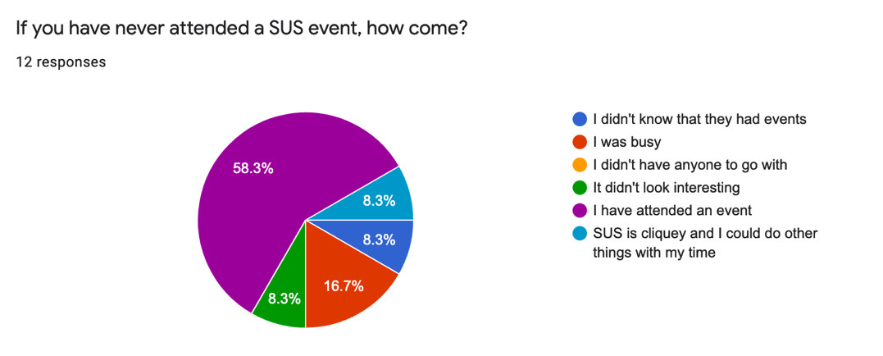
Figure 2. Survey results for why students did not attend a SUS event.
It was also found that 77.3% of students had previously voted in the SUS elections, though 22.7% did not. For those that had never voted, the reasoning was that 33.3% didn’t care about the elections, and 8.3% of students didn’t know who to vote for as seen in Figure 3.
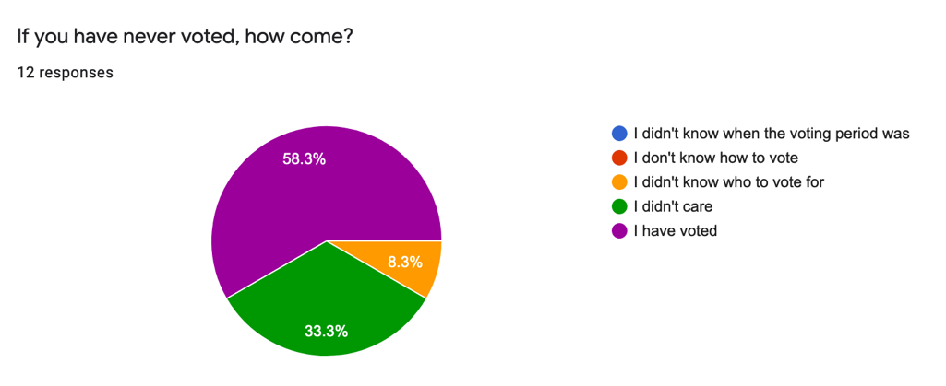
Figure 3. Survey results for why students did not vote in a SUS election.
It was also found that 68.2% of student had never volunteered with SUS, and the most common reasons for this was that 53.3% of students were just not interesting in volunteering, 20% did not have time to volunteer, 20% did not know that you could volunteer with SUS as seen in Figure 4.
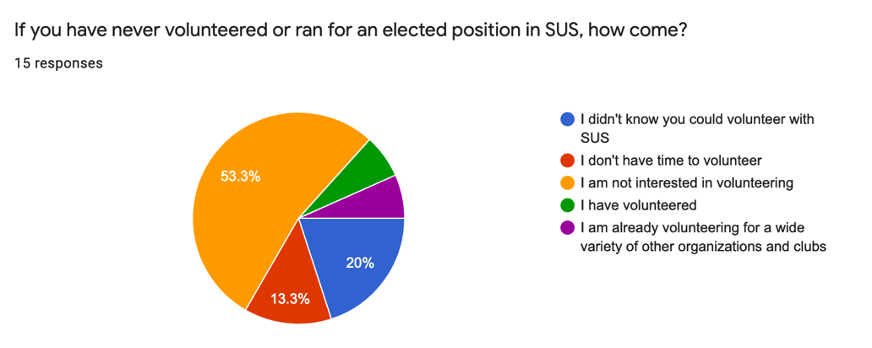
Figure 4. Results on why student had never volunteered with SUS.
Overall Feedback on Participating in SUS
Some overall comments on participating in SUS from students included the issue that students felt like the executive team were all friends and it seemed difficult to break into. Some students feared to run for an elected position because they felt like the most votes came from current members of SUS. They feared that current SUS members would only vote for their friend or people that they knew. Other students felt like the focus of the organization was for pre-med students and did not focus on other majors such as physics or environmental sciences. Another comment was that there was a negative stigma about participating in events. Lastly, some students felt like the events were not commuter friendly as they happened later in the evening when most students were commuting home.
Research on Current Practices at SUS
According to current members in SUS, participation is an ongoing battle and the organization tries to be as inclusive as it can. To increase voter turnout, SUS advertises the election on social media and through email. Nominees will go to classrooms and announce their platform. Last year SUS also held a “vote for blue chip campaign” that offered students a cookie if they could prove that they voted, which was said to increase voter turnout. SUS events are typically held in the Abdul Lahda Science Student Centre, which decreases the cost of events. Most events are free or cost very little which is also done to draw in more students. Events were also claimed to commonly happen throughout the day to include commuter students as well, which contradicted student feedback. The current VP Student Life ran with the platform of hosting fewer, but higher quality events in order to allocate more of the budget per event. SUS also conducts surveys every September to try and listen to students and gather what kind of events they want. The volunteering positions are also open to any science student, allowing the positions to be inclusive. Lastly, SUS has been enforcing a new policy called “1 person/position” which limits each member to only one position within SUS so that there are more open positions for more people.
Possible solutions for increasing student participation
Short term Solutions
These solutions are suggested for the current school year.
- Holding more events outside of the science building. Many students feel intimidated or don’t belong in the building and avoid going inside. By hosting events in various science buildings around campus such as the computer science building, biology building, or chemistry building, it may portray SUS as a more inclusive organization and help students not to feel as intimidated going into the science building. It also does not cost any money to reserve spaces in other buildings which would not cut into the budget at all.
- Advertising events earlier. Many events are posted one week prior to the date, though this may not give students enough time to plan for the event. By advertising events earlier, it will help to reach more students and increase more interest. Posting events at least two weeks in advance is suggested.
Long Term Solutions
These solutions are suggested for the following school year.
- Improving marketing strategies. 20% of surveyed students didn’t know that you could volunteer with SUS, and 8.3% of students didn’t know that SUS had events. The SUS Facebook page already posts a lot, which helps students who follow SUS, though is not helpful to students who do not follow the page. In order to stay up to date on events with SUS, advertising students to follow the page in the first week of class should be expanded, especially for first year students.
- Collaborating with other department organizations such as BIOSOC (the biology student government) or CSSS (the computer science student government). Again, these events will not only unite students in those departments to students in other departments, it may also promote inclusivity and diversity within SUS.
- Creating a transfer student program. Transfer students are often overlooked when deciding on marketing strategies. Transfer students are often in higher years, though do not have established friend groups in their field of study. Since most other students have established friend groups, it can be more difficult for transfer students to make friends. By establishing a transfer student program, you can bring transfer students together within the context of SUS.
- Starting science student exclusive traditions. Engineering students tend to feel closer together due to their exclusive rituals, especially at UBC. By creating science only rituals, it may help to improve science pride and promote participation.

Conclusion
Summary and Overall Interpretation of Results
In summary, the Science Undergraduate Society has an opportunity to increase the participation within the organization and to improve the university experience of more students. It was found that most students chose not to participate in the organization due to previous negative perceptions. Students also felt that the organization was not accommodating to their schedules or their majors. While the organization has many initiatives to increase participation, the election data shows that there are areas for improvement.
Recommendations
This report recommends a combination of short-term and long-term solutions to increase participation in both the short-term and long-term. Recommended short term solutions include holding more events outside of the science building, and advertising events at least two weeks before each event. Long term solutions include increasing advertising students to like the SUS Facebook page in the first week of class, collaborating with other science departments for events, creating a transfer student program, and starting science exclusive traditions.

References

UBC Science Undergraduate Society. “Who are we”. Science Undergraduate Society, 2019, https://sus.ubc.ca/.

University of British Columbia. “Enrollment Statistics 2018/2019”. Vancouver Academic Calendar 2019/2020, 1 November 2019, http://www.calendar.ubc.ca/vancouver/index.cfm?page=appendix1.

