Workstation Inventory Survey
Please send your responses to joyce.wu@ubc.ca
by Tuesday, November 26, 2019 at 4:30PM

Dear HR colleagues,
Every 4-5 years, Human Resources department replaces our workstation hardware. It’s time to do it again in 2019. To initiate the process, I will need to inventory the computer equipment you are currently using. Please follow the instructions provided below to answer questions regarding your computer equipment, and email your responses to me at joyce.wu@ubc.ca by 4:30PM on Tuesday, November 26, 2019.
If you need assistance answering the questionnaire, feel free to contact me or arrange a time for me to visit your workstation. I will need a few minutes to access your machine and gather the specifications to answer the questionnaire.

VDI Users:
- VDI User: Y/N Please indicate that you are a VDI user
- Monitor size and quantity: 19” or 23”, 1 or 2 monitors
- Keyboard: Regular or Ergonomic
- Mouse: Regular or Ergonomic
- Other Equipment: i.e. webcam, external speakers, etc.

PC and Laptop users:
- PC or Laptop: Please indicate which one you use.
- Laptop users only: what type of docking station do you have? Old docking stations require you to snap the laptop into the dock. New ones connect with a USB cable.
- Do you use Remote Desktop
- Monitor size and quantity: 19” or 23”, 1 or 2 monitors
- Keyboard: Regular or Ergonomic
- Mouse: Regular or Ergonomic
- Other Equipment: i.e. webcam, external speakers, etc.
- System information: Screenshot or indicate BIOS Version/Date, Processor and the Installed Physical Memory (Ram)

Instruction on how to access your workstation’s System Information is provided on the next page. If you have any questions, feel free to reach out.
Thank you,
-Joyce
Instructions on Accessing System Information
- Go to the start menu and Type ‘sys’ into the CMD line and select System Information.
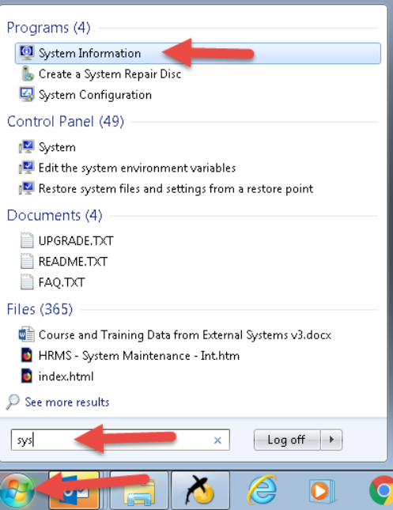
- Either take a screenshot of the page or list the BIOS Version/Date and the Installed Physical Memory (Ram) information in your response
