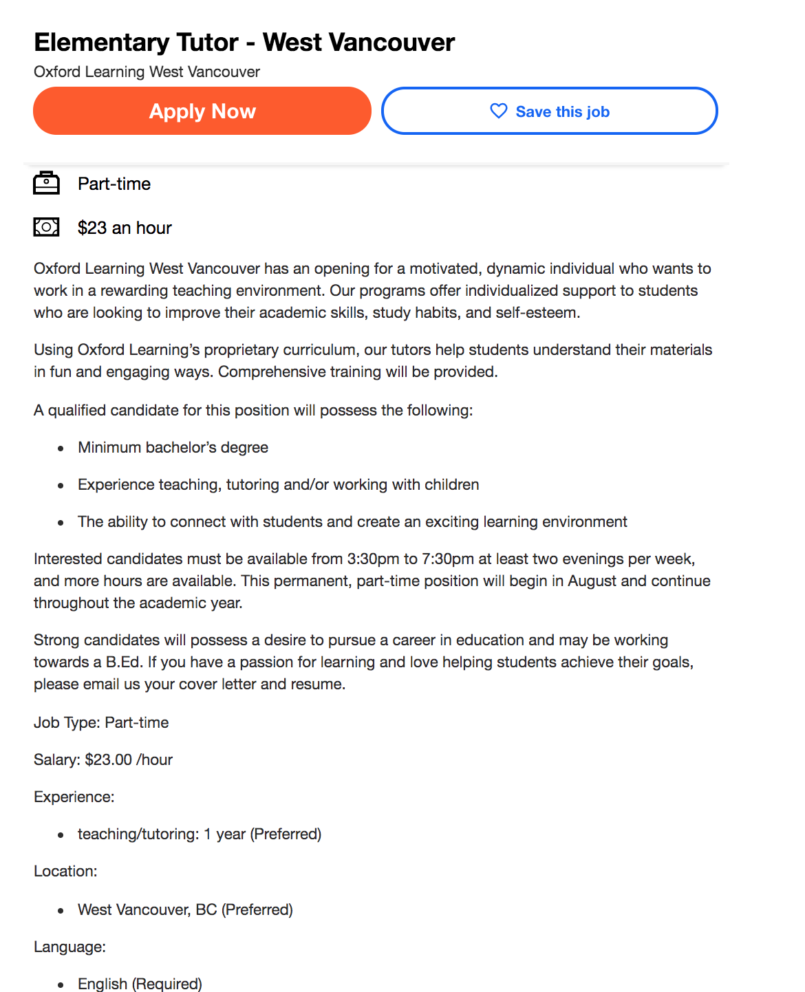

Citation
“Job Search.” Indeed, https://www.indeed.com/.

