Increasing Data Collection Accuracy at Fairview Behaviour Consulting Inc.

For Jackie Pun, Directing Behaviour Consultant
Fairview Behaviour Consulting Inc.
Vancouver, BC

By Cheryl Chao
English 301
December 4th, 2019

Table of Contents

Introduction 3
Background Information 3
Statement of the problem 3
Purpose of Study 3

Data Analysis 4
Methods 4
Client Data 4
Results from BI Surveys 7
Results from parent Surveys 10
Results from Interview 11

Conclusion 12
Summary of Findings 12
Recommendations 13
Expected outcome 13

Appendix 14
References 15

Introduction
Fairview Behaviour Consulting Inc. is an incorporation that supports clients diagnosed with Autism. Ms. Pun is the directing behaviour consultant and she designs programs and goals for each client to correct their unexpected behaviours. She employs behaviour interventionists to support clients on a day-to-day basis and each client typically have a team 2-3 behaviour interventionists supervised by a behaviour consultant. Behaviour interventionists receives training and program checklists from a behaviour consultant and runs corresponding programs on clients and records data after every session. Programs will be adjusted when the behaviour consultant reads data showing mastery on some of the programs. Without accurate data collection, behaviour consultants would have inaccurate judgements for programs to alter and sessions would be less efficient.
Purpose of the report
The purpose of this report is to provide solutions to tackle the issue of inconsistent and sometimes inaccurate data collection amongst the team. This is because a child often has 2-3 behaviour interventionists and each interventionist may have slightly different judgements and some are unsure of how to run a specific program. As sessions are run individually, it becomes an issue when the whole team gathers for a meeting (which usually happens monthly) and notices that there is consistent successes with one interventionist and consistent incorrect trials with another interventionist. This affects the behaviour consultant as it leads to inaccurate judgements on whether programs need to be altered or not. Furthermore, clients would receive inconsistent requirements which also increases the time it takes to correct unexpected behaviour. Specifically, inaccurate data collection affects Ms. Pun because situations of creating programs that are too difficult or too easy have occured before and parents have subsequently complained. Therefore, in order to mitigate parents’ complaints, solutions are needed to improve data collection accuracy.
This purpose of this report is to improve data collection accuracy by proposing solutions that could align the behaviour interventionists’ methods of running programs and to increase communication. By increasing data collection accuracy, jugements in altering or improving programs for clients would better reflect the real progress and suit the clients’ needs.
Data Analysis
Data Collection
In order to understand the causes of inaccurate data collection and the team’s view upon the proposed solutions, surveys and interviews will be conducted. Specifically, there will be two surveys, one for parents and one for the behaviour interventionists. There will also be one interview with Ms. Pun to to receive insights on causes and impacts as well as the possibility to implement these proposed solutions. In consideration to confidentiality, survey and interview questions would not ask about specific programs or mention client names. Survey questions would focus on understanding the causes and impacts of differing data and to understand their viewpoints on my proposed solutions. The participants were chosen as these behaviour interventionists, parents and Ms. Pun are all people that are directly involved in Fairview Behaviour Consulting Inc. and thus the current issue and proposed solutions would have a direct impact on them. Furthermore, prior to the surveys and the interview, three clients’ data for the past 6 months will be reviewed. As I currently work with these clients, consent has been given to access program information and pass session data. In consideration to confidentiality, specific programs and client names will be kept anonymous and only the differing trends of successful rates for the different BIs will be shown.
Client Data

For the three clients, program information and session data in the past three months have been collected. Most of the programs are recorded in number of successful trials and unsuccessful trials for the session and then the percentage of success is calculated. For this report, each client’s success percentages were averaged for each program then compared amongst the three BIs that each client has. For each client, the program with the most inconsistent success percentages amongst the three BIs were plotted in the graph below.

Graph 1
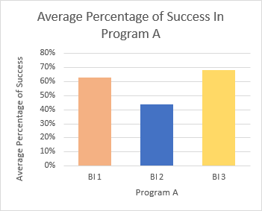
Graph 2
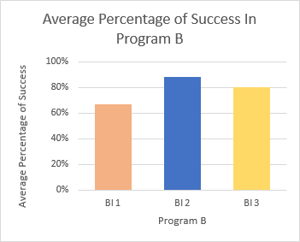

Graph 3
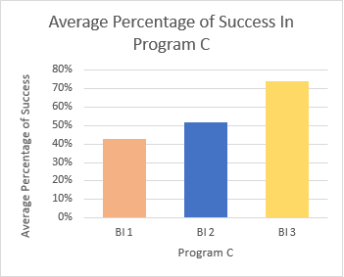

Graph 1 shows that BI 1 had an average success of 63%, BI 2 had an average success of 44% and BI 3 had an average success of 68%. This graph indicates that BI 2 had an exceptionally low average success rate in this program compared to the other BIs. Graph 2 shows that BI 1 had an average success of 67%, BI 2 had an average success of 88% and BI 3 had an average success of 80%. For this client, BI 1 had a much lower average success rate in this program. Graph 3 shows that BI 1 had an average success of 43%, BI 2 had an average success of 52% and BI 3 had an average success of 74%. For this client, BI 3 had higher average success rate in this program. In addition to the exceptionally high or low success rate some BIs had, the results also showed that the variance between each of the BIs’ success averages were also very big. This meant that the programs were more successful with certain BIs than others.

it is difficult to judge whether that program had been successful or moderations on the programs are needed.

Results from BI Surveys
This survey included 6 BIs, 2 from each of the 3 clients that have been part of this report. The BIs are all university students and the sample consisted of 5 females and 1 male participant.
Graph 4
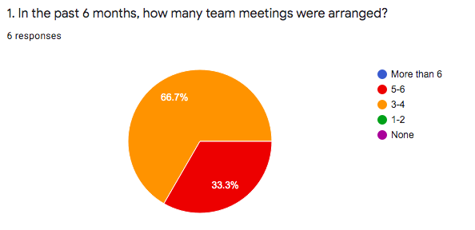
This graph indicated that within 6 months, only 33.3% which is 2 BIs responded that there were 6 meetings arranged while the other 66.7% indicated that less than 6 meetings were arranged. This meant that BIs were not receiving regular monthly support from the behaviour consultant.
Graph 5
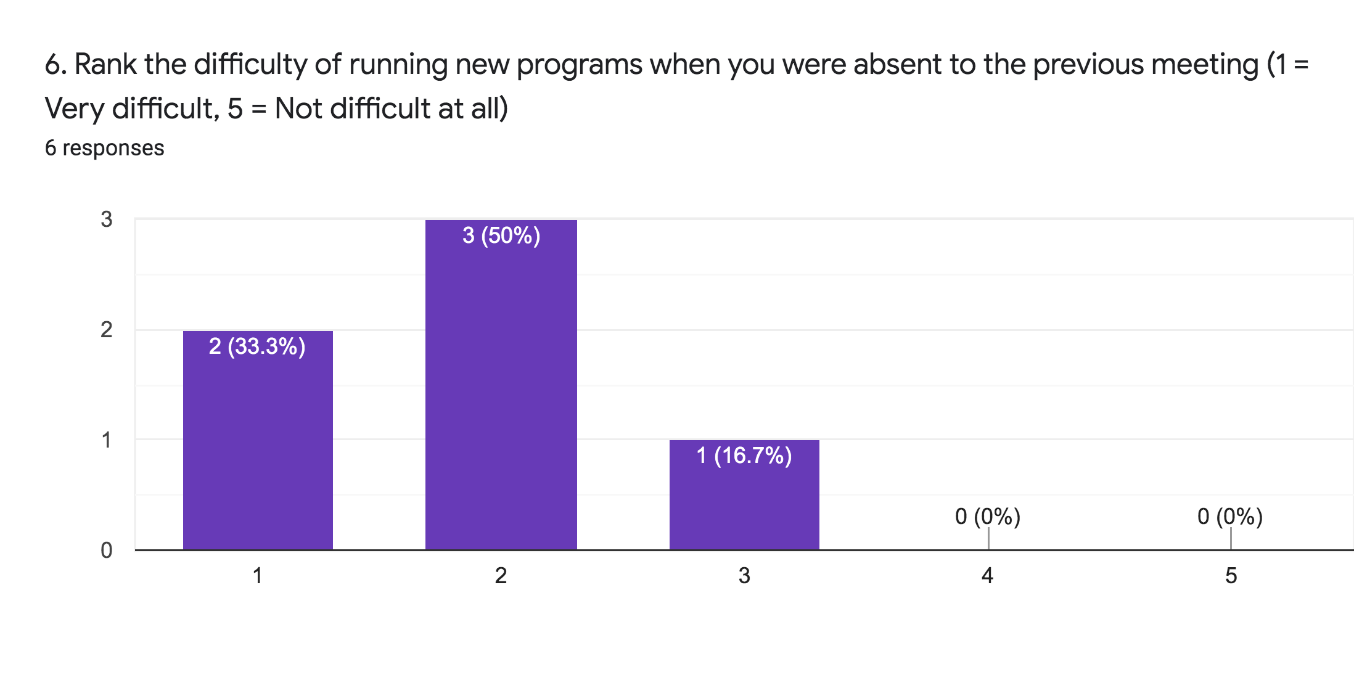
On top of the lack of meetings, BIs that have been absent for some of the meetings, five out of six had found that running new programs to be very difficult, somewhat difficult. Specifically half of my participants found it to be somewhat difficult.
Graph 6
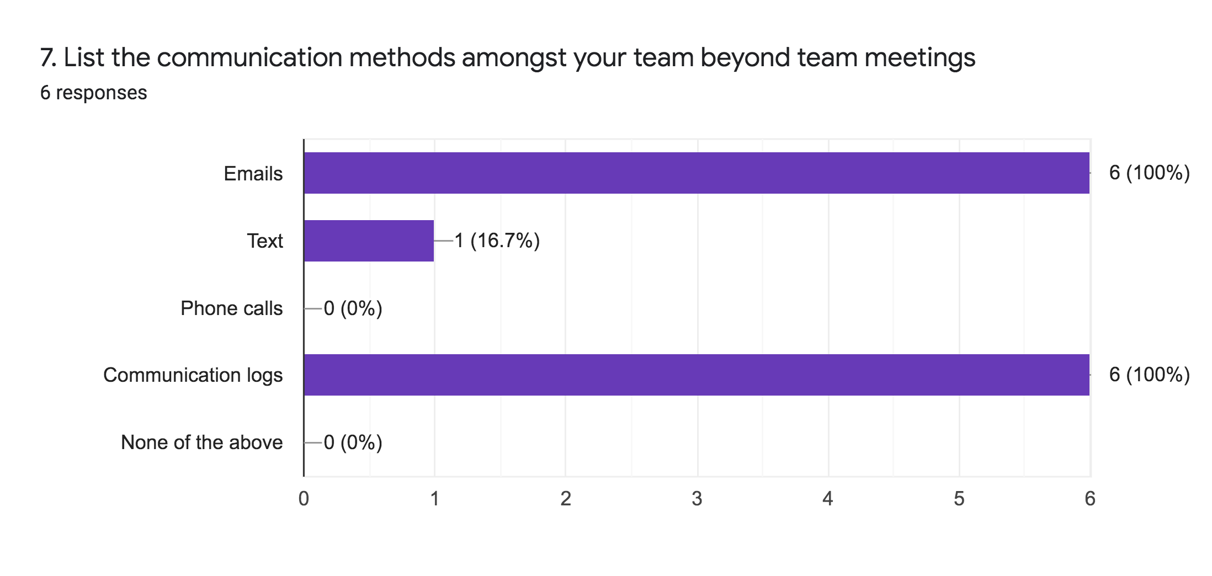
In addition, all 6 participants had responded that written communication logs and emails were used beyond team meetings. One participant had responded to use text as a mode of communication. Given that communication logs are written offline and emails tend to be more formal and a slower form of communication, the current communication methods are not as helpful to BIs that found running sessions with new information difficult.
Graph 7
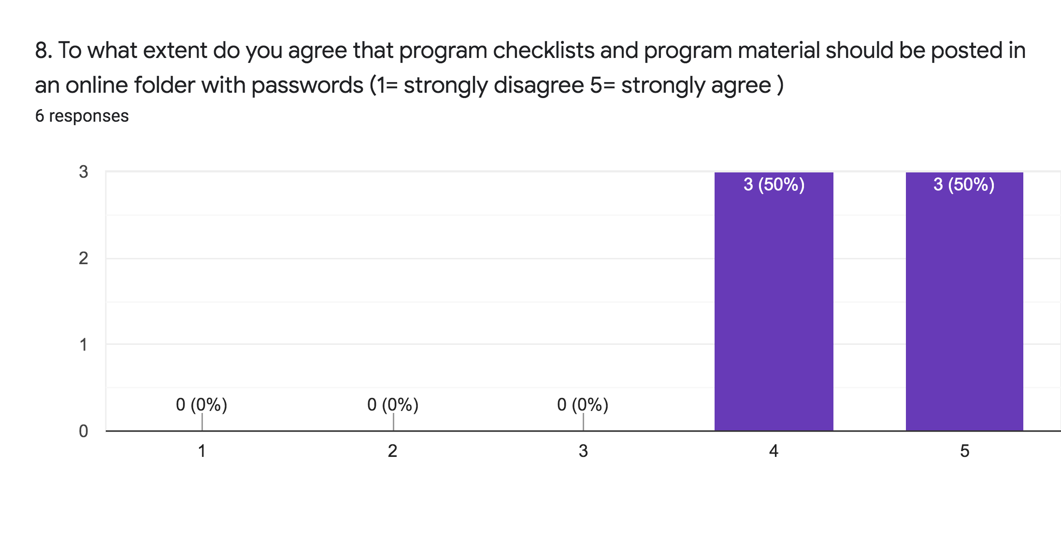

For the first proposed solution, there were 3 participants that somewhat agree and 3 participants that strongly agree to post program information online secured with passwords. None of the participants had disagreed to this solution.
Graph 8
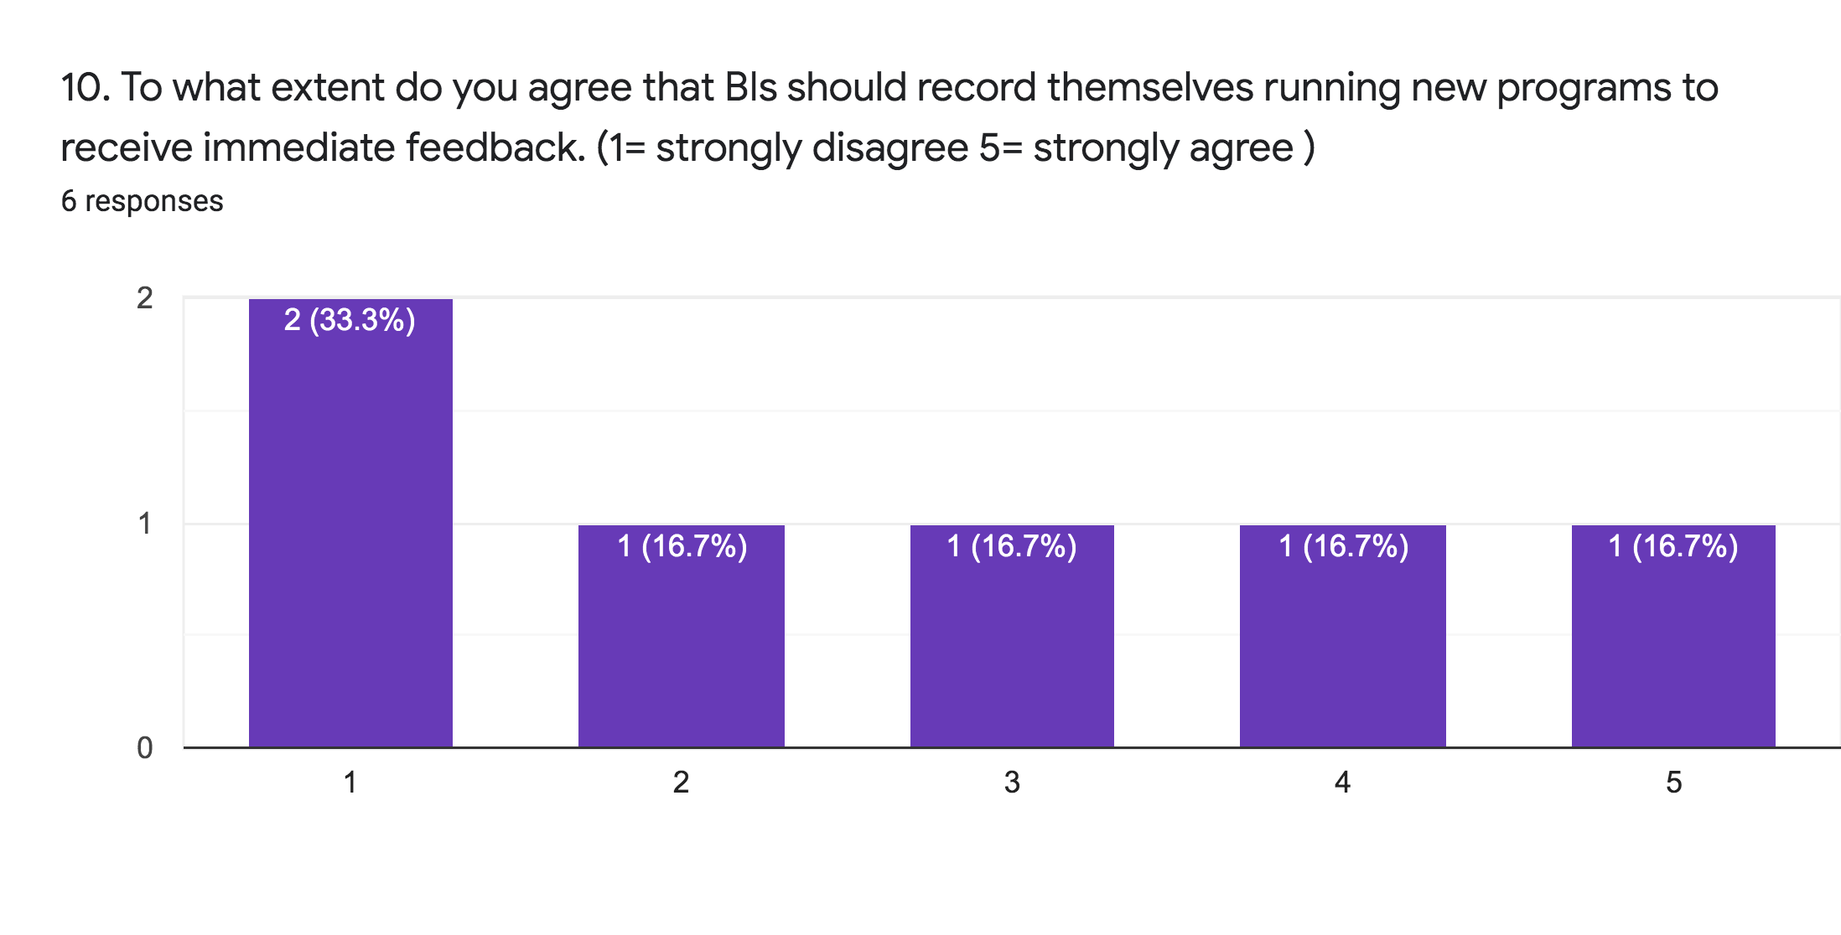
For the second proposed solution, there is a variety of responses. There are 2 participants that strongly disagreed and 1 participant that disagrees to recording themselves running new programs. However, there were also 1 participant that agree and 1 participant that strongly agrees. There is 1 participant that is neutral to this proposed solution.
Graph 9
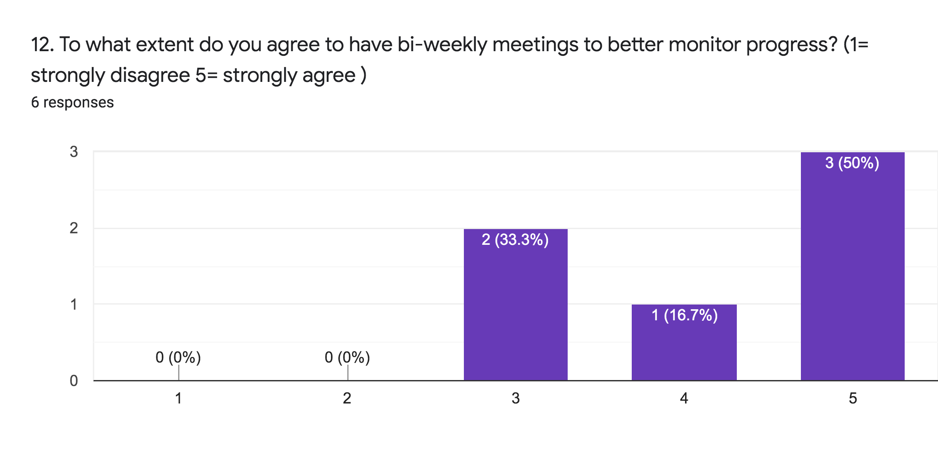
For the third proposed solution, most participants agreed to having bi-weekly meetings. 1 participant agreed and 3 participants strongly agreed to having bi-weekly meetings. 2 participants responded neutral to this solution.

Results from Parent Surveys
This survey included 6 parents from the 3 clients that are part of this report. This sample consisted of 3 females and 3 male participants.
Graph 10
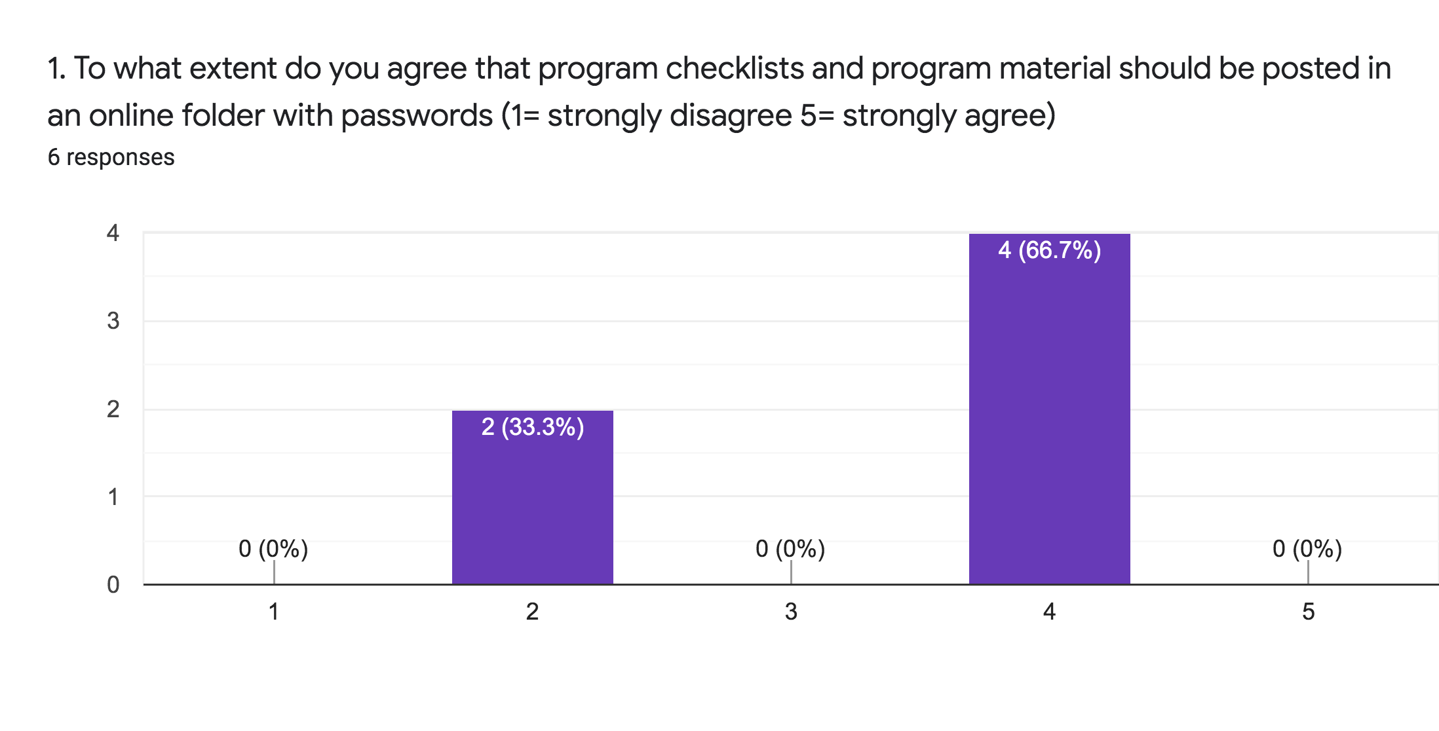
For the first proposed solution, 4 participants have agreed while 2 participants have disagreed to posting session material online.
Graph 11
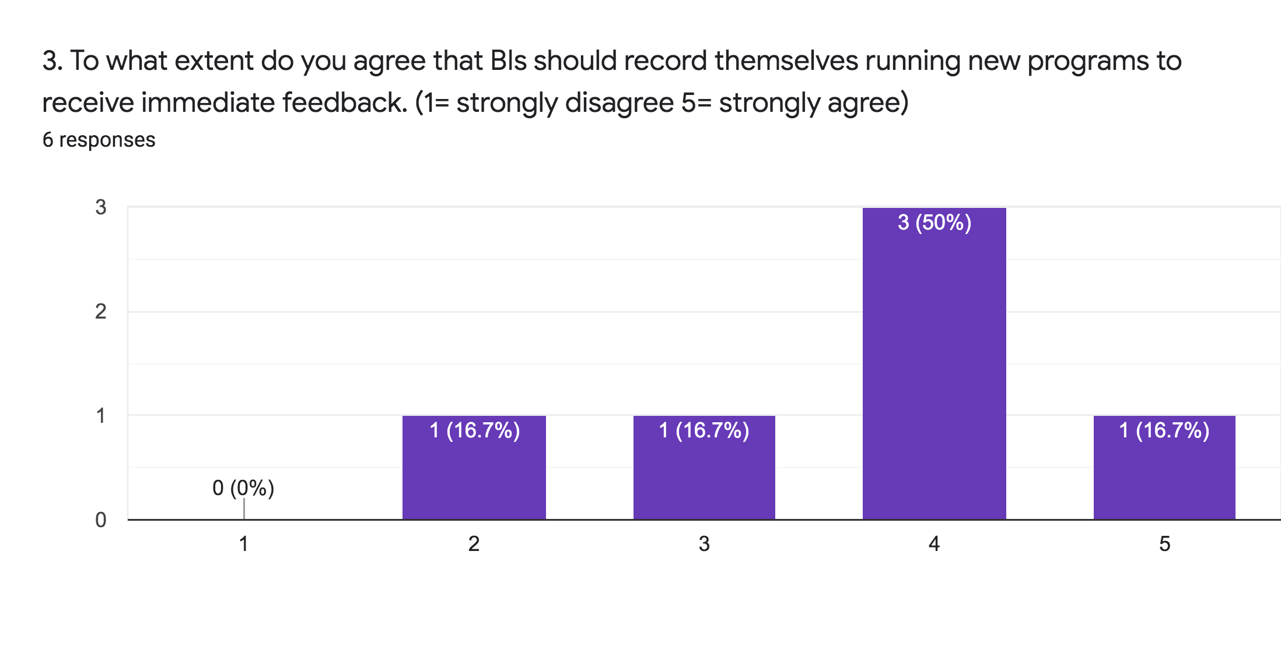
For the second proposed solution, there was a variety of responses. 3 of the participants agreed to have BIs record their sessions. 1 participant disagreed while 1 participant strongly agreed. There was also 1 participant that responded with neutral.

Graph 12
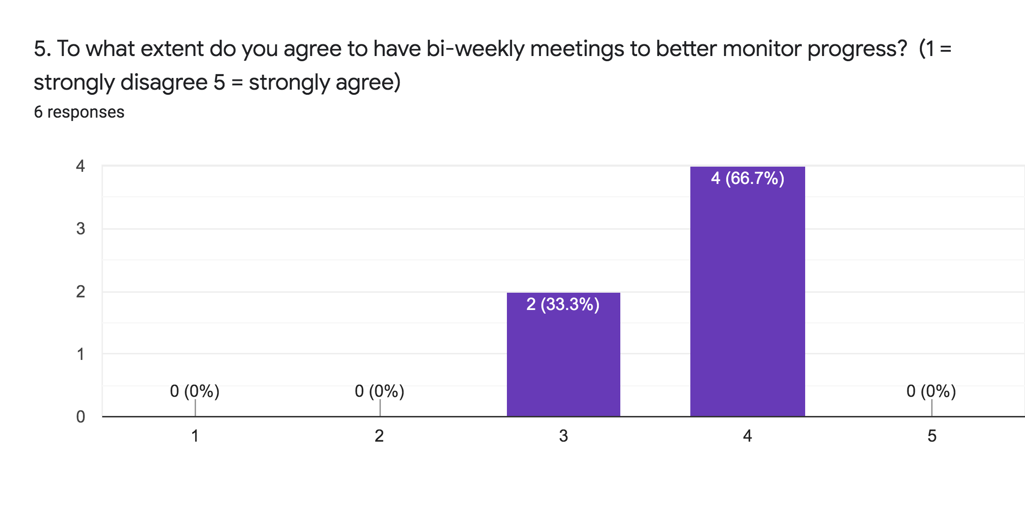
For this proposed solution, 4 participants had agreed to having bi-weekly meetings while 2 participants had responded with neutral.

Results from Interview
For the interview, Ms Jackie Pun had been recruited. Ms. Pun is the directing behaviour consult of Fairview Consulting Inc.. She hires BIs to different clients and creates programs for clients. She is also involved with updating or changing program goals once BIs’ session data has shown a success rate of 80% and above for 5 consecutive sessions. The data of 5 consecutive sessions must involve all BIs to ensure that success is not only shown with one person. Ms. Pun has responded that team meetings are aimed to be scheduled monthly, however due to lots of scheduling clashes and limited funding, meetings often occur every one and a half months. In terms of support, Ms. Pun said the main mode of communication is through the written communication logs at the end of every session. She uses it to review what has happened in the past month and BIs could refer to that to observe past successes or failures. Ms. Pun also stated that inaccurate data collection is very impactful towards her judgement on future programs. Some potential impacts that she mentioned includes less efficient sessions as she would not be able to create programs that best suit the client’s progress. For the proposed solutions, Ms. Pun agrees that online folders should be implemented. She has concerns regarding the confidentiality of information. She believes that it would be beneficial for BIs in the future so if there is a way to ensure confidentiality, it would be possible to implement. For the proposed solution of filming sessions, she strongly agrees to it. She believes it would greatly benefit BIs and they could get immediate feedback. She suggests for BIs to film occasionally or when there are new programs just to get feedback. She has concerns regarding BIs being distracted or too focused on filming rather than the quality of the session. For the last proposed solution, she disagrees to have biweekly meetings. A lot of clients face issues with funding especially older children as they receive less funding. As some clients have other therapists other than behaviour consultants and behaviour interventionists, she disagrees to implement more meetings. Furthermore, monthly meetings are already difficult to implement due to list of clashes, she does not believe that it would be plausible.
Conclusion
Summary of Findings
Overall, it seems that there is a weak communication amongst the team. Within the past 6 months, not every client has had 6 meetings as there are issues with fitting the whole team’s schedule and limited funding. Furthermore, it seems that within each team, their mode of communication is mostly offline and email, meaning that BIs are unable to receive immediate support and feedback from their sessions. In terms of the proposed solutions, the first solution with creating online folders with passwords for program information had been agreed upon for BIs and Ms. Pun. Both believe that creating online folders could help increase communication amongst the team. This solution had some agreement and some disagreement with parents as some parents are worried about confidentiality issues. For the second proposed solution of filming sessions, results were varied. There were responses disagreement to strongly agree for both BIs and parents. Disagreement were mostly revolved around BIs being distracted if asked to film. Ms. Pun had been supportive of this solution and believes it would be plausible if BIs only filmed occasionally for new programs. The final proposed solution of bi-weekly meetings were opposed by Ms. Pun as she was worried about limited funding and difficulties to schedule meetings. However, BIs and parents were somewhat supportive and believed that it could be beneficial.
Recommendations
To improve data collection accuracy when BIs are having sessions, three solutions were proposed. The first solution would be to create an online folder with passwords. Based on the survey and interview results, it would be recommended to upload only program checklists, session data and communication logs online. Clients’ personal information and diagnosis should continue to be kept offline. The second solution would be to have BIs record their sessions. Based on survey and interview results, it is recommended to have BIs record only one to two programs occasionally if the programs are new or if they have questions regarding their way of implementing a certain program. That way, BIs could receive immediate feedback without being overly concerned with filming and interactions with the client. The final solution was to implement bi-weekly meetings. However, based on the results, it was not recommended due to concerns with limited funding.
Expected outcome
By implementing the first two proposed solutions, BIs would receive more immediately feedback and could have access to program information or other session data prior visiting the client. By doing so, BIs could spend time reviewing notes from other BIs and not feel pressured to flip through different pages of notes or updated programs when arrive to sessions. Furthermore, BIs would be able to correct their methods of implementing programs immediately and not wait until the next team meeting for issues to be brought up. With information being available whenever needed and programs implementation methods corrected immediately, BIs are likely to have session data that are more consistent which would mean that Ms. Pun could update programs that best suit the client’s current progress and needs.

Appendix

References

