Replacing existing virtual desktop infrasturcture thin clients with local desktop computers
a feasibility study report

Prepared for

Robert Boudreau
Director
HR Information Systems
University of British Columbia
Kailey Patton
Office Manager
Human Resources
University of British Columbia

Prepared by
Joyce Wu
ENGL 301 Student
University of British Columbia

December 4, 2019

Table of Contents
EXECUTIVE SUMMARY 4
INTRODUCTION 4
Technical Background 4
Virtual Desktop Infrastructure 4
The Virtual Desktop Pilot Implementation Project 4
Problem Statement 4
Purpose of the Study 5
Scope and Limitation 5
SOURCES AND METHODS 5
Email Interviews from HR Staff 5
Assessment of Equipment without an Assigned Staff 6
Information Provided by UBC IT Desktop Services 6
FACTS AND FINDINGS 6
Number of Users for Each Type of Machine 6
Information Provided by UBC IT Desktop Services 7
Current Cost of VDI Thin Client 7
Annual Fees for VDI Service 9
Current Cost of Desktop Computer 9
Comparison of VDI vs. Desktop Computers 10
Calculations of Costs 11
CONCLUSIONS AND RECOMMENDATIONS 13
APPENDICES 13
APPENDIX A – EMAIL INTERVIEW INVITATION 13
APPENDIX B – EMAIL INTERVIEW QUESTIONNAIRES 14
APPENDIX C – QUESTIONS FOR UBC IT DESKTOP SERVICES 17

EXECUTIVE SUMMARY
(To be completed)

INTRODUCTION
The Human Resources (HR) department at the University of British Columbia (UBC) provides HR support and advice to UBC departments. HR offers a range of services for faculty and staff, including recruitment and employment, training and development for faculty and staff, labour relations, benefits administration, and the development of human resource policies.
The HR Information Systems (HRIS) team takes part in reassessment of workstation equipment for the HR department every four to five years. The last assessment was done in year 2015; therefore, a review of workstation equipment is required this year. When the assessment is completed, the HRIS team and the HR Administration team will work with the Information Technology (IT) department at UBC to implement workstation upgrades.

Technical Background

Virtual Desktop Infrastructure
The virtual desktop infrastructure (VDI) requires software, hardware and other resources to support virtualization of a standard desktop system. The hardware is a computer terminal called a Thin Client. A thin client typically has a lifespan of six to ten years. VDI software and other resources such as applications needed for day-to-day work are managed by IT, and the departments that use VDI pay annual fees to IT for these services.

The Virtual Desktop Pilot Implementation Project
The IT department had advocated for switching local desktop computer to Virtual Desktop Infrastructure (VDI) in 2009/2010. The HR department took part in the Virtual Desktop Pilot Implementation project and switched the majority of its workstations to VDI in 2010.

Problem Statement
The VDI thin clients that were installed in HR back in 2010 are now approaching to the end of lifespan. Due to budget constraints, HR is now faced with the question of whether to replace old VDI thin clients with new VDI thin clients, or to replace old VDI thin clients with local desktop computers. The price difference between a thin client and a desktop computer is marginal. VDI user relies heavily on network connection while local desktop users can still work offline when the network is unavailable. Also, increase in annual fees to renew VDI software has become too costly for the department to maintain.

Purpose of the Study
The purpose of this study is to examine an alternative solution to the existing workstation setup, with a focus on the cost of hardware replacements. The report will compare the cost of replacing existing virtual desktop infrastructure (VDI) thin clients with newer VDI thin clients versus local desktop computers.

Scope and Limitation
Typical workstation equipment includes computer or VDI, monitor, keyboard, mouse, desk, chair and other peripherals such as webcam and speakers. For the purpose of this study, the scope is limited to current desktop or laptop computers and VDI purchased using HR department funds. Workstation equipment for distributed HR staff, where the equipment was paid by departments other than HR, will not be included in this study.

SOURCES AND METHODS
The study uses primary sources from:
- Email interviews from HR staff
- Assessment of equipment without an assigned staff
- Information provided by UBC IT Desktop Services

Email Interviews from HR Staff
An interview invitation was sent to all HR staff via Email. The invitation briefly explained the purpose of the interview with an estimated time required to complete the interview. Staff participation is voluntary. A copy of the interview invitation is included in Appendix A.
When a staff accepted the invitation to participate in the interview, the interview questions were then emailed to the staff. The interview questions were composed with a focus on obtaining data for analysis of workstation hardware usage and the age of the computer. The email interview questions are included in Appendix B.

Assessment of Equipment without an Assigned Staff
Equipment in meeting rooms and loaner equipment have no staff assigned to them; therefore, assessment of these equipment were done in addition to email interviews. Data were collected by answering interview questions for each equipment.

Information Provided by UBC IT Desktop Services
Questions regarding the cost of VDI and desktop computer supported by UBC IT and the pros and cons of implementing VDI were submitted to IT Desktop Services via the online Help Desk Contact web form. Questions sent to IT Desktop Services are included in Appendix C.

FACTS AND FINDINGS
A total of 167 equipment were assessed.

Number of Users for Each Type of Machine
42 of the 167 machines are desktop computers. Of the 42 desktop computers, 28 of them are at least 5 years old and requires replacement. 43 of the 167 machines are laptop computers. Of the 43 laptop computers, 17 of them are at least 3 years old and requires replacement. 82 of the 167 machines are VDI thin clients. All 82 VDI thin clients are in need of replacement.

Figure 1: Percentage of Users in HR for Each Type of Machine

Figure 2: Number of Machines Requiring Replacement

Information Provided by UBC IT Desktop Services

Current Cost of VDI Thin Client
Depending on the functionality, thin clients can range anywhere from $500 to $2000. Thin client with basic functionality of being able to connect to VDI cost around $500. Higher end thin client currently available through UBC preferred vendor, Dell, with more advanced features such as better processors, video display, and security has a price tag of $1,255.15 per unit.

Table 1: Comparison of Wyse 3040 and Wyse 7040 VDI Thin Clients
Wyse 3040 Thin Client | Wyse 7040 Thin Client
Image
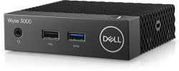
Dell Price
$501.00 | $1,255.15
Operating System
Wyse ThinOS, English, Does NOT support PCoIP, includes Wyse ThinOS Firmware Access
Power
Under 5 Watts power consumption | Less than 12 watts
Ports
3 USB 2.0  1 USB 3.1  1 Audio-mic combo jack  2 DisplayPort  1 RJ45 | 6 USB 3.0 ports  1 Display Port  1 HDMI Port  Ethernet  SFP (Fiber or Copper)
Connectivity
10Mb/100Mb/1Gb Copper RJ45 (Wired Ethernet) | 100Mb/1Gb Ethernet, 100Mb / 1Gb SFP (Copper or Fiber SFP Module)
Multimedia
Audio-mic combo jack | Internal Speakers  Universal 3.5mm Headphone Jack with microphone
Chipset
Intel Quad Core 1.44 GHz
Dimensions & Weight
Height without stand: 1.1" (27.94mm) x Width: 4" (101.6mm) x Depth: 4" (101.6mm)  Weight: 0.24 kg (0.53 lbs) | Height: 7.16" (182 mm) x Width: 7.01” (178.2 mm) x Depth: 1.41” (36 mm)  Weight: 3.12 lbs (1.41 kg)
Security
 | Kensington Lock
Systems Management
 | Software Management support - Wyse Device Manager (WDM), System Center Configuration Manager (SCCM) and Dell Command Configure (DCC) manageability.
Slots
Built-in Kensington Security Slot (cable sold separately)
Regulatory
 | TAA, Energy-Star, EPEAT and VPAT certifications

Annual Fees for VDI Service
UBC IT charges $150/year per user for use of the VDI service. Other costs such as support for infrastructure and software licensing, which currently cost UBC IT approximately $150,000 per year, is largely absorbed by UBC IT in order to provide VDI at a lower rate to users.

Current Cost of Desktop Computer
The most affordable desktop computer that is currently available via UBC IT is the Dell OptiPlex 3060 Micro Form Factor. This machine costs $805.44, which is $304.44 more than the most affordable VDI thin client, Wyse 3040.

Table 2: Specifications of Dell OptiPlex 3060 Micro Form Factor Desktop Computer
Dell OptiPlex 3060 Micro Form Factor
Image
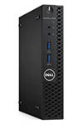
Operating System | Microsoft Windows 10 Enterprise 64-bit
Processor | Intel Core i5-8500T (6 Cores/9MB/6T/up to 3.5GHz/35W)
Memory | 8GB (1x8GB) 2666MHz DDR4 Non-ECC
Storage | M.2 256GB SATA Class 20 Solid State Drive
Optical Drive | N/A
Networking | Qualcomm QCA9377 Dual-band 1x1 802.11ac Wireless with MU-MIMO + Bluetooth 4.1
Dimensions & Weight | Width: 3.6cm (1.4")  Depth: 17.8cm (7.0")  Height: 18.2cm (7.2")  Weight: 1.18kg (2.6lb)

Comparison of VDI vs. Desktop Computers
Comparing the pros and cons of VDI and desktop computer features, Table 3 shows that when comparing VDI and desktop computer with similar specifications, the features offered by desktop computer are better than those offered by VDI.

Table 3: Comparison of Features Offered by VDI and Desktop Computer
Features |  | VDI |  | Desktop Computer
Performance |  | Performance is slower than a traditional desktop, but adequate for most common needs. Support for video conferencing is adequate, but quality can suffer with larger images. |  | Recommended desktops have higher performance capabilities for video conferencing and any other demanding needs.
Cost |  | Cost exceeds an equivalent desktop option and will be increasing due to changing technology needs. |  | Total cost is less than an equivalent VDI option.
Configurability |  | Limited flexibility to support needs of individual users. |  | Very flexible for differing end-user software, hardware and configuration needs.
Security and Software Updates |  | Well managed security and software updates. |  | Very well-managed security and software updates, with greater agility for critical security updates, and flexibility to minimize user impact.
Data Security |  | Excellent data security. |  | Excellent data security - local data is encrypted at all times.
Power Consumption |  | Slightly lower power consumption compared to traditional desktop. |  | Power consumption is similar when total consumption is considered.
Physical Space |  | VDI hardware takes up similar space compared to recommended desktops. |  | Micro Form Factor desktop takes up similar space as VDI thin client
Accessibility |  | Anytime anywhere access to the service. |  | Anytime anywhere access would require a laptop at higher cost.
Mobility |  | Ability to move from one VDI client to another and maintain the work environment with all applications and documents open. |  | Limited ability to move from one location to another and maintain the work environment with all applications and documents open, though this is possible with laptops, or with other options.

Calculations of Costs
With the thin client cost minimum of $501, when the 10% education discount is applied, the thin client costs approximately $505.01 per unit after tax. Annual fee for VDI service is $150/year. Therefore, the initial cost in year 1 is $505.01 + $150 = $655.01. The annualized cost of VDI based on a five-year lifecycle is $251/year.
The desktop computer offered by UBC IT cost minimum of $902.09 per unit after tax. The annualized cost of desktop computer based on a five-year lifecycle is $180.42/year. Figure 3 shows the annualized cost of desktop computer is lower than VDI after 3rd year.
The laptop computer offered by UBC IT cost minimum of $1,378.72 per unit after tax. In addition to having similar features to desktop computer, laptop computer offers more accessibility and mobility. The annualized cost of laptop computer based on a five-year lifecycle is $275.74/year, which is $24.74 more than the VDI option.
Table 4: Comparison of Annualized Costs
Annualized Cost ($)
Machine | Year 1 | Year 2 | Year 3 | Year 4 | Year 5
VDI | 655.01 | 402.51 | 318.34 | 276.25 | 251.00
Desktop | 902.09 | 451.05 | 300.70 | 225.52 | 180.42
Laptop | 1378.72 | 689.36 | 459.57 | 344.68 | 275.74

Figure 3: Annualized Cost of VDI, Laptop and Desktop Computer

CONCLUSIONS AND RECOMMENDATIONS
Desktop computer offers better features and lower annualized cost after the third year. The HR department reviews and replaces workstation equipment every four to five years; therefore, HR will benefit from the lower annualized cost by replacing existing VDI thin clients with desktop computers. Staff requiring remote access can sign out one of the seven loaner laptops. With the uncertainty of the increase in VDI service costs, and a chance of UBC IT phasing out of VDI support, HR staff requiring frequent remote access are recommended to have the workstation equipment replaced with laptop computers. However, the needs should be assessed case by case.

APPENDICES

APPENDIX A – EMAIL INTERVIEW INVITATION
Dear HR colleagues,
For those who don’t know me, my name is Joyce and I am an Intermediate HR Business Analyst in the HR Information Systems team. Every 4-5 years, HR department replaces our workstation hardware. It’s time to do it again in 2019. I would like to ask for your participation in an email interview. The purpose of this email interview is to obtain data for analysis of our current workstation hardware usage, which will then be used for investigating options for replacement. A formal report will be submitted to Director, HR information Systems and Administrator, Office Management and Exec Support for review and consideration. Whether you are a VDI user or a PC/Laptop user, the email interview contains maximum of 8 questions and should take about 5 minutes of your time. Your participation is voluntary. However, I do encourage all of you to participate as this will increase the accuracy of our workstation inventory and help our team plan the workstation hardware replacement for the next 5 years.
If you would like to participate in the interview, please reply to this email and I will forward the interview questions to you.

Thank you,
-Joyce

APPENDIX B – EMAIL INTERVIEW QUESTIONNAIRES
Workstation Inventory Email Interview Questionnaires
Please send your responses to joyce.wu@ubc.ca
by Tuesday, November 26, 2019 at 4:30PM

Dear HR colleagues,
Thank you for participating in the Workstation Inventory Email Interview. Please follow the instructions provided below to answer questions regarding your computer equipment, and email your responses to me at joyce.wu@ubc.ca by 4:30PM on Tuesday, November 26, 2019.
If you need assistance answering the questionnaire, feel free to contact me or arrange a time for me to visit your workstation. I will need a few minutes to access your machine and gather the specifications to answer the questionnaire.

VDI Users:
- VDI User: Y/N Please indicate that you are a VDI user
- Monitor size and quantity: 19” or 23”, 1 or 2 monitors
- Keyboard: Regular or Ergonomic
- Mouse: Regular or Ergonomic
- Other Equipment: i.e. webcam, external speakers, etc.

PC and Laptop users:
- PC or Laptop: Please indicate which one you use.
- Laptop users only: what type of docking station do you have? Old docking stations require you to snap the laptop into the dock. New ones connect with a USB cable.
- Do you use Remote Desktop
- Monitor size and quantity: 19” or 23”, 1 or 2 monitors
- Keyboard: Regular or Ergonomic
- Mouse: Regular or Ergonomic
- Other Equipment: i.e. webcam, external speakers, etc.
- System information: Screenshot or indicate BIOS Version/Date, Processor and the Installed Physical Memory (Ram)
Instruction on how to access your workstation’s System Information is provided on the next page. If you have any questions, feel free to reach out.
Thank you,
-Joyce
Instructions on Accessing System Information
- Go to the start menu and Type ‘sys’ into the CMD line and select System Information.
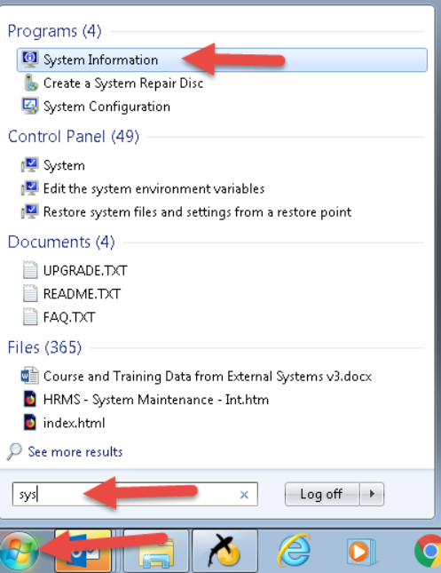
- Either take a screenshot of the page or list the BIOS Version/Date and the Installed Physical Memory (Ram) information in your response
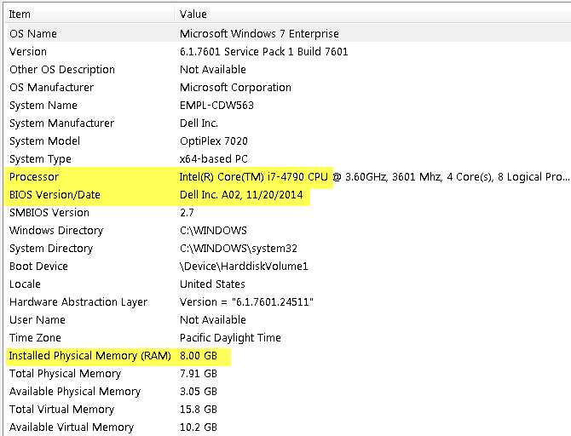

APPENDIX C – QUESTIONS FOR UBC IT DESKTOP SERVICES
Hi,
Our Human Resources department is looking to upgrade our existing workstation hardware, and I have some questions about VDI and desktop computer offered and supported by UBC IT.
- How much is the VDI thin client nowadays if it is purchased through UBC IT?
- How much is the annual fees for the VDI software?
- Could you send me a list of micro form factor desktop computer that can be purchased through UBC IT and their prices?
- For purchase of VDI thin client, software or the desktop computer, is there any group discount? If there is, what is the discounted price for each?
- What are the pros and cons of implementing VDI as compare to desktop computers?

If you need further clarifications, please contact me at joyce.wu@ubc.ca.

Thank you,
-Joyce

