Analysis of Hour Allocation and Job Satisfaction
at SW Event Technology

Presented to
Craig Westley
General Manager
SW Event Technology
Kelowna, BC

Prepared By
Morgan Brandt
Undergraduate
UBC Bachelor of Arts
English 301

December 19, 2019

Letter of Transmittal

Table of Contents

List of Figures 4
Abstract 5
1 Introduction 6
1.1 Background of SW Event Technology and The Audiovisual Industry 6
1.2 Purpose of this report 7
1.3 Proposed Solution 7
1.4 Method of Research 8
1.5 Scope of this inquiry 8
1.6 Brief description of data sources 9
2 Feasibility Analysis 9
2.1 Current Scheduling/Booking Procedures 9
2.2 Seasonal Hour Allocation Comparison 11
2.3 Lifestyle and Job Satisfaction 14
2.4 Recommendations 19

List of Figures

Abstract

Introduction

Background of SW Event Technology and The Audiovisual Industry
The audiovisual industry is a precarious labour market as it is based on freelance contractors and a multitude of businesses to provide equipment, labour, staging, operating technicians, management and talent, to produce a show. However, the industry goes beyond stages and arenas, but into the broadcasting of press conferences, banquets, and galas as well. To work in this field, technicians must be skilled in audio, lighting, and video to remain competitive and flexible on jobsites. Looking at the outlook for this industry, the Audiovisual Integrated Experience Association (AVIXA), found 2016 to 2018 had “positive sales and employment,” with AVIXA’s Industry Outlook and Trends Analysis (IOTA) founding “$59.2 billion in 2018 in North America and is forecast to reach $71.4 billion in 2023” (1). Accordingly, such projections are positive for the thriving business of SW Event Technology based in the Okanagan.

SW Event Technology was founded in 1989 by Cal McCarthy and Grant Mackeny in Kelowna, British Columbia, becoming the in-house audiovisual providers for the Grand Hotel and Convention Centre (“History of SW Event Technology”). Since 1990, SW Event technology acquired Showtime Event and Display, a tradeshow management and supply provider, becoming an anomaly in the industry as one of the only companies with business throughout corporate and festival season (“History of SW Event Technology”). From there, SW Event technology now serves North America out of the Kelowna, Nanaimo, and Vancouver offices (“History of SW Event Technology”).

Purpose of this report
There is a disparity in how hours are allocated, leaving some jobs over or understaffed, assigning some staff members under 30 hours per week and giving others over 50 hours per week. As most of the senior staff has been with the company for over a decade and with time comes lifestyle changes such as growing families, career goals, and external business ventures. Shift work becomes inconsistent to schedule around, especially when the allotted hours do not accurately reflect overtime in the schedule, sometimes working passed the scheduled work period. This disrupts the staff’s work/life balance, causing some resistance to commit during peak seasons.

Proposed Solution
The plausible solutions under investigation involve working with the employee’s goals and desires when possible to foster a dedicated workforce during peak seasons. One possible solution is revamping hour allocation based on staff survey responses for what types of shifts, gigs, and venues they prefer, while matching these parameters to the labour demands of the event. This lifestyle survey could occur during SW Event Technology yearly appraisals to identify the wants and desires of the employee regarding job demands, performing meaningful and challenging work, as well as providing a balance between work and personal life. Currently, SW carries out a thorough appraisal regarding career growth and goals, however, by coupling the lifestyle survey into this routine, the data derived from the document would prevent miscommunication of personal needs throughout the year and provide a foundation for shared work expectations between the worker and employer. So, by catering to these needs and desires most of the year, employee job satisfaction should increase, fostering a dedicated workforce in the peak seasons.

Method of Research
Field research will include interviews with management: Craig Westly, General Manager, Barry Fisher, Assistant General Manager. These interviews will be used to discuss questions of inquiry and derived the data to create an anonymous survey. In this survey, staff were asked a series of questions about work/life balance, meaningful work, and job preferences. The resulting survey has responses from 8 SW technicians for the 39-question anonymous survey designed to analyze staff perception of hour allocation, job efficiency on site, and general job satisfaction. An analysis of this data is used to see the potential solutions to better distribute hours amongst staff during festival and corporate seasons. With this information, environmental preferences for employees will be based on three factors: event type, travel opportunities, and labour requirements.

Scope of this inquiry
To asses the feasibility of improving the system of hour allocation at SW Event technology, I plan to pursue the seven areas of inquiry:
- How does management allocate hours currently?
- How much training is available and provided to staff to prepare them for a variety of jobs?
- What factors are currently taken into consideration for every job estimate?
- What are employee preferences for hour allocation and shift preferences?
- Does every employee feel that their skills are utilized and valued regularly?
- Can the annual employee appraisal be modified to asses changing lifestyles to better serve how hours are allocated?
- Where does management see room for improvement?

Brief description of data sources
The sources utilised for this study cover hour allocation and flexibility, overtime versus hiring costs, and shift work scheduling with family life. First, El-Awady Attia, Philippe Duquenne, and Jean-Marc Le-Lann’s study, "Considering Skills Evolutions in Multi-Skilled Workforce Allocation with Flexible Working Hours" investigates flexibility of staff by diversifying skill base and using hour allocation to reinforce skills as an investment in human resources. This provides a foundation for the recommendations for hour assignment to improve skill diversity.
In Jonas Ingels and Broos Maenhout’s article, "The Impact of Overtime as a Time-Based Proactive Scheduling and Reactive Allocation Strategy on the Robustness of a Personnel Shift Roster," a cost-based analysis on whether overtime scheduling or hiring is more efficient. Their findings give logistics as to how staffing should be handled during corporate and festival season. Now Robert Tuttle and Michael Garr’s article, "Shift Work and Work to Family Fit: Does Schedule Control Matter?" addresses how shift work effects family life. Their conclusions round out the analysis of how hours are allocated at SW Event Technology currently.

Feasibility Analysis

Current Scheduling/Booking Procedures
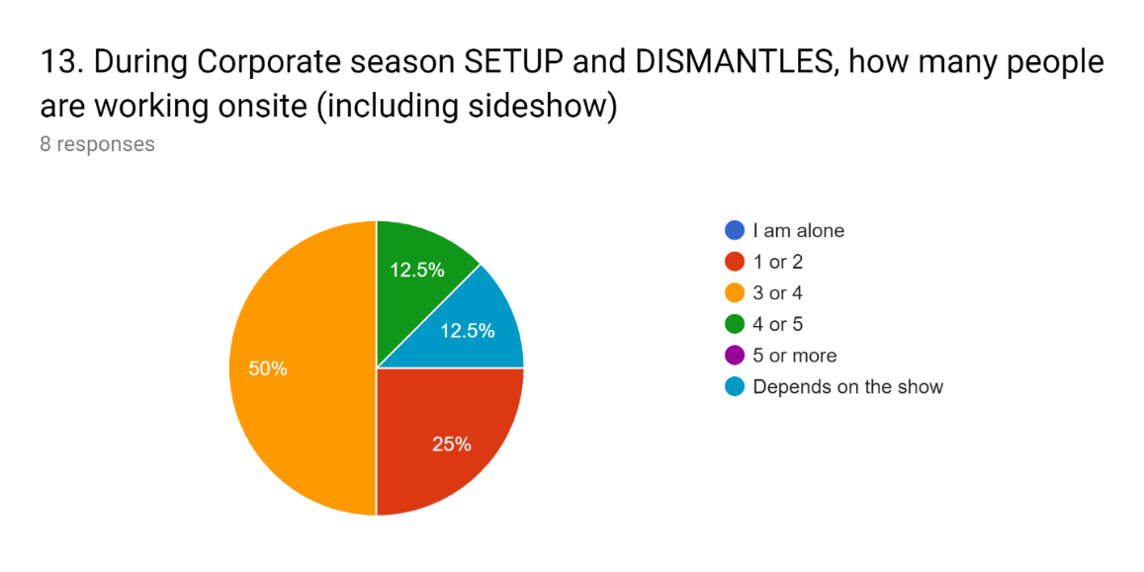
SW Event Technology currently employs over 100 employees at their multiple branch locations in Western Canada. While scheduling has migrated to the digital shift planning software Humanity, an online application for job information and timecards, hour allocation relies on deliberation during the tactical staffing phase, 1 of 3 phases in hour allocation introduced by Ingels and Maenhout (144). The creation of a duty roster during Ingels and Maenhout’s tactile phase involves scheduling with the following uncertainties in mind: uncertainty of demand, the variability of the demand for employees (144); uncertainty of arrival, when the demand for employees will increase (144); and uncertainty of capacity surrounding “unexpected absenteeism and sick leave” (144). In the interviews conducted with General Manager, Craig Westley, and Assistant General Manager, Barry Fisher, the estimate and scheduling process were discussed. Fisher notes that management’s work in allocating hours would benefit from having more project managers to carry on the jobs after sales. Nevertheless, creating quotes are non-biased as they focus on what roles need to be satisfied: operating technicians, set up and dismantle technicians to lead audio, lead video, lead lighting, and general labour. The labour requirements are restricted primarily by budget and employee demand, as illustrated in figure 1 and 2, festival season requires more labour to carry out the job demands outside of the lead technicians whereas corporate season relies more so on lead technicians work.
Figure 1: Question 13. SW Hour Allocation and Job Satisfaction Survey
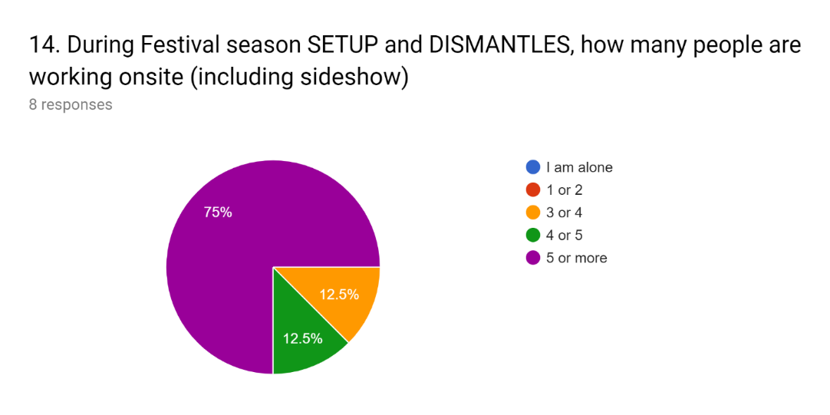
Figure 2: Question 14. SW Hour Allocation and Job Satisfaction Survey
While this strategy sustains SW, the application of proactive overtime hour allocation during the operational and tactical phases, especially with smaller crews, would decrease the need for overtime as a reactive measure would minimizing disruptions in employee availability (Ingels and Maenhout 143, 145).

Seasonal Hour Allocation Comparison
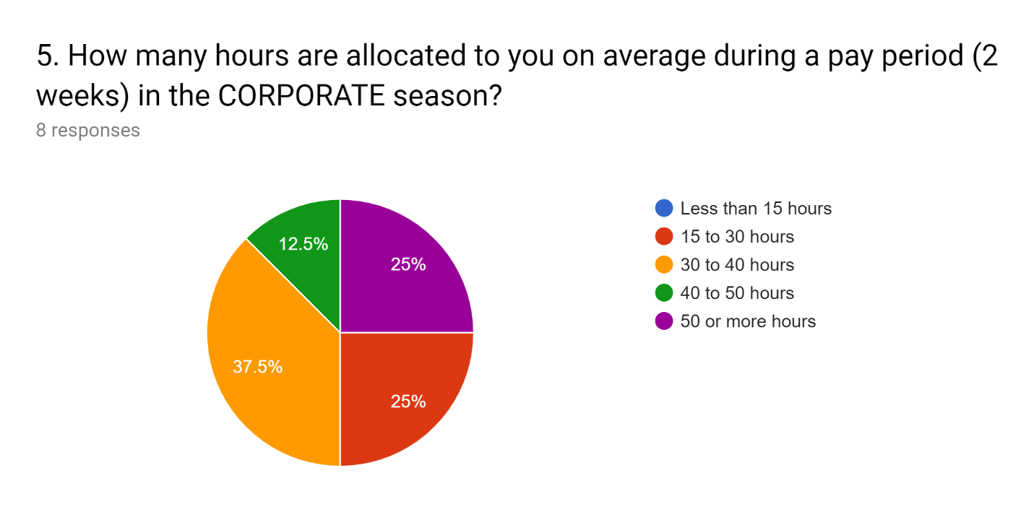
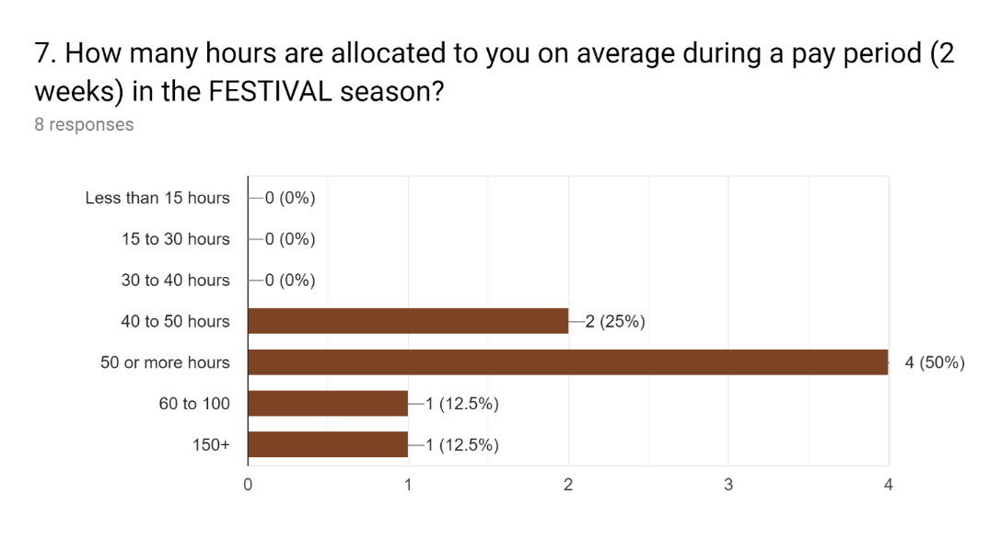
The difficulty of formulating a strategy to maintain a workforce is the nature of the event industry. To demonstrate this, staff was polled to compare hours from festival season (figure 3) and corporate season (figure 4), now these figures in conjunction with the number of technicians onsite during these given seasons demonstrate a need for either increased man power or increased flexibility as Attia et al. found that to reduce the risk of losing core competencies, increasing versatility amongst staff prevents the need to outsource labour during peak seasons (Attia et al. 4548). Therefore, investing in training staffs core competencies in audio, video, and lighting increases flexibility in job allocation, particularly on-site job completion. The issue then returns to providing hours to reinforce such competencies as to not lose efficiency, especially for junior technicians that may not always be allocated hours against lead technicians during the strategic and tactical planning phases of scheduling, When this was brought up in conversation with Craig Westley, the yearly employee appraisals were central when organizing opportunities for juniors to experience career growth and challenges. As Attia et al. suggest, utilising the same operators for jobs, “companies become dependant upon a small group of individuals,
Figure 4: Question 5. SW Hour Allocation and Job Satisfaction Survey
Figure 3: Question 7. SW Hour Allocation and Job Satisfaction Survey
and may be forced to outsource missions within their core competencies” (Attia et al., 4548)
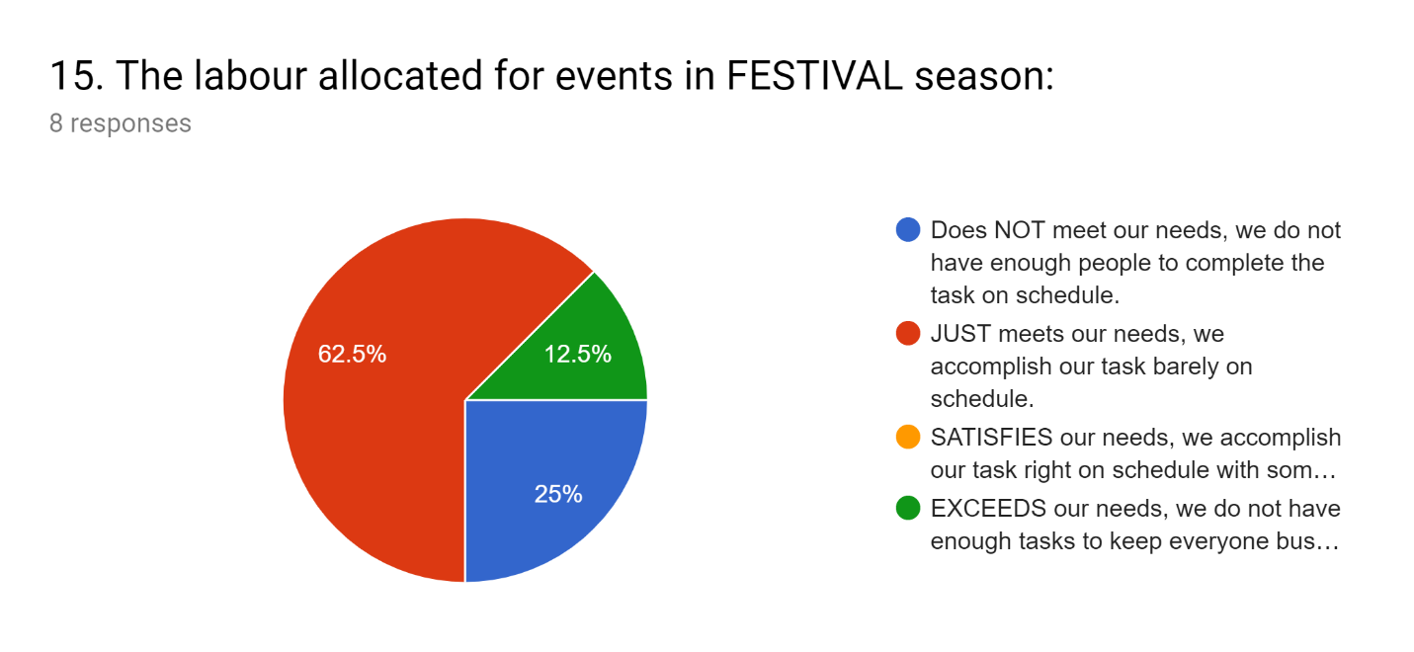
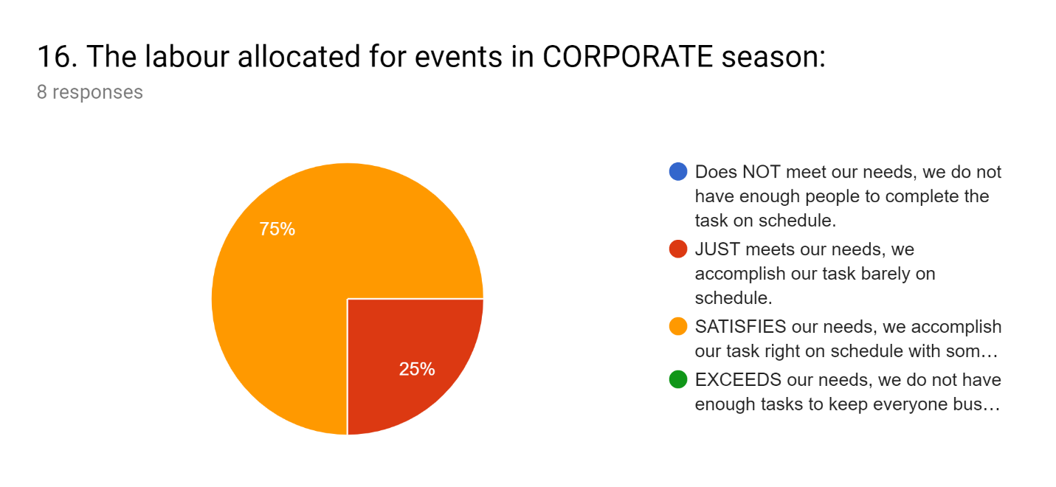
When considering the quality of work based on the number of technicians allocated to a job (see figure 5, 6, and 7) the investment of training staff sufficiently in all core competencies fosters a more confident and productive staff.
Figure 6: Question 15. SW Hour Allocation and Job Satisfaction Survey
Figure 5: Question 16. SW Hour Allocation and Job Satisfaction Survey
How much training is available and provided to staff to prepare them for a variety of jobs?
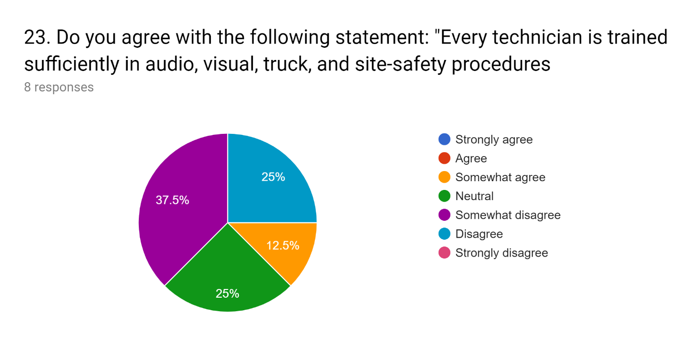
- Therefore, the companies that wish to develop their responsiveness through staff versatility should accept the additional labour cost linked to the work of non-ideally skilled operators: this additional cost of industrial activities can be considered as an

Lifestyle and Job Satisfaction
- What are employee preferences for hour allocation and shift preferences?
- Does every employee feel that their skills are utilized and valued regularly?
BARRY Family Life
1. What would be the ideal ratio of work to life outside work?
- The work week is based on 40 hours, but when busy it seems like a lot more than that. Ideally a four day work week would be nice.
2. Does the current system support that ratio?
- No, a 40 hour work week is the norm in North America
CRAIG Family life
  - Advice, you have to learn to be positive and optimistic
  - Miserable from travel, be present when you are at home
  - Any job can overtake everything
- Resources we have
  - Podcasts
  - Brain training
  - Self learning
  - My worth is in what i have chosen
  - I chose to do these things that
COMPASSIONATE SCHEDULING
- The theory of idiot compassion, I feel for you
- Active compassion, I cannot relate but I am trying to help you
- No one is a number to fill the gap
- Multigenerational work
  - Communication barrier for proactivity
- Not about priority scheduling, seniority means nothing
Appraisal
- Before: Disengaged short answers
- After: Evaluating commitment
- Going forward
  - Think harder about the goals
  - Hyperfocus the goals
  - Grow as a person

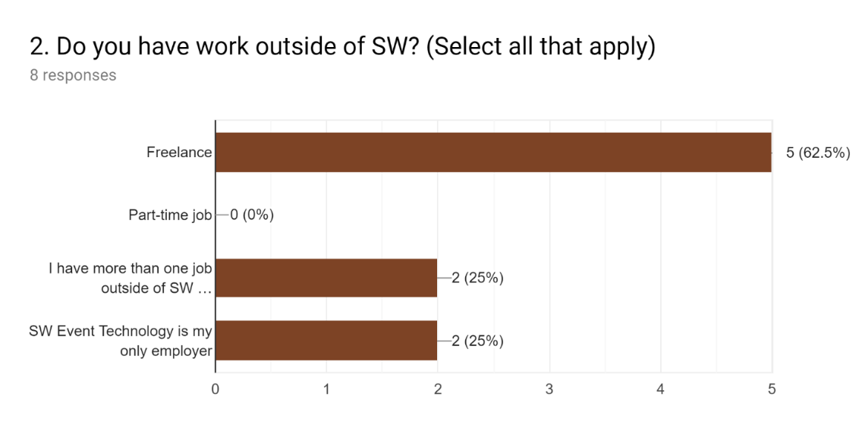
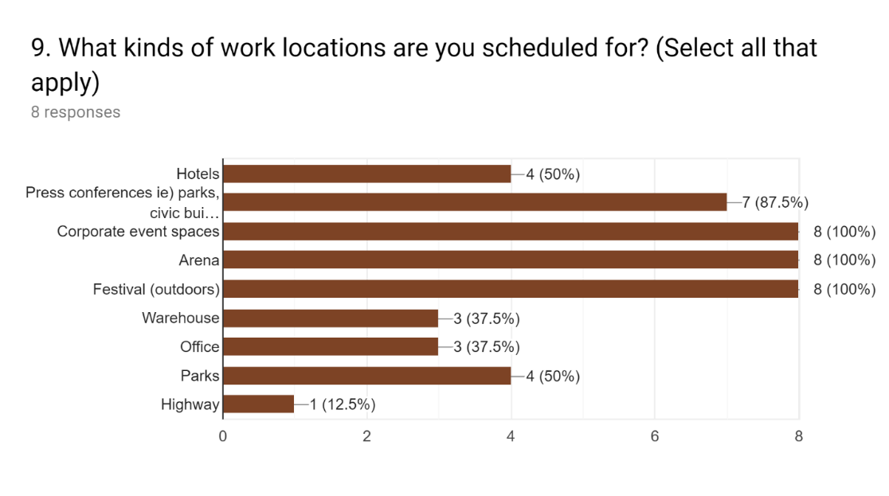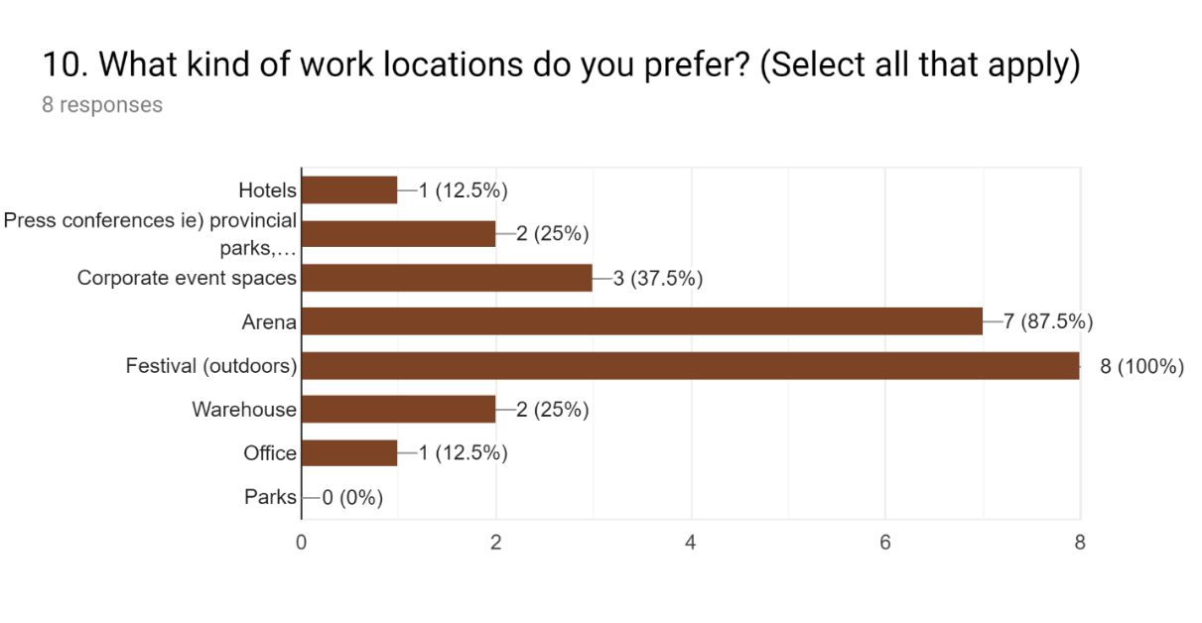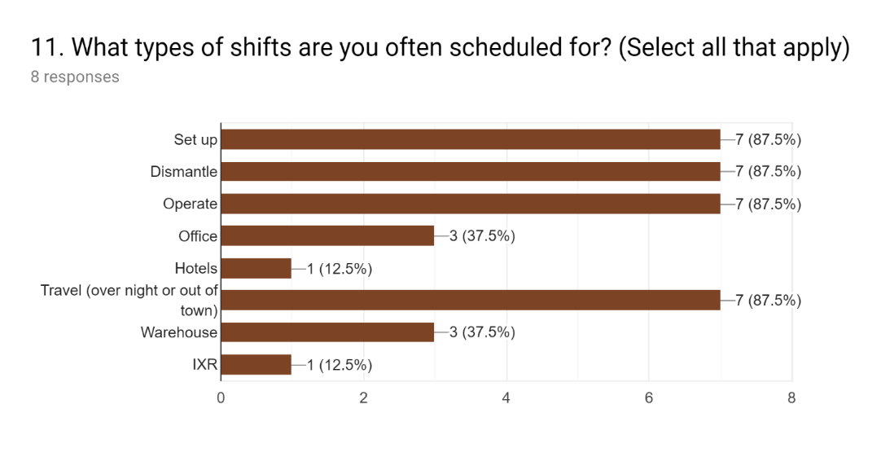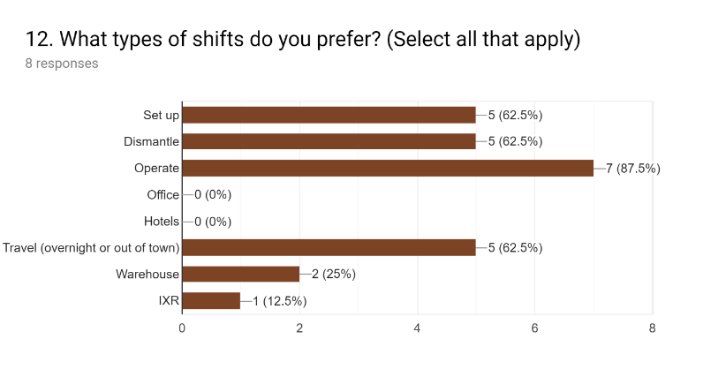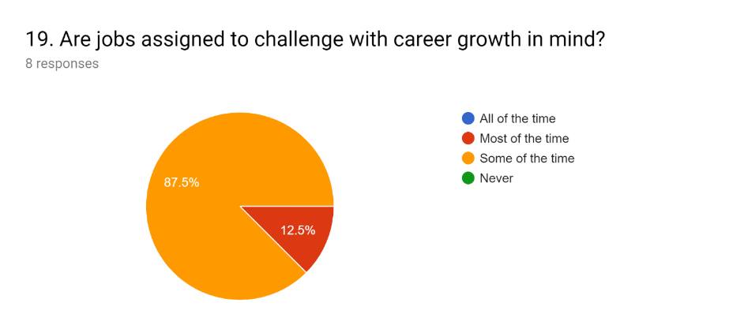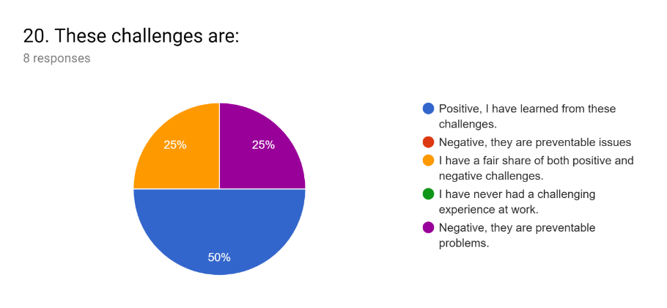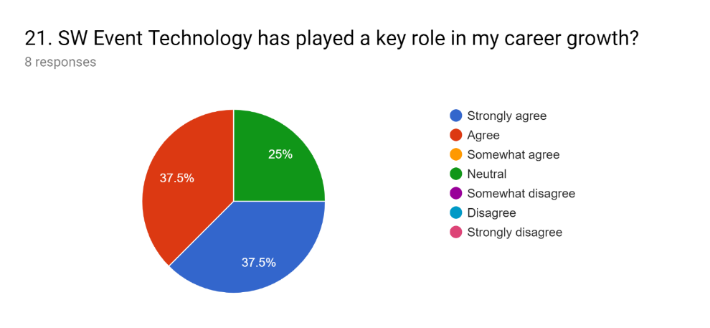
Craig Westley, General Manager
- Do we have enough time to fit in our
  - Yearly hours, no one cracks 2200hrs
  - Fairly normal
  - He would get 3 months off a year because of banked hours
  - Opportunity to freelance,
  - He is happy to allot those slow season '
Barry Fisher, Assistant General Manager
3. What have been your negative experiences as an employee?
- When I was a tech, the long and scattered hours were challenging.
6. What could be improved based on your experience?
- Look at using a different app other than Humanity that works better for the event industry
- Look at charging 4 hour minimums to clients to avoid the 2 hour shift

3. Summary and overall interpretation of Findings
What started out as a concern for individual hour allocation developed into a need for increased flexibility of staff in order to improve efficiency and rely on less labour for smaller shows. However, the importance in regularly distributing skilled tasks amongst staff to maintain versatility is key in maintaining the core competencies of the business.

Recommendations
- Coping strategies such as time buffers increase the “time between two consecutive tasks and are typically applied in project management and personnel task scheduling problems to avoid delay propagation” (Ingels and Maenhout 144).
- Disruptions in for shifts can be prevented through on call reserve duties rather than converting a day off into working duty (Ingels and Maenhout 144).
- The above fulfills a reactive strategy in personnel assignment.
Therefore, the companies that wish to develop their responsiveness through staff versatility should accept the additional labour cost linked to the work of non-ideally skilled operators: this additional cost of industrial activities can be considered as an investment in human resources and in the company’s future adaptability” (Attia et al.4571)
OVERTIME
- “the incorporation of scheduled overtime in the minimum cost and time buffer baseline roster leads to an increased assignment flexibility, which is not existent in the basic baseline roster

ON CALL roster to prevent having unscheduled overtime on each unit crew for DM and SU
ON CALL roster for pop up events one per department
Works Cited
Attia, El-Awady, Philippe Duquenne, and Jean-Marc Le-Lann. "Considering Skills Evolutions in Multi-Skilled Workforce Allocation with Flexible Working Hours." International Journal of Production Research, vol. 52, no. 15, 2014, pp. 4548-4573.
AVIXXA. “The Commercial Audiovisual Industry has Enjoyed Two Years of Growing Sales and Employment, According to AVIXA's Monthly Sentiment Index." Targeted News Service, 10/03/2018,
Humanity Inc. “The Leading Cloud-Based Employee Shift Scheduling Software.” Humanity, www.humanity.com/platform. Accessed 3 December 2019.
Ingels, Jonas, and Broos Maenhout. "The Impact of Overtime as a Time-Based Proactive Scheduling and Reactive Allocation Strategy on the Robustness of a Personnel Shift Roster." Journal of Scheduling, vol. 21, no. 2, 2018;2017;, pp. 143-165.
“History of SW Event Technology.” SW Event Technology, 19 Feb. 2018, www.sw-online.com/about-sw-audiovisual/history/.
Tuttle, Robert, and Michael Garr. "Shift Work and Work to Family Fit: Does Schedule Control Matter?" Journal of Family and Economic Issues, vol. 33, no. 3, 2012, pp. 261-271.

