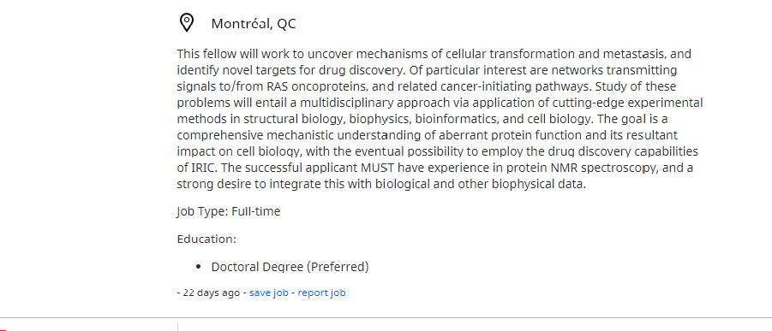

Citation:
“Jobs” Institute for Research in Immunology and Cancer (IRIC), University of Montréal, https://ca.indeed.com/viewjob?cmp=Institute-for-Research-in-Immunology-and-Cancer. Accessed on December 10, 2019

Taras Shyp
675 West 10th Avenue
Vancouver, BC V5Z 1L1

December 12, 2019

Institute for Research in Immunology and Cancer
Université de Montréal
2950, Chemin de Polytechnique
Pavillon Marcelle-Coutu, Rm. 4480
Montréal, Québec H3T 1J4

Dear Representative of the Institute for Research in Immunology and Cancer,

Please consider my application for a Postdoctoral Fellowship at the Smith`s Laboratoty at Institute for Research in Immunology and Cancer as advertised on December 11on caindeed.ca. I am pursuing the Doctor of Philosophy degree at Sorensen`s Laboratory at the University of British Columbia and willing to get an experience of cancer-initiated pathways studying. As my supervisor, Dr. Sorensen, suggested the multidisciplinary approach in studying signalling causative of human disease will foster my own project and research output.
As you can see from my resume, I obtained medical degree and have been working as a pathologist in the biggest pathology laboratory of the Western Ukraine for 3 years, and as a histopathologist at the diagnostic center “MeDiS”. Moreover, I researched thyroid cancer at the Department of Pathology at Lviv National Medical University using immunohistochemical methods. At all institutions I worked with specimens from patients with different kinds of cancer using multidisciplinary approach to elucidate the important proteins in cancerogenesis. Additionally, working at the Sorensen`s lab I trained in various approach of proteomics, namely NML spectroscopy and mass-spectrometry.
My medical background and research experience helped me to integrate clinical and experimental approach in identifying possible targetable proteins in cancer signal cascades. Moreover, my experience in genetic field could increase the multidisciplinary approach in cancer-causing pathways studying at yours laboratory.
If my background find your need, please phone any weekday after 3 p.m. at 604 2882 345 or email at tshyp@alumni.ubc.ca.

Sincerely,
Taras Shyp

Encl.: Resume

Contact Indormation  675 W 10th Ave  Vancouver, BC V5Z 1L1  604 2882 345  https://www.linkedin.com/in/tshyp/  tshyp@alumni.ubc.ca  Interests  Molecular oncology  Cell death mechanisms  Metastasis process  Childhood cancer |  | Taras Shyp  Anatomical Pathologist, PhD student  Objectives  Intensive training and research work in molecular pathology and cancer molecular biology. Willing to subspecialize in paediatric cancers  Education  University of British Columbia  Doctor of Philosophy in Interdisciplinary Oncology. Appointed May 2019  Danylo Halytsky Lviv National Medical University  August 2015 – August 2016  Anatomical Pathologist  Danylo Halytsky Lviv National Medical University  September 2009 – June 2015  Doctor of Medicine  Work  Lviv Regional Pathology Bureau, Pathologist (full-time)  September 2016–April 2019  Pathohistological Laboratory of the Diagnostic Centre “MeDiS”, Pathologist (part-time)  June 2019–April 2019  Charity Organisation “Galician Hospital Fund” Executive Director (part-time)  April 2017–April 2019  Department of Pathology and Forensic Medicine, Danylo Halytsky Lviv National Medical University, Resident in Pathology (full-time)  September 2015–September 2016  Division of Nephrology, Lviv Regional Clinical Hospital, Clinical Nurse (part-time)  January 2014–June 2015  Volunteer  Lviv Public Integrity Council at Lviv Regional State Admistration, Secretary at Helth Commision  April 2017–February 2019  Skills

References
Available on request

Volodymyr Vovk, M. D., Ph. D.,
Assistance of Professor of Pathology,
Danylo Halytsky Lviv National Medical University
Chief of the Pathohistological Laboratory of Diagnostic Centre “MeDiS”
Pekarska str., 69b
Lviv 79010
Ukraine

Subject: Reference request

Dear Dr. Vovk,

I believe that you are doing well and have a great time with your family during this holiday season. I also hope that the conference organized in November was successful and attracted many outstanding researches in pathology field. I am reaching you out to ask about a reference for a job possition I am currently applying.

I am applying for a position of a Postdoctoral Fellowship at the Smith`s Laboratoty at Institute for Research in Immunology and Cancer. This fellowship allows to design and conduct research projects in studying oncoproteins and related cancer-initiating pathways. I am very passionate about detecting new possible targetable proteins, which are involved in cancerogenesis, as you may be aware of.

Providing your reference would be profitable for me, and increase the chances to get a desirable position. As you can evidence my clinical and research skills in working with cancer patients samples, using different techniques. Moreover, you can attest my ability to choose appropriate approach to solve research questions, as well as ability to be scrupulous in supporting my project ideas. If you have any questions or willing to discuss this question more, please feel free to contact me at tshyp@alumni.ubc.ca. For your convenience, a copy of my resume is attached to this letter.

Thank you for your time and consideration.

Sincerely yours,

Taras Shyp
Encl.: Resume

Oleh Lyubinets, M. D., Ph. D., D. M. Sci,
Professor of Public Health,
Chief of the Department of Public Health
Danylo Halytsky Lviv National Medical University
Head of Lviv Regional Society of Public Health
Pekarska str., 69b
Lviv 79010
Ukraine

Subject: Reference request

Dear Dr. Lyubinets,

I hope that you doing well and reach great success in reorganizing oncological service in Lviv region. Confidently, that you got a lecturer position at Krakiv National University. I am reaching you out to ask about a reference for a job possition I am currently applying.

I am applying for a position of a Postdoctoral Fellowship at the Smith`s Laboratoty at Institute for Research in Immunology and Cancer. This fellowship allows to design and conduct research projects in studying oncoproteins and related cancer-initiating pathways. I am very passionate about detecting new possible targetable proteins, which are involved in cancerogenesis, as you may be aware of.

Providing your reference would be profitable for me, and increase the chances to get a desirable position. As you can evidence my ability to work either independently or in a multidisciplinary team. Moreover, you can attest my ability to operate with various methodology in research work, and my university achievements in cancer exploration. If you have any questions or willing to discuss this question more, please feel free to contact me at tshyp@alumni.ubc.ca. For your convenience, a copy of my resume is attached to this letter.

Thank you for your time and consideration.

Sincerely yours,

Taras Shyp

Encl.: Resume

Amal Mohammad Ell-Nagar, MD, Ph. D.
Research Project Manager,
Department of Molecular Oncology
BC Cancer Research Center
675 West 10th Avenue,
Vancouver, BC V5Z 1L1

Subject: Reference request

Dear Dr. Ell-Nagar,

I hope that you doing well and establish your new project at the Huntsman`s lab. Confidently, that your last paper on metastasis process in childhood osteosarcoma is already accepted by editors withoun any corrections. I am writing you to ask about a reference for a job possition I am currently applying.

I am applying for a position of a Postdoctoral Fellowship at the Smith`s Laboratoty at Institute for Research in Immunology and Cancer. This fellowship allows to design and conduct research projects in studying oncoproteins and related cancer-initiating pathways. I am very passionate about detecting new possible targetable proteins, which are involved in cancerogenesis, as you may be aware of.

Providing your reference would be profitable for me, and increase the chances to get a desirable position, as your achievements in pediatric cancer research are well known across all Canada. You can evidence my passion to learn new research techniques and apply them in my own research. Additionally, you can attest my ability autonomously organize research project and reach expected goals. If you have any questions or willing to discuss this question more, please feel free to contact me at tshyp@alumni.ubc.ca. For your convenience, a copy of my resume is attached to this letter.

Thank you for your time and consideration.

Sincerely yours,

Taras Shyp

Encl.: Resume

