Maximizing Effectiveness of Lecture Capture Systems in the Statistics Department at UBC

For:

Paul Gustafson
Head Professor
Department of Statistics
Faculty of Science
University of British Columbia

By:

Yury Zhuk
University of British Columbia

Date:

Dec. 4, 2019
Table of Contents
Introduction 3
Lecture Capture Systems 3
Case Study and UBC Statistics department 3
Purpose of Report 3
Data 4
Targeted Factors 4
Survey 4
Responses 4
Other Insights 6
Opportunities in the Statistics Department 7
Proposed Modifications to Courses 7
Survey 7
Conclusions 7
Bibliography 8
Appendix 8
Survey 8

Introduction

Lecture Capture Systems

Lecture Capture Systems are designed to make lecture content available online via audio and/or video-recordings distributed online (e.g. posted on a course website). According to UBC Information Technology, these systems are being actively integrated across campus [1]. As of June 24th 2019, there were 40 such systems across different faculties, introduced over the past 10 years, according to The Ubyssey’s interview with Shaun Filwok, the senior manager at Audio Visual Services UBC.

Case Study and UBC Statistics department

The Computer Science department at UBC has taken lecture capture even further by introducing the “reverse classroom” model to courses such as CPSC 110. Under this model, video content is viewed online by students ahead of lecture sessions. The online content is focussed on teaching concepts for the first time, whereas physical lectures are for disseminating examples, problem solving, and Q/A [2]. This example and other uses of lecture capture systems will be particularly useful for analysis, because many students are enrolled in both Computer Science and Statistics courses.

Purpose of Report

The Statistics Department at UBC is continuously modernizing lectures provided to students with the introduction of a variety of technologies. For example, mixed-content notebooks, I-clicker systems, and online discussion forums are now being in lectures. With the installation of audio and video-recording technology in more classrooms, this report will aim to provide recommendations to the Faculty of Statistics at UBC on the best use of these systems, These recommendations will target student performance, satisfaction, and participation as the primary metrics for evaluating successful implementation of these systems.

Data Collection Methods

To collect data for this report, a short survey was created and distributed via class discussion groups for statistics and computer science courses. A secondary survey was posted online to the UBC Reddit subcommunity, with the same questions to obtain responses from a wider range of students.

Scope of Inquiry

This project investigates how the implementation of lecture capture systems has impacted student learning in other Faculties at UBC, then provide recommendations based on existing evidence and student survey responses.

The following factors were, in order to deliver the most effective ways of using Lecture Capture systems:
- Ways of delivering lectures that have been tested at UBC (e.g. reverse classroom model at the department of Computer Science);
- How varying methods of lecture delivery impact student participation, student performance, and student satisfaction
- How a course’s structure impacts the effectiveness of the systems, and which types of courses benefit from the system the most
  - Classified by year level
  - By the type of textbook used
- What changes can be made to courses to best-utilize the systems
- How the extra burden on lecturers in providing access to the recorded content can be reduced
- How often recordings need to be updated to ensure they are up-to-date

Data

Targeted factors

The aim of this study is to provide recommendations which will maximize the following three performance measures.

Student Participation is simply defined as lecture attendance and attentiveness during those lectures.

Student Performance is defined as the average student GPA at the end of the course

Student Satisfaction is not trivial to quantify. Student satisfaction can be measured through end-of-term feedback surveys, comments on in-class discussion forums, and students’ willingness to recommend the course to their peers.

Survey

To gain insights into the possible effects of Lecture Capture Systems on students, a survey was conducted. 23 survey responses were collected through Piazza and the Canvas discussion board from students enrolled in STAT 404, STAT 406, and CPSC 422 in the first winter term of 2019. 26 more responses were collected from a wider set of students via the UBC subcommunity of Reddit (reddit.com).

The following questions were asked:

1. What is Your Year Standing at UBC?
2. Which Faculty are You In?
3. For most of my classes, I attend lectures: {options}
4. The Availability of Recorded Lectures Online (Please Check all that Apply)
5. Please Rank the Following by Desirability {supplementary course material varieties}
6. Which of the Following are Motivators for Physical Lecture Attendance? (Please Check all that Apply)

Responses

Although the results from the two surveys are very similar, there are notable differences between lower-year (1-2) and upper-year (3+) students, as well as Statistics, and non-statistics-major students. 7 total Statistics-majoring students, and 9 total Computer Science majors responded.

Students, which indicated “The availability of recorded lectures online is helpful for reviewing course content”:
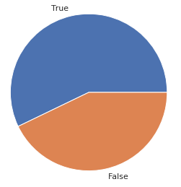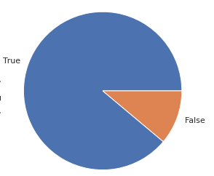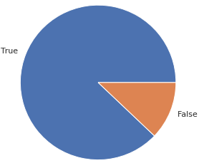

Statistics Students Computer Science Students All Other Students

Although the majority of Statistics students state that recorded lectures are helpful for review, the ratio is much lower compared to other students and even computer science students. This significant difference is not noticed when comparing upper and lower-year students.

Students, which indicated “The availability of recorded lectures online helps in understanding a course's material”

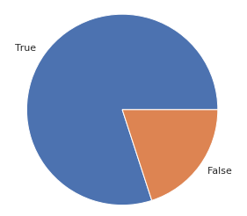
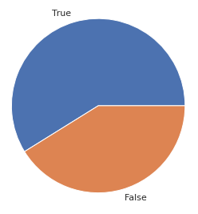
Students in years 3+ (including Graduate Students) Students in years 1 and 2

Other Insights

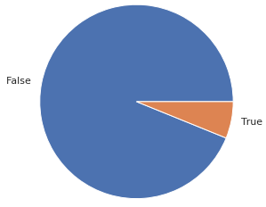 | 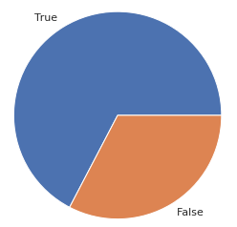 | 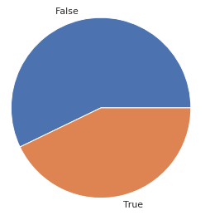
All Students, which indicated “The availability of recorded lectures online is unnecessary (Please note blue is False)” | All Students, which indicated “The availability of recorded lectures online makes studying easier” | All Students, which indicated “The availability of recorded lectures online discourages lecture attendance”

Students, which indicated that derivations of complex equations are motivators for physical lecture attendance

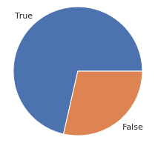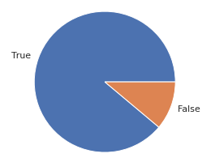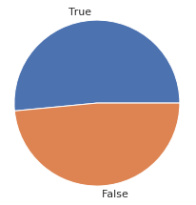
Statistics Students Computer Science Students All Other Students

Students, which indicated that good quality of teaching is a motivator for physical lecture attendance

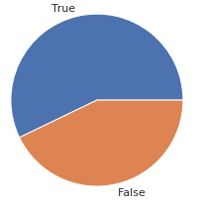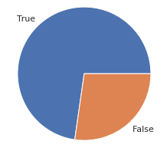
Statistics Students Computer Science Students All Other Students

Furthermore, 82% of students stated that hints about test material are motivators for physical lecture attendance, and 78% stated that participation marks, e.g. I-Clicker marks are motivators.

Opportunities in the Statistics Department

Most students believe that online video-recorded lecture material will be beneficial to their learning. Students in years 1 and 2 may benefit more from these systems as opposed to other types of media. Statistics students specifically indicate that professors explaining complicated derivations of mathematical and statistical concepts will motivate their presence in physical lectures. Online lectures may therefore focus on other aspects of the course to boost student satisfaction and participation.

Most students indicated that the presence of online lectures will decrease attendance. To counteract this, the use of I-clickers and other methods of assessing participation in lectures may be implemented if attendance is an important factor to be considered.

Although the majority of upper-year statistics students indicated that video-recording lectures would benefit learning among a few criteria, this group is the least convinced of this (compared to Computer Science and all other students). For this reason, a supplementary medium of content delivery will be most beneficial, such as online lecture notes.

Proposed Modifications to Courses

In order to best accommodate Statistics students in situations where lectures are being recorded and posted online, the following changes should be made:

- Physical lecture should be incentivized, through one or more of the following:
  - A portion of the final mark awarded for participation, such as I-Clicker marks
  - Hints revealed about content of the exam
- Physical lectures should focus on deep conceptual understanding, by relating theory with mathematical derivations.
- Ample opportunities should be given for students to ask questions during lectures

The following things should also be taken into consideration:

- Video-recordings of lectures may be supplemented with written notes and explanation for upper-year Statistics students

Conclusions

The findings from the surveys indicate that students in every major will benefit from Lecture Capture systems. However, certain measures may be taken to encourage attendance. Lower-year students will benefit the most from video-recorded lectures, whereas upper-year students may prefer supplementary media for studying.

Several modifications to Statistics courses are recommended if Lecture Capture systems are to become a core part of the lecture, outlined in the Data section.

Bibliography

[1] https://it.ubc.ca/services/audio-visual-creative-services/lecture-capture
[2] https://edge.edx.org/courses/course-v1:UBC+CPSC110+2019W1/course/

Appendix (Survey)
