Application Package
Emily Jasmine Krisnamurti
ENGL 301
December 4, 2019

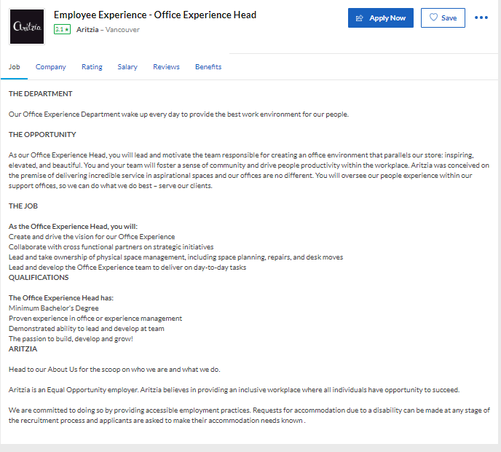

Citation:
“Aritzia Employee Experience - Office Experience Head Job in Vancouver.” Glassdoor, https://www.glassdoor.ca/job-listing/employee-experience-office-experience-head-aritzia-JV_IC2278756_KO0,42_KE43,50.htm?jl=3351436084&ctt=1575465941898&srs=EI_JOBS.

Emily Jasmine Krisnamurti
1933 East 41st Avenue
Vancouver BC, V5P 4Y4

December 4, 2019

Aritzia Recruitment Team
611 Alexander St.
Vancouver, BC V6A 1E1

Dear Aritzia Recruitment Team,
I am writing to express my interest in applying for the position of Office Experience Head under the Employee Experience division.
Having previously been exposed to the Human Resource industry, I now have a passion in contributing to a positive and healthy culture in the workplace. My experience in the Learning for Development team when I was interning at L’Oreal Indonesia has taught me to understand how to develop employees in order to work efficiently and effectively, as well as collaborating with different divisions and functions in the workplace to solve any disputes and/or tensions through a program I help contribute called, “Collab”. This program enables two different teams to settle existing tension, and encourage them to collab in a project that benefits both. It leads to a better understanding and ultimately diminishing the tension.
My experiences in Korn Ferry as a Project Support Intern allowed me to understand the significance of space management in employees’ performance. In Korn Ferry, I manage assessments for clients, and when you manage assessments, you try your best to create an atmosphere that allows clients to feel the most comfort. From this, I believe I can be a great addition to your team.
Currently, I am still undergoing my bachelor’s degree but will be graduating soon. I am confident that I am able to put my best effort and contribute to your company’s growth and success.
I hereby attached my resume and am readily available via phone or email. Please don’t hesitate to reach out to me if you have any further questions. Thank you for your considerations and I am looking forward to hearing from you!

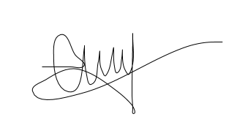
Sincerely,

Emily Jasmine Krisnamurti

Emily Jasmine Krisnamurti
1933 East 41st Avenue
Vancouver BC, V5P 4Y4
Phone: (604)725-6221
Email: emilyjasmine25@gmail.com

Objective Psychology student with exposure to Human Resource and Mental Health related field
Education
2017 – 2020 University of British Columbia, Vancouver Canada
Bachelor Degree on Psychology
2015 – 2017 Edmonds Community College, Seattle, WA USA
Associates Degree
Employment
2018 – Present Ubah Stigma (Change the Stigma) NGO, Indonesia
Co-founder
Create yearly events including a fundraiser, talk show and art exhibition focusing on mental health, create ongoing online campaign called “Let’s Talk” through Instagram, collaborate with numerous NGO to raise awareness and educate Indonesians about mental health.
2018 – Present L’Oréal Indonesia
Learning for Development Intern
Execute daily trainings for employees, organize campaigns to boost digital learning hours, create training events with other divisions.
2018 Korn Ferry Indonesia
Project Support Intern
Manages assessment days, undergo weekly meetings with clients, administering and analyzing assessment results.
Personal Awards
“Contribution on World Mental Health Day” from Indonesia’s Ministry of Health
Activities
Participated in various speaking roles covering topics such as: Ending the Stigma, Breaking the Stigma, Suicide and Preventing Anxiety through Reducing Stigma

Special skills
Bilingual: Indonesian and English
Interests
Movies, travelling, reading, cuisines.
References Available upon requests.

1933 East 41st Avenue
Vancouver BC, V5P 4Y4

December 4, 2019

Indri Lestari
Assessment Manager
Korn Ferry Indonesia
DBS Bank Tower, Fl. 25
Karet Kuningan, Jakarta, 12940

Dear Mrs. Indri Lestari,
I hope this email finds you well. I heard that Korn Ferry is changing their organizational structure, I hope it’s going smoothly and it will accommodate you well in the future. I wanted to write you to ask for a letter of recommendation, as I am trying to apply to a position within the field of Human Resources, specifically on Employee Experience.
I am interested in the role of Office Experience Head here in Vancouver, Canada. The role will require me to handle strategic initiatives, day-to-day office experience tasks and space management. I believe that when I was working for you in Korn Ferry, you have taught me a lot about space management when it comes to handling clients and how important our surrounding is in order to comfort people. For that, I believe that you are the perfect person as a reference.
If you do have time out of your busy schedule to write me a reference letter, please let me know at your earliest convenience. You are able to contact me through my email: emilyjasmine25@gmail.com or through my WhatsApp number: +1(604)725-5856.
Thank you for your time. I look forward to hearing from you! Have a great day.

Sincerely,
Emily Jasmine Krisnamurti

1933 East 41st Avenue
Vancouver BC, V5P 4Y4

December 4, 2019

Ditari Smaraputri
Learning for Development Senior Manager
L’Oreal Indonesia
DBS Bank Tower, Fl. 29
Karet Kuningan, Jakarta, 12940

Dear Mrs. Ditari Smaraputri,
I hope this email finds you well. First and foremost, I would like to congratulate you for your promotion from junior to senior manager of the Learning for Development team. It is very well deserved. I am writing to you now to ask whether or not you would be willing to write me a reference letter for a role I am applying for in Aritzia Headquarters here in Vancouver, as a part of the Employee Experience Division.
The specific role I am applying for is called the Office Experience Head. The role will require me to handle strategic initiatives, day-to-day office experience tasks and space management. Whilst working for you in the past 5 months, I have learned what it’s like to be able to manage, organize and be efficient in a very fast paced environment like L’Oreal. I believe you have taught me more than just what we could do to improve employees’ skills through training, but you also guide me in understanding the beauty market. I believe that my familiarity in the beauty industry also lead me to the fashion industry, and that’s partly thanks to your guidance.
With that being said, I believe you would be a great person to write my reference letter. If you do have time out of your busy schedule to write me a reference letter, please let me know at your earliest convenience. You are able to contact me through my email: emilyjasmine25@gmail.com or through my WhatsApp number: +1(604)725-5856.
Thank you for your time. I look forward to hearing from you! Have a great day.

Sincerely,
Emily Jasmine Krisnamurti

1933 East 41st Avenue
Vancouver BC, V5P 4Y4

December 4, 2019

Asaelia Aleeza
Co-founder of Ubah Stigma
Ubah Stigma
Kemang Selatan VII
Jakarta Selatan, 12730

Dear Miss Asaelia,
I hope this email finds you well. I want to congratulate you for getting your masters degree on Clinical Psychology from the University of College London. It is truly an amazing achievement and well-deserved. I am writing to you to ask for a reference letter from you as I am applying for a position in Aritzia, in the Employee Experience division.
The specific role I am applying for is called the Office Experience Head. The role will require me to handle strategic initiatives, day-to-day office experience tasks and space management. Because I have worked side-by-side with you in developing a NGO for almost 3 years now, I have learn so much about organizational development, event planning, creating professional networks and being an effective speaker from you. I believe that these are important skills that would make me apt for any job I would want to undertake.
With that being said, I believe you would be a great person to write my reference letter. If you do have time out of your busy schedule to write me a reference letter, please let me know at your earliest convenience. You are able to contact me through my email: emilyjasmine25@gmail.com or through my WhatsApp number: +1(604)725-5856.
Thank you for your time. I look forward to hearing from you! Have a great day.

Sincerely,
Emily Jasmine Krisnamurti

