Reducing waste and carbon emissions in promoting a sustainable lifestyle in Metro Vancouver.
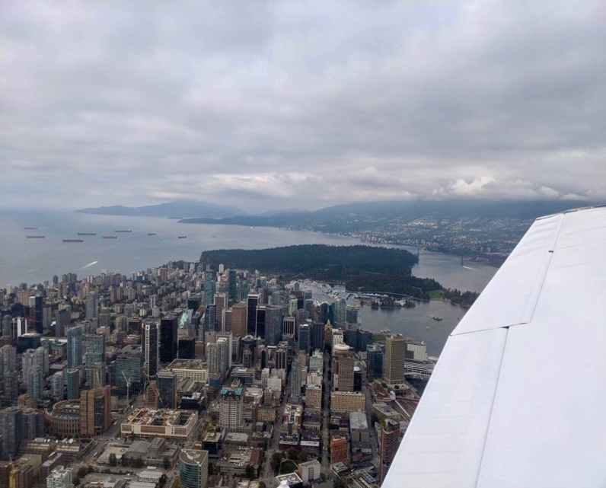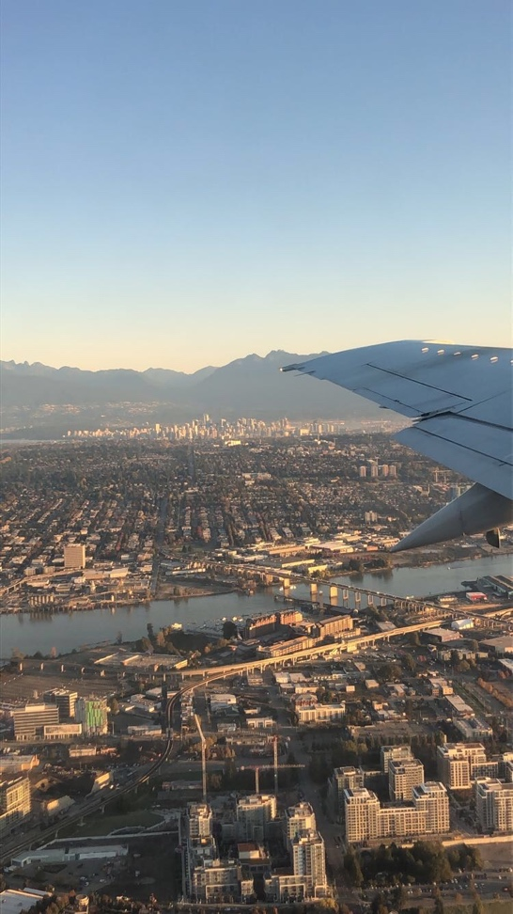
Figure 1: Aerial view of Downtown Vancouver from a seaplane (left) and a commercial aircraft (right). (Sources: Erfan Ahmed)
For:
City of Vancouver Council Members
Vancouver, British Columbia, Canada
By:
Erfan Ahmed
English 301 99A Student
December 4th, 2019
TABLE OF CONTENTS
I. INTRODUCTION
A. Background of carbon emission and climate change
B. Background on the impact of wasting and climate change
i. Current statistics on global emission
ii. Major sources of emissions in Vancouver
C. how carbon emission and increased wasting impacts the community
D. Purpose of the research
II. DATA COLLECTION
a. Current ridership of Transportation in Vancouver
b. Surveys from local residents on waste management and transportation alternatives
III. CONCLUSION
a. Summary of findings
i. Analyze Data from the City of Vancouver
b. Flaws in current system
c. Recommendations and Solutions
d. Expected outcomes

I. INTRODUCTION
Vancouver is situated on the unceded traditional homelands of the Musqueam, Squamish and Tsleil-Waututh Nations - and is the largest metropolitan city in western Canada, with a growing population of 631,486 as per the 2016 census (City of Vancouver), and a population of 2.4 million people in the greater Vancouver area. Rising population has proven to create challenges for the region to overcome issues pertained to urban expansion, gentrification of neighborhoods and improving the transportation network within the region. With rising population growth and urban expansion, there has also been a prevalence of increased climate change around the globe has played a significant role in contributing problems related to household waste and carbon emissions. In order to combat the issues relating to this, it is crucial to start by implementing changes in our lifestyle. Vancouver is known to be one of the eco-friendliest cities in Canada and implementing initiatives in the daily life such as the use of transit and cycling which provides an alternative to other forms of transportation. Furthermore, reducing household waste and using reusable items can act as a viable solution to overcome this area of concern.

A. BACKGROUND OF CARBON EMISSION AND CLIMATE CHANGE
Climate change is one of the most significant challenges that has had an impact on achieving sustainable development, and thereby threatens a vulnerable ecosystem in all realms of the globe. The prevalence of rising climate change has impacted economies and affected millions of lives, costing people, communities around the globe. And subsequently, weather patterns have been changing significantly with sea levels rising at all-time highs, and greenhouse gas emissions that are now at their highest levels in history (UN Sustainable Development). Hence without taking an immediate action plan towards this issue, the problems associated with global warming will continue threaten the ecosystem with high temperatures and sea levels, leaving the poorest and most vulnerable people affected the most.
B. BACKGROUND ON THE IMPACT OF WASTING AND CARBON EMISSION
Mass waste of food on a large-scale level has shown to decompose and release methane gas into the atmosphere. Food waste and loss creates 3.3 gigatons of greenhouse gas emissions which contributes to our current climate issues that occur on a global scale. In addition, all of the resources that have been used to produce food are also wasted. According to the Government of British Columbia, the total greenhouse gas emissions in 2017 in the province were 64.5 million tonnes of carbon dioxide equivalent which reflects a 1.2% increase in emissions since 2016 (British Columbia Greenhouse Gas Emission Inventory 2017).

i. CURRENT STATISTICS ON GLOBAL EMISSION

[To be Completed]

ii. MAJOR SOURCES OF EMISSIONS

[To be Completed]

C. HOW CARBON EMISSIONS AND WASTING CAN IMPACT THE COMMUNITY

[To be Completed]

D. PURPOSE OF RESEARCH
To propose the City of Vancouver council members with an opportunity to invest in tax paying dollars towards strategic and smart solutions that will help in the overall reduction of carbon emissions in the region, such as providing more transportation alternatives that allows reducing the individual carbon footprint, followed by a consideration in the expansion of the Millennium line Skytrain extension that will reduce vehicular traffic to UBC campus

II. DATA COLLECTION
Residents of the city of Vancouver have been included and assessed optional surveys and questionnaires regarding the daily commute within the region, with a purpose to analyze what the average time and distance is spent per day in commuting from home to work or school, and the modes of transportation that is taken. The latter part of the survey analyzes the amount and types of waste that is generated in the average household, and what type of waste management strategies are currently being taken into consideration.

a. CURRENT RIDERSHIP OF TRANSPORTATION IN VANCOUVER
Vancouver is also known to have one of the most comprehensive and reliable transportation networks within the region. With a soaring rise in fuel prices, there has been a steady increase in transit ridership that has forced commuters to find other alternatives to getting to work and school without breaking the bank or spending endless amounts of time stuck in traffic. One of the major bus routes known as the ‘99-B line’ which connects the city from east to west along the Broadway corridor, has been reported to be the busiest bus line in North America, with an annual boarding of more than 17 million people each year (TransLink, 2018). Furthermore, TransLink currently uses a diverse fleet of low and zero emission electric buses that operate within the region and creates a rapid transit system featuring high-capacity vehicles with priority over regular traffic, making it fast, frequent, and reliable (TransLink, 2018). The growing rapid transit expansion within the region has proven to create challenges pertained to an inadequate transportation infrastructure. One of these is the 99-B line along the Broadway corridor which has proven to be a challenge to solve mass ridership that has caused a great deal of overcrowding and busses running at over-capacity, thereby forcing some riders to wait for increased amounts of time until they can successfully get on. The exponential growth of a rising population within the region has resulted in the development of the Broadway subway project that will extend the current Millennium SkyTrain line to travel westbound beneath Broadway through a lower tunnel network. However, the extension of the Millennium line has also created a challenge for transit riders using service to UBC, as the project currently does not extend the line beyond the current proposed terminus station at Arbutus street.
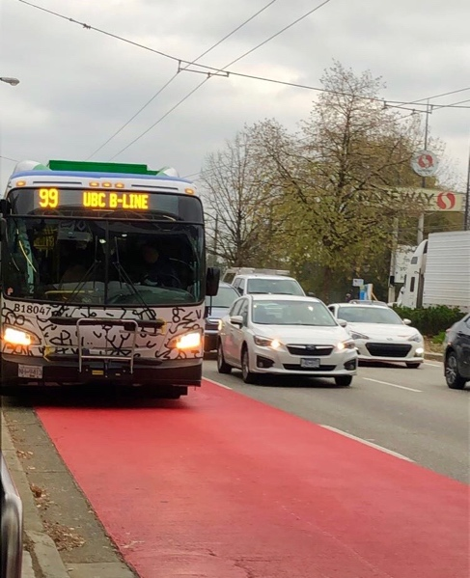
Figure 2: Newly red-painted high occupancy vehicle lane for the 99-B line bus to make drivers aware of the on-stopping zone along the Broadway corridor. (Source: Erfan Ahmed)

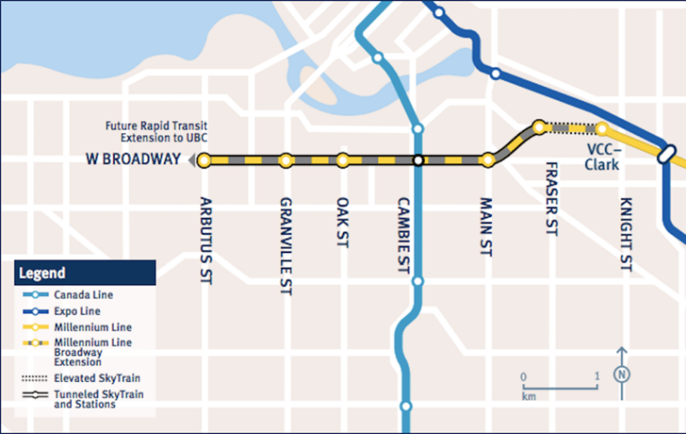
Figure 3: Proposed extension of the Millennium line for the Broadway Subject project. (Source: TransLink website)
I. SURVEYS FROM RESIDENTS
[To be Completed]

b. FLAWS IN THE CURRENT SYSTEM
[To be Completed]
i. FUTURE PROBLEMS ASSOCIATED WITH HIGH CARBON FOOTPRINT
[To be Completed]
c. RECOMMENDATIONS AND SOLUTIONS
A possible solution to this issue is to focus more on strategic actions in the daily life such as buying only what is needed, eliminating plastic bags and bringing reusable tote bags, picking ugly fruits and vegetables at smaller supermarkets, recycling efficiently and using leftover food for meals instead of making it go to waste. All of this can be achieved if the City of Vancouver counsellors introduce a smart solution to recycling that will allow residents to engage and take an active role through a rewards system that tracks household waste and promotes the reuse of items. Therefore, by reducing food waste, we can also reduce the amount of resources lost in its production, processing and distribution. Moreover, providing subsidized transportation alternatives such as the use of transit at a lower cost will allow residents to minimize the use of personal vehicles on the road, especially during peak hours on weekdays. In addition, metro Vancouver has seen a 23 per cent increase in vehicle traffic crossing on the Port Mann Bridge which has led up from 132,000 per day in 2017 to 150,100 after the removal of the tolling system (CBC News, 2019). In addition, Vancouver will have to work with the surrounding tri-cities to find a viable solution to re-implement tolls on the Port Mann bridge during peak hours to encourage residents to take transit to work and school, and therefore aid in reducing carbon emissions.

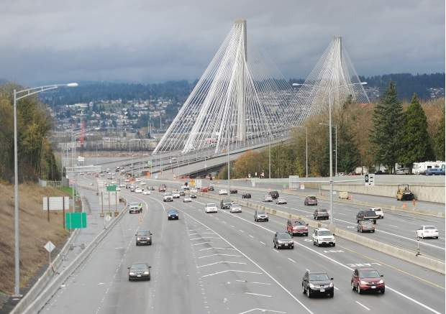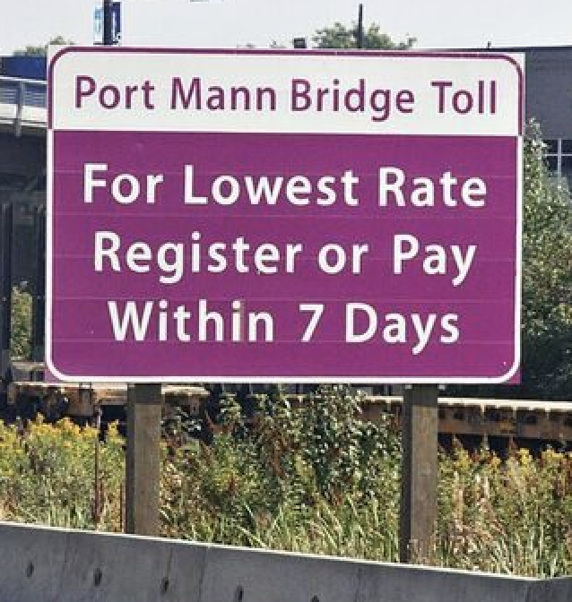
Figure 4: Traffic on the Portmann Bridge, BC Highway 1 (Source: Vancouver Sun)

d. EXPECTED OUTCOME
It is evident that the rising problems associated with wasting and carbon emission plays a key role in the acceleration of some of the world’s largest social challenges. In order to start reducing waste in our daily lives, and how everybody in society can take an active role in reducing one’s carbon footprint. It is evident that Vancouver is one of the fastest growing metropolitan cities in North America, with an envision to become one of the greenest and eco-friendliest cities in the world. And with rising growth in the region, there continues to be challenges associated with finding viable solutions towards planning sustainable housing and transportation to meet the projected higher demands within the next decade. Therefore, integrating the concept of today’s urban city aims to create a sustainable model for high-density housing with easy access to reliable transportation systems. Furthermore, the need for public feedback and outreach is crucial as majority urban projects thrive better with continued support from the community collaborating together towards a better city and future for Vancouver.

Sources
Image: http://www.vancouversun.com/news/Drivers+hate+Port+Mann+toll+more+than+ever+poll/9285808/story.html
“Climate Change - United Nations Sustainable Development.” United Nations, United Nations, https://www.un.org/sustainabledevelopment/climate-change/.
Food and Agriculture Organization of “Key facts on food loss and waste you should know” (n.d.). Retrieved from http://www.fao.org/save-food/resources/keyfindings/en/
“Port Mann Bridge Traffic up 23% since Going Toll-Free | CBC News.” CBCnews, CBC/Radio Canada, 10 Oct. 2019, https://www.cbc.ca/news/canada/british-columbia/port-mann-bridge-traffic-up-23-since-going-toll-free-1.5316459
Smithers, R. (2018, April 12). Want to save the world from hunger? Start by not wasting food, shoppers told. Retrieved from https://www.theguardian.com/global-development/2018/apr/12/food-waste-recipe-for-disaster-global-hunger-fight-shoppers-warned-world-food-programme
Ministry of Environment. “Provincial Greenhouse Gas Emissions Inventory.” Province of British Columbia, Province of British Columbia, 13 Aug. 2019, https://www2.gov.bc.ca/gov/content/environment/climate-change/data/provincial-inventory.

