Improving mental health and wellness of graduate students of the Interdisciplinary Oncology program (IOP) at the BC Cancer Research Center (BCCRC)

To Dr. Kevin Bennewith, Co-Director of the Interdisciplinary Oncology Program at the BC Cancer Research Center
Vanessa Porter, the President of GrasPods

By Taras Shyp
Student of the English 301 course

December 04, 2019
Table of Contents
I. Introduction
1.1. Definition of mental health and wellness and their key components 3
1.2 Impact of mental health and wellness on the overall health 3
1.3. Graduate students, as a vulnerable cohort of mental wellbeing 3
1.4. Purpose of the report 4
1.5. Description of data sources 4

II. Data section
2.1. Main mental health and wellness triggers (based on survey) 4
2.1.1. Work and study environment 5
2.1.2. Student-supervisor relationship and interpersonal communication 6
2.1.3. Work-life balance 6
2.1.4. Social support 7
2.1.5. Others 7
2.2. Mental wellbeing resources available for IOP graduate students 8
2.3. Interviews 9
2.3.1. Geetha V., Wellness Coordinator at GradPods 9
2.3.2. Levonne A., Health Promotion Strategist at UBC 10

III. Conclusions
3.1. Summary and recommendations 12

IV. Appendicies
4.1. Supplementary figures 14
4.2. Survey form 16
4.3. References 20

INTRODUCTION
  - Definition of mental health and wellness and their key components

World Health Organisation (WHO) interprets mental health as “a state of well-being in which the individual realizes his or her own abilities, can cope with the normal stresses of life, can work productively and fruitfully, and is able to make a contribution to his or her community”(1). Mental health is an essential component for overall health wellness. It composed of psychological (i.e., liking most parts of one's own personality, being good at managing the responsibilities of daily life, having good interpersonal relationships), emotional (i.e., happiness, interest in life) and social wellbeing (feeling of social contribution, social integration, and social coherence). Hence, mental wellness is a key aspect of mental health and recognized as a positive state of mental health. Mental wellbeing evolves from feeling balanced, socially connected and ready to cope with life`s challenges. Mental wellness based on a few crucial aspects, such as good sleeping, social connections, eating habits, physical health, etc.

1.2. Impact of mental health and wellness on the overall health

Mental health goes along with overall health and they are fundamentally linked. The relationship between mental health and overall health is obvious in the context of chronic conditions:
- Poor mental health is a risk factor for evolving of chronic physical disorders (e.g., heart diseases, high blood pressure, asthma)
- People with mental health problems more prone to experience chronic physical conditions (i.e., obesity, diabetes)
- Moreover mental health have an impact on how you think, feel, and behave in daily life

  - Graduate students, as a vulnerable cohort of mental wellbeing

The Interdisciplinary Oncology program (IOP) at the University of British Columbia(UBC) is a
graduate program which offers advanced opportunities to study and research in the diversity fields related to oncology for nearly a hundred students. The big number of IOP graduate students study and research in over 60 laboratories at the BC Cancer Research Center (BC CRC), a nationally and world recognized center for supporting ground-breaking researches in oncology.
Although universities and research institutions traditionally consider as the environment with a low stress level, currently emerged researches denoted the prevalence and increasing of mental challenges among academics (2). Graduate students and young post-docs are groups that typically deal with high levels of occupational stress. This problem could be connected with current shifts in the academic world, such as levels of competition on job market increased workload, pace and intensification of changes (3).

1.4. Purpose of the report

The purpose of this investigation is to estimate the state of currently provided resources for mental health and wellness support for graduate students at the BC CRC, and identify possible ways of improving young academics mental health and wellness.

  - Description of data sources

Sixteen graduate students responded to a short survey (Appendix A) designed to estimate the importance of mental wellness resources for graduate students as well as find out the factors that impact on mental wellbeing. Additionally, interviews were conducted with Levonne Absire, Health Promotion Strategist at the Department of Health Promotion and Education of the University of British Columbia, and Geetha Venkateswaran, Wellness Coordinator of GrasPods at the BC Cancer Research Center, to elucidate new available strategies for improving accessibility of mental health and wellness resources for off-campus graduate students.
Search for secondary data was conducted through a biomedical literature database, PubMed. The list of references is provided in Appendicies section.

DATA SECTION

2.1. Main mental health and wellness triggers (Results from the survey)

The study includes 22 questions, two of them were with multiple choice answers. All participants took part in the survey voluntary and responded to all questions.
In total 16 graduate students took part in the survey, among them eight students are PhD students and eight are Master`s students. Students who took part in the study are at different years of their study, which enable more random estimation of mental health awareness among students. Gender and origin distribution among graduate students are given in Appendicies section (Fig.1.1 and Fig.1.2).
The majority of students indicated on high influence of stress on academic performance (81.3%), 18.7% of students did not consider that stress has influence of their academic performance. As can be seen in Fig. the main stress factors for graduate students were lack of sleep, financial pressure, poor work-life balance, academic responsibilities and pressure.

Fig.1 Usual stress factors for graduate students at the BC CRC

2.1.1.Work and study environment

The survey showed that the majority of graduate students (87.4%) are fully satisfied with the IOP, which indicates reasonable organization and workload of the program. Two students (12.6%) estimated their satisfaction of the program as neutral or close to not satisfied.
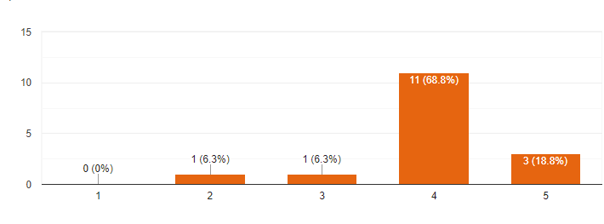
Very satisfied
Not satisfied
Fig.2 Graduate students` satisfaction by the program

Work environment has strong impact on graduate students academic achievements (93.3%), at the same time the majority of students rated their overall well-being when they are at work as excellent or almost excellent (75.1%) that indicates on the proper organization of occupational milieu at the BC CRC.
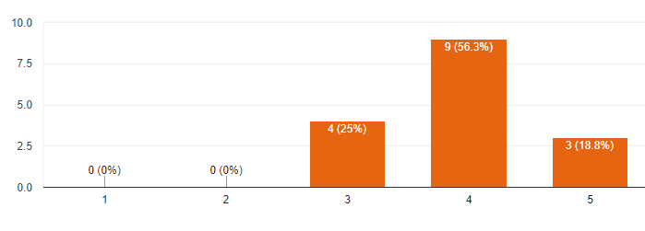
Fig.3 Overall wellbeing of graduate students at work
Excellent
Poor

2.1.2. Student-supervisor relationship and interpersonal communication
Most of the students agreed with the importance of interpersonal relationships with their peers and colleagues (appendicies, Fig.1.3). Moreover, all students defined the key role of the student-supervisor relationship for graduate students academic success and chose that graduate students should meet with their supervisors at least once per two weeks (appendicies, Fig.1.4)

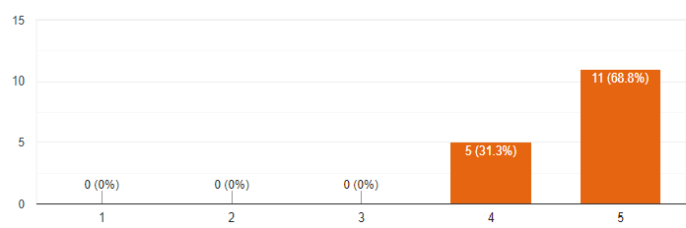
Highly important
Not important
Fig.4 Role of the student-supervisor relationship for graduate students academic success

2.1.3. Work-life balance
Work and study often seem to be the only parts of a graduate student’s life and good balance between both is crucial for preventing work burnout and successful academic output. Respondents recognized high importance of the work-life balance what is indicated in Fig.5. Additionally, most of the students (75%) pointed out that optimal time to devote to the project outside work are 1-6 hours or 6-12 hours (per week, Appendicies, Fig. 1.4). Interestingly, that students gave dissimilar estimation of influence of work in the laboratory on weekends on mental wellness (Appendicies, Fig. 1.5), and a great number of students suggested that work at weekends does not have impact on mental wellbeing.
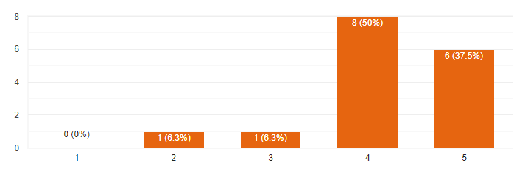
Unimportant
Highly important
Fig.5 Role of of work-life balance for graduate students

2.1.4. Social support
All students estimated a pivotal role of social support from friends and family to academic studies. It is worth to say that the lack of this type of support could be a strong stress-generating factor, especially for international trainees.
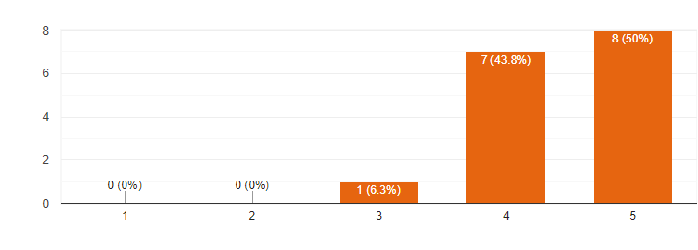
Fig. 6 Role of social support from friends and family to academic studies graduate students

Highly important
Unimportant

2.1.5. Other factors
Funding and financial pressure
The majority of students (87.5%) pointed out on high impact of life expenses on academic studies.
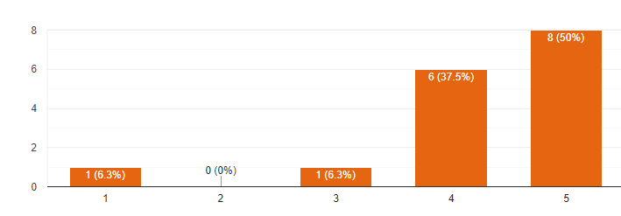
Fig. 7 Impact of the cost of living on academic performance of graduate students
Powerfully
Poorly

Moreover, 62.5% of students responded that the university provides not enough amount of funding. The financial pressure become more potent on graduate students at the BC CRC due to high cost of living in Vancouver (4).
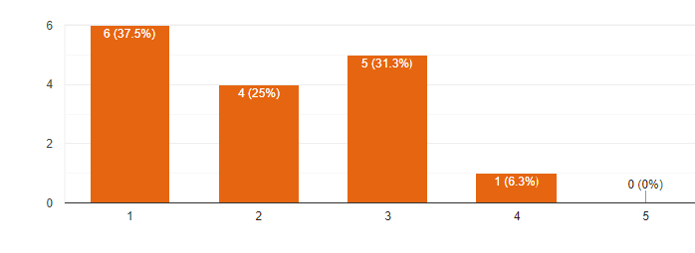
Fig. 8 Impact of the cost of living on academic performance of graduate students

Fully enough

Not enough

2.2 Awareness of services provided by UBC

Interesting was to look at how graduate students are aware of available resources provided by UBC. The survey shown a scarce level of awareness of the services for mental health support, more than a half of trainees are not enough aware of the resources. As a result, respondents indicated a high level (37.5%) of discontent by the wellness resources provided by UBC (Appendices, Fig.1.7).
Well aware
Not aware
Fig. 9 Awareness of of the mental wellness resources available for graduate students

Among all resources available for graduate students, trainees are aware of such resources: UBC Wellness Center, UBC Counselling Services, Student Health Services, AMS Sexual Assault Support Centre. No one among trainees have been aware of a few of resources: Foundry, Nurse on Campus Initiative and The Caleidoscope.

Fig. 10 Number of resources that graduate students were aware of before taking this survey

2.3. Interviews

2.3.1. Geetha V., Wellness Coordinator at GradPods

1. What are your tasks and responsibilities as Wellness Coordinator?

As a wellness coordinator in the BC Cancer Graduate Student and Post-doctoral Fellow Society (GrasPods), my role is to come up with initiatives to promote physical and mental wellness in our student community. In line with this, I organize activities and events that would provide an opportunity for the off campus graduate students and post-doctoral fellows to de-stress and achieve a healthy work-life balance. Some of the events that we have organized in the past year include hiking, Step It Up challenge at workplace, plant workshop, clay art workshop, monthly art nights, high tea and community garden.

2. What are current GrasPods projects or programs, which focused on students` mental health and wellness?

​Currently, we are aiming to improve the awareness of mental wellness and various resources that are available to UBC graduate students and post-doctoral fellows by organizing workshops. We are also trying to have counselling services on site; initiate 'Not Myself Today' program in the workplace and create wellness resource folders that are accessible to all students and post-doctoral fellows.

3. What are the main mental wellness challenges of graduate students at BC CRC?

This year, our GrasPods wellness team initiated a survey to assess the wellbeing of off-campus graduate students and post-doctoral fellows. Through this survey we have identified the major mental wellness challenges of graduate students to be financial stress; stress caused by degree related concerns; and lack of easy access to mental wellness resources (counselling and other heath related services)

4. What are the available resources for graduate students` wellbeing support at BC CRC?

UBC has extensive wellness support for students and post-doctoral fellows however, currently there are not many wellness resources at BC CRC. GrasPods is now actively pushing forward initiatives to expand the wellness resources/support at BC CRC.

5. What are the possible ways of improving students` mental wellbeing?

Creating a friendly workspace that is safe to express one's mental/emotional state is one way to improve mental wellbeing. In order to create such a workspace we are planning to adopt a program called 'Not Myself Today'. Not Myself Today (https://www.notmyselftoday.ca/) is a mental health initiative that helps to create awareness, reduce stigma and foster a safe and supportive workplace.

2.3.2. Levonne A., Health Promotion Strategist at UBC

- What are your responsibilities as a Health Promotion Strategist?
I work at the Health Promotion and Education Unit promote and educate students, staff and faculties health literacy, namely how to maintain physical and mental health. We also look at the connections between ones health and well-being and their ability to learn, and be successful in graduate studies. I specifically work with graduate students and focus on their wellbeing. I work closely with the Faculty of Graduate students and other central units, that have graduate students services. Some of the work is looking at different programs and services that graduate students are interested in when it comes to their health and wellbeing, psycho-educational workshops around stress management, time management, work-life balance, imposter phenomenon. The other direction of work is around capacity building. For example, one of the program that I`m coordinating called the “Graduate students ambassador program”. This program about identifying and calling on graduate students leaders which can play formal or informal role in supporting their peers and colleagues wellness. I provide them with resources on campuss, teach how to have a conversation with their peers. I also involve in 10 years mental health promoting campine Thrive, how to promote your mental health.
2. Thrive campaign sounds like powerful tool for mental health promotion. Can you tell a little bit more about this program.
Thrive is an annual program which concentrates on a mental health awareness, specifically, mental literacy approach. So, how can we share with the campus community knowledge about mental literacy, what are the different ways to promote mental health, how can you seek help when there is a need in it, reducing stigma, being understand to comprehend the language around mental health (stress stimuli, coping mechanism, etc.).
3. What other approaches do you have do you use for mental health literacy?
We work in partnerships with different units. During the orientation season we provide workshops and presentations around mental health literacy to students, faculties. We don`t share the entire mental literacy, but we do really emphasize the ability to promote mental health: what are the different life style factors, that you should being thinking about while you here: physical activity, social connections, nutrition, sleep hygiene and helping others. We call those Thrive five. Five life factors that can promote ones mental health.
4. What are currently available on and off campus resources for mental health?
There are many different resources. There are online resources, like our website, where you can find different strategies and tips online. In person, would be Counseling service at Brook Hall. And Empower me is a life couching and counseling telephone service that all students can access, if the student is not ready to go to a health counselor or if they are off site. It is the best way that students can get connected to a counselor or life couch, and it is included in their tuition fees.
5. So Empover Me is a kind of an e-health technology?
It is a telephone service available for students 24 hours, 7 days per week. So you will call on you will speak with a trained counselor or navigator on the other line. They would do an intake and then recommend you either a counselor or life coach, if that what you are want.
6. Can you emphasize on off-campus facilities that available for graduate students?
It is more faculty dependent. For example, in the Faculty of Medicine they do have counselors to work with residents. But I do not believe that is the same of the other faculties. In addition, one of our psychologist goes to the BC Women and Children Hospital once or twice a week to offer counseling services to local students.
7. What are the main mental health challenges among graduate students?
Through consultation we have heard in the last few years about some of the challenges that may be more specific for trainees. They are intertwined with the supervisor-student relationship, isolation (independent research, being no longer in groups), the idea of career development, and funding and finances challenges, of course. Others, specific for both groups of students are imposter phenomenon, perfectionism.

CONCLUSIONS
3.1. Summary and recommendations
Overall, the results from the survey and interviews indicated on adequate number of facilities for mental health and wellness support. However, graduate students at the BC CRC indicated insufficient awareness of available resources at UBC. Unawareness of some of them could be explained by a short term of existence of some of the resources: Foundry, Nurse on Campus Initiative.
From the survey trainees pointed out that the major concerns for them are:
- Financial concerns, which could limit students outside activities, and impact on research output
- Academic responsibilities and career opportunities in context of an increasingly competitive and uncertain employment market, unfavorable shift in the labor-supply demand balance
- Lack of sleep that can contribute to students' stress more than other factors
- Poor work-life balance, as graduate students are prone to overworked and unable to set workplace boundaries.

Recommendation for improving mental health and wellness of graduate students of the Interdisciplinary Oncology program (IOP) at the BC Cancer Research Center:
Short term:
- Increasing visibility of mental health and wellness resources, particularly available online:
- Joining to the national campaign “Not Myself Today” (https://www.notmyselftoday.ca/)
- Creating a care package for incoming students
- Providing a presentation about mental wellness literacy in courses that IOP graduate students take
- Improving the content of the Graduate Student Resources Folder on the program website
(https://www.iop.ca/well-being)
- Empowering students to take part in university efforts to support their wellbeing which can raise the awareness and decrease the stigma around mental health issues

- Improving accessibility to off-campus resources:
- Providing counselling service for graduate students at an appropriate facility (BC CRC, Vancouver General Hospital, iCord, etc.)
- Establishing by the IOP a mentorship program between senior students and novice students to facilitate initial period of studying
- Increasing the number of UBC-wellness off-campus facilities or providing discounts for trainees to nearby facilities (gyms, pools, etc.)
Long term
- Initiating of a low barrier bursary for students which unable to obtain subsidized on-campus dwelling, students who have families, foreign students, etc.
- Launching a separate mental wellbeing service dedicated specifically to graduate students
- Implementing annual workshops for academic educators focused on graduate students mental literacy and mental challenges
- Creating a career advice service for young academics

IV. APPENDICIES
4.1. Supplementary figures

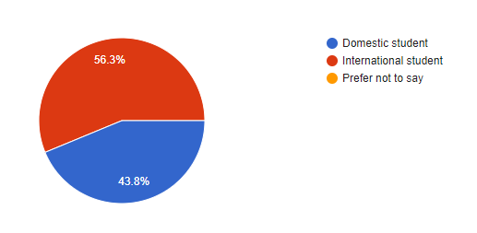
Fig.1.1. Distribution of students according to the origin

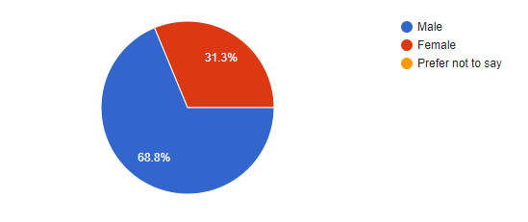
Fig.1.2. Gender distribution of graduate students
Very important
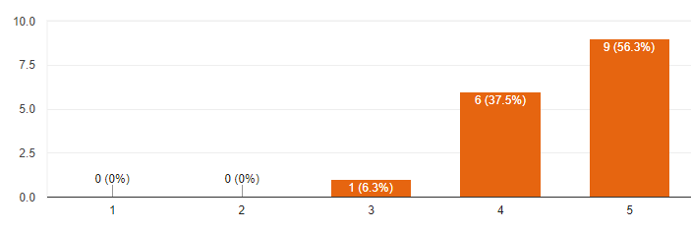
Unimportant
Fig.1.3 Role of interpersonal relationship for the trainee population
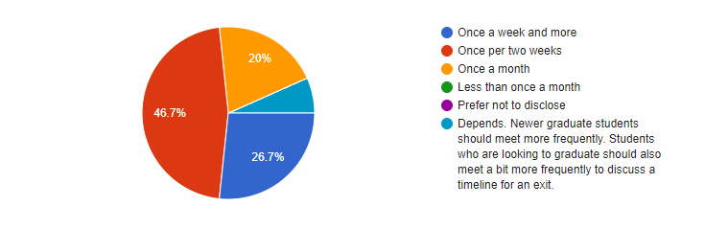
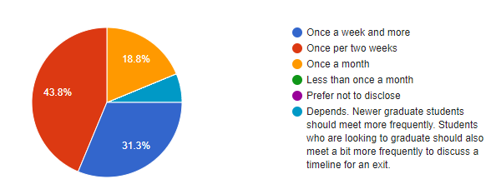
Fig.1.4. Optimal number of meeting graduate students with supervisors

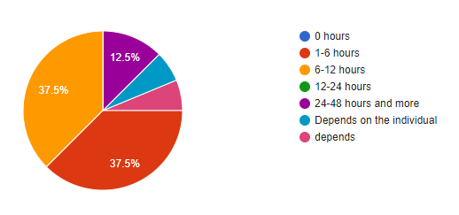
Fig.1.5 Suggested number of hours outside the office that graduate students devote to their project (per week)

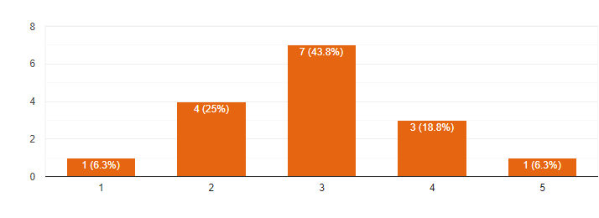
Very positive
Very negative
Fig 1.6 Impact of work in the laboratory on weekends on mental wellness of graduate students

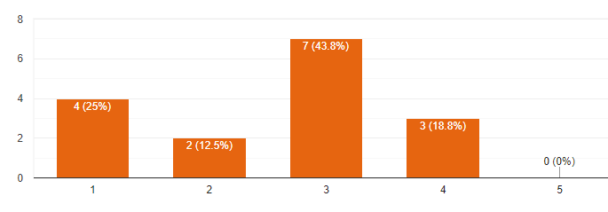
Fig 1.7 Satisfaction with the wellness resources provided by UBC

4.2. Survey form
1. What degree are you pursuing?
- PhD
- Masters
- Prefer not to disclose
- Other______________

2. You are?
- Domestic student
- International student
- Prefer not to say

3. At what year of study you are?
- 1
- 2
- 3
- 4
- 5 and more
- Prefer not to say

4. What gender you are?
- Male
- Female
- Prefer not to say
- Other

5. How satisfied you are with your program?
- 1 Not satisfied
- 2
- 3
- 4
- 5 Very satisfied

6. How would you estimate the role of stress on academic performance of graduate students?
- 1 Do not influence
- 2
- 3
- 4
- 5 High influence

7. What are the usual causes of stress for graduate students at work? (Select all that apply)
- Studies issues and program workflow
- Academic responsibilities or pressures
- Poor work-life balance
- Interpersonal issues
- Financial pressure
- Physical inactivity
- Lack of sleep
- Food and nutrition
- Career opportunities
Other
8. How important are interpersonal relationships between graduate students and peers, colleagues?
- 1 Low
- 2
- 3
- 4
- 5 High
9. How would you rate your overall well-being levels when you are at work?
- 1 Poor
- 2
- 3
- 4
- 5 Excellent
10. What is impact of work environment on graduate students academic achievements?
- 1 Do not affect
- 2
- 3
- 4
- 5 Strongly affect
11. How do you define the role of the student-supervisor relationship for graduate students academic success?
- 1 Not important
- 2
- 3
- 4
- 5 Highly important
12. How often do you think graduate students should meet with their supervisor?
- Once a week and more
- Once per two weeks
- Once a month
- Less than once a month
- Prefer not to disclose
Other
13. How improtant is the role of work-life balance for graduate students?
- 1 Unimportant
- 2
- 3
- 4
- 5 Highly important
14. How many hours outside the office should graduate students devote to their project (per week)?
- 0 hours
- 1-6 hours
- 6-12 hours
- 12-24 hours
- 24-48 hours and more
Other
15. How does work in the laboratory on weekends influence mental wellness of graduate students?
- 1 Very negative
- 2
- 3
- 4
- 5 Very positive
16. How important is social support from friends and family to academic studies?
- 1 Unimportant
- 2
- 3
- 4
- 5 Highly important
17. How does cost of living infuence academic studies of graduate students?
- 1 Poorly
- 2
- 3
- 4
- 5 Powerfully
18. How would you describe the amount of funding that graduate students receive?
- 1 Not enough
- 2
- 3
- 4
- 5 Fully enough
19. How satisfied are you with the wellness resources provided by UBC?
- 1 Not satisfied
- 2
- 3
- 4
- 5 Very satisfied
20. How aware are you of the mental wellness resources available for graduate students (including on- or off- campus/ personal or online?
- 1 Not aware
- 2
- 3
- 4
- 5 Very aware
21. Please choose all the resources that you were aware of before taking this survey:
- EMPOWER ME (over the phone resource)
- UBC Wellness Center
- UBC Counselling Services
- UBC Psychology Clinic
- Student Health Services
- AMS Sexual Assault Support Centre
- AMS Speakeasy
- The Kaleidoscope
- Centre for Accessibility
- CounsellingBC.com
- Therapy Assisted Online (TAO) Self-Help
- Nurse on Campus Initiative
- Foundry
- Thrive program
Other

22. Please leave any suggestions that you would like for us to know regarding how we can improve your wellbeing

References
1. World Health Organization. Promoting mental health: concepts, emerging evidence, practice (Summary Report) Geneva: World Health Organization; 2004.
2. Evans T.M., Bira L., Gastelum J.B., Weiss L.T., Vanderford N.L. Evidence for a mental health crisis in graduate education. Nature Biotechnology. 2018 March 6;36(3). 282-284
3. Levecque K., Anseel F., De Beuckelaer A., Van der Heyden, Gisle L.Work organization and mental health problems in PhD students. Research Policy. Vol. 46 (4). 2017 May. 868-879
4. https://www.mercer.com/newsroom/mercers-25th-annual-cost-of-living-survey-finds-cities-in-asia-most-expensive-locations-for-employees-working-abroad.html. Accessed, December 02, 2019.

