Erfan Ahmed
student: 22041875 erfan@ualberta.ca
English 301 application draft

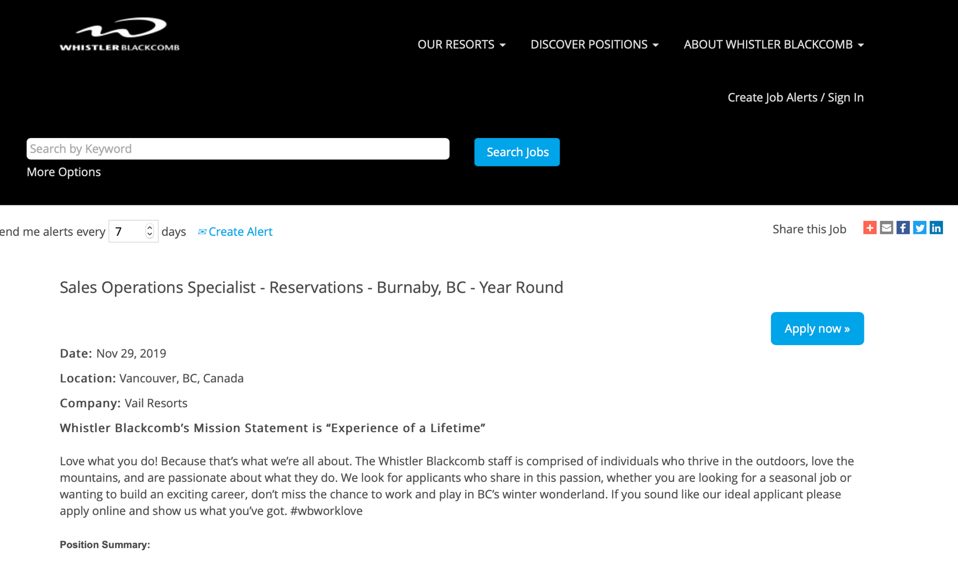
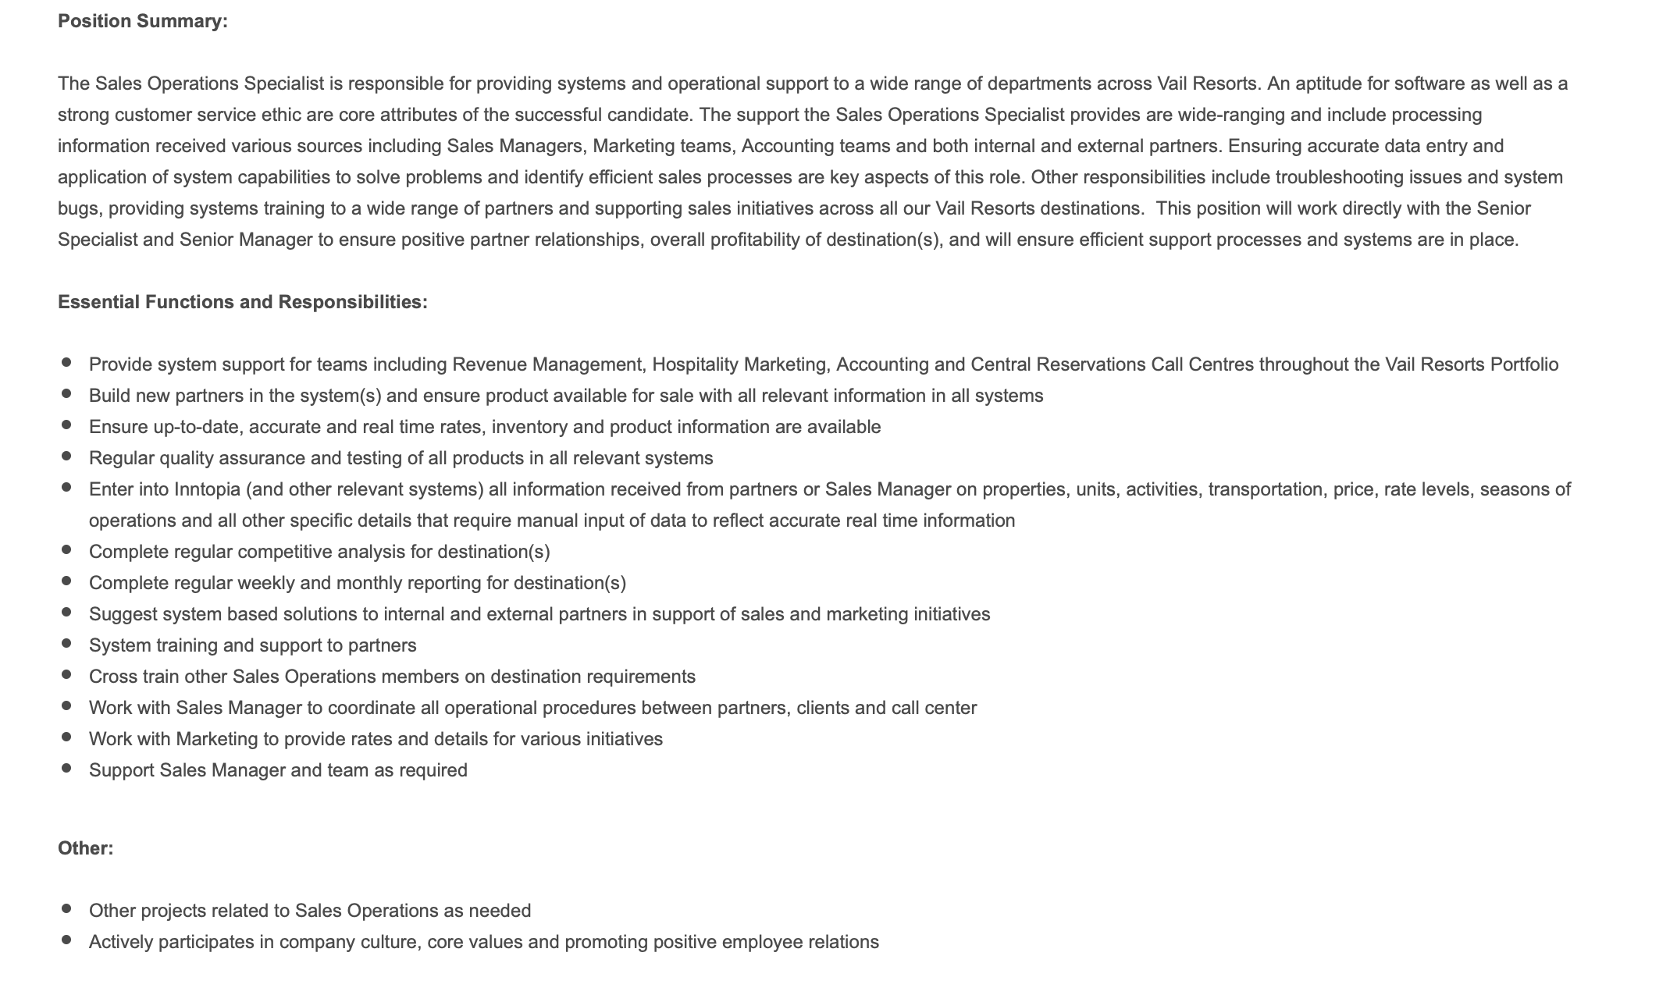

Citation:
“Sales Operations Specialist - Reservations - Burnaby, BC - Year Round.” View All Resorts, https://jobs.vailresortscareers.com/whistler/job/Vancouver-Sales-Operations-Specialist-Reservations-Burnaby,-BC-Year-Round-BC/611916700/?utm_source=Indeed&utm_medium=organic&utm_campaign=krtppc_.

ERFAN AHMED
Vancouver BC
erfan@ualberta.ca
EDUCATION
The University of British Columbia Vancouver, BC
Bachelor of Arts and Sciences in Psychology: Research Psychology December 2019
- Relevant coursework: Organizational Behaviour, Communications, Project Management

SUMMARY
Detail-oriented, responsible and committed professional with 6 years of work experience and a great ability to engage in teamwork towards a common goal or objective. My leadership and positive attitude allow me to take a consultative approach to understand that communication is critical in obtaining success within a team-oriented environment. I have also acquired project management education that I will be using towards gaining a Project Management Professional (PMP) certification.

HIGHLIGHT OF SKILLS
- Soft Skills: Team Leadership, Communications, Project Management Skills, Strong Interpersonal Skills, Problem-Solving, Analytical Skills, Time Management
- Technical Skills: Microsoft Office, Adobe CSS, Sage, CRM, Digital Marketing
- Languages: English & French

WORK EXPERIENCE
Change Healthcare, TEKsystems Richmond, BC
IT Consultant (Contractor) November 2019 – December 2019
- Assess physical and technical security risks to data, software and hardware
- Develop and implement policies and procedures throughout the software development life cycle by mitigating risk and conducting reviews to assess quality assurance practices, software products and information systems
Insurance Corporation of British Columbia (ICBC) North Vancouver, BC Broker Relations Coordinator April 2019 – August 2019
- Providing guidance and information on issues such as licensing and insurance matters and assisting with the implementation of new insurance services and initiatives.
- Routinely access computer databases and reference manuals to research and obtain required information to mediate efficient communication.

UBC Department of Athletics & Recreation Vancouver, BC
Project Worker in Marketing September 2018 – April 2018
- Implement communications with traditional, digital and social media to achieve business objectives.
- Manage accounting budget and Design promotional posters and signage with Adobe InDesign and CSS.

Studentcare Health & Dental (ASÉQ) Edmonton, AB
Member Services Coordinator August 2016 – May 2018
- Respond and handle confidential health claims and investigate high volume of complex cases in accordance with company policies.
- Coordinate insurance health benefit policies for all major post-secondary institutions in Western Canada

TD Bank/Financial Group Edmonton, AB
Customer Services Representative January 2013 – April 2015
- Provide superior customer services to customers and potential customers, giving in detail explanations about products and services available to them.
- Responsible to maintain a consistent sales revenue statistic per shift and provide finance advice such as providing guidance for opening TFSA's, RRSP's, RESP's, mortgage applications and lines of credit.

VOLUNTEER/EXTRA-CURRICULAR EXPERIENCE
Carrie Brown Management Ltd.
Team Leader
- Responsible for leading team members in an efficient and effective manner and ensure safety among music festival patrons.

Elections Canada
Deputing Returning Office & Poll Clerk
- Responsible for the delivery and control of federal electoral events within the Vancouver-Kingsway appointed electoral district.

Alexander Stott, Team Manager – Sales Operations
Whistler Blackcomb, Vail Resorts
300-4445 Lougheed Hwy
Burnaby, BC
V5C 0E4

December 12, 2019

Subject: Job Opportunity with Whistler Blackcomb
Dear Hiring Manager(s),
I am interested in undertaking a position with the Sales Operations team and I believe that an opportunity to work with your team the best place for me to pursue my career goals. Having the ability to choose from a wide array of specializations will help me advance my interests in this diverse field. I would consider myself detail-oriented, responsible and committed professional, with a great ability to engage in teamwork towards a common goal. I take a consultative approach and understand communication is critical in obtaining success within a team-oriented environment.
I believe that my qualifications, education and professional experience would make me a strong candidate for this role and I firmly believe that my leadership, team-player skills and positive attitude can bring a valuable asset to your team. I welcome the opportunity to speak with you about this position and how my experience and skills could help achieve the goals for this position.
Thank you for taking the time to consider my application for this position. Should you have any have further questions or concerns, please do not hesitate to contact me at erfan@ualberta.ca.
Sincerely,
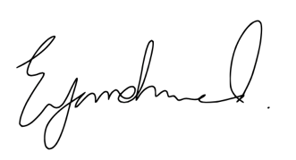
Erfan Ahmed

Brady Johnson, Manager - Broker Relations
The Insurance Corporation of British Columbia
151 W Esplanade, North Vancouver, BC
V7M 3H9
December 12, 2019

Subject: Request for Reference Letter
Hi Brady,
I hope this email finds you well. I am writing to you in regard to requesting a reference letter on your behalf for a new opportunity that I am currently in the process of applying for with Whistler Blackcomb. I learned a lot about working as a Coordinator in communications while working with you at ICBC, and I think you would be able to provide an insight into my skills and previous experiences that would increase my chances of acquiring a new position. I believe that my qualifications, education and professional experience would make me a strong candidate for this role and I firmly believe that the experiences and skills that I have gained while working with your team will help enhance my application with Whistler Blackcomb.
Thank you for taking the time to consider my request for a reference letter. I have attached a copy of my most recent resume and the job posting for your review. Should you have any have further questions or concerns, please do not hesitate to contact me at erfan@ualberta.ca.
Sincerely,
Erfan Ahmed

Sadaf Khatibi | Technical Recruiter - Network Infrastructure
TekSystems
4601 Canada Way
Burnaby, BC
V5G 4X7

December 12, 2019

Subject: Request for Reference Letter
Hi Sadaf,
I hope this email finds you well. I am writing to you in regard to requesting a reference letter on your behalf for a new opportunity that I am currently in the process of applying for with Whistler Blackcomb. I learned a lot about working in the information technology sector while working with you at TekSystems and I think you would be able to provide an insight into my skills and previous experiences that would increase my chances of acquiring a new position. I believe that my qualifications, education and professional experience would make me a strong candidate for this role and I firmly believe that the experiences and skills that I have gained while working with your team will help enhance my application with Whistler Blackcomb.
Thank you for taking the time to consider my request for a reference letter. I have attached a copy of my most recent resume and the job posting for your review. Should you have any have further questions or concerns, please do not hesitate to contact me at erfan@ualberta.ca.
Sincerely,
Erfan Ahmed

Kaya Wiggins, Marketing Manager
UBC Department of Athletics and Recreation
272-6081 University Blvd, Vancouver BC
V6T 1Z1

December 12, 2019

Subject: Request for Reference Letter
Hi Kaya,
I hope this email finds you well. I am writing to you in regard to requesting a reference letter on your behalf for a new opportunity that I am currently in the process of applying for with Whistler Blackcomb. I learned a lot about working in marketing while working with you at with the UBC Thunderbirds Athletics team and I think you would be able to provide an insight into my skills and previous experiences that would increase my chances of acquiring a new position. I believe that my qualifications, education and professional experience would make me a strong candidate for this role and I firmly believe that the experiences and skills that I have gained while working with your team will help enhance my application with Whistler Blackcomb.
Thank you for taking the time to consider my request for a reference letter. I have attached a copy of my most recent resume and the job posting for your review. Should you have any have further questions or concerns, please do not hesitate to contact me at erfan@ualberta.ca.
Sincerely,
Erfan Ahmed

