Improving the Co-op Program at the Employment Standards Branch

For
William Boyte, Executive Director of Employment Standards Branch
Mary Walsh, Regional Manager of Employment Standards Branch, Lower Mainland

By
Tameen Imran
Political Science Undergraduate Student
University of British Columbia
Vancouver, Canada

December 11, 2019

Table of Contents

Introduction 4
Statement of Problem 3
Purpose of this Report 3
Methods of Research 4
Scope of Inquiry 4
Data Analysis 5
Results from Survey of Current Co-op Students 5
Results from Survey of Past Co-op Students 9
Conclusion 13
Summary and Interpretations of Result 13
Recommendations 13
Works Cited: 15
Appendix 1. Survey Questions for Previous Interns
Appendix 2. Survey Questions for Current Interns
Appendix 3.
Appendix 4.

Abstract

Introduction

The Employment Standards Branch, headed by British Columbia’s Ministry of Labour, is an agency that administers the Employment Standards Act which sets the minimum standards of wages and working conditions in BC. It does so by providing compliance support, conducting proactive inspections of payroll records and workplace practices to ensure the Act is being followed, mediating, investigating and resolving complaints, and enforcing the Act and its regulations.

Through its services, the Branch promotes the fair treatment of employees and employers, encourages open communication between employers and employees, provides fair and efficient procedures for resolving disputes over the application and interpretation of the Act, and fosters the development of a productive and efficient labour force that can contribute fully to the prosperity of British Columbia.

The Branch serves the public in a dynamic and multifaceted way which makes working there a challenging and rewarding experience for those interested in pursuing a career in human resources, case management or public administration and policy. This is also explained by the increasing amount of university students applying as co-op students to the Branch’s co-op program in hopes of acquiring a versatile professional skill set.

Statement of Problem
The co-op program at the Employment Standards Branch is a recent initiative created by management that provides opportunities to students interested in public service, however, there are still areas in the program that need to be improved for students to maximize their skills. Students are not comprehensively provided necessary training, guidance and mentorship, which hinders their professional growth, but also the efficiency of the organization. This leads to disengaged students with little motivation to further the mandate of the organization. Additionally, this also reduces the pool of qualified prospective employees as co-op students will no longer consider applying for permanent positions, thus creating staffing shortages.

Purpose of the Report
Co-op programs allow post-secondary students to gain practical work experience in areas that complement their personal strengths, interests and educational needs, as well as develop the marketable skills necessary for success in the workplace.The purpose of this report is to enhance the co-op program at the Employment Standards Branch by providing recommendations for additional training and support for co-op students to achieve their expected goals and excel in their position.

Methods of Research
To investigate the shortcomings of the co-op program, receiving feedback from co-op students themselves would be an optimal measure to determine what factors can enhance the quality of the co-op program. To do this, the first step was to create two different surveys for current co-op students and previous co-op students. The second step was to interview the regional manager to understand the qualifications, current training process, expectations and compensation for co-op students. The third step is, through secondary research, compiling resources offered by other Branch locations and the Government of British Columbia online and in print to better assist co-op students.

The surveys were provided to over fifteen different co-op students who spent and are spending eight months to one year working at the Employment Standards Branch. All of which worked at the same office with similar job descriptions. There are ten questions in each survey and all of them are in the form of close ended questions (e.g. multiple questions, rankings, yes or no). All questions focus on co-op students’ quality of training, challenges, and improvements regarding their individual experiences. The survey remained anonymous and kept confidential for all participants of the survey.

Scope of Inquiry
The scope of inquiry will be to assess the gaps between the current structure and implementation of the co-op program at the Employment Standards Branch and how it can be improved. This report will investigate the underlying problems that need to be addressed for the Employment Standards Branch to strengthen their co-op program to attract and retain upcoming students from post-secondary institutions. The results of this report will then be used as a recommendation for revising the co-op program.

Data Analysis
Results from Surveys from Current Co-op Students
There are a total of 12 responses from this survey. The questions the participants were asked that is relevant to creating a recommendation for the co-op program focuses on:
- Level of training and instructions received
- Level of mentorship and professional feedback provided
- Challenges faced in the workplace
- Improvements for the program
- Whether or not they want to continue working at the Branch
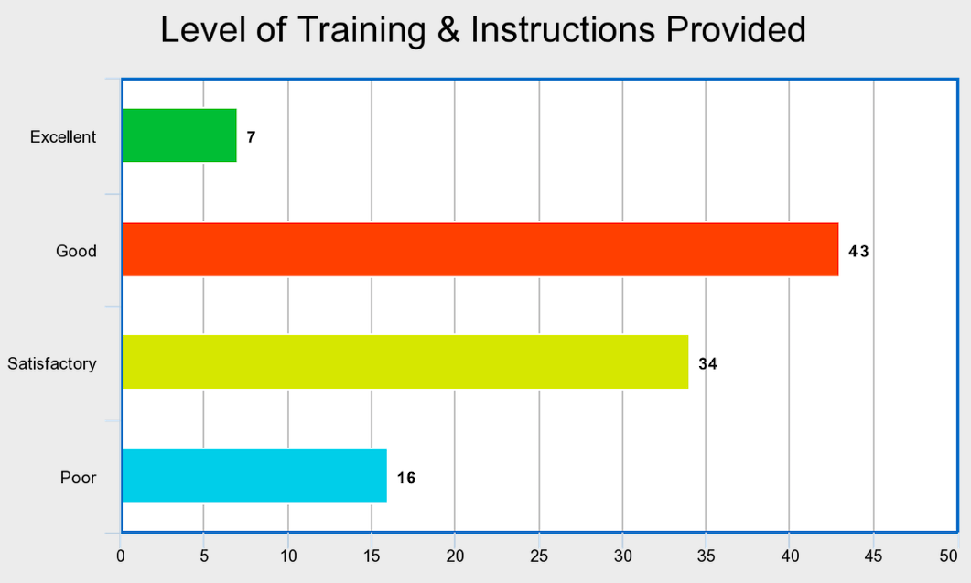
Figure 1. Participants’ rating of the level of training and instructions provided
According to the survey results, the majority of participants indicated the level of training received to be good and satisfactory. Very few responded with excellent, in fact, more people rated it to be poor than excellent.

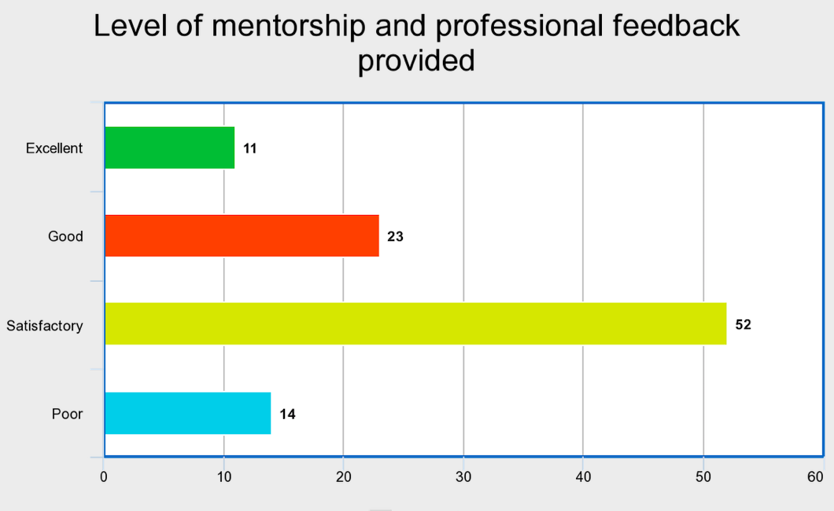
Figure 2. Participants’ rating of the level of mentorship and feedback provided
As indicated above, the majority of participants responded that the level of mentorship and professional feedback that they received was satisfactory, with as much as 52% of respondents selecting that choice.

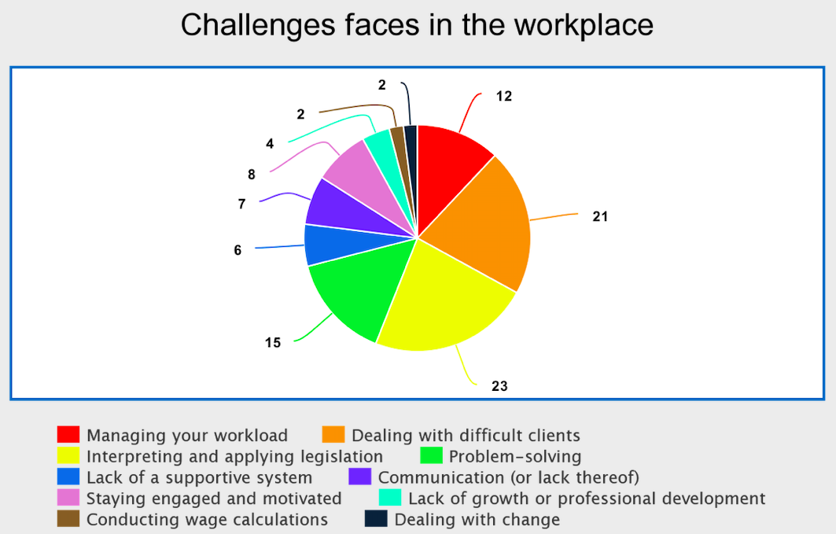
Figure 3. Challenges faced by Current Co-op Students
The top three challenges faced by co-op students is interpreting and applying legislation, dealing with difficult clients, and problem-solving. Some participants also indicated the challenge of managing their workload.
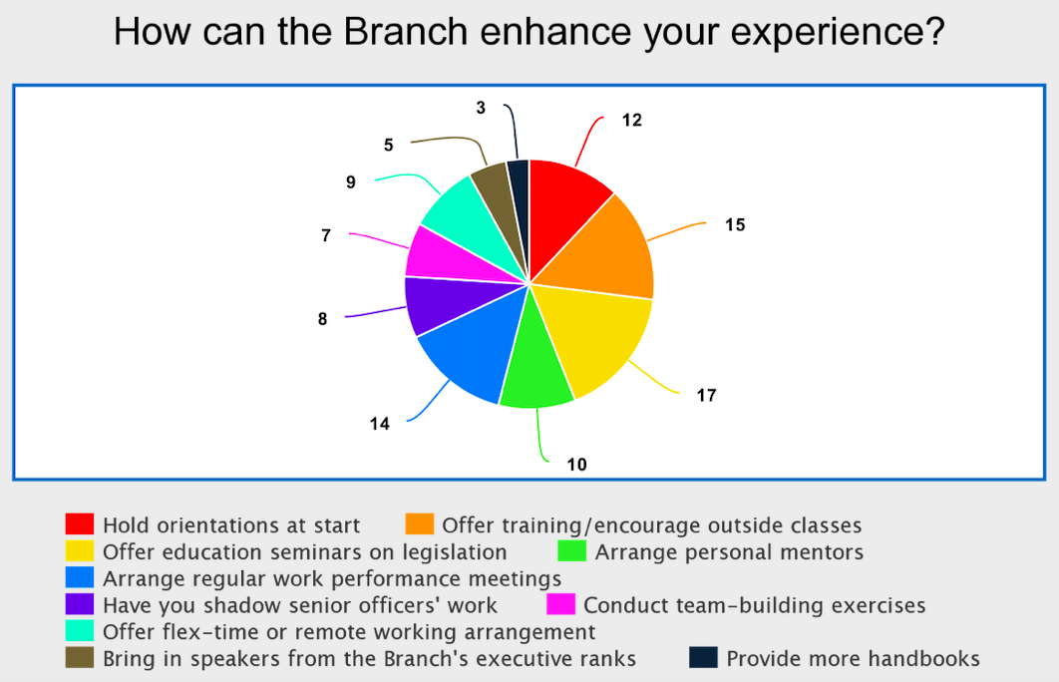
Figure 4. How to Enhance Co-op Students’ Experience
The top three ways the Branch can improve students’ co-op experience, as expressed by the participants, is offering education seminars on legislation, offering training and encouraging outside classes, and holding co-op student orientations at the start of employment. The least preferred way to enhance their experience is through providing more handbooks.

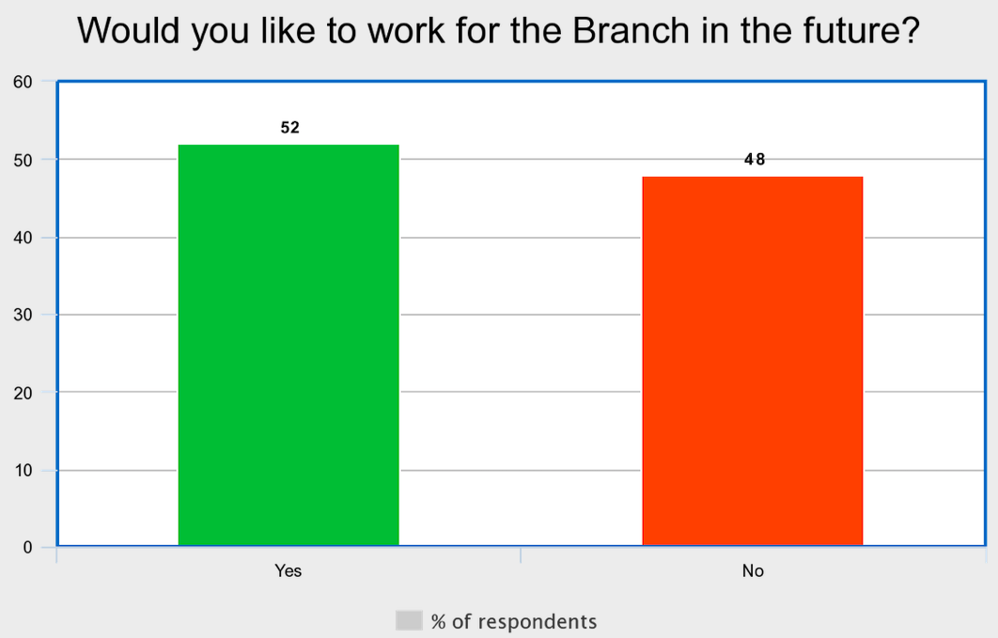

Figure 5. Percentage of co-op students willing to continue working for the Branch
Co-op students were nearly split on this question. Fifty-two percent of respondents indicated that they would like to continue working, whereas 48% preferred not to continue working.

Results from Surveys from Past Co-op Students
There are a total of 14 responses from this survey. The questions the participants were asked that is relevant to creating a recommendation for the co-op program focuses on:
- Reasons for applying
- New skills and knowledge gained
- Challenges experienced
- Whether or not opportunities for growth were provided
- Areas of improvement
- Whether or not they would recommend the co-op program to other students
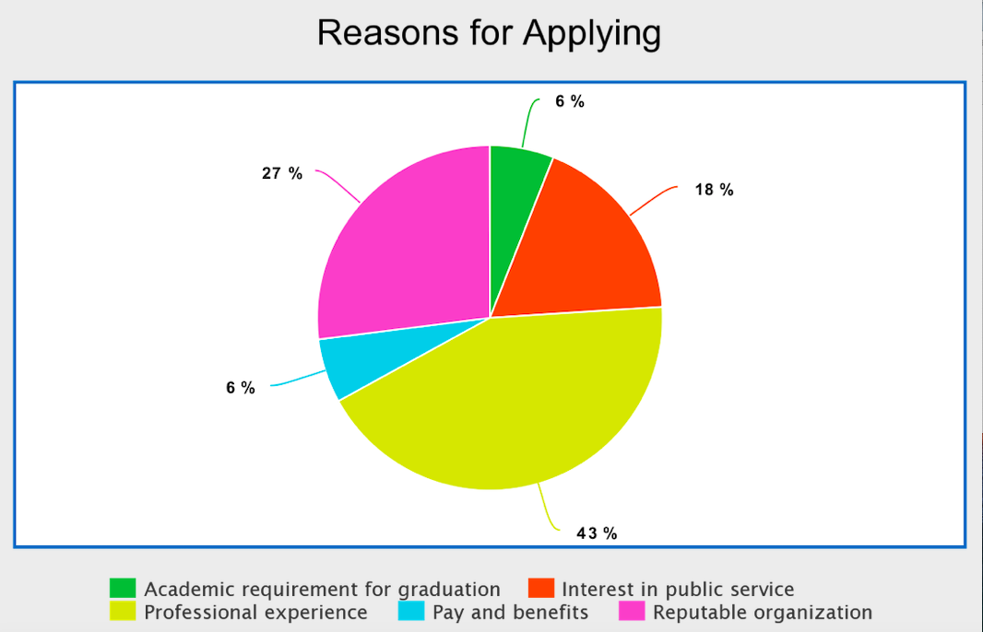
Figure 6. Respondents’ reasons for applying to the Branch’s co-op program
About 43% of past co-op students indicated that they applied to the program in hopes of gaining professional experience. The fact that the Employment Standards Branch is a reputable public service-oriented organization also attracted post-secondary co-op students to apply.
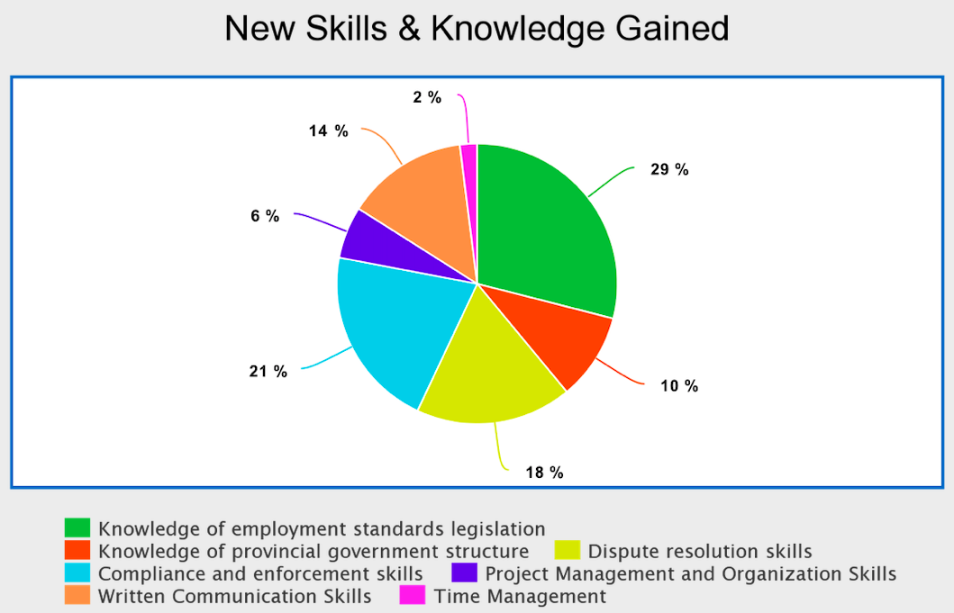
Figure 7. New skills and knowledge gained by past co-op students
Majority of past co-op students who took the survey indicated that they acquired knowledge of employment standards legislation, compliance/enforcement skills and dispute resolution skills through the co-op program at the Branch.
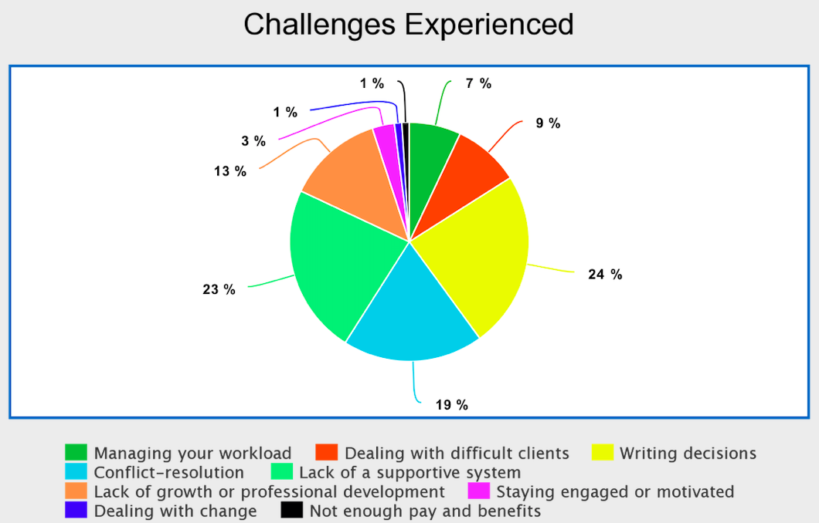
Figure 8. Challenges experienced in the workplace by past co-op students
The top three challenges indicated by past co-op students were writing decisions, managing their workload, and conflict resolution between employers and employees. Lack of growth or professional development was also a challenge they faced, which may have gone against their expectations for the job.
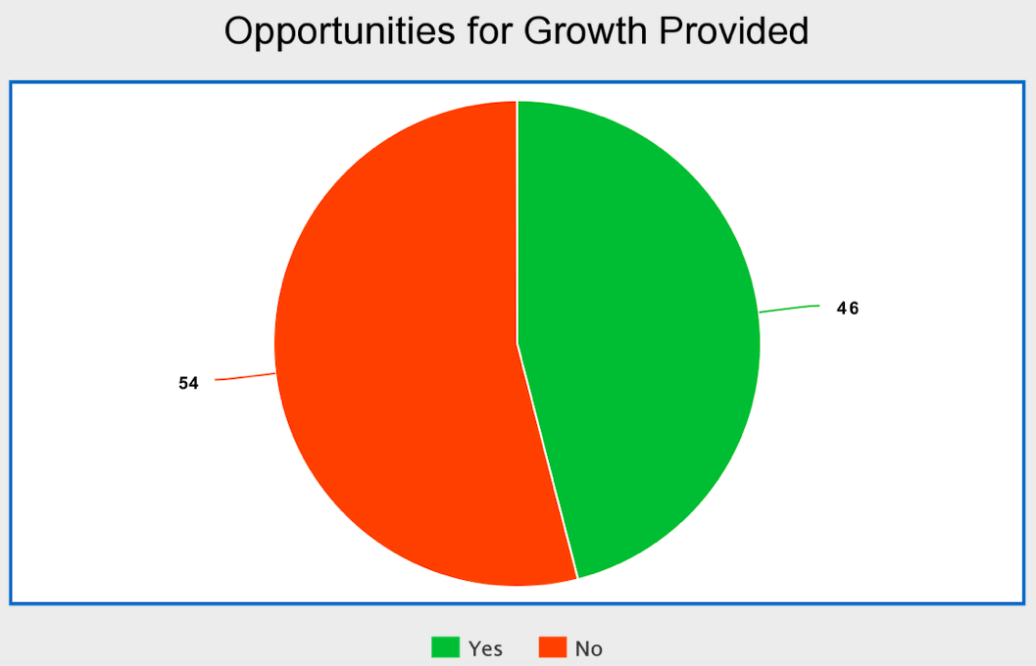
Figure 9. Participants’ response to whether or not opportunities for growth were provided during the co-op program
When participants were specifically asked whether they felt opportunities for professional growth were provided, 54% of past co-op students indicated no.

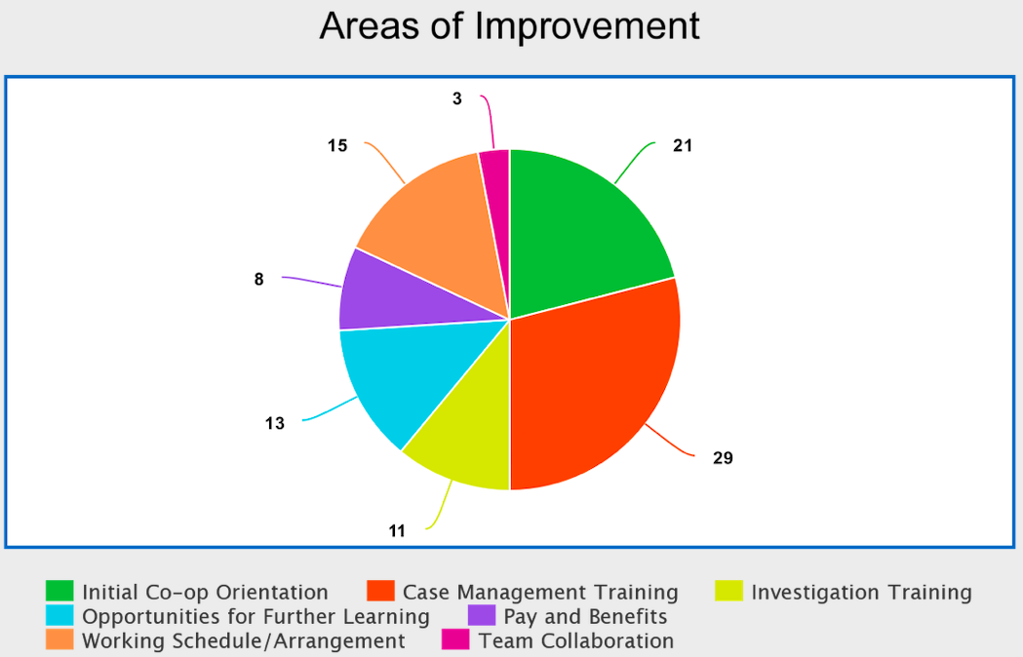
Figure 10. Areas of the co-op program they want to see improved
The top three areas of improvement for the co-op program, as expressed by past co-op students, are the case management training, the initial co-op orientation, and opportunities for further learning.
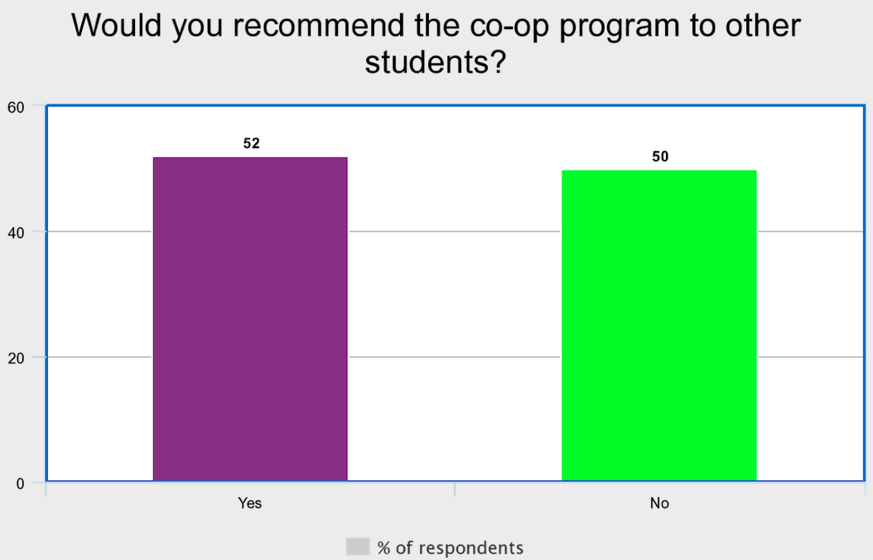
Figure 11. Percentage of respondents who would recommend the program
The participants were nearly split when it come to whether or not they would recommend the Employment Standards Branch’s co-op program to other students. Nearly 52% indicated yes, and 50% indicated no.

Conclusion
Summary and Interpretation of Findings
Based on the results of both surveys, the biggest improvements that are needed to improve the co-op program is to provide co-op students with a comprehensive initial orientation to employment standards, legislation and case management training, additional opportunities for learning. Both current and past co-op students’ survey responses coincide in expressing the need for these improvements. Based on the findings, it can be inferred that co-op students may not feel confident in their work given the lack of training and learning opportunities, which may explain why past co-op students felt that the program did not contribute to their growth and professional development. Studies show that there exists a strong relationship between different levels of training and employees’ commitment to the organisation - the more the training given to employees, the higher their level of commitment to the organisation will be (Owoyemoi et al., 280). According to Figure 5, about 48% of current co-op students indicated that they are not willing to continue working for the Branch, which indicates weak commitment. This weak commitment can, however, be strengthened by offering co-op students the necessary training as indicated in Figure 4.

Recommendations
Based on the data of the surveys and after interpreting the results, these are some recommendations for the senior management of the Employment Standards Branch in order to improve the student co-op program:
- Upon the hiring of co-op students, allot one week to the orientation of new co-op students to provide comprehensive training on Employment Standards legislation, dispute resolution and case management techniques.
- Avoid the dissemination of lengthy and outdated handbooks to co-op students
- Pair each co-op student with a senior officer at the Branch for two weeks to shadow their work such as mediations and hearings at the Branch. This can provide them with skills on how to resolve conflicts between the two conflicting parties.
- Assign an officer to each co-op student as a mentor for the course of their co-op term. Have the officer go over the co-op student’s caseload (on an ad-hoc basis if needed), helping them to review complaints, interpret legislation, draft legal notices and agreements, and provide guidance on investigating complaints.
- Create a repository of written decisions and rulings by issued by the Branch. Not only will this assist co-op students in improving their writing skills, but also serve as a reference for issuing decisions for completed complaint investigations.
- Conduct a workshop on administrative law for co-op students. This will serve as an additional opportunity for them to learn about the body of law that governs the activities of administrative agencies of government, such as rule making, adjudication, and the enforcement of regulatory agendas.

Works Cited
Owoyemi, Oluwakemi Ayodeji, et al. "Enhancing employees’ commitment to organisation through training." International Journal of Business and Management 6.7 (2011): 280-286.

Appendices

